Comment–Topic Correlation Report
Model: llama3

Summary
Topics processed: 4
Comments available for this video: 2
Comments correlated to ≥ 60: 2 (100.0%)
Total candidate pairs checked: 8

Most/Least correlated topics (by average score across correlated comments):
Top 3:
• Topic T1: Introduction to Operational Amplifiers — avg 80.00, contributions 2
• Topic T4: Conclusion and Future Directions — avg 80.00, contributions 2
• Topic T3: Testing the Op-Amp Circuit — avg 0.00, contributions 0
Bottom 3:
• Topic T2: Designing a Simple Op-Amp Circuit — avg 0.00, contributions 0
• Topic T3: Testing the Op-Amp Circuit — avg 0.00, contributions 0
• Topic T4: Conclusion and Future Directions — avg 80.00, contributions 2
Correlated comment coverage (all comments):
- matched 2 topic(s), max score 80.0000: This video gives an overview of operational amps. It gives a brief background of its purposes and its functionality. It also shows its applications and how it’s wired. The video breaks down sections of configurations: inverting, non-inverting, high pass, and low pass filters. This video helps to give a better understanding of utilizing op amps.
Source: https://www.youtube.com/watch?v=_HHxV-7alwE : (187) Op-Amps - Using Operational Amplifiers - YouTube
Top correlated topics:
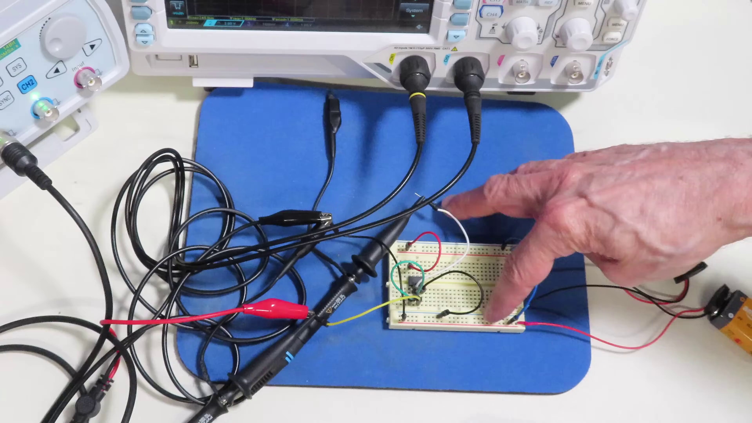 | 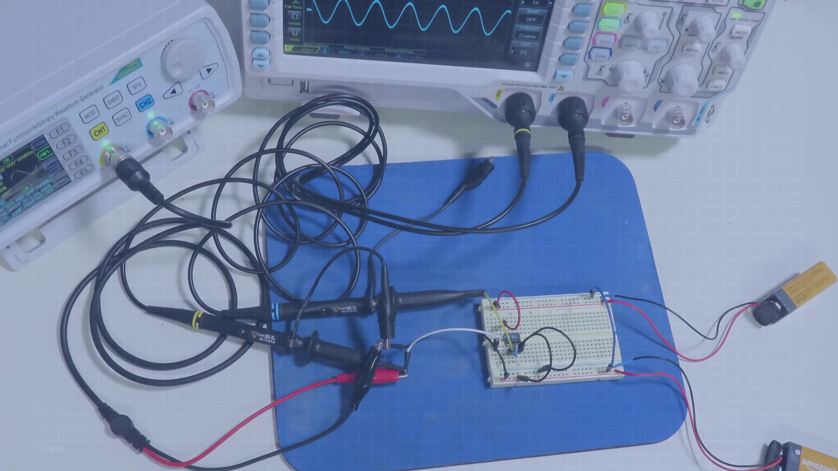 | 
Topic T4: Conclusion and Future Directions — score 80.0000
Description: Summarizing the importance of operational amplifiers and their applications in electronics projects.
Reason: The comment directly discusses the same topic (operational amplifiers) and mentions specific applications and configurations (inverting, non-inverting, high pass, and low pass filters), which are described in the topic.
 |  | 
Topic T1: Introduction to Operational Amplifiers — score 80.0000
Description: Overview of operational amplifiers and their uses.
Reason: The comment directly discusses the same topics mentioned in the topic description, such as operational amplifiers' purposes, functionality, applications, and configurations (inverting, non-inverting, high pass, and low pass filters), showing a strong correlation with the topic.
 |  | 
Topic T3: Testing the Op-Amp Circuit — score 20.0000
Description: Measuring the voltage and verifying the operation of the op-amp circuit.
Reason: The comment provides an overview of operational amps and their applications, but does not specifically discuss testing or measuring the voltage of an op-amp circuit as described in the topic. The comment also focuses on general concepts and configurations, rather than directly discussing the steps or settings required for testing.
 |  | 
Topic T2: Designing a Simple Op-Amp Circuit — score 20.0000
Description: Building a simple op-amp circuit to split a single power supply into two dual supplies.
Reason: The comment provides an overview of operational amplifiers and their applications, but does not directly discuss designing a simple op-amp circuit to split a single power supply into two dual supplies. The topic is related to the concept of op-amps in general, but the specific goal and steps described in the topic are not mentioned.
Least correlated topics:
 |  | 
Topic T2: Designing a Simple Op-Amp Circuit — score 20.0000
Description: Building a simple op-amp circuit to split a single power supply into two dual supplies.
Reason: The comment provides an overview of operational amplifiers and their applications, but does not directly discuss designing a simple op-amp circuit to split a single power supply into two dual supplies. The topic is related to the concept of op-amps in general, but the specific goal and steps described in the topic are not mentioned.
 |  | 
Topic T3: Testing the Op-Amp Circuit — score 20.0000
Description: Measuring the voltage and verifying the operation of the op-amp circuit.
Reason: The comment provides an overview of operational amps and their applications, but does not specifically discuss testing or measuring the voltage of an op-amp circuit as described in the topic. The comment also focuses on general concepts and configurations, rather than directly discussing the steps or settings required for testing.
 |  | 
Topic T1: Introduction to Operational Amplifiers — score 80.0000
Description: Overview of operational amplifiers and their uses.
Reason: The comment directly discusses the same topics mentioned in the topic description, such as operational amplifiers' purposes, functionality, applications, and configurations (inverting, non-inverting, high pass, and low pass filters), showing a strong correlation with the topic.
 |  | 
Topic T4: Conclusion and Future Directions — score 80.0000
Description: Summarizing the importance of operational amplifiers and their applications in electronics projects.
Reason: The comment directly discusses the same topic (operational amplifiers) and mentions specific applications and configurations (inverting, non-inverting, high pass, and low pass filters), which are described in the topic.
- matched 2 topic(s), max score 80.0000: This video covers the basics of Op-Amps and how they work. An Op-Amp is a high gain differential amplifier, and these devices are extremely cheap, with some being as low as 10 cents in price. Op-amps have high input and low output impedances. Op-amps were first created with vacuum tubes, which makes sense as vacuum tubes were also used to construct instrument amplifiers as well. The same Op-Amp can be used in different circuit designs to create varying results, such as high and low pass filters.
Source: https://www.youtube.com/watch?v=_HHxV-7alwE: Basic of Op-Amps - Using Operational Amplifiers
Top correlated topics:
 |  | 
Topic T4: Conclusion and Future Directions — score 80.0000
Description: Summarizing the importance of operational amplifiers and their applications in electronics projects.
Reason: The comment directly discusses the same topic of operational amplifiers (Op-Amps), their applications, and characteristics (high gain, high input and low output impedances) mentioned in the topic description. The comment also provides specific examples of circuit designs and uses, which further reinforces the strong correlation with the topic.
 |  | 
Topic T1: Introduction to Operational Amplifiers — score 80.0000
Description: Overview of operational amplifiers and their uses.
Reason: The comment directly discusses the basics of Op-Amps, their characteristics (high gain differential amplifier, high input and low output impedances), and their uses (creating filters) as described in the topic description.
 |  | 
Topic T2: Designing a Simple Op-Amp Circuit — score 20.0000
Description: Building a simple op-amp circuit to split a single power supply into two dual supplies.
Reason: The comment provides general information about Op-Amps, their characteristics and history, but does not specifically discuss designing a simple op-amp circuit to split a single power supply into two dual supplies as described in the topic. The comment lacks any mention of the topic's specific goal or steps.
 |  | 
Topic T3: Testing the Op-Amp Circuit — score 10.0000
Description: Measuring the voltage and verifying the operation of the op-amp circuit.
Reason: The comment discusses the basics of Op-Amps, their characteristics and history, but does not directly discuss testing or measuring an op-amp circuit as described in the topic. The topic is specific to a particular application (testing a circuit) while the comment provides general information about Op-Amps.
Least correlated topics:
 |  | 
Topic T3: Testing the Op-Amp Circuit — score 10.0000
Description: Measuring the voltage and verifying the operation of the op-amp circuit.
Reason: The comment discusses the basics of Op-Amps, their characteristics and history, but does not directly discuss testing or measuring an op-amp circuit as described in the topic. The topic is specific to a particular application (testing a circuit) while the comment provides general information about Op-Amps.
 |  | 
Topic T2: Designing a Simple Op-Amp Circuit — score 20.0000
Description: Building a simple op-amp circuit to split a single power supply into two dual supplies.
Reason: The comment provides general information about Op-Amps, their characteristics and history, but does not specifically discuss designing a simple op-amp circuit to split a single power supply into two dual supplies as described in the topic. The comment lacks any mention of the topic's specific goal or steps.
 |  | 
Topic T1: Introduction to Operational Amplifiers — score 80.0000
Description: Overview of operational amplifiers and their uses.
Reason: The comment directly discusses the basics of Op-Amps, their characteristics (high gain differential amplifier, high input and low output impedances), and their uses (creating filters) as described in the topic description.
 |  | 
Topic T4: Conclusion and Future Directions — score 80.0000
Description: Summarizing the importance of operational amplifiers and their applications in electronics projects.
Reason: The comment directly discusses the same topic of operational amplifiers (Op-Amps), their applications, and characteristics (high gain, high input and low output impedances) mentioned in the topic description. The comment also provides specific examples of circuit designs and uses, which further reinforces the strong correlation with the topic.

Topic T1: Introduction to Operational Amplifiers
 |  | 
Description: Overview of operational amplifiers and their uses.
Comment (score 80): This video gives an overview of operational amps. It gives a brief background of its purposes and its functionality. It also shows its applications and how it’s wired. The video breaks down sections of configurations: inverting, non-inverting, high pass, and low pass filters. This video helps to give a better understanding of utilizing op amps.
Reason: The comment directly discusses the same topics mentioned in the topic description, such as operational amplifiers' purposes, functionality, applications, and configurations (inverting, non-inverting, high pass, and low pass filters), showing a strong correlation with the topic.
Source: https://www.youtube.com/watch?v=_HHxV-7alwE : (187) Op-Amps - Using Operational Amplifiers - YouTube
Comment (score 80): This video covers the basics of Op-Amps and how they work. An Op-Amp is a high gain differential amplifier, and these devices are extremely cheap, with some being as low as 10 cents in price. Op-amps have high input and low output impedances. Op-amps were first created with vacuum tubes, which makes sense as vacuum tubes were also used to construct instrument amplifiers as well. The same Op-Amp can be used in different circuit designs to create varying results, such as high and low pass filters.
Reason: The comment directly discusses the basics of Op-Amps, their characteristics (high gain differential amplifier, high input and low output impedances), and their uses (creating filters) as described in the topic description.
Source: https://www.youtube.com/watch?v=_HHxV-7alwE: Basic of Op-Amps - Using Operational Amplifiers

Topic T2: Designing a Simple Op-Amp Circuit
 |  | 
Description: Building a simple op-amp circuit to split a single power supply into two dual supplies.
No strongly correlated comments found for this topic.

Topic T3: Testing the Op-Amp Circuit
 |  | 
Description: Measuring the voltage and verifying the operation of the op-amp circuit.
No strongly correlated comments found for this topic.

Topic T4: Conclusion and Future Directions
 |  | 
Description: Summarizing the importance of operational amplifiers and their applications in electronics projects.
Comment (score 80): This video gives an overview of operational amps. It gives a brief background of its purposes and its functionality. It also shows its applications and how it’s wired. The video breaks down sections of configurations: inverting, non-inverting, high pass, and low pass filters. This video helps to give a better understanding of utilizing op amps.
Reason: The comment directly discusses the same topic (operational amplifiers) and mentions specific applications and configurations (inverting, non-inverting, high pass, and low pass filters), which are described in the topic.
Source: https://www.youtube.com/watch?v=_HHxV-7alwE : (187) Op-Amps - Using Operational Amplifiers - YouTube
Comment (score 80): This video covers the basics of Op-Amps and how they work. An Op-Amp is a high gain differential amplifier, and these devices are extremely cheap, with some being as low as 10 cents in price. Op-amps have high input and low output impedances. Op-amps were first created with vacuum tubes, which makes sense as vacuum tubes were also used to construct instrument amplifiers as well. The same Op-Amp can be used in different circuit designs to create varying results, such as high and low pass filters.
Reason: The comment directly discusses the same topic of operational amplifiers (Op-Amps), their applications, and characteristics (high gain, high input and low output impedances) mentioned in the topic description. The comment also provides specific examples of circuit designs and uses, which further reinforces the strong correlation with the topic.
Source: https://www.youtube.com/watch?v=_HHxV-7alwE: Basic of Op-Amps - Using Operational Amplifiers

