Comment–Topic Correlation Report
Model: llama3

Summary
Topics processed: 9
Comments available for this video: 2
Comments correlated to ≥ 60: 2 (100.0%)
Total candidate pairs checked: 18

Most/Least correlated topics (by average score across correlated comments):
Top 3:
• Topic T7: Connecting Multiple Points — avg 85.00, contributions 1
• Topic T9: Perma-Proto Boards — avg 82.50, contributions 2
• Topic T6: Temporary Soldering Joints — avg 80.00, contributions 1
Bottom 3:
• Topic T8: Trimming Leads and Solder Joints — avg 0.00, contributions 0
• Topic T5: Using Flux Pens — avg 0.00, contributions 0
• Topic T3: Using Header Pins — avg 0.00, contributions 0
Correlated comment coverage (all comments):
- matched 5 topic(s), max score 85.0000: Perfboards are used as a long-term solution for connections made on a breadboard. They are perforated boards where all connections are soldered in place and are easily cuttable. It's advised not to solder a microcontroller or IC directly to the perfboard but use a socket instead. Perma perf boards can mimic breadboard layouts, allowing direct soldering once layout is finalized.What is an example of a circuit built on a perfboard?
Source: https://www.youtube.com/watch?v=a3wDEcORRR4: Arduino Prototyping Techniques #104: Perfboard
Top correlated topics:
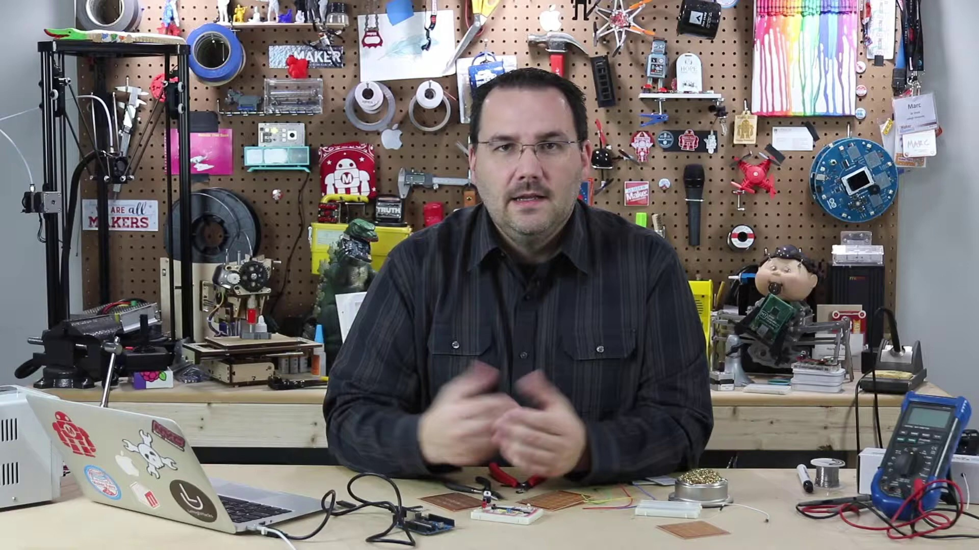 | 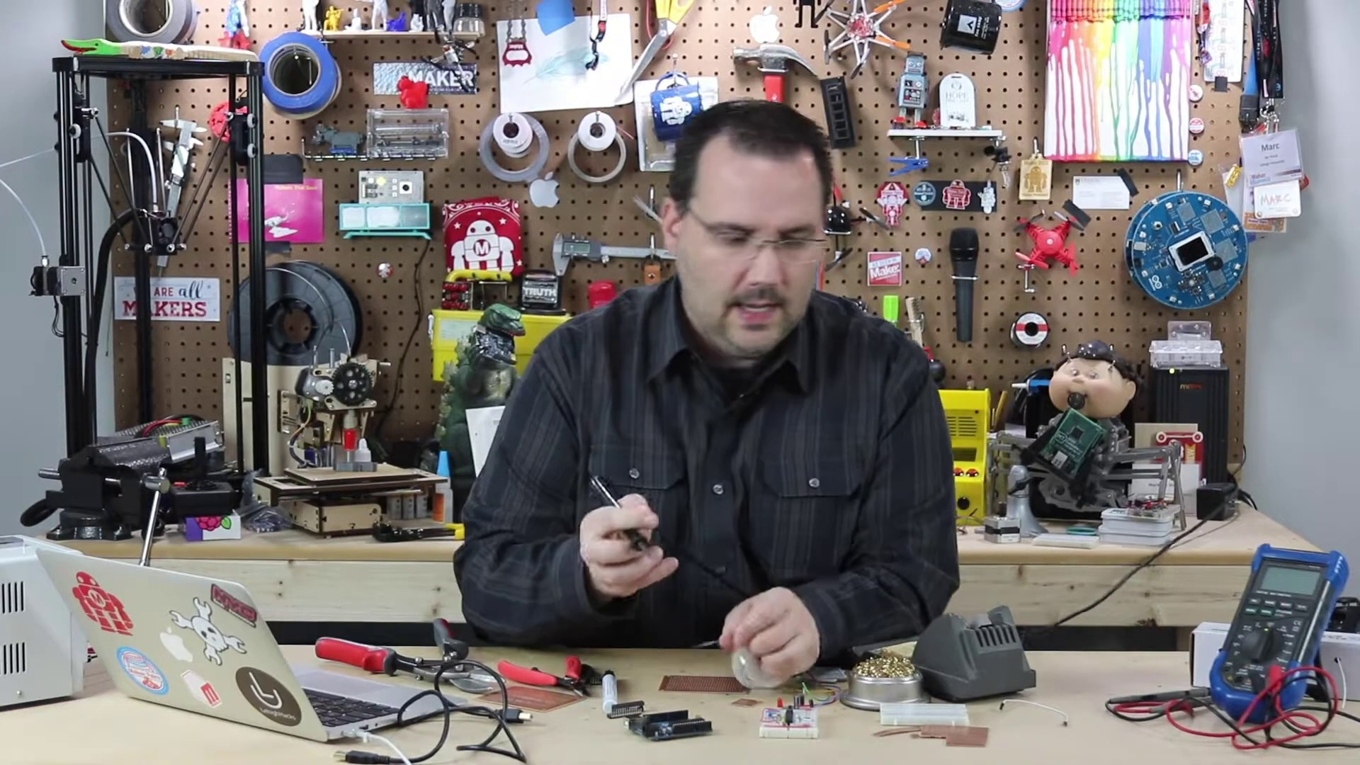 | 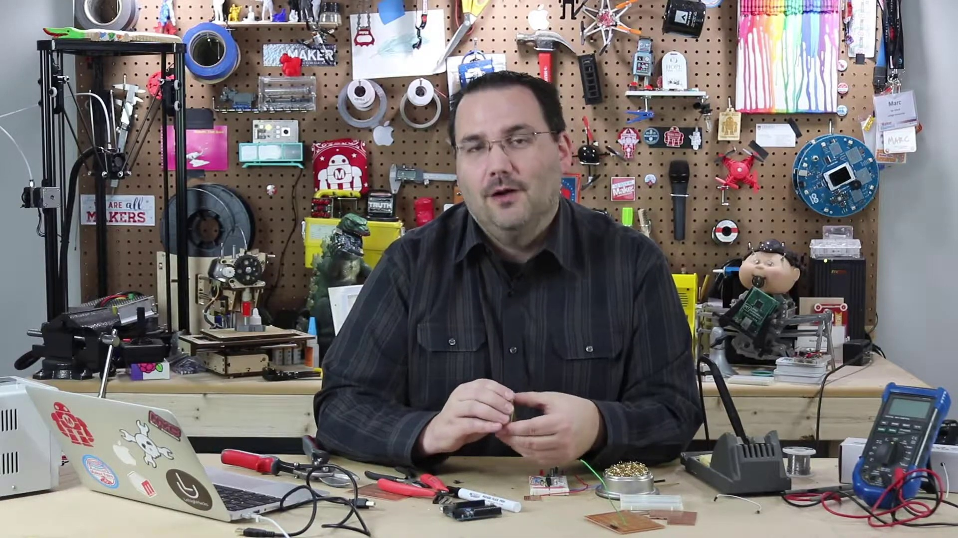
Topic T7: Connecting Multiple Points — score 85.0000
Description: Techniques for connecting multiple points on a PerfBoard
Reason: The comment mentions perfboards and connections, which are directly related to the topic of connecting multiple points on a perfboard. The mention of breadboards, soldering, and sockets also shows an understanding of the same concepts described in the topic.
 |  | 
Topic T9: Perma-Proto Boards — score 80.0000
Description: Overview of perma-proto boards as an alternative to breadboards
Reason: The comment directly discusses perma-proto boards (perfboards) and their characteristics, such as being a long-term solution for connections made on a breadboard, being perforated, and allowing direct soldering once the layout is finalized. The topic description is closely matched in the comment's specific details.
 |  | 
Topic T4: Soldering on a PerfBoard — score 80.0000
Description: Techniques and tools for soldering on a PerfBoard
Reason: The comment mentions specific details about Perfboards, such as being used as a long-term solution for connections made on a breadboard and needing sockets instead of direct soldering. It also mentions the ability to mimic breadboard layouts and provide an example of a circuit built on a perfboard.
 |  | 
Topic T2: Getting Started with Soldering — score 80.0000
Description: Tips and tricks for soldering on a PerfBoard
Reason: The comment discusses the use of Perfboards, specifically mentioning soldering connections and providing tips, which closely aligns with the topic 'Getting Started with Soldering' on a PerfBoard.
 |  | 
Topic T1: Introduction — score 80.0000
Description: Overview of building on a PerfBoard
Reason: The comment directly discusses the same topic as the introduction, specifically introducing perfboards and their use cases, which aligns with the topic's description of building on a perfboard.
 |  | 
Topic T8: Trimming Leads and Solder Joints — score 20.0000
Description: Tips for trimming leads and solder joints on a PerfBoard
Reason: The comment discusses perfboards in general, mentioning their use and advantages, but does not specifically discuss trimming leads or solder joints, which are the focus of the topic.
 |  | 
Topic T5: Using Flux Pens — score 20.0000
Description: How to use flux pens with a PerfBoard
Reason: The comment discusses perfboards and their uses, but does not directly relate to using flux pens as described in the topic.
 |  | 
Topic T3: Using Header Pins — score 20.0000
Description: How to use header pins with a PerfBoard
Reason: The comment discusses perfboards and their usage in general, but does not specifically mention header pins or how to use them with a PerfBoard.
 |  | 
Topic T6: Temporary Soldering Joints — score 10.0000
Description: Tips for temporary soldering joints on a PerfBoard
Reason: The comment discusses Perfboards and their usage, but does not directly mention temporary soldering joints or the tips described in the topic. It provides general information about Perfboards and how to use them, but does not show a strong correlation with the topic.
Least correlated topics:
 |  | 
Topic T6: Temporary Soldering Joints — score 10.0000
Description: Tips for temporary soldering joints on a PerfBoard
Reason: The comment discusses Perfboards and their usage, but does not directly mention temporary soldering joints or the tips described in the topic. It provides general information about Perfboards and how to use them, but does not show a strong correlation with the topic.
 |  | 
Topic T3: Using Header Pins — score 20.0000
Description: How to use header pins with a PerfBoard
Reason: The comment discusses perfboards and their usage in general, but does not specifically mention header pins or how to use them with a PerfBoard.
 |  | 
Topic T5: Using Flux Pens — score 20.0000
Description: How to use flux pens with a PerfBoard
Reason: The comment discusses perfboards and their uses, but does not directly relate to using flux pens as described in the topic.
 |  | 
Topic T8: Trimming Leads and Solder Joints — score 20.0000
Description: Tips for trimming leads and solder joints on a PerfBoard
Reason: The comment discusses perfboards in general, mentioning their use and advantages, but does not specifically discuss trimming leads or solder joints, which are the focus of the topic.
 |  | 
Topic T1: Introduction — score 80.0000
Description: Overview of building on a PerfBoard
Reason: The comment directly discusses the same topic as the introduction, specifically introducing perfboards and their use cases, which aligns with the topic's description of building on a perfboard.
 |  | 
Topic T2: Getting Started with Soldering — score 80.0000
Description: Tips and tricks for soldering on a PerfBoard
Reason: The comment discusses the use of Perfboards, specifically mentioning soldering connections and providing tips, which closely aligns with the topic 'Getting Started with Soldering' on a PerfBoard.
 |  | 
Topic T4: Soldering on a PerfBoard — score 80.0000
Description: Techniques and tools for soldering on a PerfBoard
Reason: The comment mentions specific details about Perfboards, such as being used as a long-term solution for connections made on a breadboard and needing sockets instead of direct soldering. It also mentions the ability to mimic breadboard layouts and provide an example of a circuit built on a perfboard.
 |  | 
Topic T9: Perma-Proto Boards — score 80.0000
Description: Overview of perma-proto boards as an alternative to breadboards
Reason: The comment directly discusses perma-proto boards (perfboards) and their characteristics, such as being a long-term solution for connections made on a breadboard, being perforated, and allowing direct soldering once the layout is finalized. The topic description is closely matched in the comment's specific details.
 |  | 
Topic T7: Connecting Multiple Points — score 85.0000
Description: Techniques for connecting multiple points on a PerfBoard
Reason: The comment mentions perfboards and connections, which are directly related to the topic of connecting multiple points on a perfboard. The mention of breadboards, soldering, and sockets also shows an understanding of the same concepts described in the topic.
- matched 5 topic(s), max score 85.0000: I really like the tip of using sockets to install chips on the board instead of soldering them directly. I hadn’t considered this before and it seems like a great way to protect components and make chip replacement easier.I’m confused about what exactly the flux pen is used for.How I plan to use the electrical system in the future: I will use sockets from now on when applicable.
Source: https://www.youtube.com/watch?v=a3wDEcORRR4: Arduino Prototyping Techniques #104: Perfboard
Top correlated topics:
 |  | 
Topic T9: Perma-Proto Boards — score 85.0000
Description: Overview of perma-proto boards as an alternative to breadboards
Reason: The comment directly discusses the use of sockets to install chips on perma-proto boards, which is mentioned in the topic description as an alternative to breadboards. The commenter also mentions their plan to use sockets in the future, showing a clear connection to the topic.
 |  | 
Topic T6: Temporary Soldering Joints — score 80.0000
Description: Tips for temporary soldering joints on a PerfBoard
Reason: The comment directly mentions the topic of temporary soldering joints on a PerfBoard and specifically references using sockets for chip installation, which is described in the topic description. Additionally, the commenter expresses confusion about the flux pen's purpose, indicating they are discussing details related to the topic.
 |  | 
Topic T4: Soldering on a PerfBoard — score 80.0000
Description: Techniques and tools for soldering on a PerfBoard
Reason: The comment directly discusses the technique of using sockets to install chips on the board, which is mentioned in the topic description. Additionally, it shows understanding of the goal of protecting components and making chip replacement easier, also described in the topic.
 |  | 
Topic T2: Getting Started with Soldering — score 80.0000
Description: Tips and tricks for soldering on a PerfBoard
Reason: The comment discusses specific techniques and concepts related to soldering on a PerfBoard, mentioning sockets for chip installation and flux pen usage. Although it doesn't directly discuss the 'tips and tricks' mentioned in the topic description, it shows understanding of soldering principles and applications.
 |  | 
Topic T1: Introduction — score 80.0000
Description: Overview of building on a PerfBoard
Reason: The comment directly discusses the same concept of using sockets instead of soldering, which is a key point in the topic description about building on a PerfBoard. The comment also mentions plans to use sockets in the future, showing a clear connection between the topic and the viewer's thoughts.
 |  | 
Topic T8: Trimming Leads and Solder Joints — score 20.0000
Description: Tips for trimming leads and solder joints on a PerfBoard
Reason: The comment mentions using sockets to install chips and protecting components, which is a tangential topic not directly discussing trimming leads and solder joints. The mention of a flux pen and future plans for electrical system use are also unrelated.
 |  | 
Topic T7: Connecting Multiple Points — score 20.0000
Description: Techniques for connecting multiple points on a PerfBoard
Reason: The comment discusses a tip about using sockets to install chips on the board, which is related but not directly discussing connecting multiple points on a PerfBoard. The comment also mentions plans for future use of sockets, but does not explicitly relate back to the topic's description.
 |  | 
Topic T5: Using Flux Pens — score 20.0000
Description: How to use flux pens with a PerfBoard
Reason: The comment discusses a different aspect of using chips on a PerfBoard (sockets vs soldering), but doesn't explicitly mention flux pens or their use in the described process.
 |  | 
Topic T3: Using Header Pins — score 20.0000
Description: How to use header pins with a PerfBoard
Reason: The comment discusses a different aspect of perfboards (sockets vs soldering) and does not directly relate to the topic of using header pins.
Least correlated topics:
 |  | 
Topic T3: Using Header Pins — score 20.0000
Description: How to use header pins with a PerfBoard
Reason: The comment discusses a different aspect of perfboards (sockets vs soldering) and does not directly relate to the topic of using header pins.
 |  | 
Topic T5: Using Flux Pens — score 20.0000
Description: How to use flux pens with a PerfBoard
Reason: The comment discusses a different aspect of using chips on a PerfBoard (sockets vs soldering), but doesn't explicitly mention flux pens or their use in the described process.
 |  | 
Topic T7: Connecting Multiple Points — score 20.0000
Description: Techniques for connecting multiple points on a PerfBoard
Reason: The comment discusses a tip about using sockets to install chips on the board, which is related but not directly discussing connecting multiple points on a PerfBoard. The comment also mentions plans for future use of sockets, but does not explicitly relate back to the topic's description.
 |  | 
Topic T8: Trimming Leads and Solder Joints — score 20.0000
Description: Tips for trimming leads and solder joints on a PerfBoard
Reason: The comment mentions using sockets to install chips and protecting components, which is a tangential topic not directly discussing trimming leads and solder joints. The mention of a flux pen and future plans for electrical system use are also unrelated.
 |  | 
Topic T1: Introduction — score 80.0000
Description: Overview of building on a PerfBoard
Reason: The comment directly discusses the same concept of using sockets instead of soldering, which is a key point in the topic description about building on a PerfBoard. The comment also mentions plans to use sockets in the future, showing a clear connection between the topic and the viewer's thoughts.
 |  | 
Topic T2: Getting Started with Soldering — score 80.0000
Description: Tips and tricks for soldering on a PerfBoard
Reason: The comment discusses specific techniques and concepts related to soldering on a PerfBoard, mentioning sockets for chip installation and flux pen usage. Although it doesn't directly discuss the 'tips and tricks' mentioned in the topic description, it shows understanding of soldering principles and applications.
 |  | 
Topic T4: Soldering on a PerfBoard — score 80.0000
Description: Techniques and tools for soldering on a PerfBoard
Reason: The comment directly discusses the technique of using sockets to install chips on the board, which is mentioned in the topic description. Additionally, it shows understanding of the goal of protecting components and making chip replacement easier, also described in the topic.
 |  | 
Topic T6: Temporary Soldering Joints — score 80.0000
Description: Tips for temporary soldering joints on a PerfBoard
Reason: The comment directly mentions the topic of temporary soldering joints on a PerfBoard and specifically references using sockets for chip installation, which is described in the topic description. Additionally, the commenter expresses confusion about the flux pen's purpose, indicating they are discussing details related to the topic.
 |  | 
Topic T9: Perma-Proto Boards — score 85.0000
Description: Overview of perma-proto boards as an alternative to breadboards
Reason: The comment directly discusses the use of sockets to install chips on perma-proto boards, which is mentioned in the topic description as an alternative to breadboards. The commenter also mentions their plan to use sockets in the future, showing a clear connection to the topic.

Topic T1: Introduction
 |  | 
Description: Overview of building on a PerfBoard
Comment (score 80): Perfboards are used as a long-term solution for connections made on a breadboard. They are perforated boards where all connections are soldered in place and are easily cuttable. It's advised not to solder a microcontroller or IC directly to the perfboard but use a socket instead. Perma perf boards can mimic breadboard layouts, allowing direct soldering once layout is finalized.What is an example of a circuit built on a perfboard?
Reason: The comment directly discusses the same topic as the introduction, specifically introducing perfboards and their use cases, which aligns with the topic's description of building on a perfboard.
Source: https://www.youtube.com/watch?v=a3wDEcORRR4: Arduino Prototyping Techniques #104: Perfboard
Comment (score 80): I really like the tip of using sockets to install chips on the board instead of soldering them directly. I hadn’t considered this before and it seems like a great way to protect components and make chip replacement easier.I’m confused about what exactly the flux pen is used for.How I plan to use the electrical system in the future: I will use sockets from now on when applicable.
Reason: The comment directly discusses the same concept of using sockets instead of soldering, which is a key point in the topic description about building on a PerfBoard. The comment also mentions plans to use sockets in the future, showing a clear connection between the topic and the viewer's thoughts.
Source: https://www.youtube.com/watch?v=a3wDEcORRR4: Arduino Prototyping Techniques #104: Perfboard

Topic T2: Getting Started with Soldering
 |  | 
Description: Tips and tricks for soldering on a PerfBoard
Comment (score 80): Perfboards are used as a long-term solution for connections made on a breadboard. They are perforated boards where all connections are soldered in place and are easily cuttable. It's advised not to solder a microcontroller or IC directly to the perfboard but use a socket instead. Perma perf boards can mimic breadboard layouts, allowing direct soldering once layout is finalized.What is an example of a circuit built on a perfboard?
Reason: The comment discusses the use of Perfboards, specifically mentioning soldering connections and providing tips, which closely aligns with the topic 'Getting Started with Soldering' on a PerfBoard.
Source: https://www.youtube.com/watch?v=a3wDEcORRR4: Arduino Prototyping Techniques #104: Perfboard
Comment (score 80): I really like the tip of using sockets to install chips on the board instead of soldering them directly. I hadn’t considered this before and it seems like a great way to protect components and make chip replacement easier.I’m confused about what exactly the flux pen is used for.How I plan to use the electrical system in the future: I will use sockets from now on when applicable.
Reason: The comment discusses specific techniques and concepts related to soldering on a PerfBoard, mentioning sockets for chip installation and flux pen usage. Although it doesn't directly discuss the 'tips and tricks' mentioned in the topic description, it shows understanding of soldering principles and applications.
Source: https://www.youtube.com/watch?v=a3wDEcORRR4: Arduino Prototyping Techniques #104: Perfboard

Topic T3: Using Header Pins
 |  | 
Description: How to use header pins with a PerfBoard
No strongly correlated comments found for this topic.

Topic T4: Soldering on a PerfBoard
 |  | 
Description: Techniques and tools for soldering on a PerfBoard
Comment (score 80): Perfboards are used as a long-term solution for connections made on a breadboard. They are perforated boards where all connections are soldered in place and are easily cuttable. It's advised not to solder a microcontroller or IC directly to the perfboard but use a socket instead. Perma perf boards can mimic breadboard layouts, allowing direct soldering once layout is finalized.What is an example of a circuit built on a perfboard?
Reason: The comment mentions specific details about Perfboards, such as being used as a long-term solution for connections made on a breadboard and needing sockets instead of direct soldering. It also mentions the ability to mimic breadboard layouts and provide an example of a circuit built on a perfboard.
Source: https://www.youtube.com/watch?v=a3wDEcORRR4: Arduino Prototyping Techniques #104: Perfboard
Comment (score 80): I really like the tip of using sockets to install chips on the board instead of soldering them directly. I hadn’t considered this before and it seems like a great way to protect components and make chip replacement easier.I’m confused about what exactly the flux pen is used for.How I plan to use the electrical system in the future: I will use sockets from now on when applicable.
Reason: The comment directly discusses the technique of using sockets to install chips on the board, which is mentioned in the topic description. Additionally, it shows understanding of the goal of protecting components and making chip replacement easier, also described in the topic.
Source: https://www.youtube.com/watch?v=a3wDEcORRR4: Arduino Prototyping Techniques #104: Perfboard

Topic T5: Using Flux Pens
 |  | 
Description: How to use flux pens with a PerfBoard
No strongly correlated comments found for this topic.

Topic T6: Temporary Soldering Joints
 |  | 
Description: Tips for temporary soldering joints on a PerfBoard
Comment (score 80): I really like the tip of using sockets to install chips on the board instead of soldering them directly. I hadn’t considered this before and it seems like a great way to protect components and make chip replacement easier.I’m confused about what exactly the flux pen is used for.How I plan to use the electrical system in the future: I will use sockets from now on when applicable.
Reason: The comment directly mentions the topic of temporary soldering joints on a PerfBoard and specifically references using sockets for chip installation, which is described in the topic description. Additionally, the commenter expresses confusion about the flux pen's purpose, indicating they are discussing details related to the topic.
Source: https://www.youtube.com/watch?v=a3wDEcORRR4: Arduino Prototyping Techniques #104: Perfboard

Topic T7: Connecting Multiple Points
 |  | 
Description: Techniques for connecting multiple points on a PerfBoard
Comment (score 85): Perfboards are used as a long-term solution for connections made on a breadboard. They are perforated boards where all connections are soldered in place and are easily cuttable. It's advised not to solder a microcontroller or IC directly to the perfboard but use a socket instead. Perma perf boards can mimic breadboard layouts, allowing direct soldering once layout is finalized.What is an example of a circuit built on a perfboard?
Reason: The comment mentions perfboards and connections, which are directly related to the topic of connecting multiple points on a perfboard. The mention of breadboards, soldering, and sockets also shows an understanding of the same concepts described in the topic.
Source: https://www.youtube.com/watch?v=a3wDEcORRR4: Arduino Prototyping Techniques #104: Perfboard

Topic T8: Trimming Leads and Solder Joints
 |  | 
Description: Tips for trimming leads and solder joints on a PerfBoard
No strongly correlated comments found for this topic.

Topic T9: Perma-Proto Boards
 |  | 
Description: Overview of perma-proto boards as an alternative to breadboards
Comment (score 85): I really like the tip of using sockets to install chips on the board instead of soldering them directly. I hadn’t considered this before and it seems like a great way to protect components and make chip replacement easier.I’m confused about what exactly the flux pen is used for.How I plan to use the electrical system in the future: I will use sockets from now on when applicable.
Reason: The comment directly discusses the use of sockets to install chips on perma-proto boards, which is mentioned in the topic description as an alternative to breadboards. The commenter also mentions their plan to use sockets in the future, showing a clear connection to the topic.
Source: https://www.youtube.com/watch?v=a3wDEcORRR4: Arduino Prototyping Techniques #104: Perfboard
Comment (score 80): Perfboards are used as a long-term solution for connections made on a breadboard. They are perforated boards where all connections are soldered in place and are easily cuttable. It's advised not to solder a microcontroller or IC directly to the perfboard but use a socket instead. Perma perf boards can mimic breadboard layouts, allowing direct soldering once layout is finalized.What is an example of a circuit built on a perfboard?
Reason: The comment directly discusses perma-proto boards (perfboards) and their characteristics, such as being a long-term solution for connections made on a breadboard, being perforated, and allowing direct soldering once the layout is finalized. The topic description is closely matched in the comment's specific details.
Source: https://www.youtube.com/watch?v=a3wDEcORRR4: Arduino Prototyping Techniques #104: Perfboard

