Comment–Topic Correlation Report
Model: llama3

Summary
Topics processed: 3
Comments available for this video: 4
Comments correlated to ≥ 60: 0 (0.0%)
Total candidate pairs checked: 12

Most/Least correlated topics (by average score across correlated comments):
Top 3:
• Topic T3: Personal Experience — avg 0.00, contributions 0
• Topic T2: Kids' Clothing — avg 0.00, contributions 0
• Topic T1: Kids Club — avg 0.00, contributions 0
Bottom 3:
• Topic T1: Kids Club — avg 0.00, contributions 0
• Topic T2: Kids' Clothing — avg 0.00, contributions 0
• Topic T3: Personal Experience — avg 0.00, contributions 0
Correlated comment coverage (all comments):
- matched 0 topic(s), max score 0.0000: This video showed a TDA2030 amplifier being hooked up using a 12V, 2A power supply like I have. I think this video is a decent example, but his method of hooking it up without a breadboard is pretty fragile for phase II. I do know now that I need a large heatsink for the chip as the one I have will likely be too small for the chip. I will also likely borrow the idea of using a 2200uF capacitor on the speaker to further clean noise.
Source: https://www.youtube.com/watch?v=cggDZE7gZNw: DIY simple Powerful Amplifier using TDA2030, Homemade Amplifier 12V
Top correlated topics:
 | 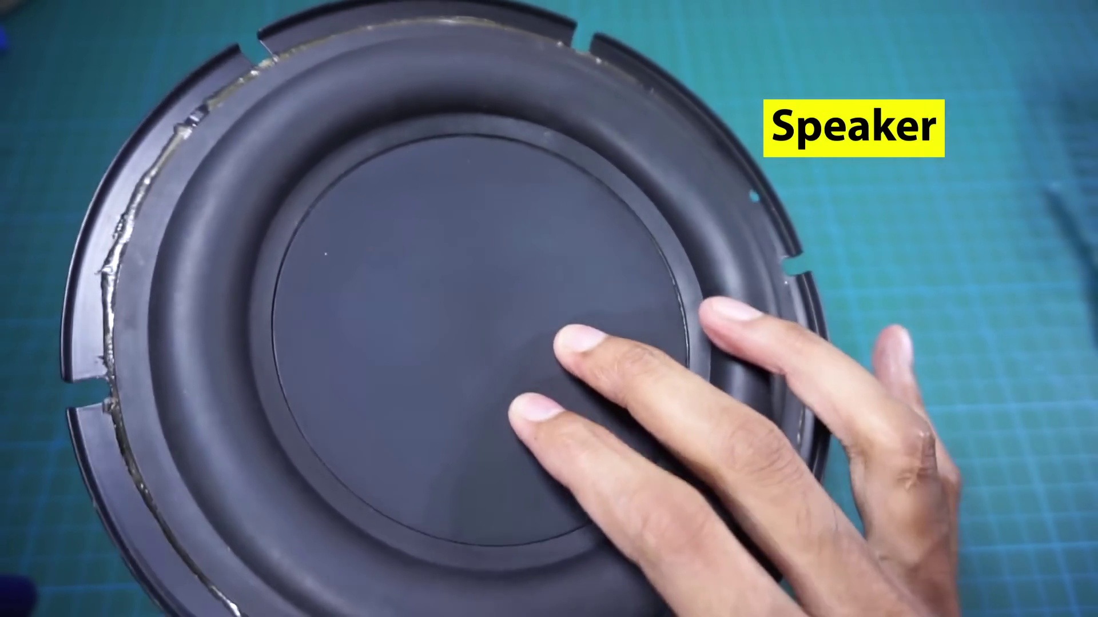 | 
Topic T1: Kids Club — score 20.0000
Description: The speaker mentions that they usually make a kids club, which includes moms and children.
Reason: The comment mentions a specific electronics project (TDA2030 amplifier) and component selection (heatsink, capacitor), whereas the topic 'Kids Club' is about an event or activity for children. There is no direct overlap between the two.
 |  | 
Topic T3: Personal Experience — score 10.0000
Description: The speaker shares a personal experience, mentioning that their dad was actually present.
Reason: The comment discusses electronics and amplifier setup, but does not mention personal experiences or the presence of someone's dad as described in the topic. The only connection is a passing reference to 'this video' which could be unrelated to the topic.
 |  | 
Topic T2: Kids' Clothing — score 0.0000
Description: The speaker notes that kids are not bare, implying that they wear clothing.
Reason: No overlap between topic about kids' clothing and comment about electronics and amplifier setup.
Least correlated topics:
 |  | 
Topic T2: Kids' Clothing — score 0.0000
Description: The speaker notes that kids are not bare, implying that they wear clothing.
Reason: No overlap between topic about kids' clothing and comment about electronics and amplifier setup.
 |  | 
Topic T3: Personal Experience — score 10.0000
Description: The speaker shares a personal experience, mentioning that their dad was actually present.
Reason: The comment discusses electronics and amplifier setup, but does not mention personal experiences or the presence of someone's dad as described in the topic. The only connection is a passing reference to 'this video' which could be unrelated to the topic.
 |  | 
Topic T1: Kids Club — score 20.0000
Description: The speaker mentions that they usually make a kids club, which includes moms and children.
Reason: The comment mentions a specific electronics project (TDA2030 amplifier) and component selection (heatsink, capacitor), whereas the topic 'Kids Club' is about an event or activity for children. There is no direct overlap between the two.
- matched 0 topic(s), max score 0.0000: This video is 9:16 minutes. What I learned from this video – This video taught how to make a simple audio amplifier using a TDA 2030. My group will use this amplifier circuit in phase two of the project as the initial prototype for our design. I don’t have any questions about this. The video clearly shows how to make the amplifier, but it doesn’t explain how it works.
Source: https://www.youtube.com/watch?v=cggDZE7gZNw : DIY simple Powerful Amplifier using TDA2030, Homemade Amplifier 12V
Top correlated topics:
 |  | 
Topic T3: Personal Experience — score 0.0000
Description: The speaker shares a personal experience, mentioning that their dad was actually present.
Reason: The comment discusses a video about making an audio amplifier using TDA 2030, which has no connection to the topic of 'Personal Experience' that shares a personal story about someone's dad being present.
 |  | 
Topic T2: Kids' Clothing — score 0.0000
Description: The speaker notes that kids are not bare, implying that they wear clothing.
Reason: The topic 'Kids' Clothing' and the comment are unrelated, as the comment is discussing audio amplifiers and electronics, whereas the topic is about children's clothing.
 |  | 
Topic T1: Kids Club — score 0.0000
Description: The speaker mentions that they usually make a kids club, which includes moms and children.
Reason: The comment discusses an audio amplifier circuit using TDA 2030, whereas the topic is about a 'Kids Club' and has no mention of electronics or circuits.
Least correlated topics:
 |  | 
Topic T1: Kids Club — score 0.0000
Description: The speaker mentions that they usually make a kids club, which includes moms and children.
Reason: The comment discusses an audio amplifier circuit using TDA 2030, whereas the topic is about a 'Kids Club' and has no mention of electronics or circuits.
 |  | 
Topic T2: Kids' Clothing — score 0.0000
Description: The speaker notes that kids are not bare, implying that they wear clothing.
Reason: The topic 'Kids' Clothing' and the comment are unrelated, as the comment is discussing audio amplifiers and electronics, whereas the topic is about children's clothing.
 |  | 
Topic T3: Personal Experience — score 0.0000
Description: The speaker shares a personal experience, mentioning that their dad was actually present.
Reason: The comment discusses a video about making an audio amplifier using TDA 2030, which has no connection to the topic of 'Personal Experience' that shares a personal story about someone's dad being present.
- matched 0 topic(s), max score 0.0000: Demonstrates another circuit using the TDA2030 amplifier.No captions or explanations; viewer must figure out component placement.Looks like a good circuit for the final project.
Source: https://www.youtube.com/watch?v=cggDZE7gZNw: DIY Simple Powerful Amplifier Using TDA2030, Homemade Amplifier 12V
Top correlated topics:
 |  | 
Topic T3: Personal Experience — score 0.0000
Description: The speaker shares a personal experience, mentioning that their dad was actually present.
Reason: The comment discusses electronics and amplifier circuits, while the topic is about personal experience. There are no overlaps between the two.
 |  | 
Topic T2: Kids' Clothing — score 0.0000
Description: The speaker notes that kids are not bare, implying that they wear clothing.
Reason: The comment discusses an electronic circuit and amplifier, whereas the topic is about kids' clothing, with no overlap between the two subjects.
 |  | 
Topic T1: Kids Club — score 0.0000
Description: The speaker mentions that they usually make a kids club, which includes moms and children.
Reason: The comment discusses an amplifier and component placement, which has no direct relation to the topic of a kids club.
Least correlated topics:
 |  | 
Topic T1: Kids Club — score 0.0000
Description: The speaker mentions that they usually make a kids club, which includes moms and children.
Reason: The comment discusses an amplifier and component placement, which has no direct relation to the topic of a kids club.
 |  | 
Topic T2: Kids' Clothing — score 0.0000
Description: The speaker notes that kids are not bare, implying that they wear clothing.
Reason: The comment discusses an electronic circuit and amplifier, whereas the topic is about kids' clothing, with no overlap between the two subjects.
 |  | 
Topic T3: Personal Experience — score 0.0000
Description: The speaker shares a personal experience, mentioning that their dad was actually present.
Reason: The comment discusses electronics and amplifier circuits, while the topic is about personal experience. There are no overlaps between the two.
- matched 0 topic(s), max score 0.0000: After I decided to use the TDA2050 for the tweeter and the TDA2030 for the subwoofer, I watched two videos on circuit construction of amplifiers using the TDA2030. Each of these videos provides in-depth step by step process on how to set up an amplifier using TDA2030. These videos are extremely helpful for when I am constructing the speaker circuit as I can easily follow along with the videos to create my own speaker.
Source: https://www.youtube.com/watch?v=cggDZE7gZNw: DIY simple Powerful Amplifier using TDA2030, Homemade Amplifier 12V
Top correlated topics:
 |  | 
Topic T3: Personal Experience — score 0.0000
Description: The speaker shares a personal experience, mentioning that their dad was actually present.
Reason: The topic is about a personal experience, while the comment discusses electronics and amplifier construction, with no overlap in topics or concepts.
 |  | 
Topic T2: Kids' Clothing — score 0.0000
Description: The speaker notes that kids are not bare, implying that they wear clothing.
Reason: The topic is about kids' clothing, while the comment is about electronics and amplifier construction, with no relevant overlap.
 |  | 
Topic T1: Kids Club — score 0.0000
Description: The speaker mentions that they usually make a kids club, which includes moms and children.
Reason: The comment discusses amplifier circuit construction and specific components (TDA2050, TDA2030), while the topic title 'Kids Club' and description mention a kids club with moms and children, showing no relevant overlap.
Least correlated topics:
 |  | 
Topic T1: Kids Club — score 0.0000
Description: The speaker mentions that they usually make a kids club, which includes moms and children.
Reason: The comment discusses amplifier circuit construction and specific components (TDA2050, TDA2030), while the topic title 'Kids Club' and description mention a kids club with moms and children, showing no relevant overlap.
 |  | 
Topic T2: Kids' Clothing — score 0.0000
Description: The speaker notes that kids are not bare, implying that they wear clothing.
Reason: The topic is about kids' clothing, while the comment is about electronics and amplifier construction, with no relevant overlap.
 |  | 
Topic T3: Personal Experience — score 0.0000
Description: The speaker shares a personal experience, mentioning that their dad was actually present.
Reason: The topic is about a personal experience, while the comment discusses electronics and amplifier construction, with no overlap in topics or concepts.

Topic T1: Kids Club
 |  | 
Description: The speaker mentions that they usually make a kids club, which includes moms and children.
No strongly correlated comments found for this topic.

Topic T2: Kids' Clothing
 |  | 
Description: The speaker notes that kids are not bare, implying that they wear clothing.
No strongly correlated comments found for this topic.

Topic T3: Personal Experience
 |  | 
Description: The speaker shares a personal experience, mentioning that their dad was actually present.
No strongly correlated comments found for this topic.

