Comment–Topic Correlation Report
Model: llama3

Summary
Topics processed: 3
Comments available for this video: 1
Comments correlated to ≥ 60: 0 (0.0%)
Total candidate pairs checked: 3

Most/Least correlated topics (by average score across correlated comments):
Top 3:
• Topic T3: Termitting — avg 0.00, contributions 0
• Topic T2: Serving or Sucking Rope — avg 0.00, contributions 0
• Topic T1: Filthy — avg 0.00, contributions 0
Bottom 3:
• Topic T1: Filthy — avg 0.00, contributions 0
• Topic T2: Serving or Sucking Rope — avg 0.00, contributions 0
• Topic T3: Termitting — avg 0.00, contributions 0
Correlated comment coverage (all comments):
- matched 0 topic(s), max score 0.0000: This video demonstrates how to build a powerful amplifier using the TDA2030 in a simple and clear way.Nothing was confusing in this video—it was very clear.This simple circuit will be a great reference for Phase II amplifier builds.
Source: https://www.youtube.com/watch?v=dKB7uHYU-ow: DIY Powerful Ultra Bass Amplifier TDA2030, Homemade Amplifier 12V
Top correlated topics:
 | 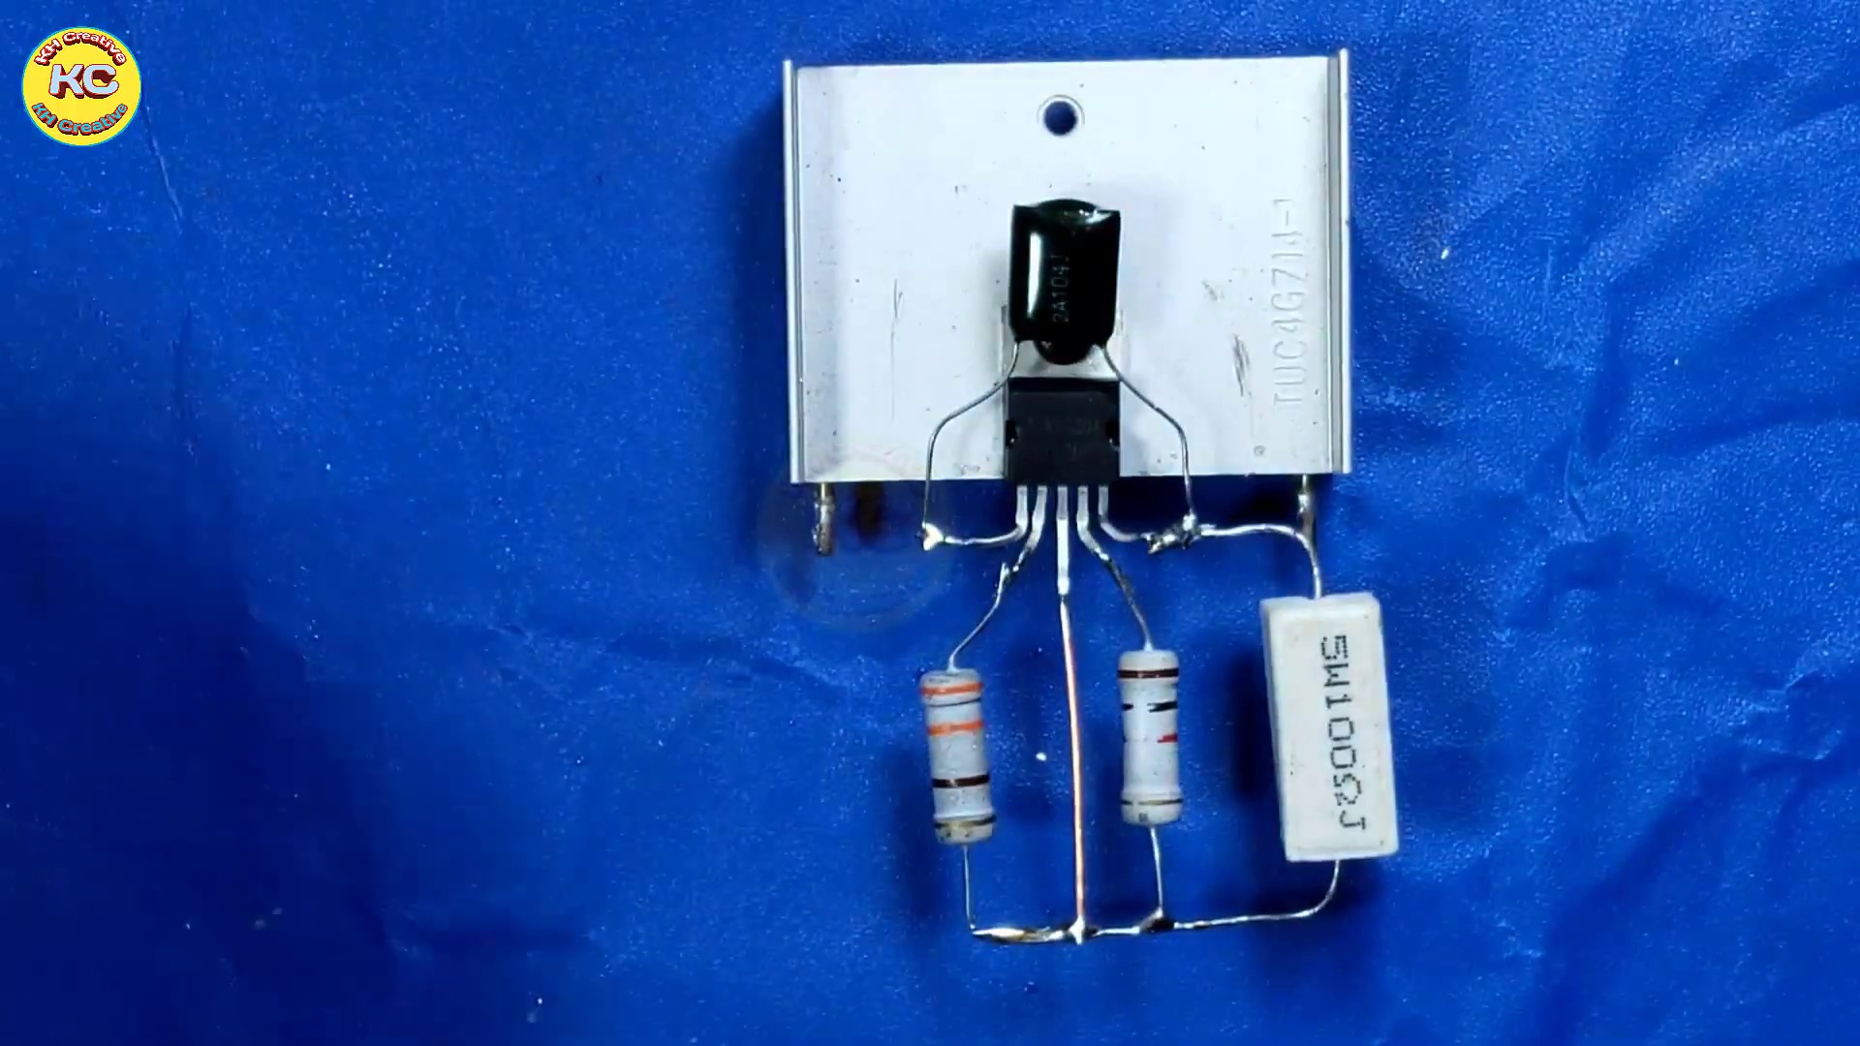 | 
Topic T3: Termitting — score 20.0000
Description: The speaker mentions termitting.
Reason: The comment mentions building an amplifier and using a specific IC (TDA2030), but does not discuss termitting, which is the main topic.
 |  | 
Topic T2: Serving or Sucking Rope — score 0.0000
Description: The speaker talks about serving or sucking rope.
Reason: The comment discusses building an amplifier using the TDA2030, whereas the topic is about serving or sucking rope. There is no overlap between the two topics.
 |  | 
Topic T1: Filthy — score 0.0000
Description: The speaker says something is filthy.
Reason: The topic 'Filthy' has no relation to the comment about building an amplifier, as it doesn't mention anything about filth or cleanliness.
Least correlated topics:
 |  | 
Topic T1: Filthy — score 0.0000
Description: The speaker says something is filthy.
Reason: The topic 'Filthy' has no relation to the comment about building an amplifier, as it doesn't mention anything about filth or cleanliness.
 |  | 
Topic T2: Serving or Sucking Rope — score 0.0000
Description: The speaker talks about serving or sucking rope.
Reason: The comment discusses building an amplifier using the TDA2030, whereas the topic is about serving or sucking rope. There is no overlap between the two topics.
 |  | 
Topic T3: Termitting — score 20.0000
Description: The speaker mentions termitting.
Reason: The comment mentions building an amplifier and using a specific IC (TDA2030), but does not discuss termitting, which is the main topic.

Topic T1: Filthy
 |  | 
Description: The speaker says something is filthy.
No strongly correlated comments found for this topic.

Topic T2: Serving or Sucking Rope
 |  | 
Description: The speaker talks about serving or sucking rope.
No strongly correlated comments found for this topic.

Topic T3: Termitting
 |  | 
Description: The speaker mentions termitting.
No strongly correlated comments found for this topic.

