Comment–Topic Correlation Report
Model: llama3

Summary
Topics processed: 3
Comments available for this video: 1
Comments correlated to ≥ 60: 0 (0.0%)
Total candidate pairs checked: 3

Most/Least correlated topics (by average score across correlated comments):
Top 3:
• Topic T3: Sponsorship — avg 0.00, contributions 0
• Topic T2: Free Applications — avg 0.00, contributions 0
• Topic T1: Altium Designer — avg 0.00, contributions 0
Bottom 3:
• Topic T1: Altium Designer — avg 0.00, contributions 0
• Topic T2: Free Applications — avg 0.00, contributions 0
• Topic T3: Sponsorship — avg 0.00, contributions 0
Correlated comment coverage (all comments):
- matched 0 topic(s), max score 0.0000: This circuit is using a custom designed board to solder the capacitors and resistors to. He used the oscilloscope to show the square wave pattern and first being very choppy, then getting smoother as the camera distance was changed. After focusing the camera, he was able to connect the board to an old tv to get a visual signal. The board does not look to complicated with the capacitors and resistors soldered on it. The heart seems to be in the compact camera with attached boards already on it that are doing most of the signal conversion.
Source: https://www.youtube.com/watch?v=fcmXG3wB_1M: How to Make Video Transmitter - Make Your Own Television Transmitter
Top correlated topics:
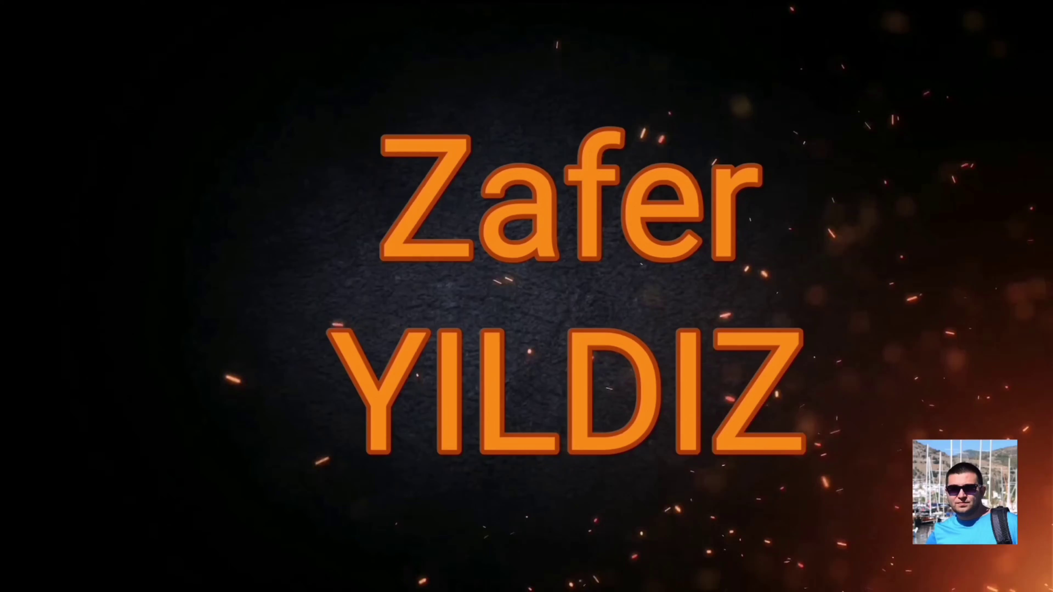 | 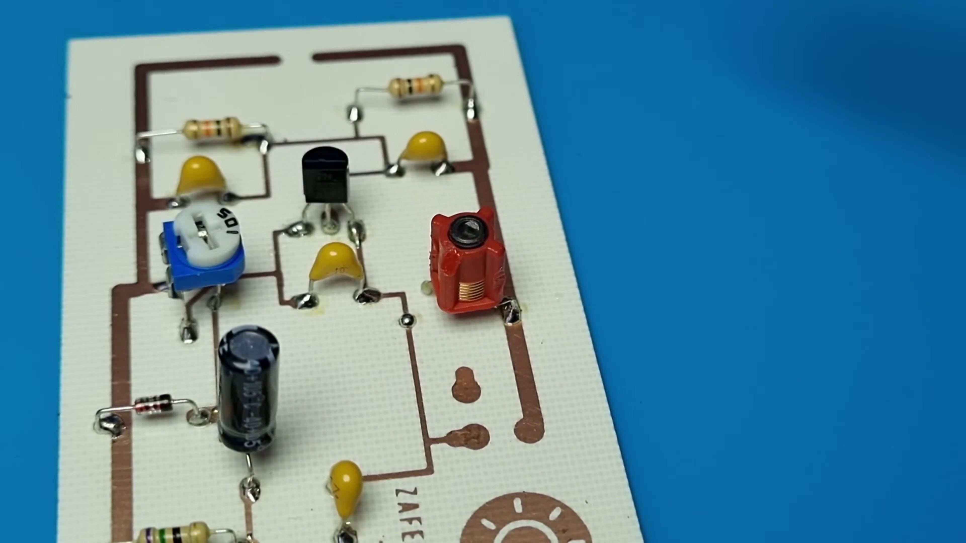 | 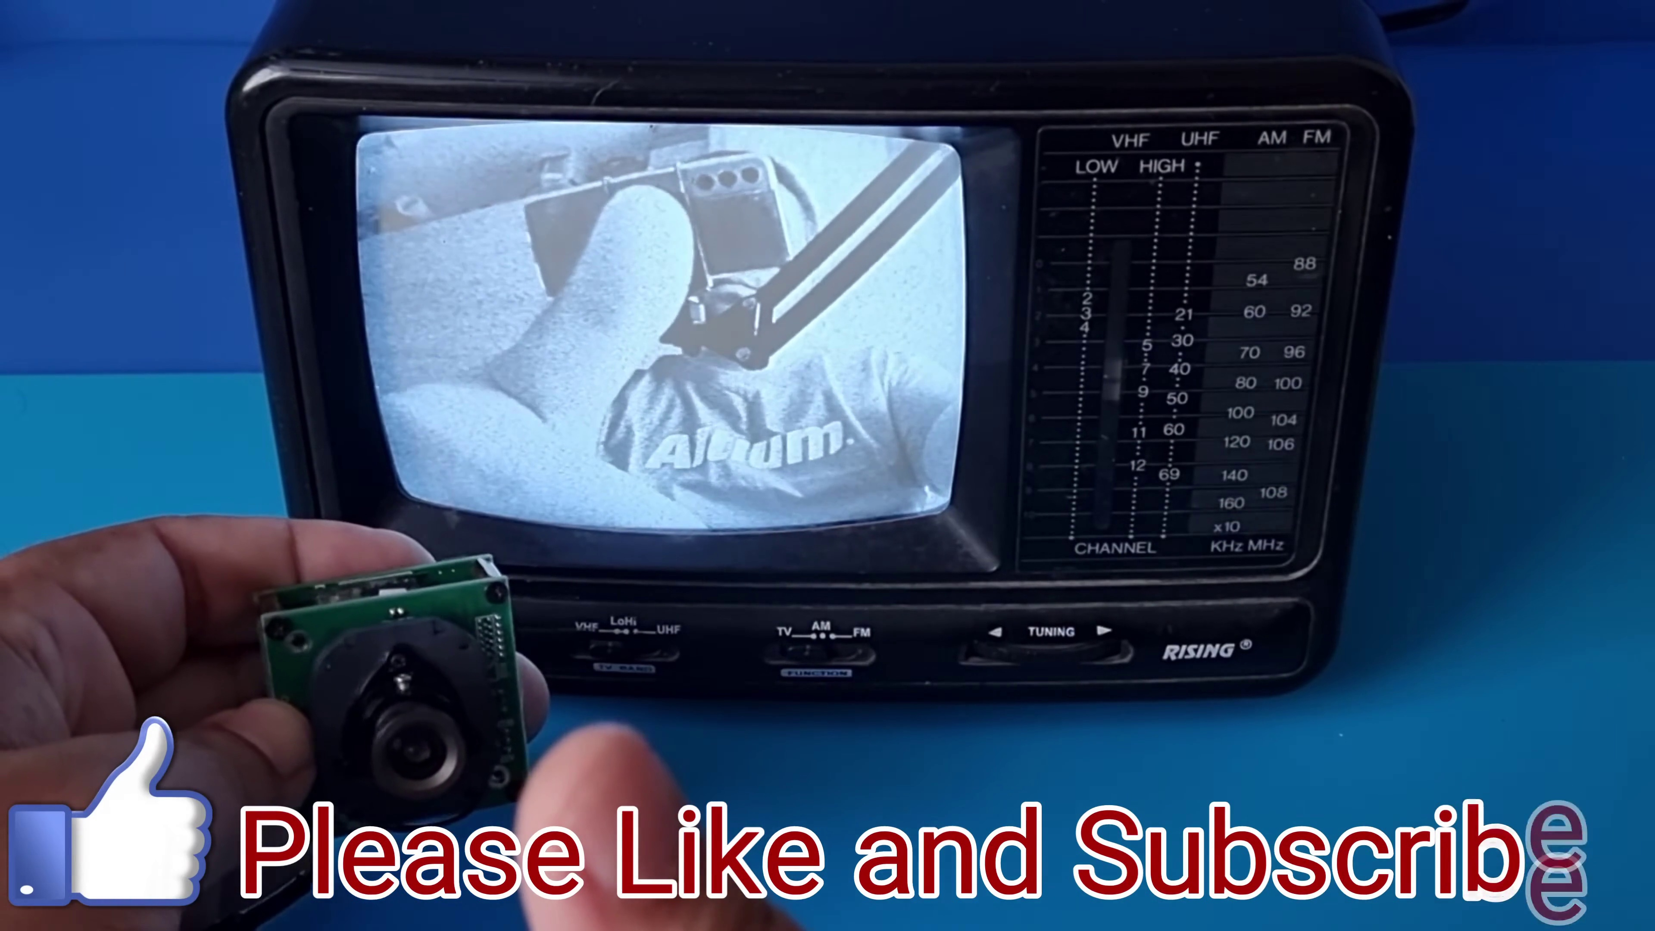
Topic T2: Free Applications — score 20.0000
Description: The speaker encourages viewers to try and use the free applications available.
Reason: The comment discusses a specific project and its components (circuit, board, oscilloscope, camera), whereas the topic 'Free Applications' is about software applications. Although there is no direct discussion of free applications in the comment, it does not contain generic praise either.
 |  | 
Topic T3: Sponsorship — score 0.0000
Description: The speaker expresses gratitude to the sponsor of the video.
Reason: The topic 'Sponsorship' discusses expressing gratitude to a sponsor, while the comment describes electronic circuitry and signal conversion, with no overlap in topics.
 |  | 
Topic T1: Altium Designer — score 0.0000
Description: The speaker introduces Altium Designer, a tool for creating PCB designs without extra setup or configuration.
Reason: The comment discusses a specific PCB design and its usage, whereas the topic Altium Designer is about the tool used to create designs. There are no direct overlaps between the topic and the comment.
Least correlated topics:
 |  | 
Topic T1: Altium Designer — score 0.0000
Description: The speaker introduces Altium Designer, a tool for creating PCB designs without extra setup or configuration.
Reason: The comment discusses a specific PCB design and its usage, whereas the topic Altium Designer is about the tool used to create designs. There are no direct overlaps between the topic and the comment.
 |  | 
Topic T3: Sponsorship — score 0.0000
Description: The speaker expresses gratitude to the sponsor of the video.
Reason: The topic 'Sponsorship' discusses expressing gratitude to a sponsor, while the comment describes electronic circuitry and signal conversion, with no overlap in topics.
 |  | 
Topic T2: Free Applications — score 20.0000
Description: The speaker encourages viewers to try and use the free applications available.
Reason: The comment discusses a specific project and its components (circuit, board, oscilloscope, camera), whereas the topic 'Free Applications' is about software applications. Although there is no direct discussion of free applications in the comment, it does not contain generic praise either.

Topic T1: Altium Designer
 |  | 
Description: The speaker introduces Altium Designer, a tool for creating PCB designs without extra setup or configuration.
No strongly correlated comments found for this topic.

Topic T2: Free Applications
 |  | 
Description: The speaker encourages viewers to try and use the free applications available.
No strongly correlated comments found for this topic.

Topic T3: Sponsorship
 |  | 
Description: The speaker expresses gratitude to the sponsor of the video.
No strongly correlated comments found for this topic.

