Comment–Topic Correlation Report
Model: llama3

Summary
Topics processed: 3
Comments available for this video: 2
Comments correlated to ≥ 60: 0 (0.0%)
Total candidate pairs checked: 6

Most/Least correlated topics (by average score across correlated comments):
Top 3:
• Topic T3: Thank You and Calculations — avg 0.00, contributions 0
• Topic T2: Saint's Introduction — avg 0.00, contributions 0
• Topic T1: Association with Old Things — avg 0.00, contributions 0
Bottom 3:
• Topic T1: Association with Old Things — avg 0.00, contributions 0
• Topic T2: Saint's Introduction — avg 0.00, contributions 0
• Topic T3: Thank You and Calculations — avg 0.00, contributions 0
Correlated comment coverage (all comments):
- matched 0 topic(s), max score 0.0000: The video was helpful in demonstrating how to connect two MOSFETs together, aiding my understanding of parallel configurations.If there were clearer diagrams or additional explanations, especially towards the end when everything was combined, as I found it a bit confusing.
Source: https://www.youtube.com/watch?v=gdJHi9I0V4w&t=382s: DIY Powerful Ultra Bass Amplifier Capacitor , No IC , Simple circuit
Top correlated topics:
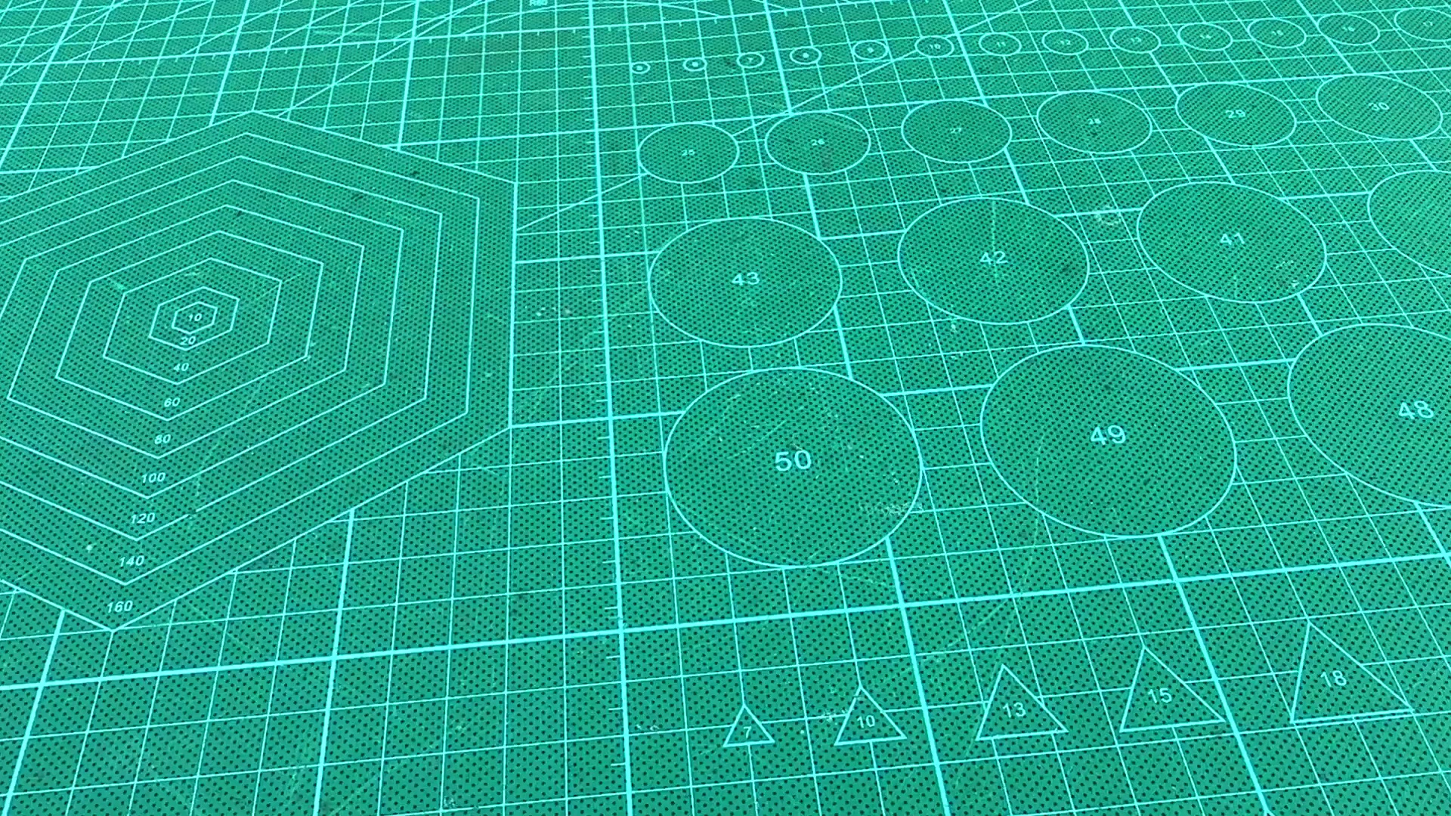 | 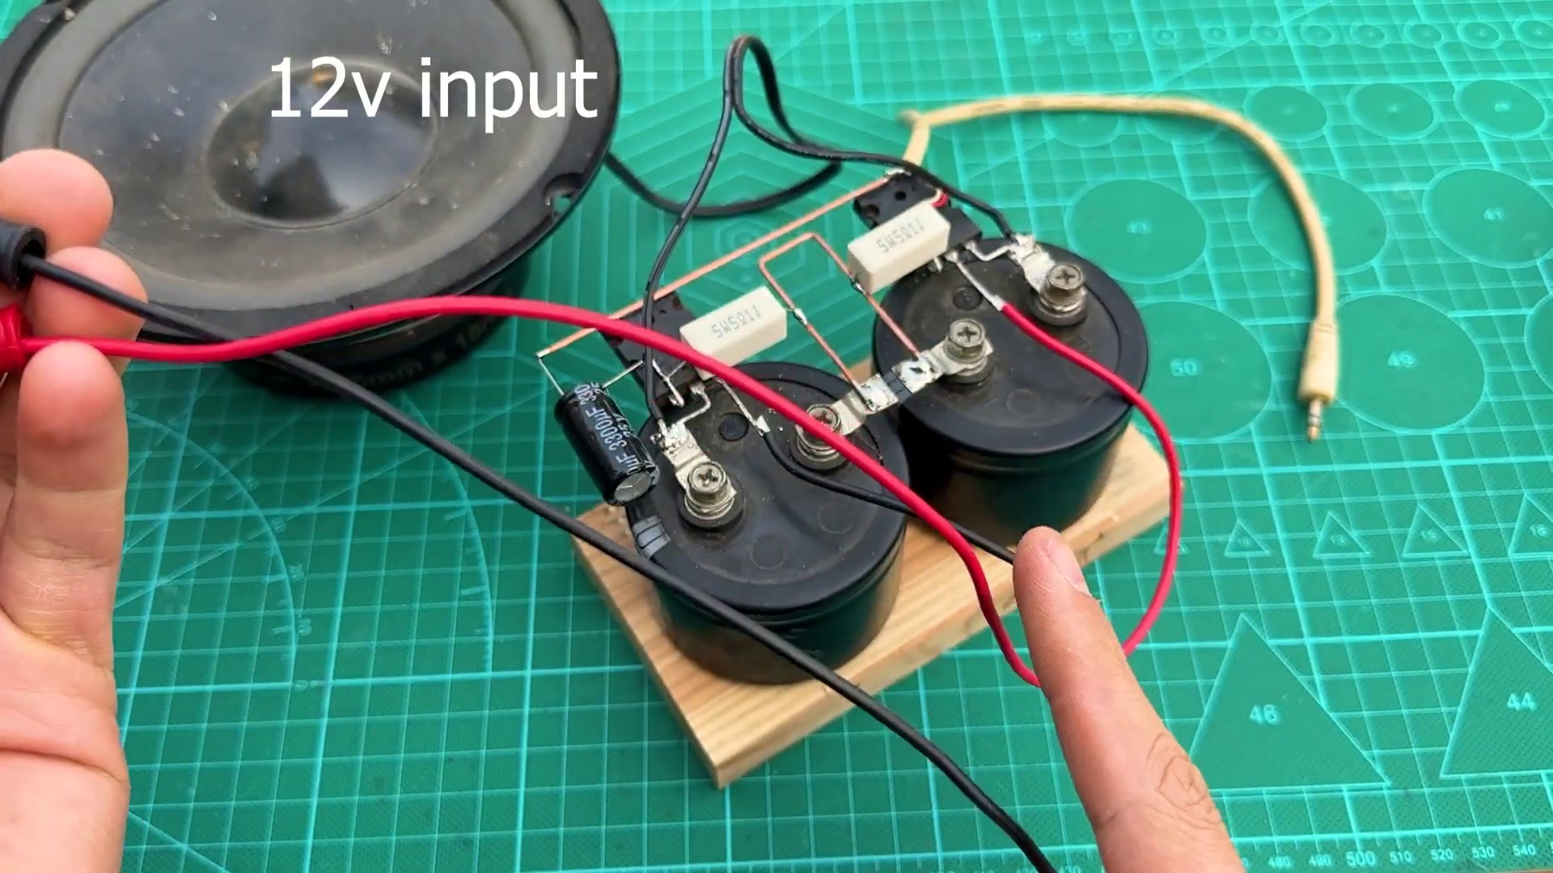 | 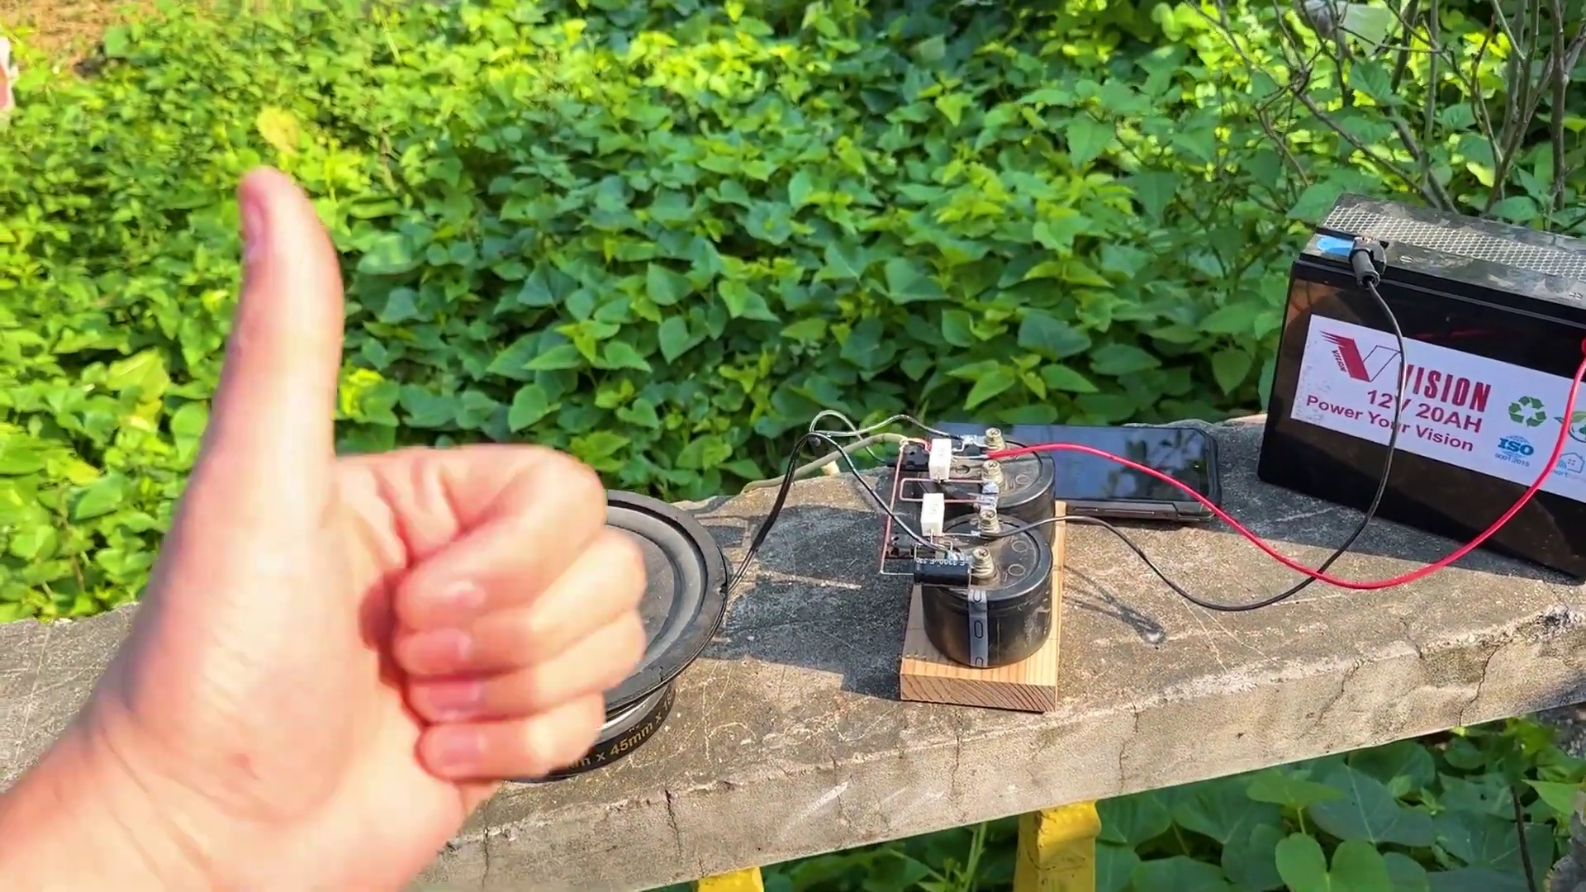
Topic T3: Thank You and Calculations — score 20.0000
Description: The speaker thanks someone and mentions calculations and twist.
Reason: The comment discusses MOSFETs and parallel configurations, which is not mentioned in the topic title or description. The thank you and calculations mentioned in the topic are not directly related to the viewer's experience with the video.
 |  | 
Topic T2: Saint's Introduction — score 0.0000
Description: The speaker introduces themselves as a saint.
Reason: The comment discusses MOSFETs and parallel configurations, which are unrelated to the topic of a saint's introduction.
 |  | 
Topic T1: Association with Old Things — score 0.0000
Description: The speaker associates themselves with old things.
Reason: The comment discusses electronics and circuit configurations, while the topic is about associating with old things, which are unrelated concepts.
Least correlated topics:
 |  | 
Topic T1: Association with Old Things — score 0.0000
Description: The speaker associates themselves with old things.
Reason: The comment discusses electronics and circuit configurations, while the topic is about associating with old things, which are unrelated concepts.
 |  | 
Topic T2: Saint's Introduction — score 0.0000
Description: The speaker introduces themselves as a saint.
Reason: The comment discusses MOSFETs and parallel configurations, which are unrelated to the topic of a saint's introduction.
 |  | 
Topic T3: Thank You and Calculations — score 20.0000
Description: The speaker thanks someone and mentions calculations and twist.
Reason: The comment discusses MOSFETs and parallel configurations, which is not mentioned in the topic title or description. The thank you and calculations mentioned in the topic are not directly related to the viewer's experience with the video.
- matched 0 topic(s), max score 0.0000: Helpful to see the terminal connections between capacitors and understand the directionality of speakers for builds or purchases.What made you confused is that Skeptical about some of the connections; also unsure due to conflicting comments calling the video fake.
Source: https://www.youtube.com/watch?v=gdJHi9I0V4w: DIY Powerful Ultra Bass Amplifier Capacitor
Top correlated topics:
 |  | 
Topic T3: Thank You and Calculations — score 20.0000
Description: The speaker thanks someone and mentions calculations and twist.
Reason: The topic mentions 'calculations' and 'twist', but the comment discusses electronics and speaker builds/purchases, with no direct relation to calculations or twist.
 |  | 
Topic T1: Association with Old Things — score 20.0000
Description: The speaker associates themselves with old things.
Reason: The comment discusses a specific topic (terminal connections between capacitors and speaker directionality) that is not related to the topic 'Association with Old Things' nor its description. The only mention of old things is in the context of conflicting comments calling the video fake, which is a tangential point.
 |  | 
Topic T2: Saint's Introduction — score 0.0000
Description: The speaker introduces themselves as a saint.
Reason: The comment discusses electronics and audio equipment, whereas the topic is about a saint's introduction. There is no overlap between the two.
Least correlated topics:
 |  | 
Topic T2: Saint's Introduction — score 0.0000
Description: The speaker introduces themselves as a saint.
Reason: The comment discusses electronics and audio equipment, whereas the topic is about a saint's introduction. There is no overlap between the two.
 |  | 
Topic T1: Association with Old Things — score 20.0000
Description: The speaker associates themselves with old things.
Reason: The comment discusses a specific topic (terminal connections between capacitors and speaker directionality) that is not related to the topic 'Association with Old Things' nor its description. The only mention of old things is in the context of conflicting comments calling the video fake, which is a tangential point.
 |  | 
Topic T3: Thank You and Calculations — score 20.0000
Description: The speaker thanks someone and mentions calculations and twist.
Reason: The topic mentions 'calculations' and 'twist', but the comment discusses electronics and speaker builds/purchases, with no direct relation to calculations or twist.

Topic T1: Association with Old Things
 |  | 
Description: The speaker associates themselves with old things.
No strongly correlated comments found for this topic.

Topic T2: Saint's Introduction
 |  | 
Description: The speaker introduces themselves as a saint.
No strongly correlated comments found for this topic.

Topic T3: Thank You and Calculations
 |  | 
Description: The speaker thanks someone and mentions calculations and twist.
No strongly correlated comments found for this topic.

