Comment–Topic Correlation Report
Model: llama3

Summary
Topics processed: 6
Comments available for this video: 1
Comments correlated to ≥ 60: 1 (100.0%)
Total candidate pairs checked: 6

Most/Least correlated topics (by average score across correlated comments):
Top 3:
• Topic T2: Controller Tuning — avg 85.00, contributions 1
• Topic T6: Tuning of KP and KI parameters — avg 80.00, contributions 1
• Topic T4: KP parameter adjustment — avg 80.00, contributions 1
Bottom 3:
• Topic T1: Arduino Board Configuration — avg 0.00, contributions 0
• Topic T3: KI parameter adjustment — avg 0.00, contributions 0
• Topic T5: Stepper Motor Settings — avg 0.00, contributions 0
Correlated comment coverage (all comments):
- matched 3 topic(s), max score 85.0000: Rank 2, The video provided an engaging walkthrough of the inverted pendulum system, illustrating the practical application of control theory through PID controllers. Using an Arduino as the control hub, it skillfully demonstrated how to translate encoder feedback into precise stepper motor movements to keep the system balanced. The tutorial offered a clear, step-by-step guide on implementing and tuning the PID controller on the Arduino, emphasizing the importance of fine- tuning the proportional, integral, and derivative constants to achieve system equilibrium. The iterative process of calibrating motor control, along with the adjustment of acceleration and speed parameters, was meticulously covered, showcasing the depth of control required to optimize the system's performance. Through manual tuning and Python code integration, the project refined the PID constants, KP, KI, and KD, to successfully stabilize the pendulum with minimal oscillation, underscoring the effectiveness of carefully applied control strategies. This demonstration enhanced my understanding of PID controllers in dynamic control systems.
Source: https://www.youtube.com/watch?v=hRnofMxEf3Q: “How to Tune a PID Controller for an Inverted Pendulum | DigiKey”
Top correlated topics:
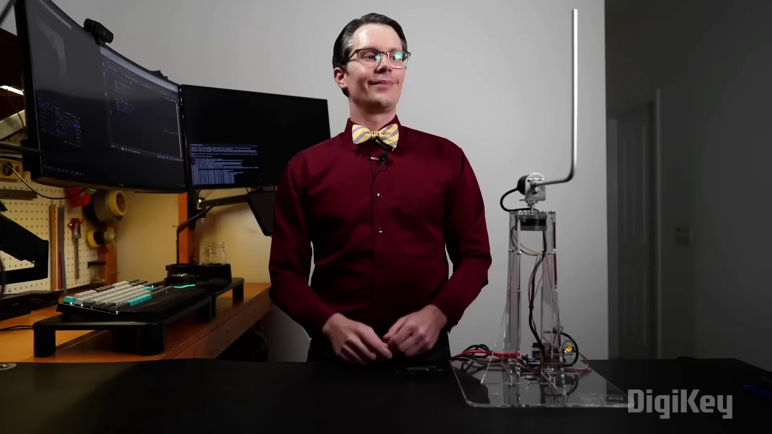 | 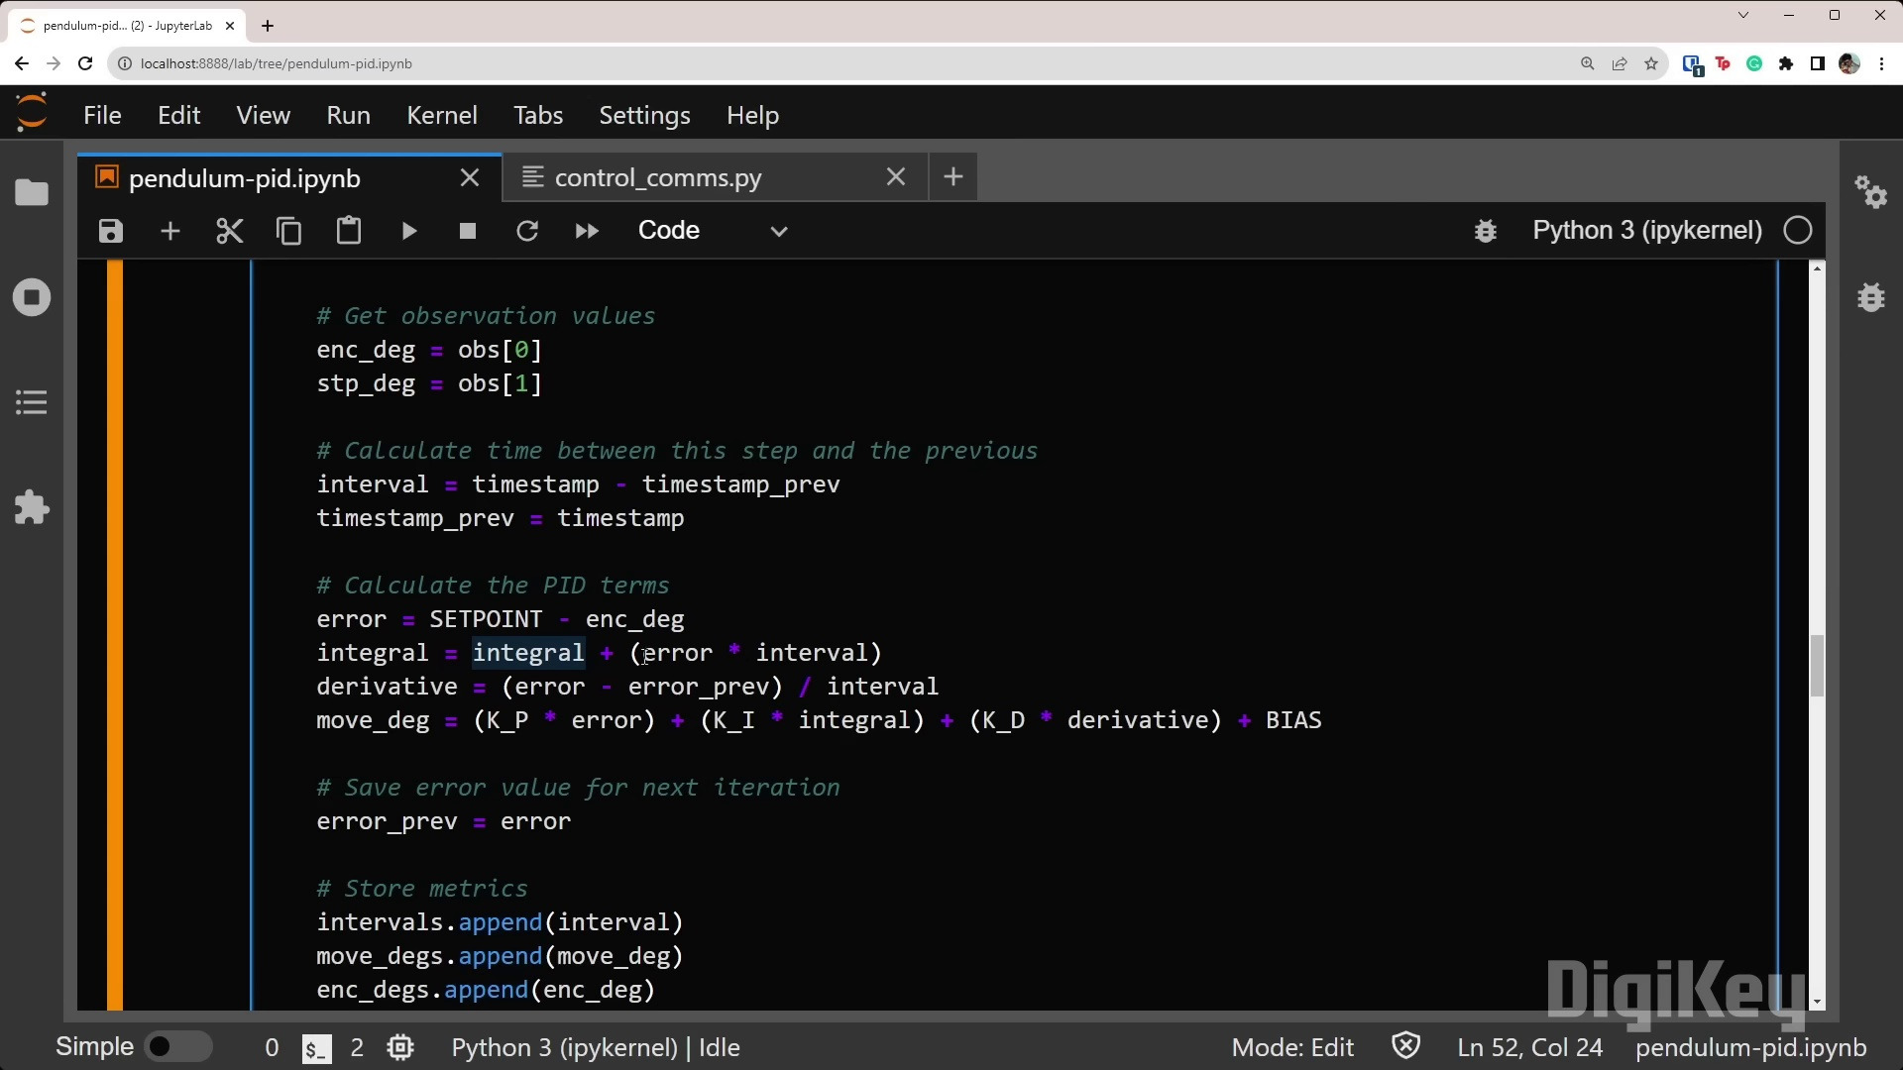 | 
Topic T2: Controller Tuning — score 85.0000
Description: Tuning the PID controller for controlling the stepper motor.
Reason: The comment discusses the same steps, objects (PID controller), settings (Arduino), parameters (proportional, integral, and derivative constants), and claims (importance of fine-tuning) described by the topic. The specific overlap is the focus on PID controller tuning for controlling a stepper motor.
 |  | 
Topic T6: Tuning of KP and KI parameters — score 80.0000
Description: The speaker is adjusting the KP and KI parameters to achieve stable control.
Reason: The comment explicitly mentions tuning KP and KI parameters for achieving system equilibrium, matching the topic description. The mention of PID controllers, proportional, integral, and derivative constants also aligns with the topic's focus on parameter adjustment.
 |  | 
Topic T4: KP parameter adjustment — score 80.0000
Description: The speaker is adjusting the KP parameter to achieve stable control.
Reason: The comment discusses the adjustment of KP parameter (mentioned in topic description) and PID controller tuning (same concept as adjusting KP parameter), highlighting manual tuning and Python code integration to achieve system equilibrium.
 |  | 
Topic T5: Stepper Motor Settings — score 20.0000
Description: Setting stepper mode and commands for controlling the stepper motor.
Reason: The comment discusses a different application of stepper motors (inverted pendulum system) and PID controllers, with no direct overlap in settings or commands mentioned in the topic description.
 |  | 
Topic T3: KI parameter adjustment — score 20.0000
Description: The speaker is adjusting the KI parameter to achieve stable control.
Reason: The comment discusses a broader topic of PID controllers and their application in control systems, but does not specifically mention KI parameter adjustment. The topic description focuses on adjusting the KI parameter for stable control, which is not directly discussed in the comment.
 |  | 
Topic T1: Arduino Board Configuration — score 10.0000
Description: Setting up Arduino board with L6474 library and stepper motor configuration.
Reason: The comment discusses a different topic (inverted pendulum system) and uses Arduino for control hub, but does not specifically discuss setting up Arduino board with L6474 library and stepper motor configuration.
Least correlated topics:
 |  | 
Topic T1: Arduino Board Configuration — score 10.0000
Description: Setting up Arduino board with L6474 library and stepper motor configuration.
Reason: The comment discusses a different topic (inverted pendulum system) and uses Arduino for control hub, but does not specifically discuss setting up Arduino board with L6474 library and stepper motor configuration.
 |  | 
Topic T3: KI parameter adjustment — score 20.0000
Description: The speaker is adjusting the KI parameter to achieve stable control.
Reason: The comment discusses a broader topic of PID controllers and their application in control systems, but does not specifically mention KI parameter adjustment. The topic description focuses on adjusting the KI parameter for stable control, which is not directly discussed in the comment.
 |  | 
Topic T5: Stepper Motor Settings — score 20.0000
Description: Setting stepper mode and commands for controlling the stepper motor.
Reason: The comment discusses a different application of stepper motors (inverted pendulum system) and PID controllers, with no direct overlap in settings or commands mentioned in the topic description.
 |  | 
Topic T4: KP parameter adjustment — score 80.0000
Description: The speaker is adjusting the KP parameter to achieve stable control.
Reason: The comment discusses the adjustment of KP parameter (mentioned in topic description) and PID controller tuning (same concept as adjusting KP parameter), highlighting manual tuning and Python code integration to achieve system equilibrium.
 |  | 
Topic T6: Tuning of KP and KI parameters — score 80.0000
Description: The speaker is adjusting the KP and KI parameters to achieve stable control.
Reason: The comment explicitly mentions tuning KP and KI parameters for achieving system equilibrium, matching the topic description. The mention of PID controllers, proportional, integral, and derivative constants also aligns with the topic's focus on parameter adjustment.
 |  | 
Topic T2: Controller Tuning — score 85.0000
Description: Tuning the PID controller for controlling the stepper motor.
Reason: The comment discusses the same steps, objects (PID controller), settings (Arduino), parameters (proportional, integral, and derivative constants), and claims (importance of fine-tuning) described by the topic. The specific overlap is the focus on PID controller tuning for controlling a stepper motor.

Topic T1: Arduino Board Configuration
 |  | 
Description: Setting up Arduino board with L6474 library and stepper motor configuration.
No strongly correlated comments found for this topic.

Topic T2: Controller Tuning
 |  | 
Description: Tuning the PID controller for controlling the stepper motor.
Comment (score 85): Rank 2, The video provided an engaging walkthrough of the inverted pendulum system, illustrating the practical application of control theory through PID controllers. Using an Arduino as the control hub, it skillfully demonstrated how to translate encoder feedback into precise stepper motor movements to keep the system balanced. The tutorial offered a clear, step-by-step guide on implementing and tuning the PID controller on the Arduino, emphasizing the importance of fine- tuning the proportional, integral, and derivative constants to achieve system equilibrium. The iterative process of calibrating motor control, along with the adjustment of acceleration and speed parameters, was meticulously covered, showcasing the depth of control required to optimize the system's performance. Through manual tuning and Python code integration, the project refined the PID constants, KP, KI, and KD, to successfully stabilize the pendulum with minimal oscillation, underscoring the effectiveness of carefully applied control strategies. This demonstration enhanced my understanding of PID controllers in dynamic control systems.
Reason: The comment discusses the same steps, objects (PID controller), settings (Arduino), parameters (proportional, integral, and derivative constants), and claims (importance of fine-tuning) described by the topic. The specific overlap is the focus on PID controller tuning for controlling a stepper motor.
Source: https://www.youtube.com/watch?v=hRnofMxEf3Q: “How to Tune a PID Controller for an Inverted Pendulum | DigiKey”

Topic T3: KI parameter adjustment
 |  | 
Description: The speaker is adjusting the KI parameter to achieve stable control.
No strongly correlated comments found for this topic.

Topic T4: KP parameter adjustment
 |  | 
Description: The speaker is adjusting the KP parameter to achieve stable control.
Comment (score 80): Rank 2, The video provided an engaging walkthrough of the inverted pendulum system, illustrating the practical application of control theory through PID controllers. Using an Arduino as the control hub, it skillfully demonstrated how to translate encoder feedback into precise stepper motor movements to keep the system balanced. The tutorial offered a clear, step-by-step guide on implementing and tuning the PID controller on the Arduino, emphasizing the importance of fine- tuning the proportional, integral, and derivative constants to achieve system equilibrium. The iterative process of calibrating motor control, along with the adjustment of acceleration and speed parameters, was meticulously covered, showcasing the depth of control required to optimize the system's performance. Through manual tuning and Python code integration, the project refined the PID constants, KP, KI, and KD, to successfully stabilize the pendulum with minimal oscillation, underscoring the effectiveness of carefully applied control strategies. This demonstration enhanced my understanding of PID controllers in dynamic control systems.
Reason: The comment discusses the adjustment of KP parameter (mentioned in topic description) and PID controller tuning (same concept as adjusting KP parameter), highlighting manual tuning and Python code integration to achieve system equilibrium.
Source: https://www.youtube.com/watch?v=hRnofMxEf3Q: “How to Tune a PID Controller for an Inverted Pendulum | DigiKey”

Topic T5: Stepper Motor Settings
 |  | 
Description: Setting stepper mode and commands for controlling the stepper motor.
No strongly correlated comments found for this topic.

Topic T6: Tuning of KP and KI parameters
 |  | 
Description: The speaker is adjusting the KP and KI parameters to achieve stable control.
Comment (score 80): Rank 2, The video provided an engaging walkthrough of the inverted pendulum system, illustrating the practical application of control theory through PID controllers. Using an Arduino as the control hub, it skillfully demonstrated how to translate encoder feedback into precise stepper motor movements to keep the system balanced. The tutorial offered a clear, step-by-step guide on implementing and tuning the PID controller on the Arduino, emphasizing the importance of fine- tuning the proportional, integral, and derivative constants to achieve system equilibrium. The iterative process of calibrating motor control, along with the adjustment of acceleration and speed parameters, was meticulously covered, showcasing the depth of control required to optimize the system's performance. Through manual tuning and Python code integration, the project refined the PID constants, KP, KI, and KD, to successfully stabilize the pendulum with minimal oscillation, underscoring the effectiveness of carefully applied control strategies. This demonstration enhanced my understanding of PID controllers in dynamic control systems.
Reason: The comment explicitly mentions tuning KP and KI parameters for achieving system equilibrium, matching the topic description. The mention of PID controllers, proportional, integral, and derivative constants also aligns with the topic's focus on parameter adjustment.
Source: https://www.youtube.com/watch?v=hRnofMxEf3Q: “How to Tune a PID Controller for an Inverted Pendulum | DigiKey”

