Comment–Topic Correlation Report
Model: llama3

Summary
Topics processed: 2
Comments available for this video: 6
Comments correlated to ≥ 60: 4 (66.7%)
Total candidate pairs checked: 12

Most/Least correlated topics (by average score across correlated comments):
Top 3:
• Topic T2: LM386 Audio Amplifier Kit — avg 82.50, contributions 4
• Topic T1: Adjusting Gain — avg 80.00, contributions 1
Bottom 3:
• Topic T1: Adjusting Gain — avg 80.00, contributions 1
• Topic T2: LM386 Audio Amplifier Kit — avg 82.50, contributions 4
Correlated comment coverage (all comments):
- matched 2 topic(s), max score 80.0000: I learned that if there is nothing connected to pins 1 and 8, then internal resistance sets the gain at 20 dB. If there is something connected.
Source: https://www.youtube.com/watch?v=hnPi6i8Ua1M: A neat little LM386 Audio Amplifier Kit for just $2 – so is it Bad or a Bargain?
Top correlated topics:
 | 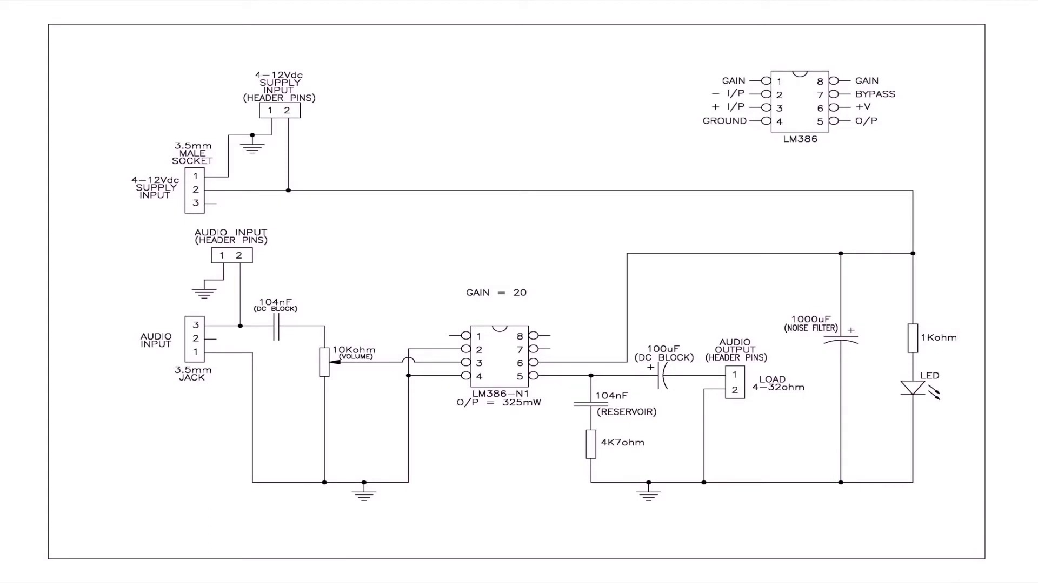 | 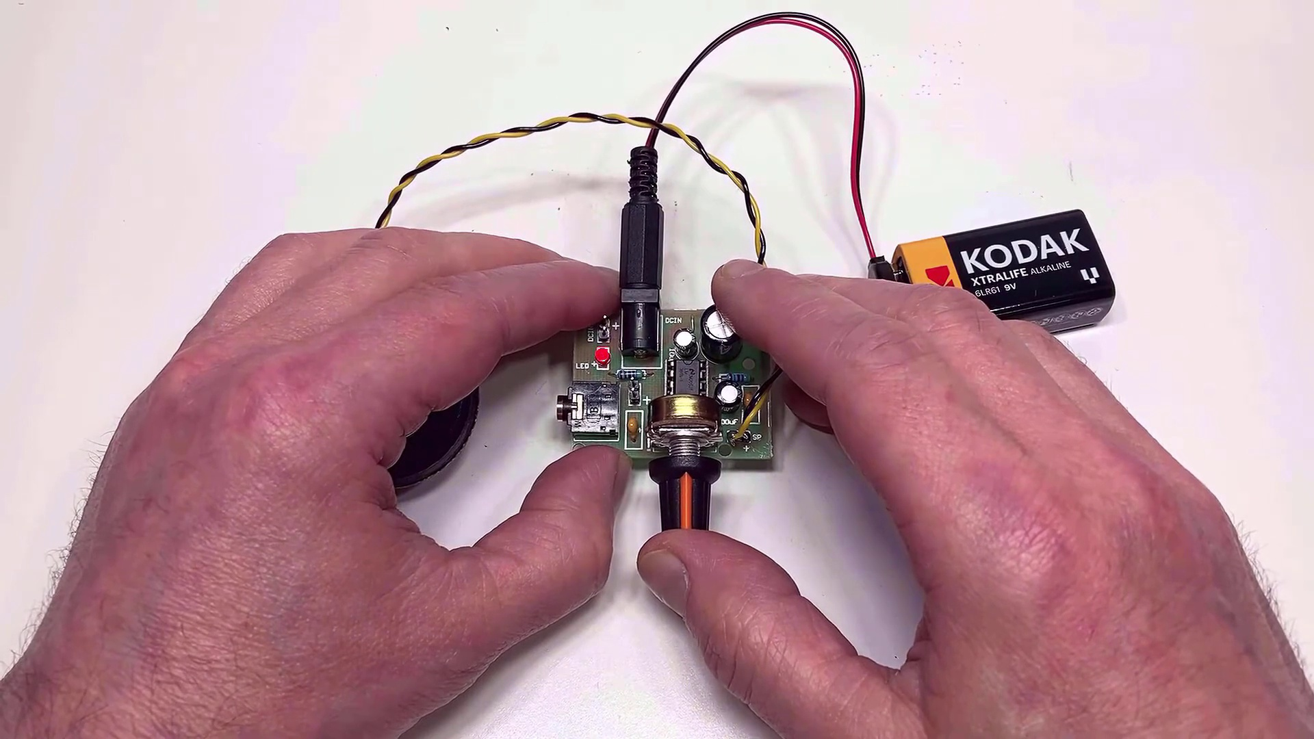
Topic T2: LM386 Audio Amplifier Kit — score 80.0000
Description: A review of the LM386 audio amplifier kit, including its features and performance.
Reason: The comment directly discusses the internal resistance setting gain in an LM386 audio amplifier kit, which is a specific aspect mentioned in the topic description. The mention of pins 1 and 8 also shows overlap with the topic's focus on the LM386 kit.
 |  | 
Topic T1: Adjusting Gain — score 80.0000
Description: The LM386 chip has a feature that allows you to adjust its gain.
Reason: The comment mentions the LM386 chip and specifically discusses gain adjustment, which matches the topic title and description. The mention of pins 1 and 8 is also relevant to the topic, although not directly discussing the adjustment process.
Least correlated topics:
 |  | 
Topic T1: Adjusting Gain — score 80.0000
Description: The LM386 chip has a feature that allows you to adjust its gain.
Reason: The comment mentions the LM386 chip and specifically discusses gain adjustment, which matches the topic title and description. The mention of pins 1 and 8 is also relevant to the topic, although not directly discussing the adjustment process.
 |  | 
Topic T2: LM386 Audio Amplifier Kit — score 80.0000
Description: A review of the LM386 audio amplifier kit, including its features and performance.
Reason: The comment directly discusses the internal resistance setting gain in an LM386 audio amplifier kit, which is a specific aspect mentioned in the topic description. The mention of pins 1 and 8 also shows overlap with the topic's focus on the LM386 kit.
- matched 1 topic(s), max score 90.0000: Details schematic, cost, and step-by-step build instructions.No confusion for this video.Good reference for the final project due to its clarity.
Source: https://www.youtube.com/watch?v=hnPi6i8Ua1M: LM386 Audio Amplifier Kit for Just $2
Top correlated topics:
 |  | 
Topic T2: LM386 Audio Amplifier Kit — score 90.0000
Description: A review of the LM386 audio amplifier kit, including its features and performance.
Reason: The comment mentions 'schematic', 'step-by-step build instructions' and 'final project', which are all directly related to the features and performance of the LM386 audio amplifier kit described in the topic.
 |  | 
Topic T1: Adjusting Gain — score 0.0000
Description: The LM386 chip has a feature that allows you to adjust its gain.
Reason: The comment does not discuss adjusting gain or any specific steps related to the LM386 chip. Instead, it provides general praise for the video's clarity and usefulness.
Least correlated topics:
 |  | 
Topic T1: Adjusting Gain — score 0.0000
Description: The LM386 chip has a feature that allows you to adjust its gain.
Reason: The comment does not discuss adjusting gain or any specific steps related to the LM386 chip. Instead, it provides general praise for the video's clarity and usefulness.
 |  | 
Topic T2: LM386 Audio Amplifier Kit — score 90.0000
Description: A review of the LM386 audio amplifier kit, including its features and performance.
Reason: The comment mentions 'schematic', 'step-by-step build instructions' and 'final project', which are all directly related to the features and performance of the LM386 audio amplifier kit described in the topic.
- matched 1 topic(s), max score 80.0000: This video is useful because it lists all the components and model numbers needed to build the amplifier kit, providing a clear reference for assembling a budget-friendly audio amplifier.The small circuit diagram in the video was confusing and difficult to follow for building the circuit.This can be used in future builds when a cheap amplifier is needed.
Source: https://www.youtube.com/watch?v=hnPi6i8Ua1M: A neat little LM 386 Audio Amplifier Kit for just $2 – so is it Bad or a Bargain?
Top correlated topics:
 |  | 
Topic T2: LM386 Audio Amplifier Kit — score 80.0000
Description: A review of the LM386 audio amplifier kit, including its features and performance.
Reason: The comment directly mentions the LM386 audio amplifier kit and its components, specifically listing model numbers needed for assembly. This aligns with the topic's description of the kit's features and performance.
 |  | 
Topic T1: Adjusting Gain — score 20.0000
Description: The LM386 chip has a feature that allows you to adjust its gain.
Reason: The comment does not directly discuss the topic of adjusting gain, instead it provides an overview of building an amplifier kit and mentions a small circuit diagram, but does not specifically relate to adjusting gain.
Least correlated topics:
 |  | 
Topic T1: Adjusting Gain — score 20.0000
Description: The LM386 chip has a feature that allows you to adjust its gain.
Reason: The comment does not directly discuss the topic of adjusting gain, instead it provides an overview of building an amplifier kit and mentions a small circuit diagram, but does not specifically relate to adjusting gain.
 |  | 
Topic T2: LM386 Audio Amplifier Kit — score 80.0000
Description: A review of the LM386 audio amplifier kit, including its features and performance.
Reason: The comment directly mentions the LM386 audio amplifier kit and its components, specifically listing model numbers needed for assembly. This aligns with the topic's description of the kit's features and performance.
- matched 1 topic(s), max score 80.0000: A good explanation of using the LM386 chip was provided in this video.The video does a great job explaining the LM386. No questions.
Source: https://www.youtube.com/watch?v=hnPi6i8Ua1M: A neat little LM386 Audio Amplifier Kit for just $2
Top correlated topics:
 |  | 
Topic T2: LM386 Audio Amplifier Kit — score 80.0000
Description: A review of the LM386 audio amplifier kit, including its features and performance.
Reason: The comment directly references the LM386 chip and its use in the video, which is a key component of the topic. The mention of 'good explanation' also implies that the video covered the same topics as the topic description.
 |  | 
Topic T1: Adjusting Gain — score 20.0000
Description: The LM386 chip has a feature that allows you to adjust its gain.
Reason: The comment mentions the LM386 chip and a video explaining it, but does not directly discuss adjusting gain. It's a generic praise about the video rather than specifically discussing the topic.
Least correlated topics:
 |  | 
Topic T1: Adjusting Gain — score 20.0000
Description: The LM386 chip has a feature that allows you to adjust its gain.
Reason: The comment mentions the LM386 chip and a video explaining it, but does not directly discuss adjusting gain. It's a generic praise about the video rather than specifically discussing the topic.
 |  | 
Topic T2: LM386 Audio Amplifier Kit — score 80.0000
Description: A review of the LM386 audio amplifier kit, including its features and performance.
Reason: The comment directly references the LM386 chip and its use in the video, which is a key component of the topic. The mention of 'good explanation' also implies that the video covered the same topics as the topic description.
- matched 0 topic(s), max score 0.0000: This video shows that building a speaker can be easy and cheap. In fact, I am thinking of buying this kit for my young brother as a gift to make him try and build his own speaker! I would be around in case he needed help, it is helpful too as might need to review the concept later on.
Source: https://www.youtube.com/watch?v=hnPi6i8Ua1M: A neat little LM386 Audio Amplifier Kit for just $2 - so is it Bad or a Bargain?
Top correlated topics:
 |  | 
Topic T2: LM386 Audio Amplifier Kit — score 10.0000
Description: A review of the LM386 audio amplifier kit, including its features and performance.
Reason: The comment does not discuss the LM386 audio amplifier kit specifically, but rather mentions it as a potential gift for someone to build their own speaker. The topic is about reviewing the kit's features and performance, which is not addressed in the comment.
 |  | 
Topic T1: Adjusting Gain — score 0.0000
Description: The LM386 chip has a feature that allows you to adjust its gain.
Reason: The comment discusses building a speaker and buying a kit as a gift, but does not mention adjusting gain or the LM386 chip.
Least correlated topics:
 |  | 
Topic T1: Adjusting Gain — score 0.0000
Description: The LM386 chip has a feature that allows you to adjust its gain.
Reason: The comment discusses building a speaker and buying a kit as a gift, but does not mention adjusting gain or the LM386 chip.
 |  | 
Topic T2: LM386 Audio Amplifier Kit — score 10.0000
Description: A review of the LM386 audio amplifier kit, including its features and performance.
Reason: The comment does not discuss the LM386 audio amplifier kit specifically, but rather mentions it as a potential gift for someone to build their own speaker. The topic is about reviewing the kit's features and performance, which is not addressed in the comment.
- matched 0 topic(s), max score 0.0000: This video is basically the first circuit we built for project 1, at the time I did not know this was on here. I just found this on a website, and it is a very cheap, simple, useful amplifier to build. I am glad that I built this for project 1 as the design we are using for project 2 is more complicated, and there was no way we could have completed on time. This one if very powerful for just using a 9 volt battery to power it up.
Source: https://www.youtube.com/watch?v=hnPi6i8Ua1M: A neat little LM386 Audio Amplifier Kit for just $2 ! - so is it Bad or a Bargain?
Top correlated topics:
 |  | 
Topic T2: LM386 Audio Amplifier Kit — score 20.0000
Description: A review of the LM386 audio amplifier kit, including its features and performance.
Reason: The comment does not directly discuss the LM386 audio amplifier kit's features or performance. Instead, it talks about building a simple amplifier as part of a project and its power output using a 9V battery. The topic title is mentioned, but not in a way that relates to specific details like settings, parameters, or claims described in the topic description.
 |  | 
Topic T1: Adjusting Gain — score 20.0000
Description: The LM386 chip has a feature that allows you to adjust its gain.
Reason: The comment does not directly discuss the topic of adjusting gain. Instead, it provides a personal anecdote about building an amplifier and its usefulness for a project.
Least correlated topics:
 |  | 
Topic T1: Adjusting Gain — score 20.0000
Description: The LM386 chip has a feature that allows you to adjust its gain.
Reason: The comment does not directly discuss the topic of adjusting gain. Instead, it provides a personal anecdote about building an amplifier and its usefulness for a project.
 |  | 
Topic T2: LM386 Audio Amplifier Kit — score 20.0000
Description: A review of the LM386 audio amplifier kit, including its features and performance.
Reason: The comment does not directly discuss the LM386 audio amplifier kit's features or performance. Instead, it talks about building a simple amplifier as part of a project and its power output using a 9V battery. The topic title is mentioned, but not in a way that relates to specific details like settings, parameters, or claims described in the topic description.

Topic T1: Adjusting Gain
 |  | 
Description: The LM386 chip has a feature that allows you to adjust its gain.
Comment (score 80): I learned that if there is nothing connected to pins 1 and 8, then internal resistance sets the gain at 20 dB. If there is something connected.
Reason: The comment mentions the LM386 chip and specifically discusses gain adjustment, which matches the topic title and description. The mention of pins 1 and 8 is also relevant to the topic, although not directly discussing the adjustment process.
Source: https://www.youtube.com/watch?v=hnPi6i8Ua1M: A neat little LM386 Audio Amplifier Kit for just $2 – so is it Bad or a Bargain?

Topic T2: LM386 Audio Amplifier Kit
 |  | 
Description: A review of the LM386 audio amplifier kit, including its features and performance.
Comment (score 90): Details schematic, cost, and step-by-step build instructions.No confusion for this video.Good reference for the final project due to its clarity.
Reason: The comment mentions 'schematic', 'step-by-step build instructions' and 'final project', which are all directly related to the features and performance of the LM386 audio amplifier kit described in the topic.
Source: https://www.youtube.com/watch?v=hnPi6i8Ua1M: LM386 Audio Amplifier Kit for Just $2
Comment (score 80): This video is useful because it lists all the components and model numbers needed to build the amplifier kit, providing a clear reference for assembling a budget-friendly audio amplifier.The small circuit diagram in the video was confusing and difficult to follow for building the circuit.This can be used in future builds when a cheap amplifier is needed.
Reason: The comment directly mentions the LM386 audio amplifier kit and its components, specifically listing model numbers needed for assembly. This aligns with the topic's description of the kit's features and performance.
Source: https://www.youtube.com/watch?v=hnPi6i8Ua1M: A neat little LM 386 Audio Amplifier Kit for just $2 – so is it Bad or a Bargain?
Comment (score 80): A good explanation of using the LM386 chip was provided in this video.The video does a great job explaining the LM386. No questions.
Reason: The comment directly references the LM386 chip and its use in the video, which is a key component of the topic. The mention of 'good explanation' also implies that the video covered the same topics as the topic description.
Source: https://www.youtube.com/watch?v=hnPi6i8Ua1M: A neat little LM386 Audio Amplifier Kit for just $2
Comment (score 80): I learned that if there is nothing connected to pins 1 and 8, then internal resistance sets the gain at 20 dB. If there is something connected.
Reason: The comment directly discusses the internal resistance setting gain in an LM386 audio amplifier kit, which is a specific aspect mentioned in the topic description. The mention of pins 1 and 8 also shows overlap with the topic's focus on the LM386 kit.
Source: https://www.youtube.com/watch?v=hnPi6i8Ua1M: A neat little LM386 Audio Amplifier Kit for just $2 – so is it Bad or a Bargain?

