Comment–Topic Correlation Report
Model: llama3

Summary
Topics processed: 6
Comments available for this video: 2
Comments correlated to ≥ 60: 1 (50.0%)
Total candidate pairs checked: 12

Most/Least correlated topics (by average score across correlated comments):
Top 3:
• Topic T5: Tone Control and Microphone Preamp — avg 80.00, contributions 1
• Topic T6: Sound Test — avg 80.00, contributions 1
• Topic T2: PCB Cleaning — avg 0.00, contributions 0
Bottom 3:
• Topic T4: Connections — avg 0.00, contributions 0
• Topic T1: Introduction — avg 0.00, contributions 0
• Topic T3: Measurements — avg 0.00, contributions 0
Correlated comment coverage (all comments):
- matched 2 topic(s), max score 80.0000: I learned how to build a tone and volume control, as well as microphone preamplification.Uncertain if the circuit will work standalone or if it depends on the specific speaker circuit shown at the end.This could help address volume issues, like the one Meena encountered recently.: Will this circuit design work with our circuit or does it depend on their speaker design? Does it work without a microphone?
Source: https://www.youtube.com/watch?v=lV6zevUF-v0: Tone and volume control + microphone preamplifier
Top correlated topics:
 | 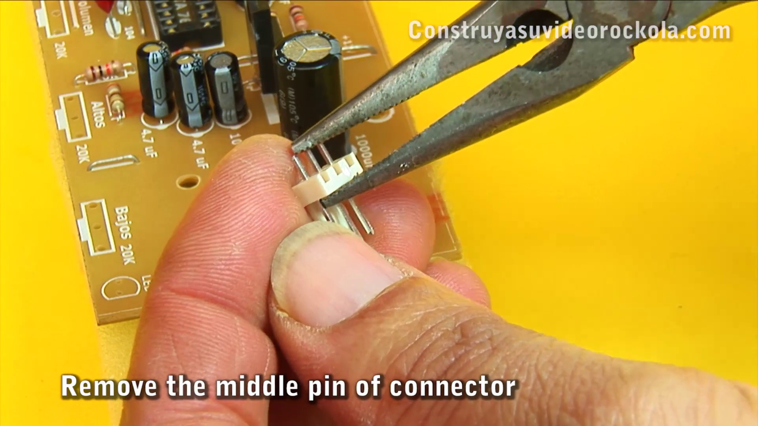 | 
Topic T6: Sound Test — score 80.0000
Description: Demonstrating the project's audio capabilities
Reason: The comment discusses building tone and volume control, preamplification, and circuit design, which are all directly related to the topic of demonstrating a project's audio capabilities.
 |  | 
Topic T5: Tone Control and Microphone Preamp — score 80.0000
Description: Building the tone control circuit with microphone preamplifier
Reason: The comment directly discusses the tone control and microphone preamplifier, using specific terms like 'tone and volume control' and 'microphone preamplification', showing strong overlaps with the topic.
 |  | 
Topic T4: Connections — score 20.0000
Description: Assembling cables and connectors for signal input and output
Reason: The comment mentions circuit design and volume control, but not specific connections or connectors described in the topic. The focus is on building a tone and volume control rather than assembling cables and connectors.
 |  | 
Topic T3: Measurements — score 20.0000
Description: Checking voltage levels and circuit performance
Reason: The comment discusses building a tone and volume control circuit, which is not directly related to the topic of measuring voltage levels and circuit performance. The mention of Meena's issue is also unrelated.
 |  | 
Topic T1: Introduction — score 20.0000
Description: Project overview and setup
Reason: The comment discusses circuit building and tone/volume control, which is unrelated to the topic of project overview and setup. The only potential overlap is the mention of addressing volume issues, but it's not a direct discussion of project setup.
 |  | 
Topic T2: PCB Cleaning — score 0.0000
Description: Washing and drying the PCB
Reason: The comment discusses tone and volume control, microphone preamplification, and circuit design, which has no direct relation to washing and drying a PCB.
Least correlated topics:
 |  | 
Topic T2: PCB Cleaning — score 0.0000
Description: Washing and drying the PCB
Reason: The comment discusses tone and volume control, microphone preamplification, and circuit design, which has no direct relation to washing and drying a PCB.
 |  | 
Topic T1: Introduction — score 20.0000
Description: Project overview and setup
Reason: The comment discusses circuit building and tone/volume control, which is unrelated to the topic of project overview and setup. The only potential overlap is the mention of addressing volume issues, but it's not a direct discussion of project setup.
 |  | 
Topic T3: Measurements — score 20.0000
Description: Checking voltage levels and circuit performance
Reason: The comment discusses building a tone and volume control circuit, which is not directly related to the topic of measuring voltage levels and circuit performance. The mention of Meena's issue is also unrelated.
 |  | 
Topic T4: Connections — score 20.0000
Description: Assembling cables and connectors for signal input and output
Reason: The comment mentions circuit design and volume control, but not specific connections or connectors described in the topic. The focus is on building a tone and volume control rather than assembling cables and connectors.
 |  | 
Topic T5: Tone Control and Microphone Preamp — score 80.0000
Description: Building the tone control circuit with microphone preamplifier
Reason: The comment directly discusses the tone control and microphone preamplifier, using specific terms like 'tone and volume control' and 'microphone preamplification', showing strong overlaps with the topic.
 |  | 
Topic T6: Sound Test — score 80.0000
Description: Demonstrating the project's audio capabilities
Reason: The comment discusses building tone and volume control, preamplification, and circuit design, which are all directly related to the topic of demonstrating a project's audio capabilities.
- matched 0 topic(s), max score 0.0000: One thing I learned in this video is that the proper soldering technique is to connect everything at the same time. I also learned some troubleshooting techniques. What is a jumper?
Source: https://www.youtube.com/watch?v=lV6zevUF-v0: Tone and volume control + microphone preamplifier
Top correlated topics:
 |  | 
Topic T6: Sound Test — score 20.0000
Description: Demonstrating the project's audio capabilities
Reason: The comment discusses soldering and troubleshooting techniques, which are not directly related to the topic's focus on sound testing or audio capabilities.
 |  | 
Topic T5: Tone Control and Microphone Preamp — score 20.0000
Description: Building the tone control circuit with microphone preamplifier
Reason: The comment discusses soldering technique and troubleshooting, but does not directly relate to tone control and microphone preamp as described in the topic.
 |  | 
Topic T4: Connections — score 20.0000
Description: Assembling cables and connectors for signal input and output
Reason: The comment mentions soldering technique and troubleshooting techniques, but not specifically about connections or assembling cables and connectors for signal input and output.
 |  | 
Topic T3: Measurements — score 20.0000
Description: Checking voltage levels and circuit performance
Reason: The comment discusses soldering technique and troubleshooting techniques, which is not directly related to the topic of measurements (voltage levels and circuit performance). The only mention of a jumper is also unrelated to the topic.
 |  | 
Topic T2: PCB Cleaning — score 20.0000
Description: Washing and drying the PCB
Reason: The comment discusses soldering technique and troubleshooting, which are not directly related to PCB cleaning. The topic description is about washing and drying the PCB, but the comment doesn't mention anything about these steps.
 |  | 
Topic T1: Introduction — score 20.0000
Description: Project overview and setup
Reason: The comment mentions soldering and troubleshooting techniques, but does not directly discuss the topic of 'project overview and setup', which seems unrelated to these specific techniques.
Least correlated topics:
 |  | 
Topic T1: Introduction — score 20.0000
Description: Project overview and setup
Reason: The comment mentions soldering and troubleshooting techniques, but does not directly discuss the topic of 'project overview and setup', which seems unrelated to these specific techniques.
 |  | 
Topic T2: PCB Cleaning — score 20.0000
Description: Washing and drying the PCB
Reason: The comment discusses soldering technique and troubleshooting, which are not directly related to PCB cleaning. The topic description is about washing and drying the PCB, but the comment doesn't mention anything about these steps.
 |  | 
Topic T3: Measurements — score 20.0000
Description: Checking voltage levels and circuit performance
Reason: The comment discusses soldering technique and troubleshooting techniques, which is not directly related to the topic of measurements (voltage levels and circuit performance). The only mention of a jumper is also unrelated to the topic.
 |  | 
Topic T4: Connections — score 20.0000
Description: Assembling cables and connectors for signal input and output
Reason: The comment mentions soldering technique and troubleshooting techniques, but not specifically about connections or assembling cables and connectors for signal input and output.
 |  | 
Topic T5: Tone Control and Microphone Preamp — score 20.0000
Description: Building the tone control circuit with microphone preamplifier
Reason: The comment discusses soldering technique and troubleshooting, but does not directly relate to tone control and microphone preamp as described in the topic.
 |  | 
Topic T6: Sound Test — score 20.0000
Description: Demonstrating the project's audio capabilities
Reason: The comment discusses soldering and troubleshooting techniques, which are not directly related to the topic's focus on sound testing or audio capabilities.

Topic T1: Introduction
 |  | 
Description: Project overview and setup
No strongly correlated comments found for this topic.

Topic T2: PCB Cleaning
 |  | 
Description: Washing and drying the PCB
No strongly correlated comments found for this topic.

Topic T3: Measurements
 |  | 
Description: Checking voltage levels and circuit performance
No strongly correlated comments found for this topic.

Topic T4: Connections
 |  | 
Description: Assembling cables and connectors for signal input and output
No strongly correlated comments found for this topic.

Topic T5: Tone Control and Microphone Preamp
 |  | 
Description: Building the tone control circuit with microphone preamplifier
Comment (score 80): I learned how to build a tone and volume control, as well as microphone preamplification.Uncertain if the circuit will work standalone or if it depends on the specific speaker circuit shown at the end.This could help address volume issues, like the one Meena encountered recently.: Will this circuit design work with our circuit or does it depend on their speaker design? Does it work without a microphone?
Reason: The comment directly discusses the tone control and microphone preamplifier, using specific terms like 'tone and volume control' and 'microphone preamplification', showing strong overlaps with the topic.
Source: https://www.youtube.com/watch?v=lV6zevUF-v0: Tone and volume control + microphone preamplifier

Topic T6: Sound Test
 |  | 
Description: Demonstrating the project's audio capabilities
Comment (score 80): I learned how to build a tone and volume control, as well as microphone preamplification.Uncertain if the circuit will work standalone or if it depends on the specific speaker circuit shown at the end.This could help address volume issues, like the one Meena encountered recently.: Will this circuit design work with our circuit or does it depend on their speaker design? Does it work without a microphone?
Reason: The comment discusses building tone and volume control, preamplification, and circuit design, which are all directly related to the topic of demonstrating a project's audio capabilities.
Source: https://www.youtube.com/watch?v=lV6zevUF-v0: Tone and volume control + microphone preamplifier

