Comment–Topic Correlation Report
Model: llama3

Summary
Topics processed: 1
Comments available for this video: 2
Comments correlated to ≥ 60: 0 (0.0%)
Total candidate pairs checked: 2

Most/Least correlated topics (by average score across correlated comments):
Top 3:
• Topic T1: Repeated Answers — avg 0.00, contributions 0
Bottom 3:
• Topic T1: Repeated Answers — avg 0.00, contributions 0
Correlated comment coverage (all comments):
- matched 0 topic(s), max score 0.0000: The video included useful examples of MOSFET-based projects like chaser lamps.Any questions not answered through the video: The video only had music and lacked explanations of theory or calculations.
Source: https://www.youtube.com/watch?v=lWgYgef-hQ8: How to make 12v chaser lamps circuit, MOSFET, IRFZ44N
Top correlated topics:
 | 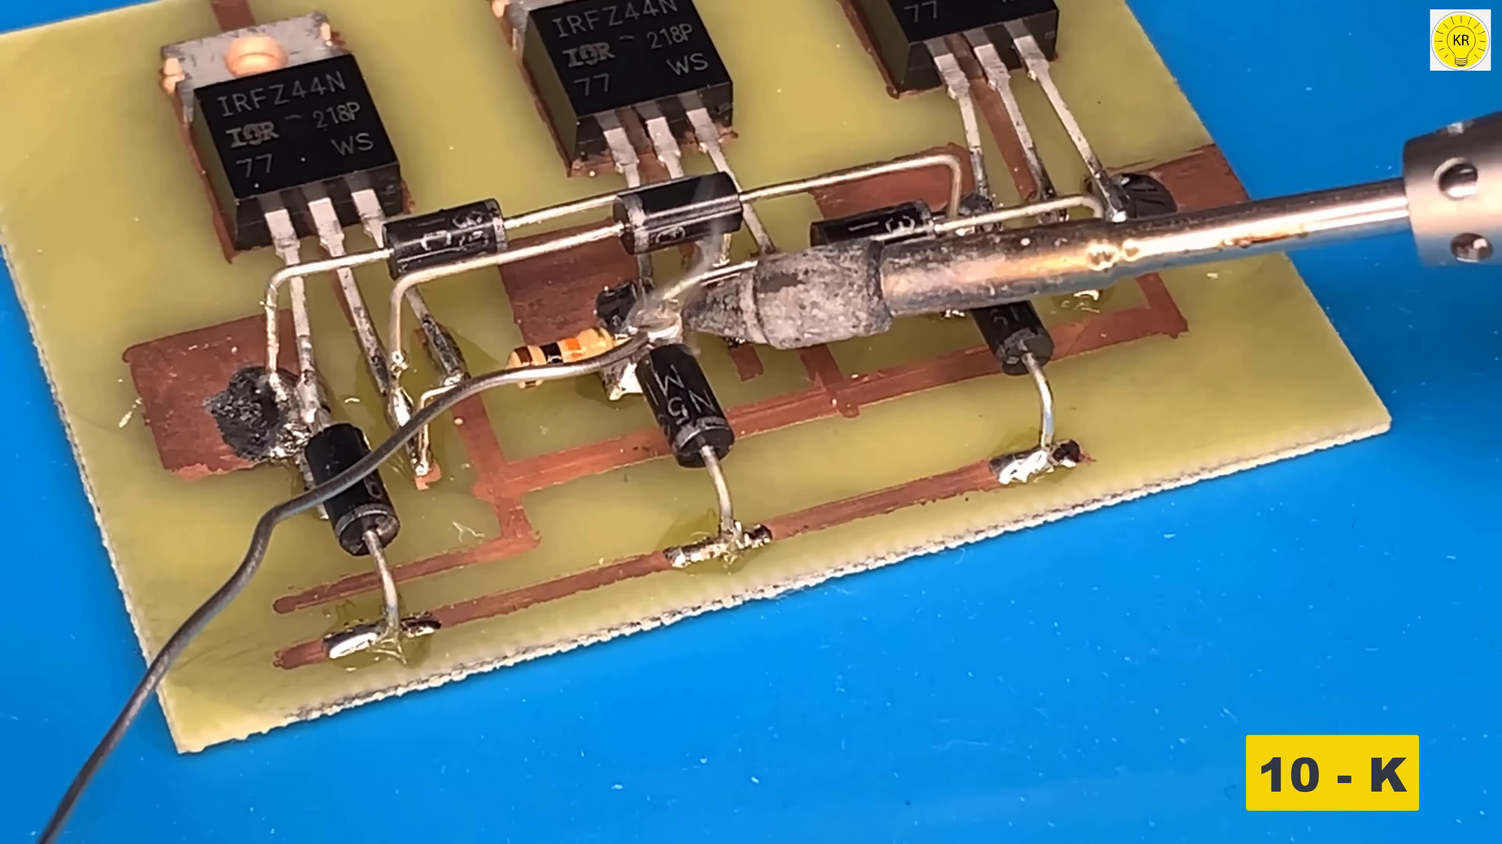 | 
Topic T1: Repeated Answers — score 10.0000
Description: The speaker repeatedly answers a question without providing any new information.
Reason: The comment discusses MOSFET-based projects and chaser lamps, which has no direct relation to the topic of repeated answers. The only overlap is a vague mention of unanswered questions, but it does not explicitly discuss the lack of new information.
Least correlated topics:
 |  | 
Topic T1: Repeated Answers — score 10.0000
Description: The speaker repeatedly answers a question without providing any new information.
Reason: The comment discusses MOSFET-based projects and chaser lamps, which has no direct relation to the topic of repeated answers. The only overlap is a vague mention of unanswered questions, but it does not explicitly discuss the lack of new information.
- matched 0 topic(s), max score 0.0000: He uses a 5k Pot to adjust the speed the three lights will alternate by powering with 12 volts and using three mosfets. Using the three mosfets and the pot to control a cd rom motor was really interesting. The oscilloscope shows how smooth the motor was running and he could even increase the speed to a very high RPM.
Source: https://www.youtube.com/watch?v=lWgYgef-hQ8: How to make 12v chaser lamps circuit , mosfet , irfz 44n
Top correlated topics:
 |  | 
Topic T1: Repeated Answers — score 0.0000
Description: The speaker repeatedly answers a question without providing any new information.
Reason: The topic discusses repeated answers without providing new information, whereas the comment talks about adjusting speed and controlling a motor with no apparent connection to the topic.
Least correlated topics:
 |  | 
Topic T1: Repeated Answers — score 0.0000
Description: The speaker repeatedly answers a question without providing any new information.
Reason: The topic discusses repeated answers without providing new information, whereas the comment talks about adjusting speed and controlling a motor with no apparent connection to the topic.

Topic T1: Repeated Answers
 |  | 
Description: The speaker repeatedly answers a question without providing any new information.
No strongly correlated comments found for this topic.

