Comment–Topic Correlation Report
Model: llama3

Summary
Topics processed: 3
Comments available for this video: 2
Comments correlated to ≥ 60: 0 (0.0%)
Total candidate pairs checked: 6

Most/Least correlated topics (by average score across correlated comments):
Top 3:
• Topic T3: Vulnerability — avg 0.00, contributions 0
• Topic T2: Love and Acceptance — avg 0.00, contributions 0
• Topic T1: Emotional Turmoil — avg 0.00, contributions 0
Bottom 3:
• Topic T1: Emotional Turmoil — avg 0.00, contributions 0
• Topic T2: Love and Acceptance — avg 0.00, contributions 0
• Topic T3: Vulnerability — avg 0.00, contributions 0
Correlated comment coverage (all comments):
- matched 0 topic(s), max score 0.0000: This video is 10:53 minutes long. What I learned from this video – This video demonstrates a circuit which will work as an alternative to the previous circuit. We can test both and decide which circuit produces a better sound. One thing I notice is that we most likely will need a much larger heat sink then we use in class for the MOSFETs. I do not have any questions from this video.
Source: https://www.youtube.com/watch?v=mcAMNsmT6uE&t=1s : How to Subwoofer Bass Amplifier HiFi with TDA2030, New Circuit at home, DIY Subwoofer Bass
Top correlated topics:
 | 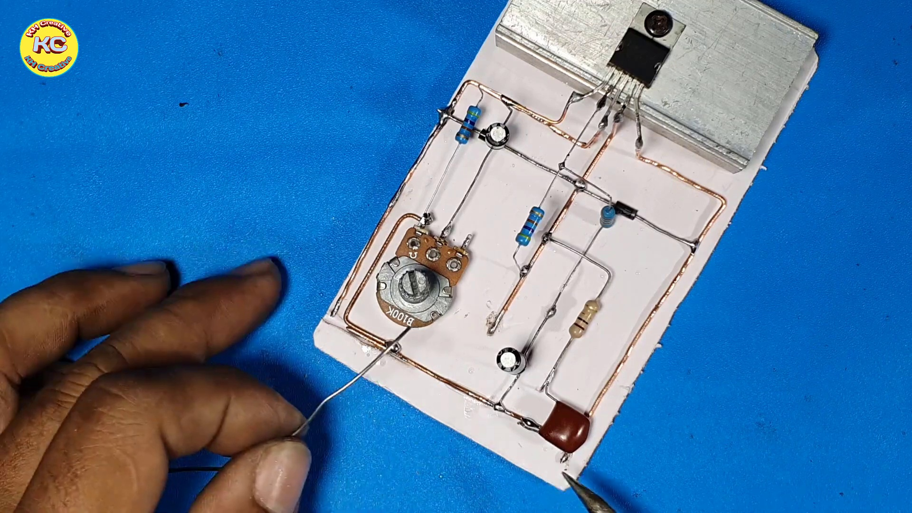 | 
Topic T3: Vulnerability — score 0.0000
Description: The speaker is being open and honest about their emotions, revealing a sense of vulnerability.
Reason: The comment discusses the length of a video and a circuit design, but does not mention emotions, vulnerability, or openness, which are the key concepts described in the topic.
 |  | 
Topic T2: Love and Acceptance — score 0.0000
Description: The speaker is seeking acceptance and love, despite their emotional turmoil.
Reason: The comment discusses a technical circuit and its testing, unrelated to the topic of Love and Acceptance.
 |  | 
Topic T1: Emotional Turmoil — score 0.0000
Description: The speaker is struggling with their emotions, feeling overwhelmed and vulnerable.
Reason: The comment discusses a circuit and MOSFETs, which has no relation to the topic 'Emotional Turmoil' that describes emotional struggles.
Least correlated topics:
 |  | 
Topic T1: Emotional Turmoil — score 0.0000
Description: The speaker is struggling with their emotions, feeling overwhelmed and vulnerable.
Reason: The comment discusses a circuit and MOSFETs, which has no relation to the topic 'Emotional Turmoil' that describes emotional struggles.
 |  | 
Topic T2: Love and Acceptance — score 0.0000
Description: The speaker is seeking acceptance and love, despite their emotional turmoil.
Reason: The comment discusses a technical circuit and its testing, unrelated to the topic of Love and Acceptance.
 |  | 
Topic T3: Vulnerability — score 0.0000
Description: The speaker is being open and honest about their emotions, revealing a sense of vulnerability.
Reason: The comment discusses the length of a video and a circuit design, but does not mention emotions, vulnerability, or openness, which are the key concepts described in the topic.
- matched 0 topic(s), max score 0.0000: This video demonstrated a third way to construct a speaker circuit using the TDA 2030 amplifier chip. The circuit constructed in this video was more complex than the two previous videos. This circuit consisted of more components and more branches to the circuit and the inclusion of multiple IN4007 diodes. This circuit layout produced high-quality sound and demonstrated another way to make a circuit with the TDA 2030 that produces high-quality sound. One point of confusion I have after watching this video is that I do not believe the guy who made this video provided a clear shot of how he wired the input jack and speaker into the circuit as the video went from the circuit before those two things were incorporated to the testing of the speaker.
Source: https://www.youtube.com/watch?v=mcAMNsmT6uE : How to Subwoofer Bass Amplifier HiFi with TDA2030, New Circuit at home, DIY Subwoofer Bass
Top correlated topics:
 |  | 
Topic T3: Vulnerability — score 0.0000
Description: The speaker is being open and honest about their emotions, revealing a sense of vulnerability.
Reason: The topic is about vulnerability in a human sense (emotional openness), while the comment is about electronics and circuit design. There are no overlaps between the two.
 |  | 
Topic T2: Love and Acceptance — score 0.0000
Description: The speaker is seeking acceptance and love, despite their emotional turmoil.
Reason: The comment discusses electronics and circuit design, while the topic is about love and acceptance. There are no overlaps in terms of concepts or ideas between the two.
 |  | 
Topic T1: Emotional Turmoil — score 0.0000
Description: The speaker is struggling with their emotions, feeling overwhelmed and vulnerable.
Reason: The topic 'Emotional Turmoil' is unrelated to a video about electronics and amplifier chips, as the comment does not discuss emotions or turmoil.
Least correlated topics:
 |  | 
Topic T1: Emotional Turmoil — score 0.0000
Description: The speaker is struggling with their emotions, feeling overwhelmed and vulnerable.
Reason: The topic 'Emotional Turmoil' is unrelated to a video about electronics and amplifier chips, as the comment does not discuss emotions or turmoil.
 |  | 
Topic T2: Love and Acceptance — score 0.0000
Description: The speaker is seeking acceptance and love, despite their emotional turmoil.
Reason: The comment discusses electronics and circuit design, while the topic is about love and acceptance. There are no overlaps in terms of concepts or ideas between the two.
 |  | 
Topic T3: Vulnerability — score 0.0000
Description: The speaker is being open and honest about their emotions, revealing a sense of vulnerability.
Reason: The topic is about vulnerability in a human sense (emotional openness), while the comment is about electronics and circuit design. There are no overlaps between the two.

Topic T1: Emotional Turmoil
 |  | 
Description: The speaker is struggling with their emotions, feeling overwhelmed and vulnerable.
No strongly correlated comments found for this topic.

Topic T2: Love and Acceptance
 |  | 
Description: The speaker is seeking acceptance and love, despite their emotional turmoil.
No strongly correlated comments found for this topic.

Topic T3: Vulnerability
 |  | 
Description: The speaker is being open and honest about their emotions, revealing a sense of vulnerability.
No strongly correlated comments found for this topic.

