Comment–Topic Correlation Report
Model: llama3

Summary
Topics processed: 3
Comments available for this video: 1
Comments correlated to ≥ 60: 0 (0.0%)
Total candidate pairs checked: 3

Most/Least correlated topics (by average score across correlated comments):
Top 3:
• Topic T3: Value of Following Service — avg 0.00, contributions 0
• Topic T2: Residential Food Style — avg 0.00, contributions 0
• Topic T1: Accessing Kaikkiou Service — avg 0.00, contributions 0
Bottom 3:
• Topic T1: Accessing Kaikkiou Service — avg 0.00, contributions 0
• Topic T2: Residential Food Style — avg 0.00, contributions 0
• Topic T3: Value of Following Service — avg 0.00, contributions 0
Correlated comment coverage (all comments):
- matched 0 topic(s), max score 0.0000: This video was helpful because I did not know that transistors can be used to increase the bass of a speaker. Also, it was not hard to build it, I hope I watched the video before finalizing our speaker project to implement transistors to get a better bass.
Source: https://www.youtube.com/watch?v=muGlauyfOGsT: How to make Ultra Bass Powerful Amplifier with Transistor, DIY Simple Amplifier at home
Top correlated topics:
 | 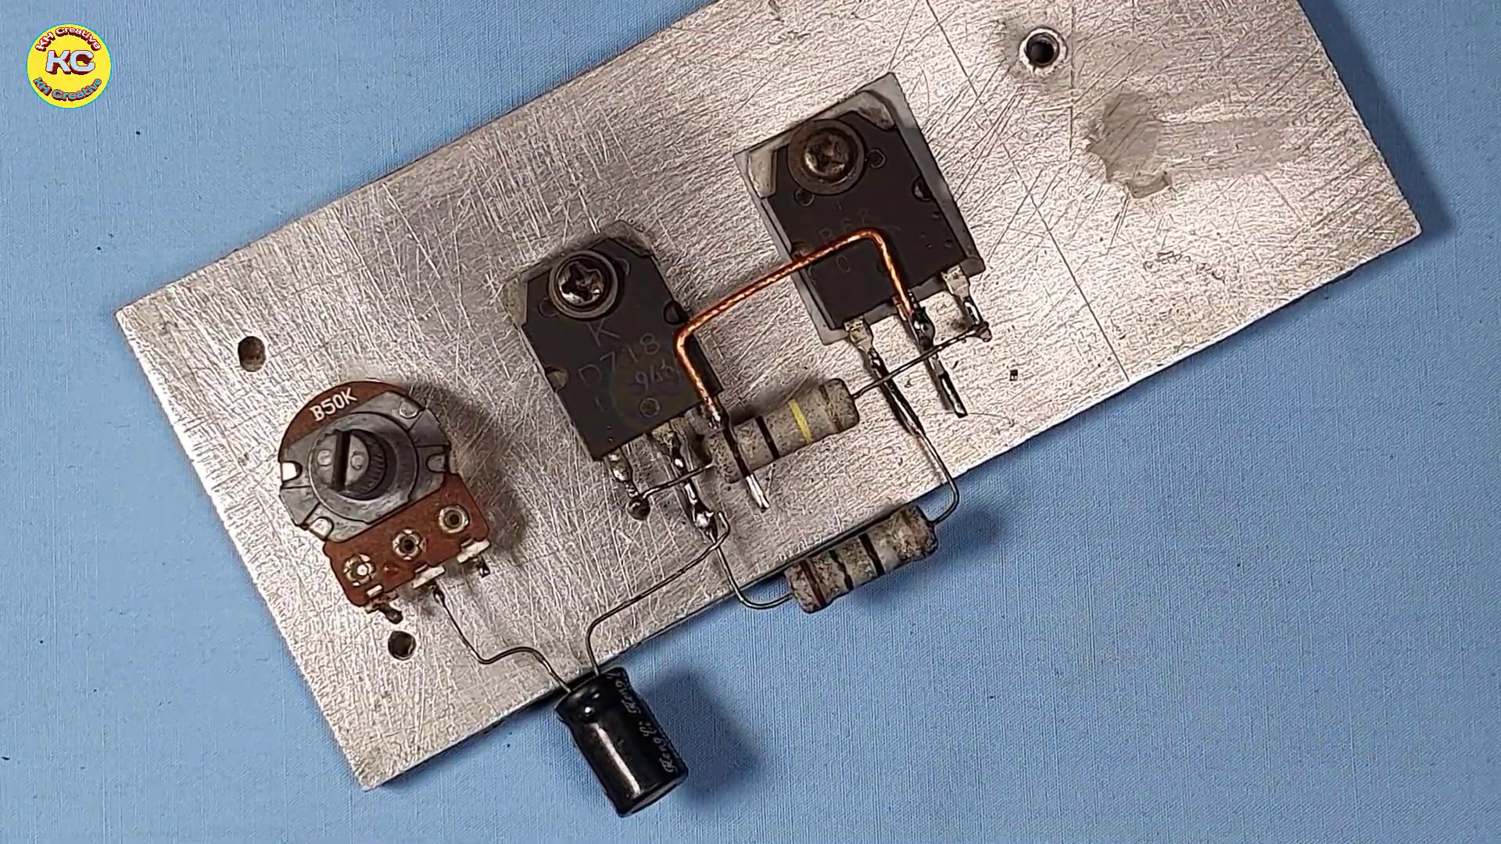 | 
Topic T3: Value of Following Service — score 20.0000
Description: The speaker highlights the value of following the яжity service.
Reason: The topic discusses the value of following a service, whereas the comment talks about building a speaker with transistors to improve bass, which is not directly related to the topic's claims or goals.
 |  | 
Topic T2: Residential Food Style — score 0.0000
Description: The speaker mentions enjoying residential food style.
Reason: The comment discusses speaker building and transistors, while the topic is about residential food style, which has no connection to electronics or hardware.
 |  | 
Topic T1: Accessing Kaikkiou Service — score 0.0000
Description: The speaker describes how to access the kaikkiou service.
Reason: The comment does not mention Kaikkiou Service or its access at all. It discusses transistors and speaker project, which are unrelated to the topic.
Least correlated topics:
 |  | 
Topic T1: Accessing Kaikkiou Service — score 0.0000
Description: The speaker describes how to access the kaikkiou service.
Reason: The comment does not mention Kaikkiou Service or its access at all. It discusses transistors and speaker project, which are unrelated to the topic.
 |  | 
Topic T2: Residential Food Style — score 0.0000
Description: The speaker mentions enjoying residential food style.
Reason: The comment discusses speaker building and transistors, while the topic is about residential food style, which has no connection to electronics or hardware.
 |  | 
Topic T3: Value of Following Service — score 20.0000
Description: The speaker highlights the value of following the яжity service.
Reason: The topic discusses the value of following a service, whereas the comment talks about building a speaker with transistors to improve bass, which is not directly related to the topic's claims or goals.

Topic T1: Accessing Kaikkiou Service
 |  | 
Description: The speaker describes how to access the kaikkiou service.
No strongly correlated comments found for this topic.

Topic T2: Residential Food Style
 |  | 
Description: The speaker mentions enjoying residential food style.
No strongly correlated comments found for this topic.

Topic T3: Value of Following Service
 |  | 
Description: The speaker highlights the value of following the яжity service.
No strongly correlated comments found for this topic.

