Comment–Topic Correlation Report
Model: llama3

Summary
Topics processed: 1
Comments available for this video: 3
Comments correlated to ≥ 60: 0 (0.0%)
Total candidate pairs checked: 3

Most/Least correlated topics (by average score across correlated comments):
Top 3:
• Topic T1: Music — avg 0.00, contributions 0
Bottom 3:
• Topic T1: Music — avg 0.00, contributions 0
Correlated comment coverage (all comments):
- matched 0 topic(s), max score 0.0000: Utilizing some diodes and a bc 547 transistor to create a tester for the correct direction of voltage use on other components. I think this is one that I will make myself to use, this is very useful, and makes finding the direction so quick. I guess I could just use a multimeter since it is mostly a basic continuity tester, but very cool way to build with minimum components.
Source: https://www.youtube.com/watch?v=nxMkX0wtLm4: Make all component Tester using BC547, Make a universal any components
Top correlated topics:
 | 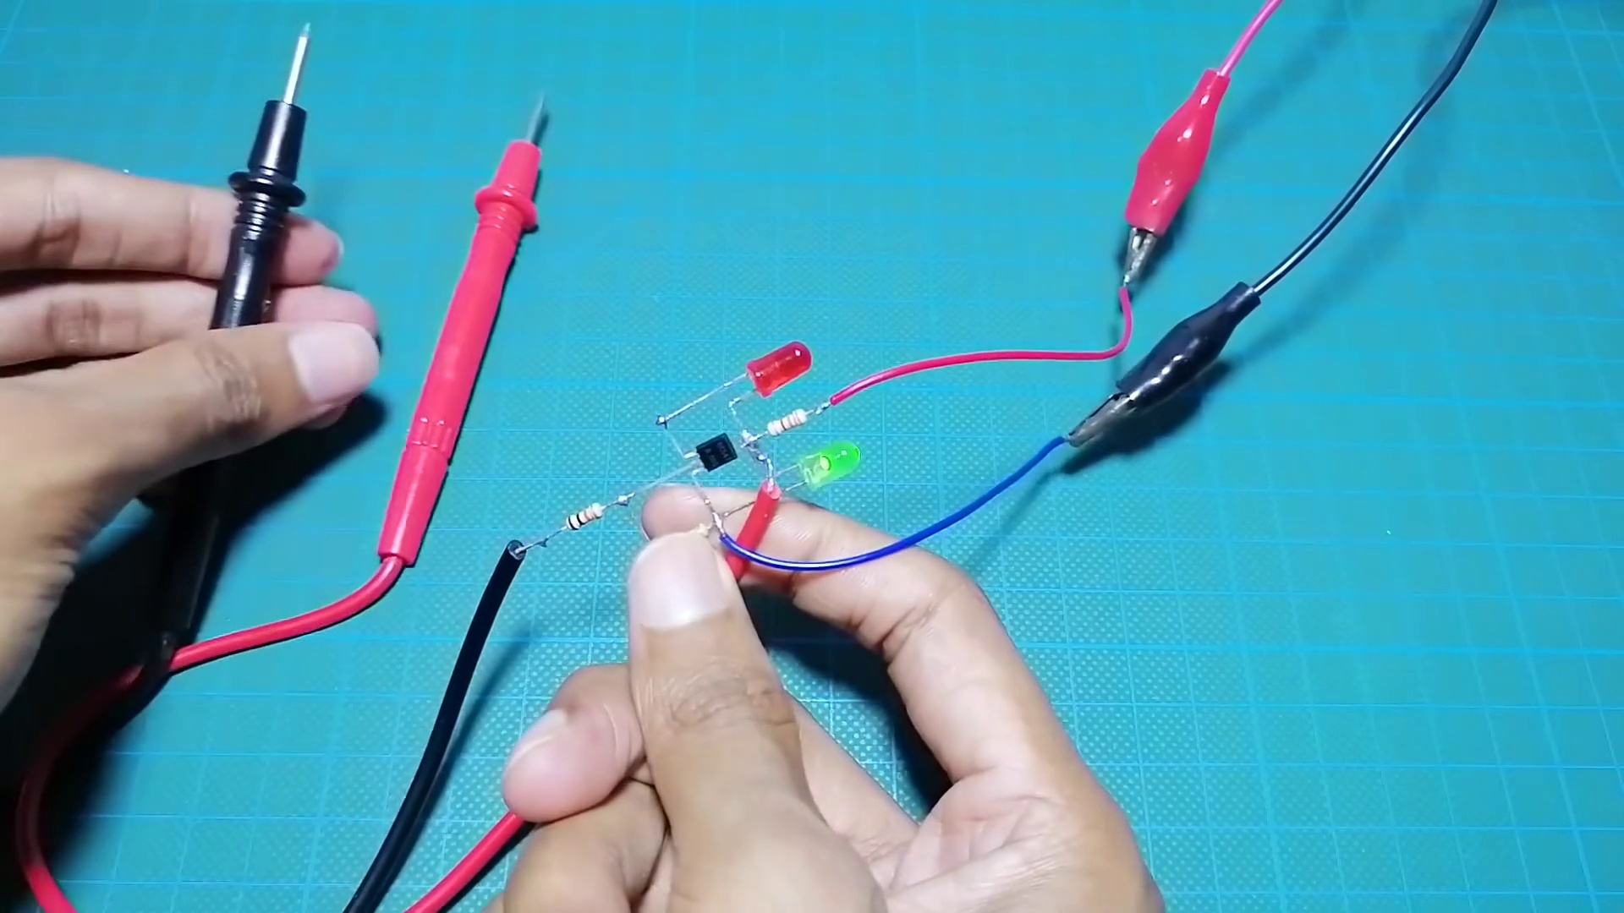 | 
Topic T1: Music — score 0.0000
Description: The speaker talks about music.
Reason: The comment is about building an electronic tester using diodes and a transistor to determine the correct direction of voltage use on components. This has no relation to music, which was described in the topic.
Least correlated topics:
 |  | 
Topic T1: Music — score 0.0000
Description: The speaker talks about music.
Reason: The comment is about building an electronic tester using diodes and a transistor to determine the correct direction of voltage use on components. This has no relation to music, which was described in the topic.
- matched 0 topic(s), max score 0.0000: This was helpful in understanding the basic components of a circuit and how a simple tool made from using chip BC547 and some LED lights with resistor, buzzer and multimeter probe can help measure pretty much every circuit element. We didn’t get a chance to make or use it but this was really helpful in better understanding the circuit elements.
Source: https://www.youtube.com/watch?v=nxMkX0wtLm4&t=53s: Make all component tester using BC547.
Top correlated topics:
 |  | 
Topic T1: Music — score 0.0000
Description: The speaker talks about music.
Reason: The comment discusses electronics and circuit components, but does not mention music at all.
Least correlated topics:
 |  | 
Topic T1: Music — score 0.0000
Description: The speaker talks about music.
Reason: The comment discusses electronics and circuit components, but does not mention music at all.
- matched 0 topic(s), max score 0.0000: In this video we learn how to make a component tester using basic circuit elements. The components need to make the tester are BC547, three resistors, one red LED light, one green LED light, a 12-volt power supply, and a multimeter. You connect the LED lights to the resistors and the BC547. After making the connections as shown in the video you can connect the circuit to the multimeter and the power supply. This circuit works to test if different circuit components are good to use. The way the circuit work is that when you are testing a broken item using the multimeter probes the LED lights turn red. In the other hand when an item is good to use it tuns green making it easy to identify bad circuit elements.
Source: https://www.youtube.com/watch?v=nxMkX0wtLm4&t=18s: Make all component Tester using BC547, Make a universal any components tester.
Top correlated topics:
 |  | 
Topic T1: Music — score 0.0000
Description: The speaker talks about music.
Reason: The comment discusses building a component tester using electronics components and does not mention music at all.
Least correlated topics:
 |  | 
Topic T1: Music — score 0.0000
Description: The speaker talks about music.
Reason: The comment discusses building a component tester using electronics components and does not mention music at all.

Topic T1: Music
 |  | 
Description: The speaker talks about music.
No strongly correlated comments found for this topic.

