Comment–Topic Correlation Report
Model: llama3

Summary
Topics processed: 7
Comments available for this video: 1
Comments correlated to ≥ 60: 1 (100.0%)
Total candidate pairs checked: 7

Most/Least correlated topics (by average score across correlated comments):
Top 3:
• Topic T6: Using I2S with Amplifier and MicroSD Card — avg 80.00, contributions 1
• Topic T5: Understanding I2S Communication Interface — avg 80.00, contributions 1
• Topic T1: Introduction to I2S — avg 80.00, contributions 1
Bottom 3:
• Topic T7: Conclusion and Next Steps — avg 0.00, contributions 0
• Topic T3: Initializing and Starting I2S Communication — avg 0.00, contributions 0
• Topic T4: Receiving Audio Data from Microphone — avg 0.00, contributions 0
Correlated comment coverage (all comments):
- matched 4 topic(s), max score 80.0000: This video provides an in-depth explanation of building a music player and pin connections for the I2S protocol.The information density was high and overwhelming, so it may require multiple viewings.This offers another approach to building audio systems like our class project.
Source: https://www.youtube.com/watch?v=qNLvoSQCx60: Building a Digital Music Player with I2S?! What is I2S! EB#45
Top correlated topics:
 | 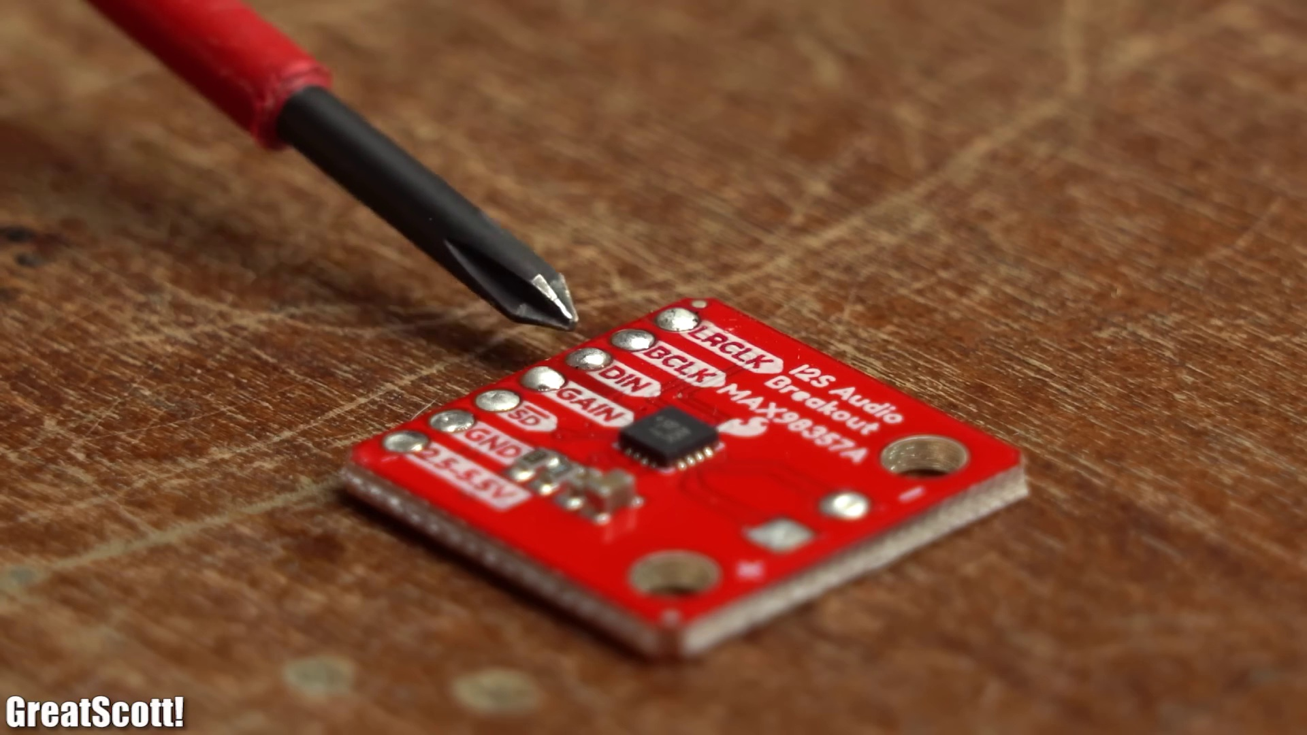 | 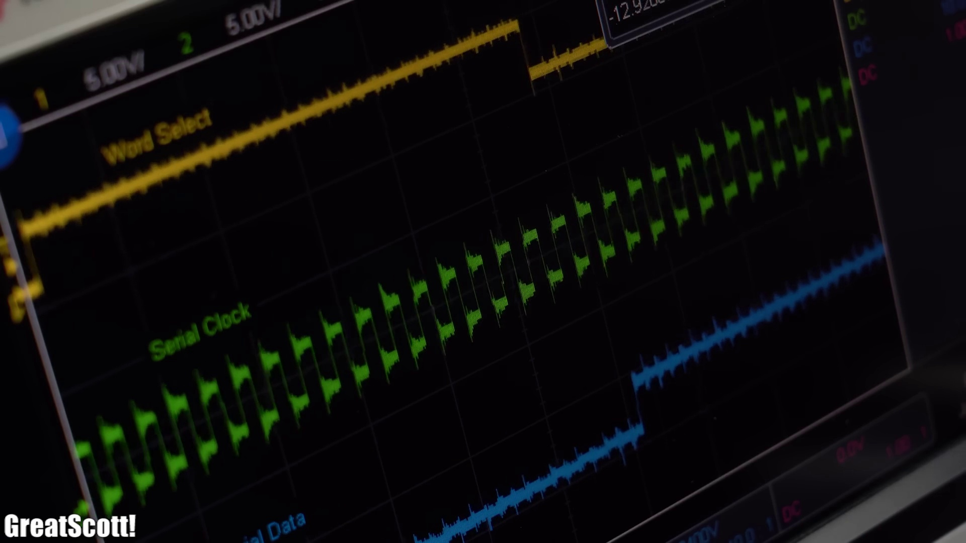
Topic T6: Using I2S with Amplifier and MicroSD Card — score 80.0000
Description: Demonstration of using I2S with an amplifier and microSD card to play audio.
Reason: The comment directly discusses the same steps and protocol (I2S) described by the topic, as well as pin connections and building a music player, which are all relevant to the topic of using I2S with an amplifier and microSD card.
 |  | 
Topic T5: Understanding I2S Communication Interface — score 80.0000
Description: Explanation of the I2S communication interface and its frequency adjustment.
Reason: The comment discusses the I2S protocol and its application in building a music player, which directly relates to the topic's description of understanding the I2S communication interface.
 |  | 
Topic T2: I2S Peripherals on ESP32 — score 80.0000
Description: Exploration of the ESP32's I2S peripherals and pin selection.
Reason: The comment directly discusses I2S protocol pin connections and building a music player, which are specific steps described in the topic. The mention of class project also suggests a direct application of the ESP32's I2S peripherals, matching the topic description.
 |  | 
Topic T1: Introduction to I2S — score 80.0000
Description: Overview of I2S and its applications.
Reason: The comment directly discusses the same topic (I2S protocol) and mentions building a music player, which is related to the 'applications' mentioned in the topic description.
 |  | 
Topic T7: Conclusion and Next Steps — score 20.0000
Description: Summary of the video's content and suggestions for further learning.
Reason: The comment discusses a specific video about building a music player and I2S protocol, whereas the topic is general and abstract, focusing on conclusion and next steps. The comment does not directly discuss the same steps, objects, settings, parameters, claims, or goals described by the topic.
 |  | 
Topic T4: Receiving Audio Data from Microphone — score 20.0000
Description: Demonstration of receiving audio data from a microphone using I2S.
Reason: The topic is about receiving audio data from a microphone using I2S, while the comment discusses building a music player and pin connections for I2S protocol. Although both mention I2S, they are not directly related as the topic focuses on receiving audio data whereas the comment is about building an audio system. The overlap is low.
 |  | 
Topic T3: Initializing and Starting I2S Communication — score 20.0000
Description: Setting up and initializing I2S communication on the ESP32.
Reason: The comment does not directly discuss the steps or settings for initializing and starting I2S communication on the ESP32, but rather mentions it as a part of building a music player. The topic is indirectly related to the project described in the video.
Least correlated topics:
 |  | 
Topic T3: Initializing and Starting I2S Communication — score 20.0000
Description: Setting up and initializing I2S communication on the ESP32.
Reason: The comment does not directly discuss the steps or settings for initializing and starting I2S communication on the ESP32, but rather mentions it as a part of building a music player. The topic is indirectly related to the project described in the video.
 |  | 
Topic T4: Receiving Audio Data from Microphone — score 20.0000
Description: Demonstration of receiving audio data from a microphone using I2S.
Reason: The topic is about receiving audio data from a microphone using I2S, while the comment discusses building a music player and pin connections for I2S protocol. Although both mention I2S, they are not directly related as the topic focuses on receiving audio data whereas the comment is about building an audio system. The overlap is low.
 |  | 
Topic T7: Conclusion and Next Steps — score 20.0000
Description: Summary of the video's content and suggestions for further learning.
Reason: The comment discusses a specific video about building a music player and I2S protocol, whereas the topic is general and abstract, focusing on conclusion and next steps. The comment does not directly discuss the same steps, objects, settings, parameters, claims, or goals described by the topic.
 |  | 
Topic T1: Introduction to I2S — score 80.0000
Description: Overview of I2S and its applications.
Reason: The comment directly discusses the same topic (I2S protocol) and mentions building a music player, which is related to the 'applications' mentioned in the topic description.
 |  | 
Topic T2: I2S Peripherals on ESP32 — score 80.0000
Description: Exploration of the ESP32's I2S peripherals and pin selection.
Reason: The comment directly discusses I2S protocol pin connections and building a music player, which are specific steps described in the topic. The mention of class project also suggests a direct application of the ESP32's I2S peripherals, matching the topic description.
 |  | 
Topic T5: Understanding I2S Communication Interface — score 80.0000
Description: Explanation of the I2S communication interface and its frequency adjustment.
Reason: The comment discusses the I2S protocol and its application in building a music player, which directly relates to the topic's description of understanding the I2S communication interface.
 |  | 
Topic T6: Using I2S with Amplifier and MicroSD Card — score 80.0000
Description: Demonstration of using I2S with an amplifier and microSD card to play audio.
Reason: The comment directly discusses the same steps and protocol (I2S) described by the topic, as well as pin connections and building a music player, which are all relevant to the topic of using I2S with an amplifier and microSD card.

Topic T1: Introduction to I2S
 |  | 
Description: Overview of I2S and its applications.
Comment (score 80): This video provides an in-depth explanation of building a music player and pin connections for the I2S protocol.The information density was high and overwhelming, so it may require multiple viewings.This offers another approach to building audio systems like our class project.
Reason: The comment directly discusses the same topic (I2S protocol) and mentions building a music player, which is related to the 'applications' mentioned in the topic description.
Source: https://www.youtube.com/watch?v=qNLvoSQCx60: Building a Digital Music Player with I2S?! What is I2S! EB#45

Topic T2: I2S Peripherals on ESP32
 |  | 
Description: Exploration of the ESP32's I2S peripherals and pin selection.
Comment (score 80): This video provides an in-depth explanation of building a music player and pin connections for the I2S protocol.The information density was high and overwhelming, so it may require multiple viewings.This offers another approach to building audio systems like our class project.
Reason: The comment directly discusses I2S protocol pin connections and building a music player, which are specific steps described in the topic. The mention of class project also suggests a direct application of the ESP32's I2S peripherals, matching the topic description.
Source: https://www.youtube.com/watch?v=qNLvoSQCx60: Building a Digital Music Player with I2S?! What is I2S! EB#45

Topic T3: Initializing and Starting I2S Communication
 |  | 
Description: Setting up and initializing I2S communication on the ESP32.
No strongly correlated comments found for this topic.

Topic T4: Receiving Audio Data from Microphone
 |  | 
Description: Demonstration of receiving audio data from a microphone using I2S.
No strongly correlated comments found for this topic.

Topic T5: Understanding I2S Communication Interface
 |  | 
Description: Explanation of the I2S communication interface and its frequency adjustment.
Comment (score 80): This video provides an in-depth explanation of building a music player and pin connections for the I2S protocol.The information density was high and overwhelming, so it may require multiple viewings.This offers another approach to building audio systems like our class project.
Reason: The comment discusses the I2S protocol and its application in building a music player, which directly relates to the topic's description of understanding the I2S communication interface.
Source: https://www.youtube.com/watch?v=qNLvoSQCx60: Building a Digital Music Player with I2S?! What is I2S! EB#45

Topic T6: Using I2S with Amplifier and MicroSD Card
 |  | 
Description: Demonstration of using I2S with an amplifier and microSD card to play audio.
Comment (score 80): This video provides an in-depth explanation of building a music player and pin connections for the I2S protocol.The information density was high and overwhelming, so it may require multiple viewings.This offers another approach to building audio systems like our class project.
Reason: The comment directly discusses the same steps and protocol (I2S) described by the topic, as well as pin connections and building a music player, which are all relevant to the topic of using I2S with an amplifier and microSD card.
Source: https://www.youtube.com/watch?v=qNLvoSQCx60: Building a Digital Music Player with I2S?! What is I2S! EB#45

Topic T7: Conclusion and Next Steps
 |  | 
Description: Summary of the video's content and suggestions for further learning.
No strongly correlated comments found for this topic.

