Comment–Topic Correlation Report
Model: llama3

Summary
Topics processed: 6
Comments available for this video: 1
Comments correlated to ≥ 60: 1 (100.0%)
Total candidate pairs checked: 6

Most/Least correlated topics (by average score across correlated comments):
Top 3:
• Topic T2: Pads and Connectors — avg 80.00, contributions 1
• Topic T1: Introduction — avg 80.00, contributions 1
• Topic T4: ESC Telemetry and Motors — avg 80.00, contributions 1
Bottom 3:
• Topic T5: Buzzer and LED Connections — avg 0.00, contributions 0
• Topic T6: Conclusion — avg 0.00, contributions 0
• Topic T3: Video Transmitter Powering — avg 0.00, contributions 0
Correlated comment coverage (all comments):
- matched 3 topic(s), max score 80.0000: I thought it was really cool that the board comes ready to input possibly 2 other motors using the E5 and E6 pin out holes.
Source: https://www.youtube.com/watch?v=r0kBl1__VEQ: First T-Motor F7 Stack // First Hand Look & Setup Guide
Top correlated topics:
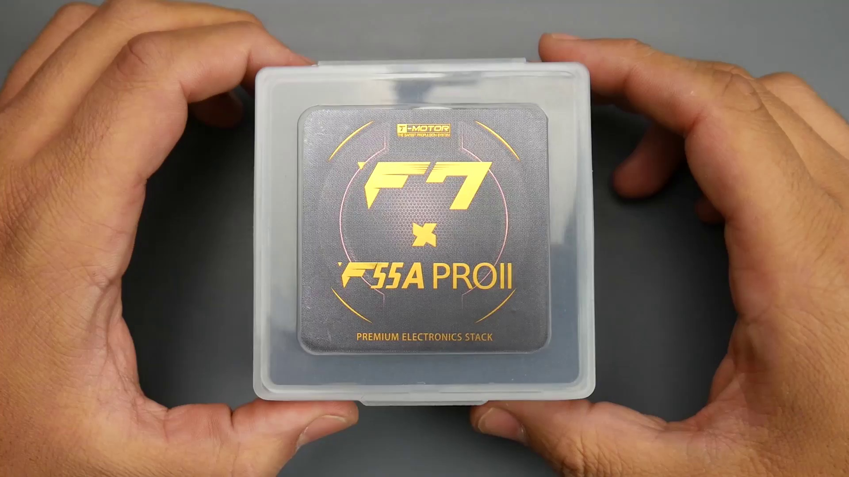 | 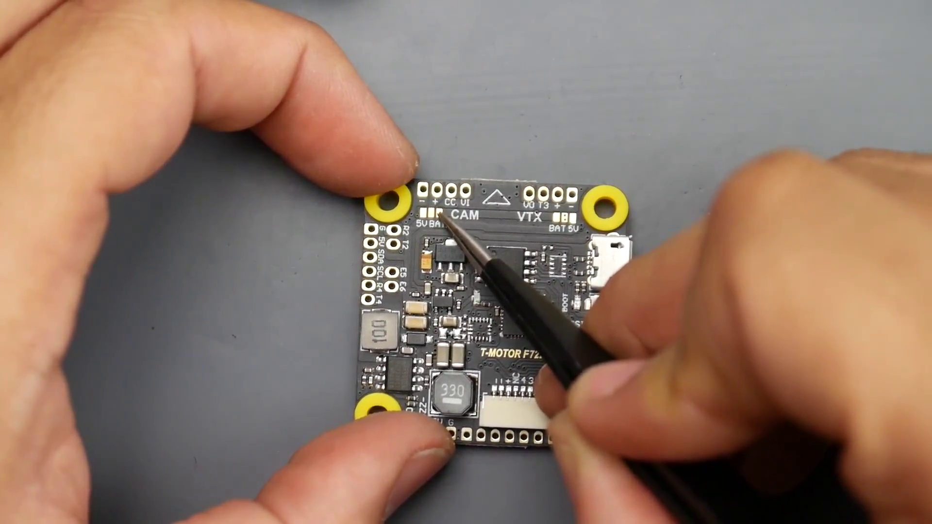 | 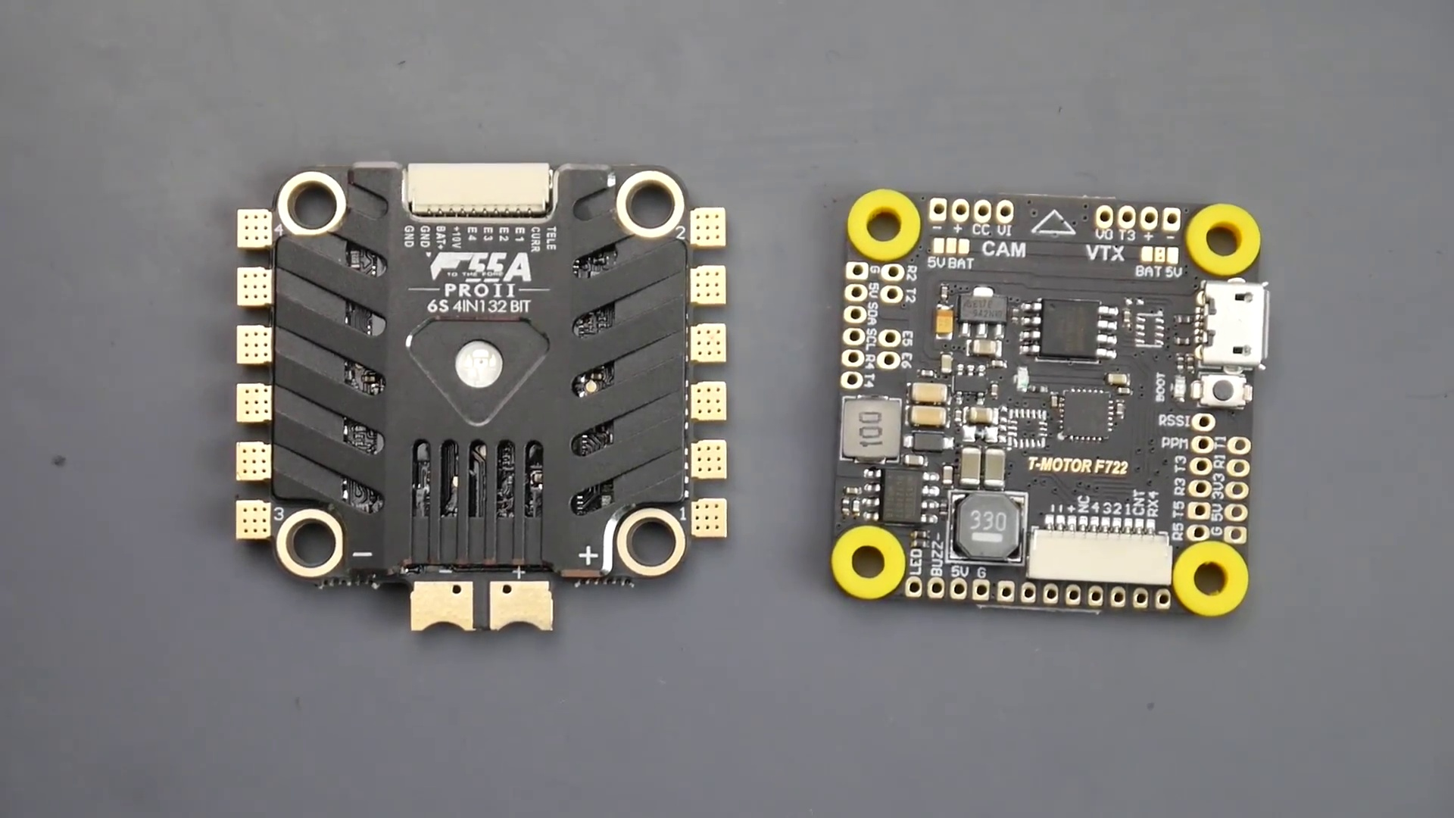
Topic T4: ESC Telemetry and Motors — score 80.0000
Description: Explaining ESC telemetry and motor connections
Reason: The comment mentions specific pins (E5 and E6) related to motor connections, which overlaps with the topic's description of ESC telemetry and motor connections.
 |  | 
Topic T2: Pads and Connectors — score 80.0000
Description: Explaining the different pads and connectors on the board
Reason: The comment mentions specific pads (E5 and E6 pin out holes) which are directly related to the topic's description of different pads and connectors on the board.
 |  | 
Topic T1: Introduction — score 80.0000
Description: Welcome to the video about [topic]
Reason: The comment directly discusses the use of specific pins (E5 and E6) which is mentioned in the topic description ('Welcome to the video about [topic]') as a possible input method for other motors.
 |  | 
Topic T6: Conclusion — score 20.0000
Description: Wrapping up the video with some final thoughts
Reason: The comment discusses the board's capabilities and motor inputs, but does not directly discuss the topic of 'Conclusion' or final thoughts. The overlap is limited to the fact that it is a video-related comment, but the specific topics do not strongly relate.
 |  | 
Topic T5: Buzzer and LED Connections — score 20.0000
Description: Describing how to connect buzzers and LEDs
Reason: The comment mentions a different topic (motors and pin out holes) and does not discuss the connection of buzzers and LEDs as described in the topic.
 |  | 
Topic T3: Video Transmitter Powering — score 20.0000
Description: Discussing the options for powering the video transmitter
Reason: The comment mentions motor input, which is not directly related to powering the video transmitter. The topic discusses powering options, while the comment talks about motor connections.
Least correlated topics:
 |  | 
Topic T3: Video Transmitter Powering — score 20.0000
Description: Discussing the options for powering the video transmitter
Reason: The comment mentions motor input, which is not directly related to powering the video transmitter. The topic discusses powering options, while the comment talks about motor connections.
 |  | 
Topic T5: Buzzer and LED Connections — score 20.0000
Description: Describing how to connect buzzers and LEDs
Reason: The comment mentions a different topic (motors and pin out holes) and does not discuss the connection of buzzers and LEDs as described in the topic.
 |  | 
Topic T6: Conclusion — score 20.0000
Description: Wrapping up the video with some final thoughts
Reason: The comment discusses the board's capabilities and motor inputs, but does not directly discuss the topic of 'Conclusion' or final thoughts. The overlap is limited to the fact that it is a video-related comment, but the specific topics do not strongly relate.
 |  | 
Topic T1: Introduction — score 80.0000
Description: Welcome to the video about [topic]
Reason: The comment directly discusses the use of specific pins (E5 and E6) which is mentioned in the topic description ('Welcome to the video about [topic]') as a possible input method for other motors.
 |  | 
Topic T2: Pads and Connectors — score 80.0000
Description: Explaining the different pads and connectors on the board
Reason: The comment mentions specific pads (E5 and E6 pin out holes) which are directly related to the topic's description of different pads and connectors on the board.
 |  | 
Topic T4: ESC Telemetry and Motors — score 80.0000
Description: Explaining ESC telemetry and motor connections
Reason: The comment mentions specific pins (E5 and E6) related to motor connections, which overlaps with the topic's description of ESC telemetry and motor connections.

Topic T1: Introduction
 |  | 
Description: Welcome to the video about [topic]
Comment (score 80): I thought it was really cool that the board comes ready to input possibly 2 other motors using the E5 and E6 pin out holes.
Reason: The comment directly discusses the use of specific pins (E5 and E6) which is mentioned in the topic description ('Welcome to the video about [topic]') as a possible input method for other motors.
Source: https://www.youtube.com/watch?v=r0kBl1__VEQ: First T-Motor F7 Stack // First Hand Look & Setup Guide

Topic T2: Pads and Connectors
 |  | 
Description: Explaining the different pads and connectors on the board
Comment (score 80): I thought it was really cool that the board comes ready to input possibly 2 other motors using the E5 and E6 pin out holes.
Reason: The comment mentions specific pads (E5 and E6 pin out holes) which are directly related to the topic's description of different pads and connectors on the board.
Source: https://www.youtube.com/watch?v=r0kBl1__VEQ: First T-Motor F7 Stack // First Hand Look & Setup Guide

Topic T3: Video Transmitter Powering
 |  | 
Description: Discussing the options for powering the video transmitter
No strongly correlated comments found for this topic.

Topic T4: ESC Telemetry and Motors
 |  | 
Description: Explaining ESC telemetry and motor connections
Comment (score 80): I thought it was really cool that the board comes ready to input possibly 2 other motors using the E5 and E6 pin out holes.
Reason: The comment mentions specific pins (E5 and E6) related to motor connections, which overlaps with the topic's description of ESC telemetry and motor connections.
Source: https://www.youtube.com/watch?v=r0kBl1__VEQ: First T-Motor F7 Stack // First Hand Look & Setup Guide

Topic T5: Buzzer and LED Connections
 |  | 
Description: Describing how to connect buzzers and LEDs
No strongly correlated comments found for this topic.

Topic T6: Conclusion
 |  | 
Description: Wrapping up the video with some final thoughts
No strongly correlated comments found for this topic.

