Comment–Topic Correlation Report
Model: llama3

Summary
Topics processed: 8
Comments available for this video: 1
Comments correlated to ≥ 60: 0 (0.0%)
Total candidate pairs checked: 8

Most/Least correlated topics (by average score across correlated comments):
Top 3:
• Topic T4: Wake Word Detection — avg 0.00, contributions 0
• Topic T7: Testing and Results — avg 0.00, contributions 0
• Topic T3: Software Overview — avg 0.00, contributions 0
Bottom 3:
• Topic T5: Command Recognition — avg 0.00, contributions 0
• Topic T8: Conclusion — avg 0.00, contributions 0
• Topic T2: Hardware Requirements — avg 0.00, contributions 0
Correlated comment coverage (all comments):
- matched 0 topic(s), max score 0.0000: It’s possible to build a smart voice assistant using open-source code and affordable parts, which makes it educational and cost-effective.Exporting the code from GitHub and setting it up was tricky.This is a practical and fun engineering project that could be used daily.
Source: https://www.youtube.com/watch?v=re-dSV_a0tM: DIY Alexa: Create Your Own Voice Assistant with ESP32 & TensorFlow Lite!
Top correlated topics:
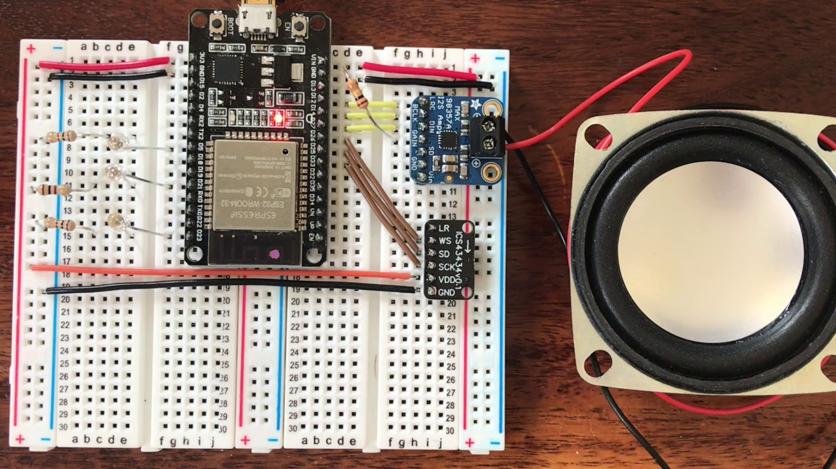 | 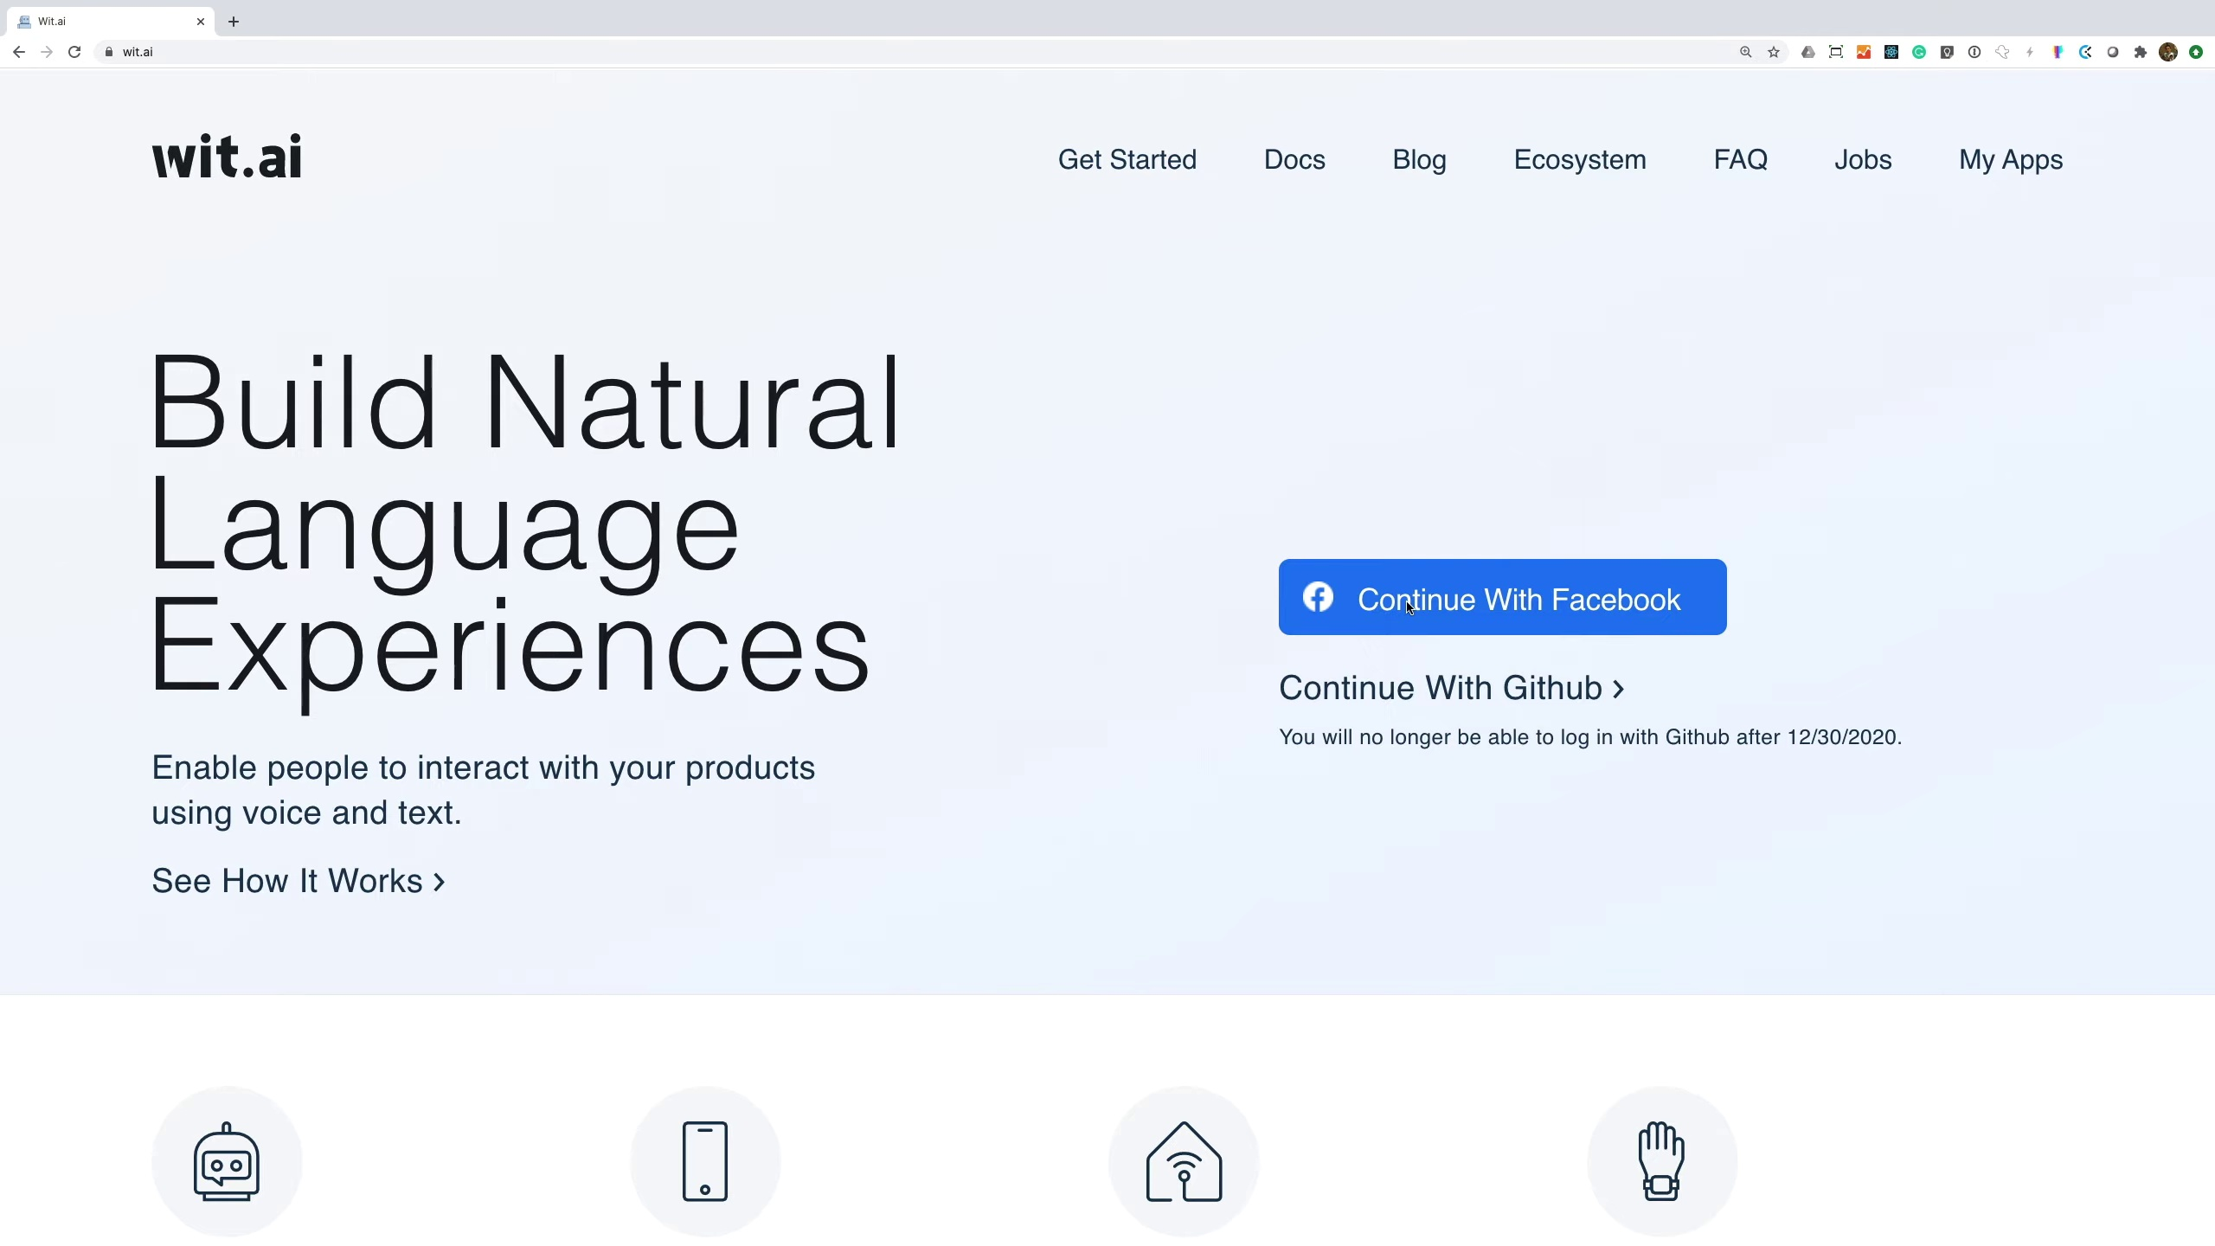 | 
Topic T8: Conclusion — score 20.0000
Description: A summary of the project and its potential applications.
Reason: The comment discusses the possibility of building a smart voice assistant and shares personal experiences with setting it up, but does not directly discuss the project's conclusion or potential applications as described in the topic.
 |  | 
Topic T7: Testing and Results — score 20.0000
Description: The results of testing the DIY Alexa device and its limitations.
Reason: The topic discusses testing and results of a DIY Alexa device, whereas the comment mentions building a smart voice assistant using open-source code and affordable parts. Although both mention DIY projects, they are not directly related to each other.
 |  | 
Topic T6: Intent Processing — score 20.0000
Description: How the DIY Alexa device processes user intents and carries out actions.
Reason: The comment does not directly discuss intent processing or user intents, but rather mentions building a smart voice assistant and setting up code from GitHub. Although the topic is related to AI and engineering, the comment's focus on practicality and cost-effectiveness does not overlap with the specific concept of intent processing.
 |  | 
Topic T5: Command Recognition — score 20.0000
Description: How the DIY Alexa device recognizes and interprets user commands using Wit.ai API.
Reason: The comment does not directly discuss command recognition or Wit.ai API, but rather mentions building a smart voice assistant and using GitHub code. The topic is about how Alexa recognizes commands, whereas the comment focuses on a broader project idea.
 |  | 
Topic T4: Wake Word Detection — score 20.0000
Description: How the DIY Alexa device detects the wake word using a neural network.
Reason: The comment does not directly discuss wake word detection or neural networks, instead focusing on building a smart voice assistant and the educational/cost-effective aspects of the project.
 |  | 
Topic T3: Software Overview — score 20.0000
Description: An introduction to the software used in the project, including the neural network and Wit.ai API.
Reason: The topic discusses the software overview, while the comment mentions building a smart voice assistant and using open-source code, which is not directly related to the software. The comment does mention GitHub and setting up code, but this is not a significant overlap with the topic.
 |  | 
Topic T2: Hardware Requirements — score 20.0000
Description: The components needed to build the DIY Alexa device.
Reason: The comment mentions building a smart voice assistant and using open-source code, which is related to the topic of hardware requirements for a DIY Alexa device. However, the focus on educational and cost-effective aspects, as well as the specific mention of setting up code from GitHub, makes it a tangential discussion rather than a direct one.
 |  | 
Topic T1: Introduction — score 20.0000
Description: An overview of the DIY Alexa project and its goals.
Reason: The comment mentions building a smart voice assistant and exporting code from GitHub, but it doesn't directly discuss the same steps, objects, settings, parameters, claims, or goals described by the topic. The topic is about an overview of the DIY Alexa project and its goals, whereas the comment focuses on the technical process and potential applications.
Least correlated topics:
 |  | 
Topic T1: Introduction — score 20.0000
Description: An overview of the DIY Alexa project and its goals.
Reason: The comment mentions building a smart voice assistant and exporting code from GitHub, but it doesn't directly discuss the same steps, objects, settings, parameters, claims, or goals described by the topic. The topic is about an overview of the DIY Alexa project and its goals, whereas the comment focuses on the technical process and potential applications.
 |  | 
Topic T2: Hardware Requirements — score 20.0000
Description: The components needed to build the DIY Alexa device.
Reason: The comment mentions building a smart voice assistant and using open-source code, which is related to the topic of hardware requirements for a DIY Alexa device. However, the focus on educational and cost-effective aspects, as well as the specific mention of setting up code from GitHub, makes it a tangential discussion rather than a direct one.
 |  | 
Topic T3: Software Overview — score 20.0000
Description: An introduction to the software used in the project, including the neural network and Wit.ai API.
Reason: The topic discusses the software overview, while the comment mentions building a smart voice assistant and using open-source code, which is not directly related to the software. The comment does mention GitHub and setting up code, but this is not a significant overlap with the topic.
 |  | 
Topic T4: Wake Word Detection — score 20.0000
Description: How the DIY Alexa device detects the wake word using a neural network.
Reason: The comment does not directly discuss wake word detection or neural networks, instead focusing on building a smart voice assistant and the educational/cost-effective aspects of the project.
 |  | 
Topic T5: Command Recognition — score 20.0000
Description: How the DIY Alexa device recognizes and interprets user commands using Wit.ai API.
Reason: The comment does not directly discuss command recognition or Wit.ai API, but rather mentions building a smart voice assistant and using GitHub code. The topic is about how Alexa recognizes commands, whereas the comment focuses on a broader project idea.
 |  | 
Topic T6: Intent Processing — score 20.0000
Description: How the DIY Alexa device processes user intents and carries out actions.
Reason: The comment does not directly discuss intent processing or user intents, but rather mentions building a smart voice assistant and setting up code from GitHub. Although the topic is related to AI and engineering, the comment's focus on practicality and cost-effectiveness does not overlap with the specific concept of intent processing.
 |  | 
Topic T7: Testing and Results — score 20.0000
Description: The results of testing the DIY Alexa device and its limitations.
Reason: The topic discusses testing and results of a DIY Alexa device, whereas the comment mentions building a smart voice assistant using open-source code and affordable parts. Although both mention DIY projects, they are not directly related to each other.
 |  | 
Topic T8: Conclusion — score 20.0000
Description: A summary of the project and its potential applications.
Reason: The comment discusses the possibility of building a smart voice assistant and shares personal experiences with setting it up, but does not directly discuss the project's conclusion or potential applications as described in the topic.

Topic T1: Introduction
 |  | 
Description: An overview of the DIY Alexa project and its goals.
No strongly correlated comments found for this topic.

Topic T2: Hardware Requirements
 |  | 
Description: The components needed to build the DIY Alexa device.
No strongly correlated comments found for this topic.

Topic T3: Software Overview
 |  | 
Description: An introduction to the software used in the project, including the neural network and Wit.ai API.
No strongly correlated comments found for this topic.

Topic T4: Wake Word Detection
 |  | 
Description: How the DIY Alexa device detects the wake word using a neural network.
No strongly correlated comments found for this topic.

Topic T5: Command Recognition
 |  | 
Description: How the DIY Alexa device recognizes and interprets user commands using Wit.ai API.
No strongly correlated comments found for this topic.

Topic T6: Intent Processing
 |  | 
Description: How the DIY Alexa device processes user intents and carries out actions.
No strongly correlated comments found for this topic.

Topic T7: Testing and Results
 |  | 
Description: The results of testing the DIY Alexa device and its limitations.
No strongly correlated comments found for this topic.

Topic T8: Conclusion
 |  | 
Description: A summary of the project and its potential applications.
No strongly correlated comments found for this topic.

