Comment–Topic Correlation Report
Model: llama3

Summary
Topics processed: 1
Comments available for this video: 1
Comments correlated to ≥ 60: 0 (0.0%)
Total candidate pairs checked: 1

Most/Least correlated topics (by average score across correlated comments):
Top 3:
• Topic T1: Greetings — avg 0.00, contributions 0
Bottom 3:
• Topic T1: Greetings — avg 0.00, contributions 0
Correlated comment coverage (all comments):
- matched 0 topic(s), max score 0.0000: The video gave me a clearer grasp on creating an amplifier using the 20n60 IGBT MOSFET. It explained the process step by step, making it easier for me to understand the circuitry and functionality.I'm still a bit unclear about the role of the diode positioned between the inductor and capacitor in the circuit.
Source: https://www.youtube.com/watch?v=rw3I118gQa8&t=19s: DIY Powerful Ultra Bass Amplifier 20N60 IGBT, No IC , Simple circuit
Top correlated topics:
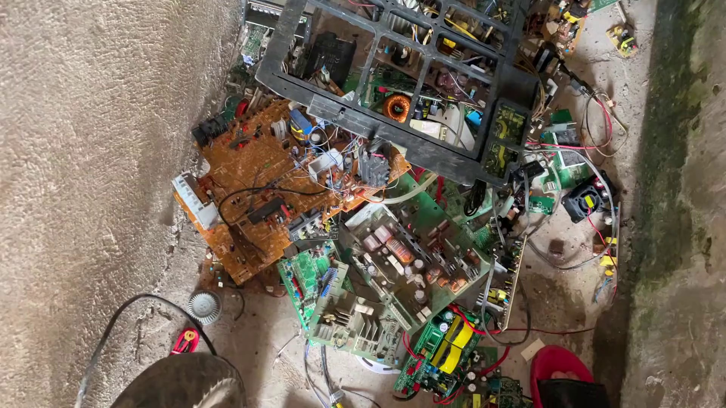 | 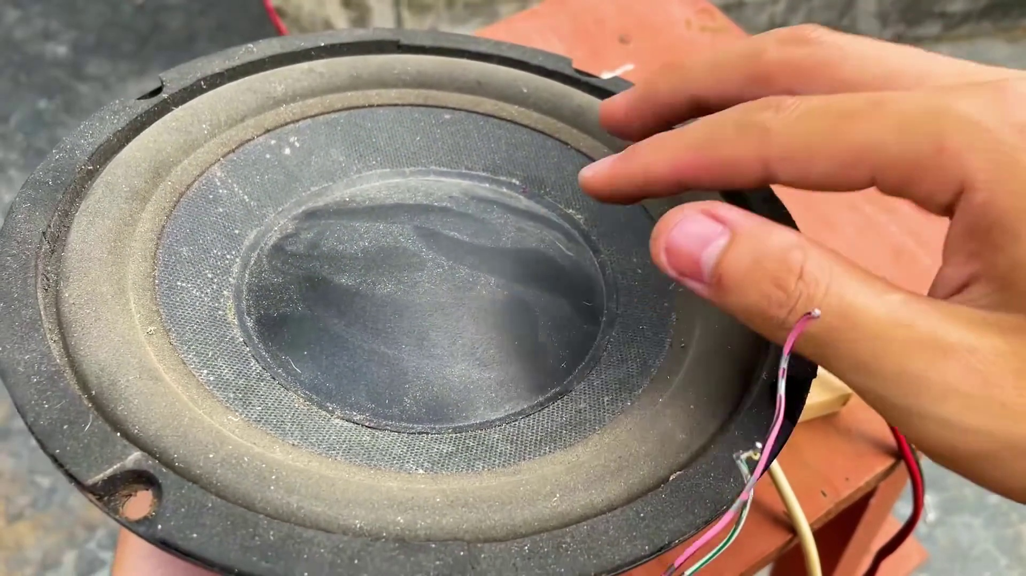 | 
Topic T1: Greetings — score 0.0000
Description: The speaker greets the audience multiple times.
Reason: The comment discusses a specific technical topic (amplifier design) and mentions a particular component (20n60 IGBT MOSFET), which is unrelated to the topic 'Greetings'.
Least correlated topics:
 |  | 
Topic T1: Greetings — score 0.0000
Description: The speaker greets the audience multiple times.
Reason: The comment discusses a specific technical topic (amplifier design) and mentions a particular component (20n60 IGBT MOSFET), which is unrelated to the topic 'Greetings'.

Topic T1: Greetings
 |  | 
Description: The speaker greets the audience multiple times.
No strongly correlated comments found for this topic.

