Comment–Topic Correlation Report
Model: llama3

Summary
Topics processed: 2
Comments available for this video: 1
Comments correlated to ≥ 60: 0 (0.0%)
Total candidate pairs checked: 2

Most/Least correlated topics (by average score across correlated comments):
Top 3:
• Topic T1: PID Tuning — avg 0.00, contributions 0
• Topic T2: Conclusion — avg 0.00, contributions 0
Bottom 3:
• Topic T2: Conclusion — avg 0.00, contributions 0
• Topic T1: PID Tuning — avg 0.00, contributions 0
Correlated comment coverage (all comments):
- matched 0 topic(s), max score 0.0000: First. Make sure the drone is mechanically sound. Don't attempt to PID tune away mechanical problems. There's even a checklist (which I won't get into.) Before tuning get the drone into flight ready status. If ou fly with a gopro, have to gopro on it. If you fly with a big battery pack, have the big battery pack. The finer the tune the less room there is for deviations from the norm. There's a process to use a flight recorder and what kinds of maneuvers need to happen in order to have the proper data to work with.If there are any vibrational issues, anything at all, go back to step 1, there's a mechanical issue that needs to be solved.When looking at the blackbox data you're looking for resonance, well, looking for it because it's undesirable. But then there's all kinds of filtering that can be done! Find the D first. Interesting.Make changes. More testing! (I'm noticing a trend here.)
Source: https://www.youtube.com/watch?v=s0dNRe0XWJ8: Somebody finally made PID tuning make sense | Chris Rosser PID tune method | Part 1
Top correlated topics:
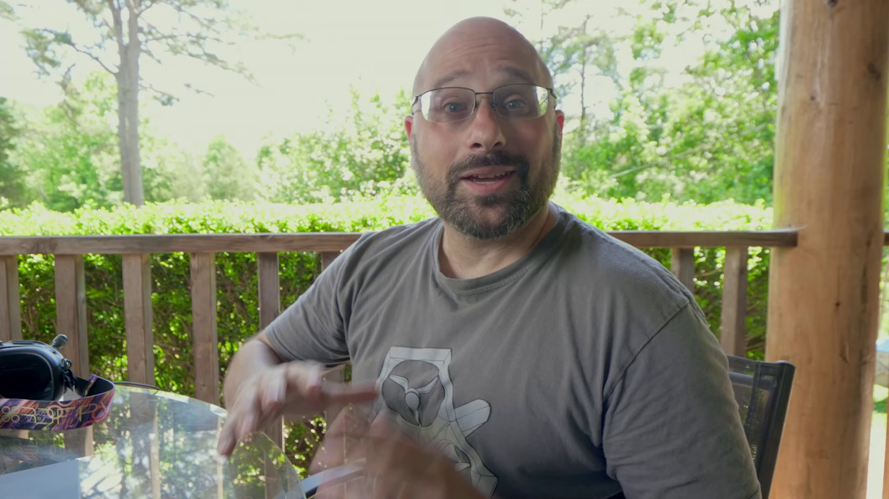 | 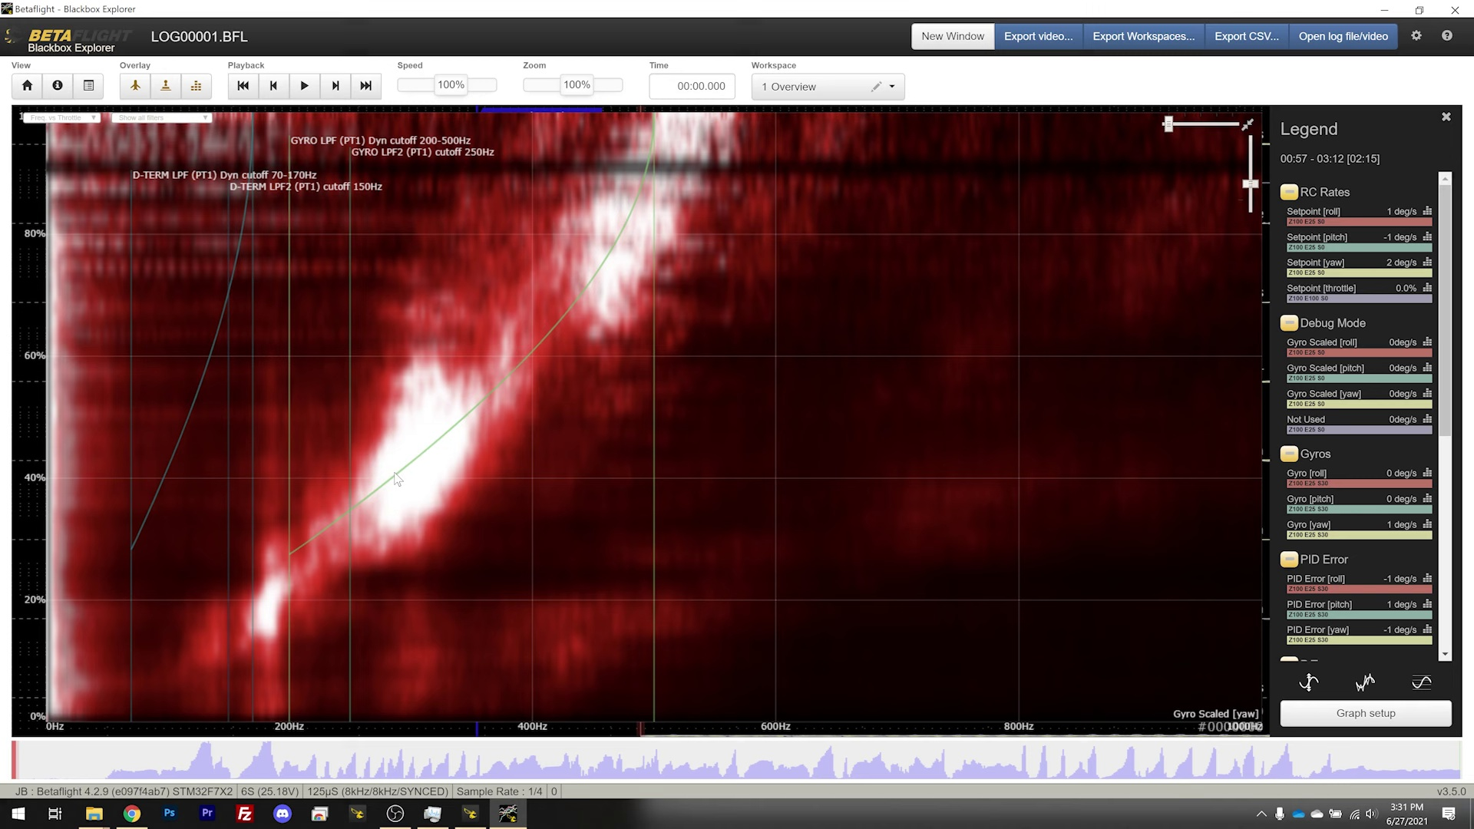 | 
Topic T1: PID Tuning — score 20.0000
Description: We're going to take that down to 1.4, and we're going to see how we do.
Reason: The topic 'PID Tuning' is discussed in a very general sense, while the comment focuses on drone maintenance and preparation for PID tuning, without directly discussing the same steps, objects, settings, parameters, claims, or goals described by the topic. The comment mentions mechanical issues and flight recorder data, which are not directly related to PID tuning.
 |  | 
Topic T2: Conclusion — score 0.0000
Description: That's so good. Damn, son.
Reason: The comment discusses drone tuning and mechanics, which is not related to the topic 'Conclusion'.
Least correlated topics:
 |  | 
Topic T2: Conclusion — score 0.0000
Description: That's so good. Damn, son.
Reason: The comment discusses drone tuning and mechanics, which is not related to the topic 'Conclusion'.
 |  | 
Topic T1: PID Tuning — score 20.0000
Description: We're going to take that down to 1.4, and we're going to see how we do.
Reason: The topic 'PID Tuning' is discussed in a very general sense, while the comment focuses on drone maintenance and preparation for PID tuning, without directly discussing the same steps, objects, settings, parameters, claims, or goals described by the topic. The comment mentions mechanical issues and flight recorder data, which are not directly related to PID tuning.

Topic T1: PID Tuning
 |  | 
Description: We're going to take that down to 1.4, and we're going to see how we do.
No strongly correlated comments found for this topic.

Topic T2: Conclusion
 |  | 
Description: That's so good. Damn, son.
No strongly correlated comments found for this topic.

