Comment–Topic Correlation Report
Model: llama3

Summary
Topics processed: 7
Comments available for this video: 2
Comments correlated to ≥ 60: 1 (50.0%)
Total candidate pairs checked: 14

Most/Least correlated topics (by average score across correlated comments):
Top 3:
• Topic T2: What are Resettable Fuses? — avg 80.00, contributions 1
• Topic T1: Introduction — avg 80.00, contributions 1
• Topic T3: Example: LED Strip Protection — avg 80.00, contributions 1
Bottom 3:
• Topic T4: How Resettable Fuses Work — avg 0.00, contributions 0
• Topic T5: Tripping and Recovery — avg 0.00, contributions 0
• Topic T6: Comparison to Traditional Fuses — avg 80.00, contributions 1
Correlated comment coverage (all comments):
- matched 5 topic(s), max score 80.0000: Small glass fuses are used to interrupt current flow, but resettable fuses offer an alternative.
Source: https://www.youtube.com/watch?v=sF0KOVWj9p8: The Best Protection for your circuit is NOT a fuse… but a resettable fuse?
Top correlated topics:
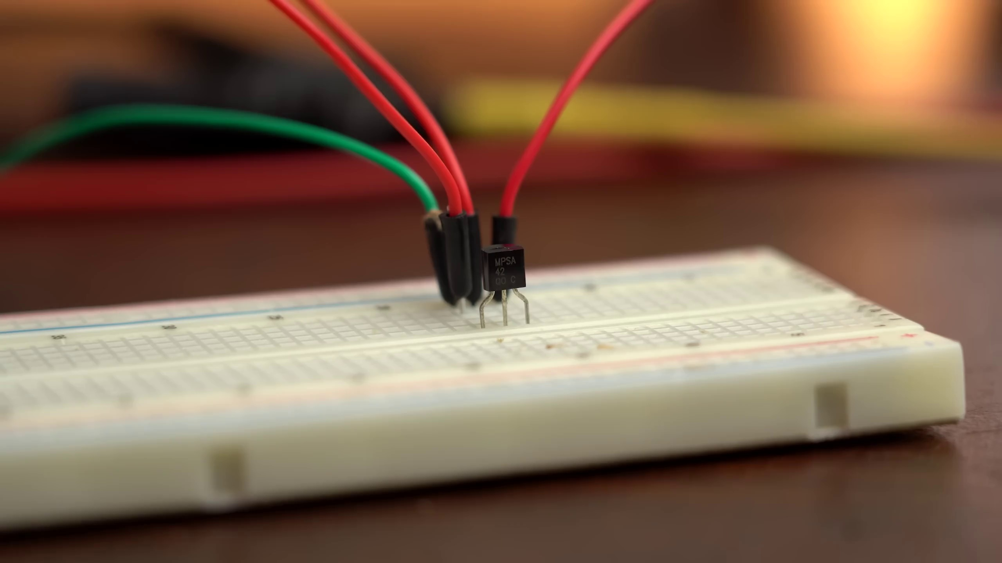 | 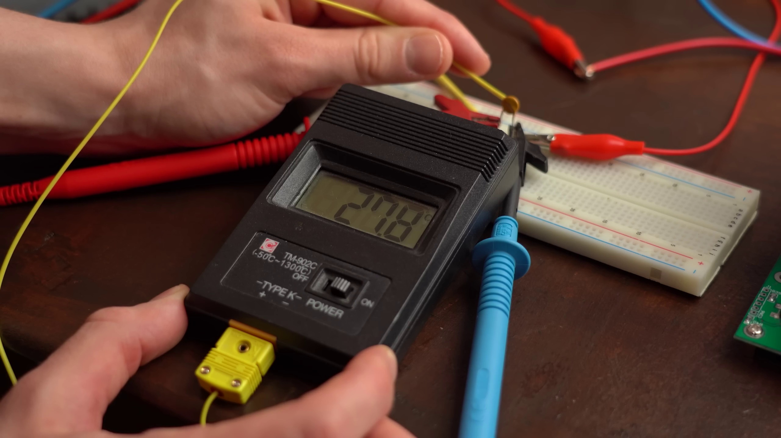 | 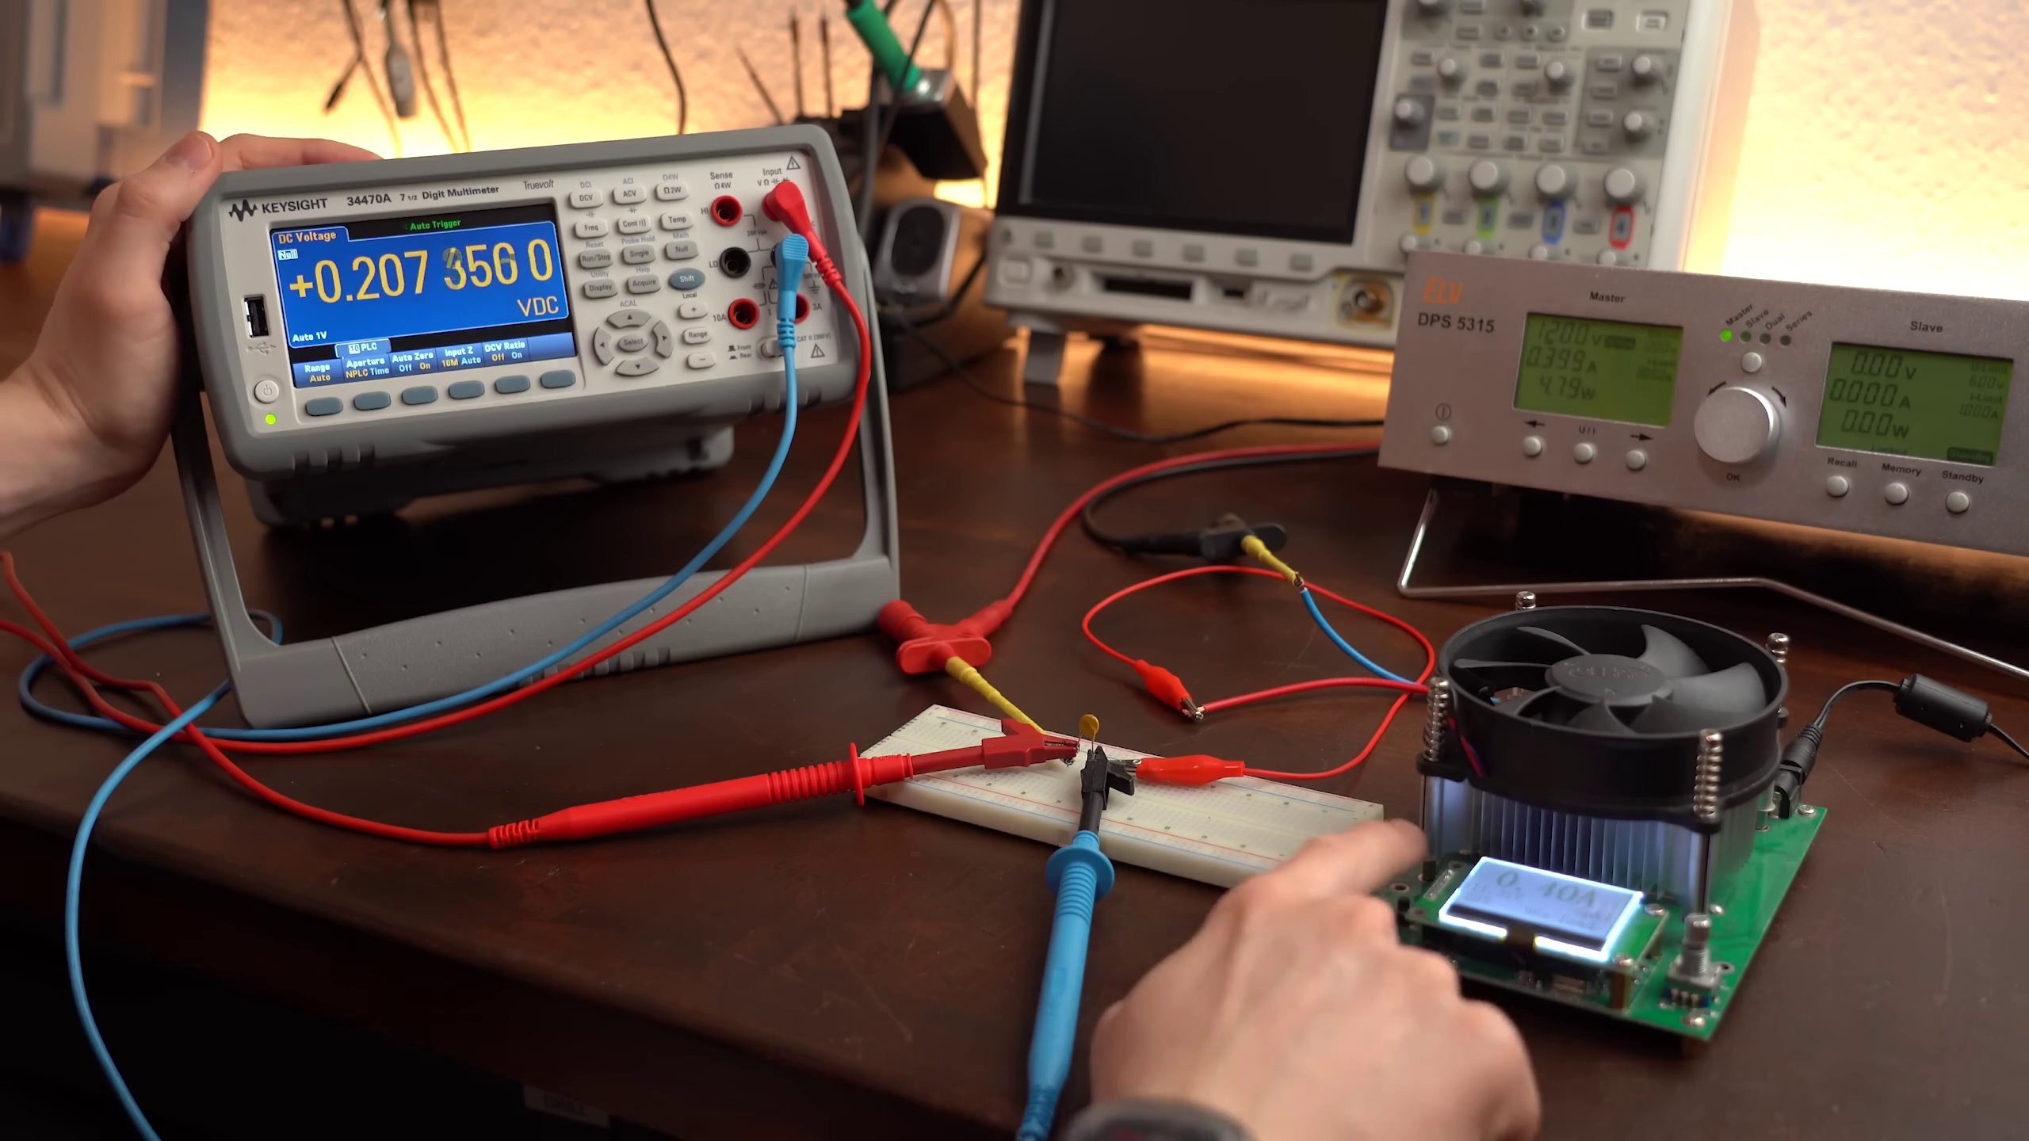
Topic T7: Conclusion and Comparison to E-Fuses — score 80.0000
Description: Summary and pros/cons of using resettable fuses vs. E-fuses.
Reason: The comment mentions 'resettable fuses' which is a key concept in the topic's description. Although it doesn't explicitly mention 'E-fuses', it refers to them indirectly by comparing resettable fuses with traditional small glass fuses.
 |  | 
Topic T6: Comparison to Traditional Fuses — score 80.0000
Description: Advantages and disadvantages of resettable fuses compared to traditional fuses.
Reason: The comment mentions traditional fuses and resettable fuses, which are directly discussed in the topic. The description of current flow interruption also aligns with the topic's focus on advantages and disadvantages.
 |  | 
Topic T3: Example: LED Strip Protection — score 80.0000
Description: Application of resettable fuses in an LED strip example.
Reason: The comment mentions resettable fuses and current flow, which are directly related to the topic's description about applying resettable fuses in an LED strip example.
 |  | 
Topic T2: What are Resettable Fuses? — score 80.0000
Description: Definition, characteristics, and differences from traditional fuses.
Reason: The comment mentions 'fuses', which is a direct reference to the topic's title. Although it doesn't discuss resettable fuses' definition or characteristics, it acknowledges the existence of fuses as a concept, showing some overlap with the topic.
 |  | 
Topic T1: Introduction — score 80.0000
Description: Overview of the topic and importance of resettable fuses.
Reason: The comment directly discusses the use of small glass fuses and resettable fuses, which are related to the topic's description about alternative fuse types.
 |  | 
Topic T5: Tripping and Recovery — score 20.0000
Description: Behavior when resettable fuses trip and recover.
Reason: The topic discusses tripping and recovery of resettable fuses, but the comment only mentions small glass fuses and resettable fuses in a general sense. While it's related to electrical systems, it doesn't directly discuss the same steps, objects, settings, parameters, claims, or goals described by the topic.
 |  | 
Topic T4: How Resettable Fuses Work — score 20.0000
Description: Explanation of how PPTCs increase resistance with temperature.
Reason: The comment only mentions fuses and their purpose to interrupt current flow, but does not specifically discuss how PPTCs work or increase resistance with temperature. The topic is more focused on the working mechanism of resettable fuses, which is not directly addressed in the comment.
Least correlated topics:
 |  | 
Topic T4: How Resettable Fuses Work — score 20.0000
Description: Explanation of how PPTCs increase resistance with temperature.
Reason: The comment only mentions fuses and their purpose to interrupt current flow, but does not specifically discuss how PPTCs work or increase resistance with temperature. The topic is more focused on the working mechanism of resettable fuses, which is not directly addressed in the comment.
 |  | 
Topic T5: Tripping and Recovery — score 20.0000
Description: Behavior when resettable fuses trip and recover.
Reason: The topic discusses tripping and recovery of resettable fuses, but the comment only mentions small glass fuses and resettable fuses in a general sense. While it's related to electrical systems, it doesn't directly discuss the same steps, objects, settings, parameters, claims, or goals described by the topic.
 |  | 
Topic T1: Introduction — score 80.0000
Description: Overview of the topic and importance of resettable fuses.
Reason: The comment directly discusses the use of small glass fuses and resettable fuses, which are related to the topic's description about alternative fuse types.
 |  | 
Topic T2: What are Resettable Fuses? — score 80.0000
Description: Definition, characteristics, and differences from traditional fuses.
Reason: The comment mentions 'fuses', which is a direct reference to the topic's title. Although it doesn't discuss resettable fuses' definition or characteristics, it acknowledges the existence of fuses as a concept, showing some overlap with the topic.
 |  | 
Topic T3: Example: LED Strip Protection — score 80.0000
Description: Application of resettable fuses in an LED strip example.
Reason: The comment mentions resettable fuses and current flow, which are directly related to the topic's description about applying resettable fuses in an LED strip example.
 |  | 
Topic T6: Comparison to Traditional Fuses — score 80.0000
Description: Advantages and disadvantages of resettable fuses compared to traditional fuses.
Reason: The comment mentions traditional fuses and resettable fuses, which are directly discussed in the topic. The description of current flow interruption also aligns with the topic's focus on advantages and disadvantages.
 |  | 
Topic T7: Conclusion and Comparison to E-Fuses — score 80.0000
Description: Summary and pros/cons of using resettable fuses vs. E-fuses.
Reason: The comment mentions 'resettable fuses' which is a key concept in the topic's description. Although it doesn't explicitly mention 'E-fuses', it refers to them indirectly by comparing resettable fuses with traditional small glass fuses.
- matched 0 topic(s), max score 0.0000: From this video I learned there is such thing as resettable fuses. This was very interesting I’ve never heard of this. No questions.
Source: https://www.youtube.com/watch?v=sF0KOVWj9p8: The Best Protection for your Circuit is NOT a Fuse!.....but a Resettable Fuse? EB#54
Top correlated topics:
 |  | 
Topic T4: How Resettable Fuses Work — score 20.0000
Description: Explanation of how PPTCs increase resistance with temperature.
Reason: The comment does not directly discuss the topic's description about PPTCs increasing resistance with temperature. Instead, it expresses general interest and surprise at learning about resettable fuses.
 |  | 
Topic T3: Example: LED Strip Protection — score 20.0000
Description: Application of resettable fuses in an LED strip example.
Reason: The comment mentions learning about resettable fuses, which is a topic-specific concept mentioned in the description. However, the comment does not directly discuss the application of resettable fuses in an LED strip example, as described in the topic.
 |  | 
Topic T2: What are Resettable Fuses? — score 20.0000
Description: Definition, characteristics, and differences from traditional fuses.
Reason: The comment does not directly discuss the characteristics or differences from traditional fuses, but only mentions the existence of resettable fuses in a general and non-specific way.
 |  | 
Topic T5: Tripping and Recovery — score 10.0000
Description: Behavior when resettable fuses trip and recover.
Reason: The comment does not discuss the steps or objects described in the topic (trip and recovery of resettable fuses). Instead, it expresses general interest and surprise at learning about the concept of resettable fuses.
 |  | 
Topic T1: Introduction — score 10.0000
Description: Overview of the topic and importance of resettable fuses.
Reason: The comment mentions learning about resettable fuses from the video, but does not directly discuss the same steps, objects, settings, parameters, claims, or goals described by the topic. The reason is that the topic description focuses on the importance of resettable fuses and provides an overview of the topic, whereas the comment only expresses interest in learning about it.
 |  | 
Topic T7: Conclusion and Comparison to E-Fuses — score 0.0000
Description: Summary and pros/cons of using resettable fuses vs. E-fuses.
Reason: The comment does not discuss the topic's specific points about resettable fuses and E-fuses, instead expressing general interest and lack of prior knowledge.
 |  | 
Topic T6: Comparison to Traditional Fuses — score 0.0000
Description: Advantages and disadvantages of resettable fuses compared to traditional fuses.
Reason: The comment does not directly discuss the same steps, objects, settings, parameters, claims, or goals described by the topic. Instead, it expresses general interest and surprise at learning about resettable fuses.
Least correlated topics:
 |  | 
Topic T6: Comparison to Traditional Fuses — score 0.0000
Description: Advantages and disadvantages of resettable fuses compared to traditional fuses.
Reason: The comment does not directly discuss the same steps, objects, settings, parameters, claims, or goals described by the topic. Instead, it expresses general interest and surprise at learning about resettable fuses.
 |  | 
Topic T7: Conclusion and Comparison to E-Fuses — score 0.0000
Description: Summary and pros/cons of using resettable fuses vs. E-fuses.
Reason: The comment does not discuss the topic's specific points about resettable fuses and E-fuses, instead expressing general interest and lack of prior knowledge.
 |  | 
Topic T1: Introduction — score 10.0000
Description: Overview of the topic and importance of resettable fuses.
Reason: The comment mentions learning about resettable fuses from the video, but does not directly discuss the same steps, objects, settings, parameters, claims, or goals described by the topic. The reason is that the topic description focuses on the importance of resettable fuses and provides an overview of the topic, whereas the comment only expresses interest in learning about it.
 |  | 
Topic T5: Tripping and Recovery — score 10.0000
Description: Behavior when resettable fuses trip and recover.
Reason: The comment does not discuss the steps or objects described in the topic (trip and recovery of resettable fuses). Instead, it expresses general interest and surprise at learning about the concept of resettable fuses.
 |  | 
Topic T2: What are Resettable Fuses? — score 20.0000
Description: Definition, characteristics, and differences from traditional fuses.
Reason: The comment does not directly discuss the characteristics or differences from traditional fuses, but only mentions the existence of resettable fuses in a general and non-specific way.
 |  | 
Topic T3: Example: LED Strip Protection — score 20.0000
Description: Application of resettable fuses in an LED strip example.
Reason: The comment mentions learning about resettable fuses, which is a topic-specific concept mentioned in the description. However, the comment does not directly discuss the application of resettable fuses in an LED strip example, as described in the topic.
 |  | 
Topic T4: How Resettable Fuses Work — score 20.0000
Description: Explanation of how PPTCs increase resistance with temperature.
Reason: The comment does not directly discuss the topic's description about PPTCs increasing resistance with temperature. Instead, it expresses general interest and surprise at learning about resettable fuses.

Topic T1: Introduction
 |  | 
Description: Overview of the topic and importance of resettable fuses.
Comment (score 80): Small glass fuses are used to interrupt current flow, but resettable fuses offer an alternative.
Reason: The comment directly discusses the use of small glass fuses and resettable fuses, which are related to the topic's description about alternative fuse types.
Source: https://www.youtube.com/watch?v=sF0KOVWj9p8: The Best Protection for your circuit is NOT a fuse… but a resettable fuse?

Topic T2: What are Resettable Fuses?
 |  | 
Description: Definition, characteristics, and differences from traditional fuses.
Comment (score 80): Small glass fuses are used to interrupt current flow, but resettable fuses offer an alternative.
Reason: The comment mentions 'fuses', which is a direct reference to the topic's title. Although it doesn't discuss resettable fuses' definition or characteristics, it acknowledges the existence of fuses as a concept, showing some overlap with the topic.
Source: https://www.youtube.com/watch?v=sF0KOVWj9p8: The Best Protection for your circuit is NOT a fuse… but a resettable fuse?

Topic T3: Example: LED Strip Protection
 |  | 
Description: Application of resettable fuses in an LED strip example.
Comment (score 80): Small glass fuses are used to interrupt current flow, but resettable fuses offer an alternative.
Reason: The comment mentions resettable fuses and current flow, which are directly related to the topic's description about applying resettable fuses in an LED strip example.
Source: https://www.youtube.com/watch?v=sF0KOVWj9p8: The Best Protection for your circuit is NOT a fuse… but a resettable fuse?

Topic T4: How Resettable Fuses Work
 |  | 
Description: Explanation of how PPTCs increase resistance with temperature.
No strongly correlated comments found for this topic.

Topic T5: Tripping and Recovery
 |  | 
Description: Behavior when resettable fuses trip and recover.
No strongly correlated comments found for this topic.

Topic T6: Comparison to Traditional Fuses
 |  | 
Description: Advantages and disadvantages of resettable fuses compared to traditional fuses.
Comment (score 80): Small glass fuses are used to interrupt current flow, but resettable fuses offer an alternative.
Reason: The comment mentions traditional fuses and resettable fuses, which are directly discussed in the topic. The description of current flow interruption also aligns with the topic's focus on advantages and disadvantages.
Source: https://www.youtube.com/watch?v=sF0KOVWj9p8: The Best Protection for your circuit is NOT a fuse… but a resettable fuse?

Topic T7: Conclusion and Comparison to E-Fuses
 |  | 
Description: Summary and pros/cons of using resettable fuses vs. E-fuses.
Comment (score 80): Small glass fuses are used to interrupt current flow, but resettable fuses offer an alternative.
Reason: The comment mentions 'resettable fuses' which is a key concept in the topic's description. Although it doesn't explicitly mention 'E-fuses', it refers to them indirectly by comparing resettable fuses with traditional small glass fuses.
Source: https://www.youtube.com/watch?v=sF0KOVWj9p8: The Best Protection for your circuit is NOT a fuse… but a resettable fuse?

