Comment–Topic Correlation Report
Model: llama3

Summary
Topics processed: 1
Comments available for this video: 1
Comments correlated to ≥ 60: 0 (0.0%)
Total candidate pairs checked: 1

Most/Least correlated topics (by average score across correlated comments):
Top 3:
• Topic T1: STA 182. WOW FUTURE — avg 0.00, contributions 0
Bottom 3:
• Topic T1: STA 182. WOW FUTURE — avg 0.00, contributions 0
Correlated comment coverage (all comments):
- matched 0 topic(s), max score 0.0000: From this video I have learned how to hook up multiple speakers to one amplifier. In the first video I watched it was a video using the TPA3110 amplifier and eight speakers. The video started with two speakers being hooked up and the sound tested. The TPA3110 allows for a left and right speaker. This would definitely be helpful for the set up that Erik and I are trying to do because we have a total of five speakers, two tweeters, two woofers, and a subwoofer. If we could split the two tweeters and two woofers to be a left and a right set for each then it would allow sound to play in stereo instead of mono. The subwoofer would be in mono but that should not be an issue because very rarely is bass recorded in stereo. As the video progresses, he continues to add more speakers. He wired his in parallel I believe but at one point it appeared that he was wiring some of them in series. It was really interesting to see eight speakers hooked up to the same amplifier. It makes me curious if the same could be said of the TDA2030A. I know if we used the headphone jack, we can still do the speakers in stereo because there is a left input and a write input. So, we will just need to put one tweeter and one woofer to the right input and one tweeter and on woofer to the left input, the subwoofer will need to go to both inputs to make it mono. After doing more research on the subwoofer I found out that both sides of the subwoofer needs to be wired in series to itself so this video helped me figure that out. The only confusion I have was whether the speakers were hooked up in series or parallel.
Source: https://www.youtube.com/watch?v=sHwSIcIdeDI : Class d amplifier sound test | TPA 3110 bass test
Top correlated topics:
 | 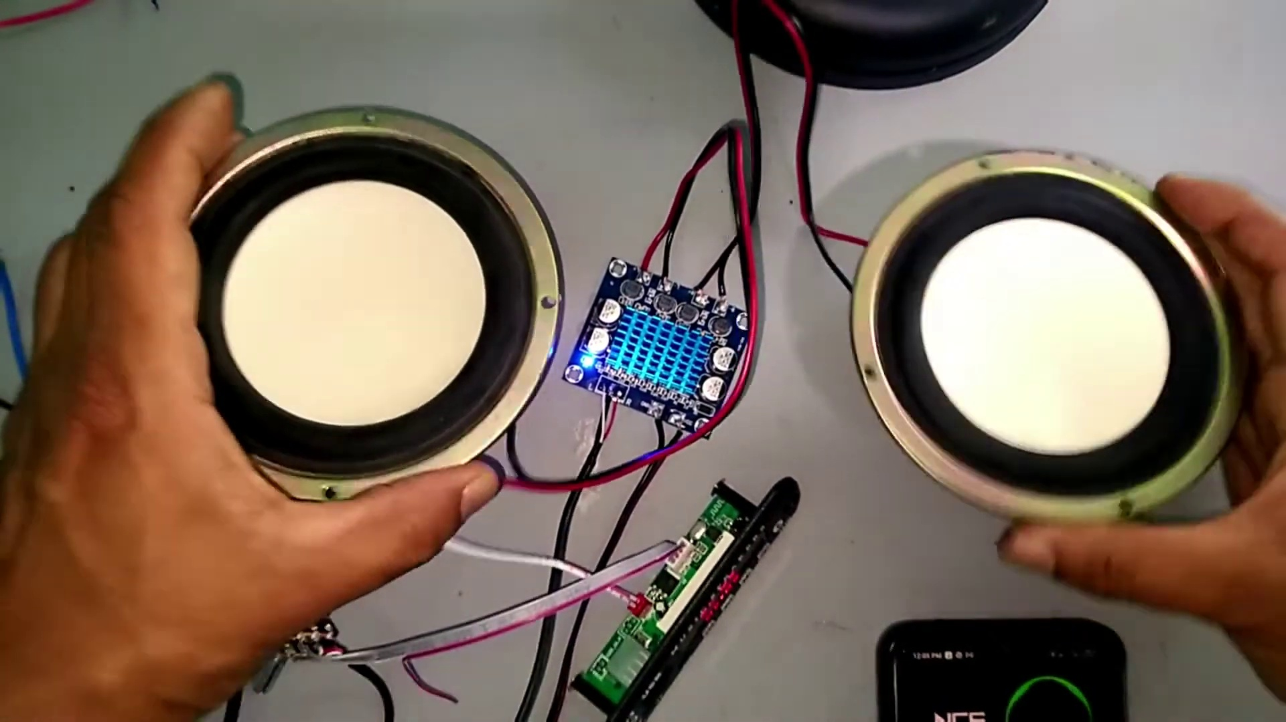 | 
Topic T1: STA 182. WOW FUTURE — score 20.0000
Description: The speaker introduces a topic or event called STA 182 with enthusiasm.
Reason: {
"correlated": false,
"score": 20,
"reason": "The topic is about the speaker introducing a topic or event called STA 182 with enthusiasm. The comment discusses hooking up multiple speakers to an amplifier and setting up stereo sound, but does not mention STA 182 specifically. The only overlap is the presence of numbers (STA 182) in the title and video name, which is not enough to establish strong
Least correlated topics:
 |  | 
Topic T1: STA 182. WOW FUTURE — score 20.0000
Description: The speaker introduces a topic or event called STA 182 with enthusiasm.
Reason: {
"correlated": false,
"score": 20,
"reason": "The topic is about the speaker introducing a topic or event called STA 182 with enthusiasm. The comment discusses hooking up multiple speakers to an amplifier and setting up stereo sound, but does not mention STA 182 specifically. The only overlap is the presence of numbers (STA 182) in the title and video name, which is not enough to establish strong

Topic T1: STA 182. WOW FUTURE
 |  | 
Description: The speaker introduces a topic or event called STA 182 with enthusiasm.
No strongly correlated comments found for this topic.

