Comment–Topic Correlation Report
Model: llama3

Summary
Topics processed: 6
Comments available for this video: 1
Comments correlated to ≥ 60: 1 (100.0%)
Total candidate pairs checked: 6

Most/Least correlated topics (by average score across correlated comments):
Top 3:
• Topic T1: Introduction to Audio IC — avg 80.00, contributions 1
• Topic T4: Audio IC Setup — avg 80.00, contributions 1
• Topic T6: Conclusion — avg 70.00, contributions 1
Bottom 3:
• Topic T2: Audio IC Basics — avg 0.00, contributions 0
• Topic T3: Dual Supply Circuit — avg 0.00, contributions 0
• Topic T5: Volume Control and Audio Quality — avg 0.00, contributions 0
Correlated comment coverage (all comments):
- matched 3 topic(s), max score 80.0000: This video was about constructing a speaker circuit using the TDA 2050 with a PCB board. One thing learned from this video is that the circuit layout for the TDA 2050, both demonstrated on the PCB and in the technical documents of the TDA 2050 shown in the video, is that the circuit for the TDA 2050 is way more complicated than the circuits shown for the TDA 2030 in the previously watched videos. Some questions and points of confusion is that I would like to know what the Thermal Fuse ring was and the purpose of that part. Like was it the speaker/woofer/subwoofer? Or was it something completely different? Also I just have general confusion about the PCB circuit construction, this stems from the fact that I personally have absolutely no experience with PCB boards.
Source: https://www.youtube.com/watch?v=t4LPzGIr41c : #TDA2050 Hi-Fi 32 watt Amplifier circuit and PCB,Tda2050 ic से 35W का Amplifier बनाऐ
Top correlated topics:
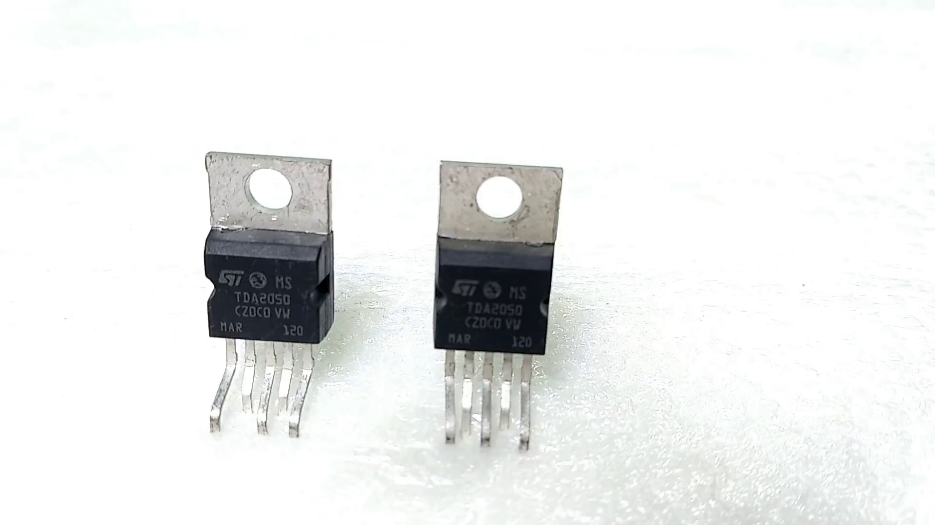 | 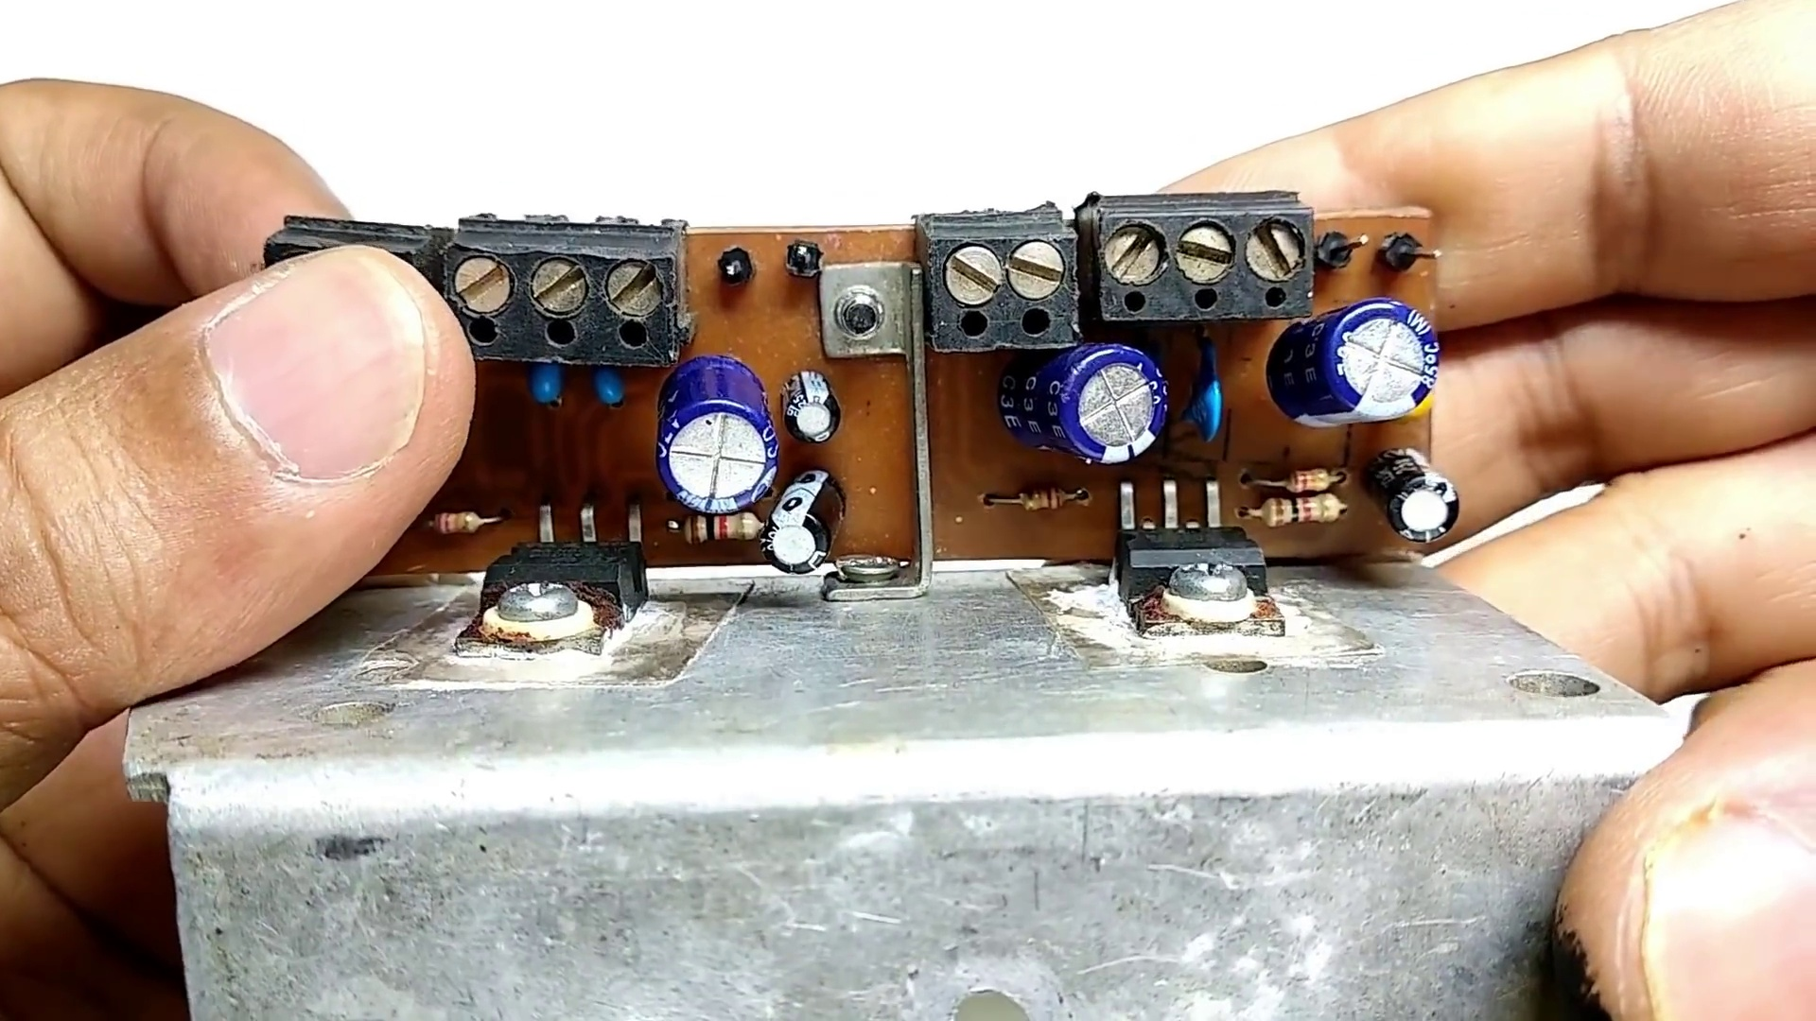 | 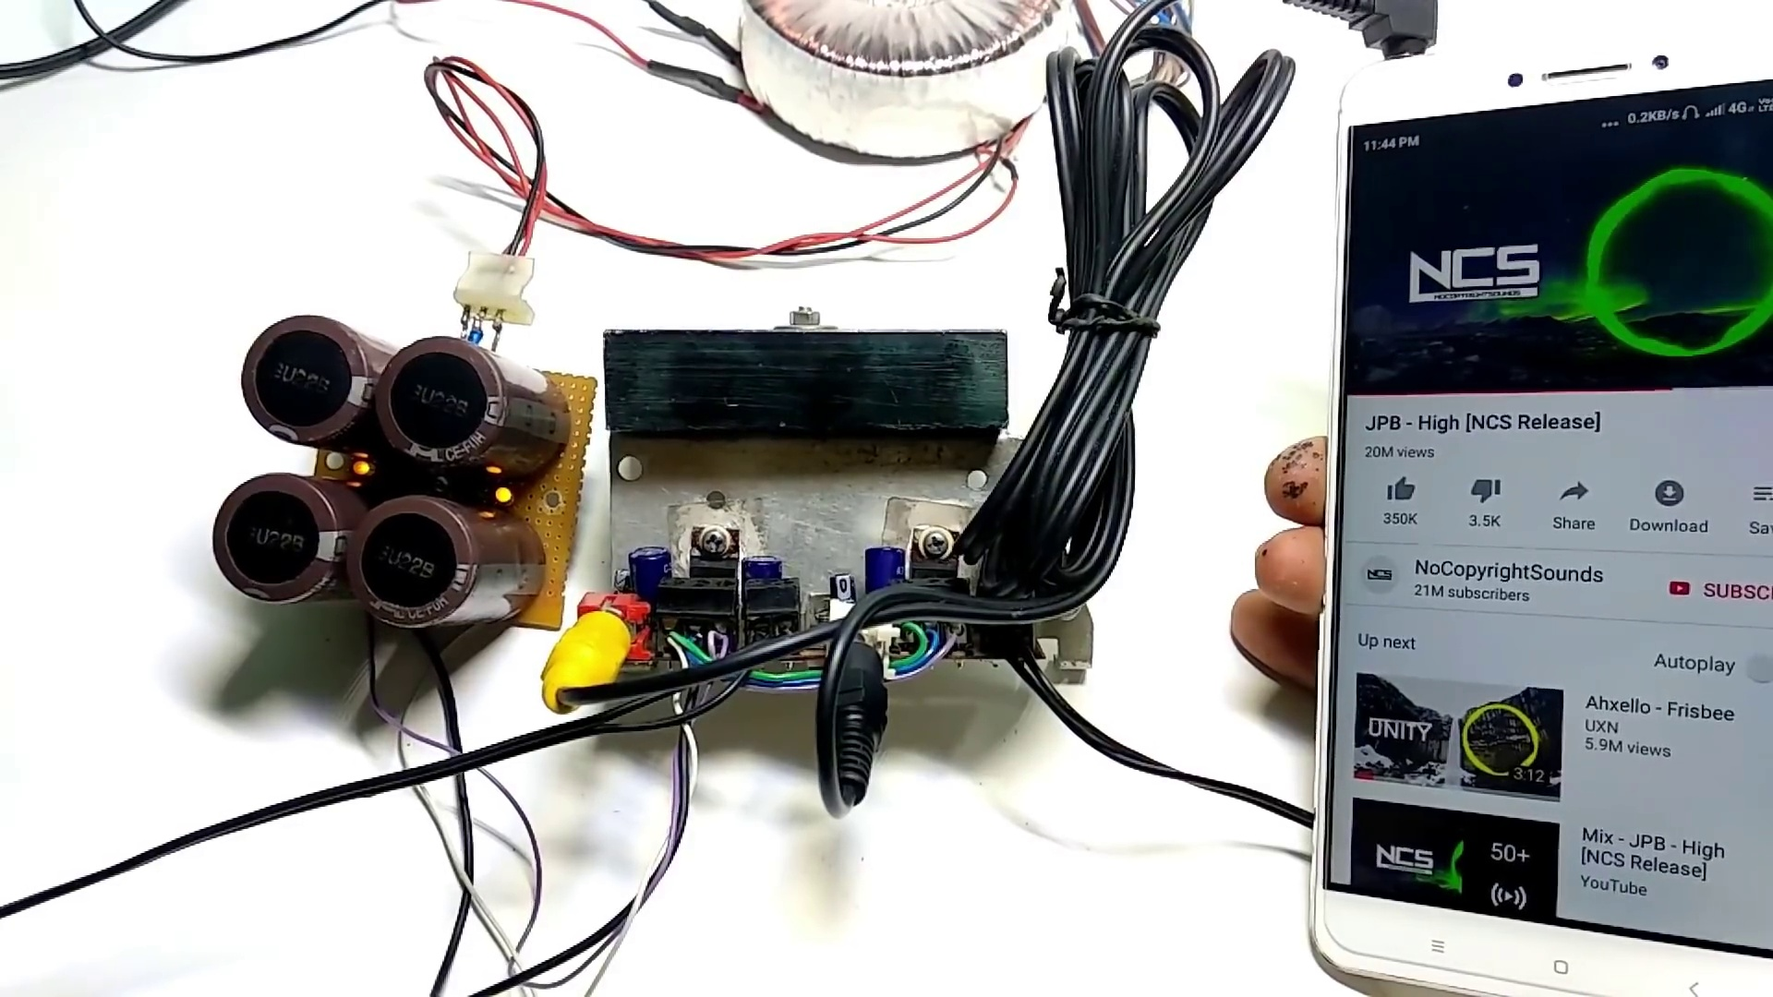
Topic T4: Audio IC Setup — score 80.0000
Description: A step-by-step guide on how to set up the audio IC for use in various applications.
Reason: The comment discusses setting up the TDA 2050 circuit on a PCB board, which is directly related to the topic of audio IC setup. Although it doesn't mention the specific steps for setting up the audio IC, it shows an understanding of the complexity of the TDA 2050 circuit layout and raises questions about other components like the Thermal Fuse ring.
 |  | 
Topic T1: Introduction to Audio IC — score 80.0000
Description: An introduction to audio IC and its applications.
Reason: The comment directly discusses the same IC (TDA 2050) and PCB board construction mentioned in the topic description, indicating a strong relationship.
 |  | 
Topic T6: Conclusion — score 70.0000
Description: A summary of the key points discussed in the video and a call to action for viewers.
Reason: The comment directly discusses the speaker circuit construction using TDA 2050 and PCB board, which is heavily related to the topic 'Conclusion' that summarizes key points discussed in the video. The comment also mentions specific components and questions about the circuit, showing a strong connection to the topic.
 |  | 
Topic T5: Volume Control and Audio Quality — score 20.0000
Description: Tips on how to control the volume of the audio IC's output and improve its quality.
Reason: The topic is about volume control and audio quality, but the comment discusses speaker circuit construction using TDA 2050, which has no direct relation to the topic.
 |  | 
Topic T3: Dual Supply Circuit — score 20.0000
Description: How to create a dual supply circuit for the audio IC using a bridge rectifier and capacitors.
Reason: The comment does not directly discuss the topic of 'Dual Supply Circuit', but rather talks about a different speaker circuit using TDA 2050. Although it mentions PCB boards and circuit construction, there is no overlap with the topic description's focus on bridge rectifiers and capacitors.
 |  | 
Topic T2: Audio IC Basics — score 10.0000
Description: A detailed explanation of the audio IC's working principle and components.
Reason: The comment discusses speaker circuit construction using the TDA 2050 and TDA 2030, whereas the topic is about audio IC basics. The only overlap is the mention of the TDA 2050, but it's not directly discussed in the context of its working principle or components.
Least correlated topics:
 |  | 
Topic T2: Audio IC Basics — score 10.0000
Description: A detailed explanation of the audio IC's working principle and components.
Reason: The comment discusses speaker circuit construction using the TDA 2050 and TDA 2030, whereas the topic is about audio IC basics. The only overlap is the mention of the TDA 2050, but it's not directly discussed in the context of its working principle or components.
 |  | 
Topic T3: Dual Supply Circuit — score 20.0000
Description: How to create a dual supply circuit for the audio IC using a bridge rectifier and capacitors.
Reason: The comment does not directly discuss the topic of 'Dual Supply Circuit', but rather talks about a different speaker circuit using TDA 2050. Although it mentions PCB boards and circuit construction, there is no overlap with the topic description's focus on bridge rectifiers and capacitors.
 |  | 
Topic T5: Volume Control and Audio Quality — score 20.0000
Description: Tips on how to control the volume of the audio IC's output and improve its quality.
Reason: The topic is about volume control and audio quality, but the comment discusses speaker circuit construction using TDA 2050, which has no direct relation to the topic.
 |  | 
Topic T6: Conclusion — score 70.0000
Description: A summary of the key points discussed in the video and a call to action for viewers.
Reason: The comment directly discusses the speaker circuit construction using TDA 2050 and PCB board, which is heavily related to the topic 'Conclusion' that summarizes key points discussed in the video. The comment also mentions specific components and questions about the circuit, showing a strong connection to the topic.
 |  | 
Topic T1: Introduction to Audio IC — score 80.0000
Description: An introduction to audio IC and its applications.
Reason: The comment directly discusses the same IC (TDA 2050) and PCB board construction mentioned in the topic description, indicating a strong relationship.
 |  | 
Topic T4: Audio IC Setup — score 80.0000
Description: A step-by-step guide on how to set up the audio IC for use in various applications.
Reason: The comment discusses setting up the TDA 2050 circuit on a PCB board, which is directly related to the topic of audio IC setup. Although it doesn't mention the specific steps for setting up the audio IC, it shows an understanding of the complexity of the TDA 2050 circuit layout and raises questions about other components like the Thermal Fuse ring.

Topic T1: Introduction to Audio IC
 |  | 
Description: An introduction to audio IC and its applications.
Comment (score 80): This video was about constructing a speaker circuit using the TDA 2050 with a PCB board. One thing learned from this video is that the circuit layout for the TDA 2050, both demonstrated on the PCB and in the technical documents of the TDA 2050 shown in the video, is that the circuit for the TDA 2050 is way more complicated than the circuits shown for the TDA 2030 in the previously watched videos. Some questions and points of confusion is that I would like to know what the Thermal Fuse ring was and the purpose of that part. Like was it the speaker/woofer/subwoofer? Or was it something completely different? Also I just have general confusion about the PCB circuit construction, this stems from the fact that I personally have absolutely no experience with PCB boards.
Reason: The comment directly discusses the same IC (TDA 2050) and PCB board construction mentioned in the topic description, indicating a strong relationship.
Source: https://www.youtube.com/watch?v=t4LPzGIr41c : #TDA2050 Hi-Fi 32 watt Amplifier circuit and PCB,Tda2050 ic से 35W का Amplifier बनाऐ

Topic T2: Audio IC Basics
 |  | 
Description: A detailed explanation of the audio IC's working principle and components.
No strongly correlated comments found for this topic.

Topic T3: Dual Supply Circuit
 |  | 
Description: How to create a dual supply circuit for the audio IC using a bridge rectifier and capacitors.
No strongly correlated comments found for this topic.

Topic T4: Audio IC Setup
 |  | 
Description: A step-by-step guide on how to set up the audio IC for use in various applications.
Comment (score 80): This video was about constructing a speaker circuit using the TDA 2050 with a PCB board. One thing learned from this video is that the circuit layout for the TDA 2050, both demonstrated on the PCB and in the technical documents of the TDA 2050 shown in the video, is that the circuit for the TDA 2050 is way more complicated than the circuits shown for the TDA 2030 in the previously watched videos. Some questions and points of confusion is that I would like to know what the Thermal Fuse ring was and the purpose of that part. Like was it the speaker/woofer/subwoofer? Or was it something completely different? Also I just have general confusion about the PCB circuit construction, this stems from the fact that I personally have absolutely no experience with PCB boards.
Reason: The comment discusses setting up the TDA 2050 circuit on a PCB board, which is directly related to the topic of audio IC setup. Although it doesn't mention the specific steps for setting up the audio IC, it shows an understanding of the complexity of the TDA 2050 circuit layout and raises questions about other components like the Thermal Fuse ring.
Source: https://www.youtube.com/watch?v=t4LPzGIr41c : #TDA2050 Hi-Fi 32 watt Amplifier circuit and PCB,Tda2050 ic से 35W का Amplifier बनाऐ

Topic T5: Volume Control and Audio Quality
 |  | 
Description: Tips on how to control the volume of the audio IC's output and improve its quality.
No strongly correlated comments found for this topic.

Topic T6: Conclusion
 |  | 
Description: A summary of the key points discussed in the video and a call to action for viewers.
Comment (score 70): This video was about constructing a speaker circuit using the TDA 2050 with a PCB board. One thing learned from this video is that the circuit layout for the TDA 2050, both demonstrated on the PCB and in the technical documents of the TDA 2050 shown in the video, is that the circuit for the TDA 2050 is way more complicated than the circuits shown for the TDA 2030 in the previously watched videos. Some questions and points of confusion is that I would like to know what the Thermal Fuse ring was and the purpose of that part. Like was it the speaker/woofer/subwoofer? Or was it something completely different? Also I just have general confusion about the PCB circuit construction, this stems from the fact that I personally have absolutely no experience with PCB boards.
Reason: The comment directly discusses the speaker circuit construction using TDA 2050 and PCB board, which is heavily related to the topic 'Conclusion' that summarizes key points discussed in the video. The comment also mentions specific components and questions about the circuit, showing a strong connection to the topic.
Source: https://www.youtube.com/watch?v=t4LPzGIr41c : #TDA2050 Hi-Fi 32 watt Amplifier circuit and PCB,Tda2050 ic से 35W का Amplifier बनाऐ

