Comment–Topic Correlation Report
Model: llama3

Summary
Topics processed: 2
Comments available for this video: 1
Comments correlated to ≥ 60: 1 (100.0%)
Total candidate pairs checked: 2

Most/Least correlated topics (by average score across correlated comments):
Top 3:
• Topic T2: Importance of Decoupling Capacitors — avg 90.00, contributions 1
• Topic T1: Analyzing Electrical Noise — avg 85.00, contributions 1
Bottom 3:
• Topic T1: Analyzing Electrical Noise — avg 85.00, contributions 1
• Topic T2: Importance of Decoupling Capacitors — avg 90.00, contributions 1
Correlated comment coverage (all comments):
- matched 2 topic(s), max score 90.0000: What I have learned from the video: I learned that adding a load can drastically increase noise in both the input and output source. Therefore, decoupling capacitors are very critical to the output sound of a speaker. The video explained several noise elimination techniques such as shielding, filtering, differential signaling, grounding, isolation, surge protection, and ground loop elimination. It was helpful for Phase 2 by showing how to test for noise sources and eliminate them effectively. Any questions not answered through the video: One question I had was why two parallel capacitors are used instead of one. This was answered—one filters low frequency noise, the other high. However, I didn’t fully understand some of the other noise elimination techniques.
Source: https://www.youtube.com/watch?v=u40kX1DYKdA: Decoupling Capacitors - And why they are important
Top correlated topics:
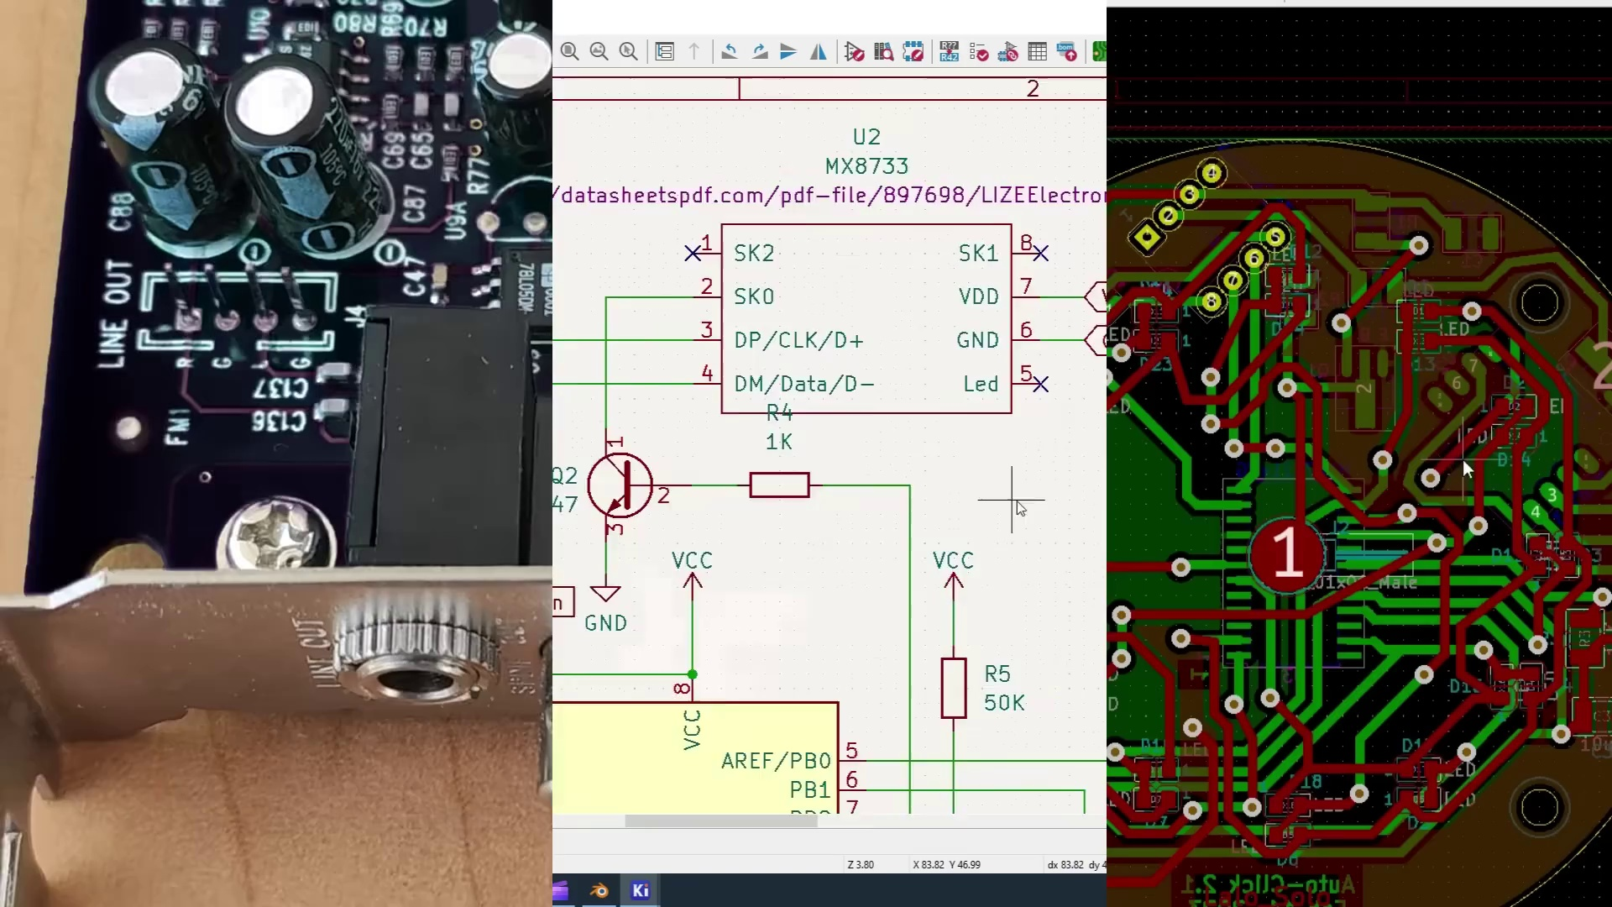 | 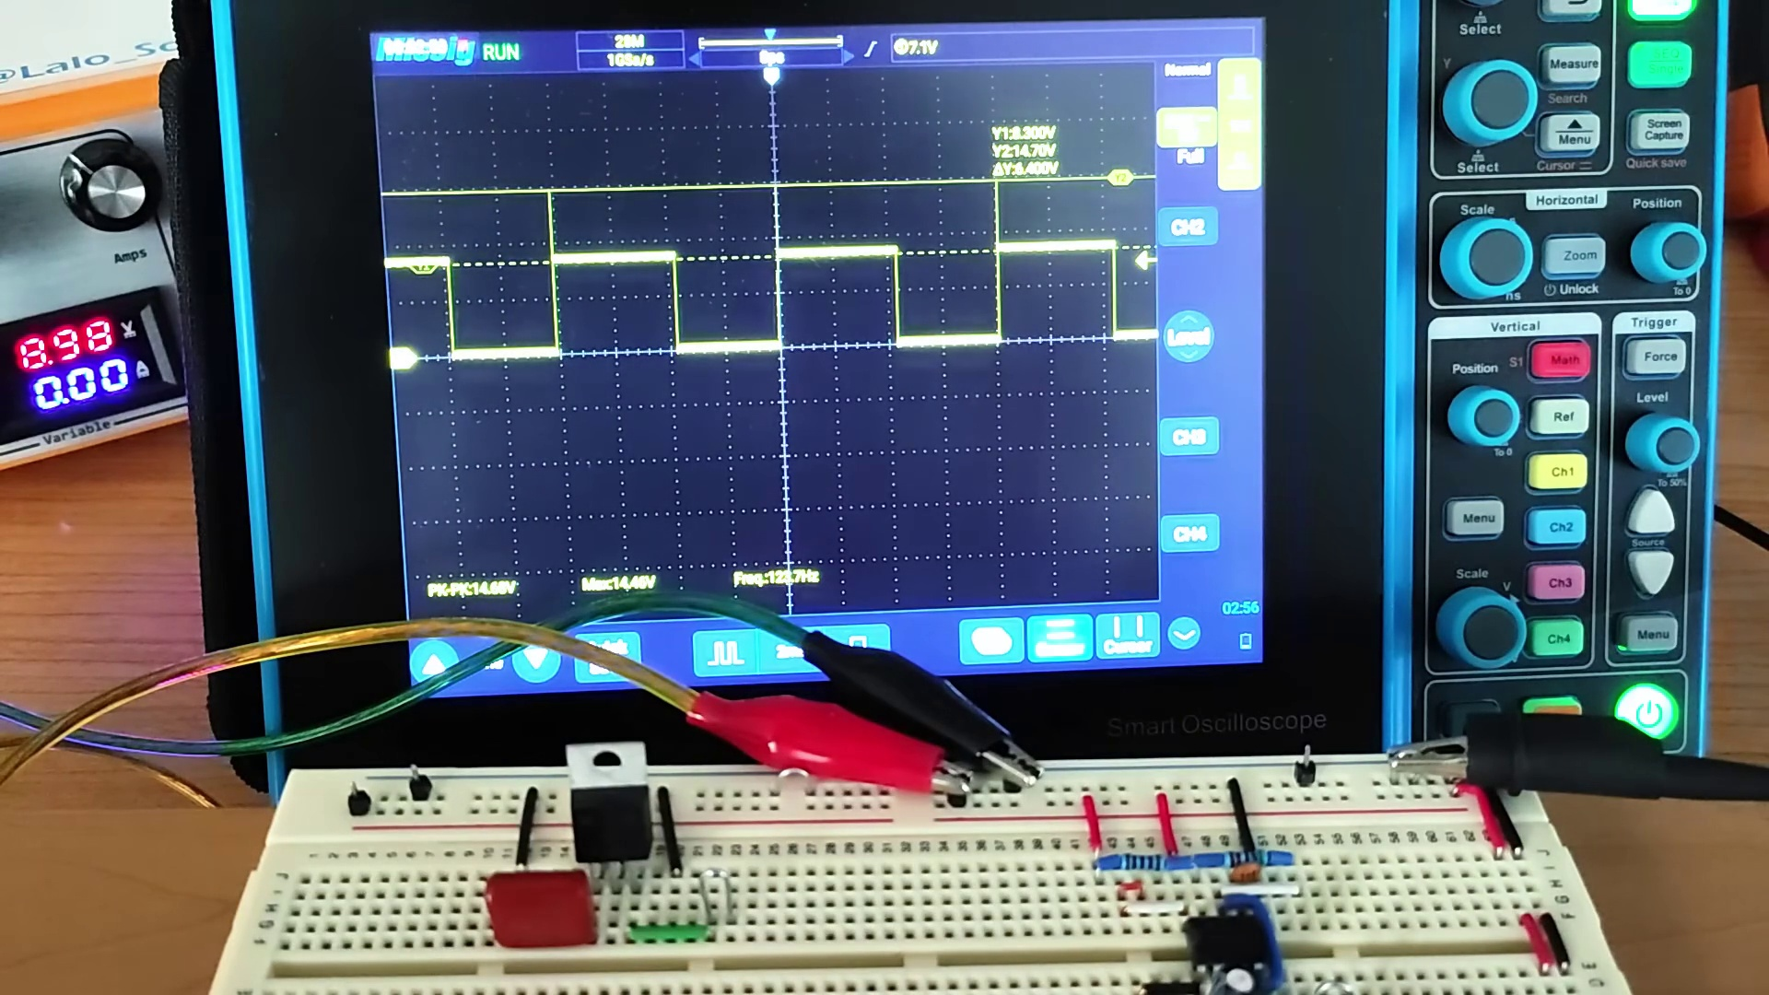 | 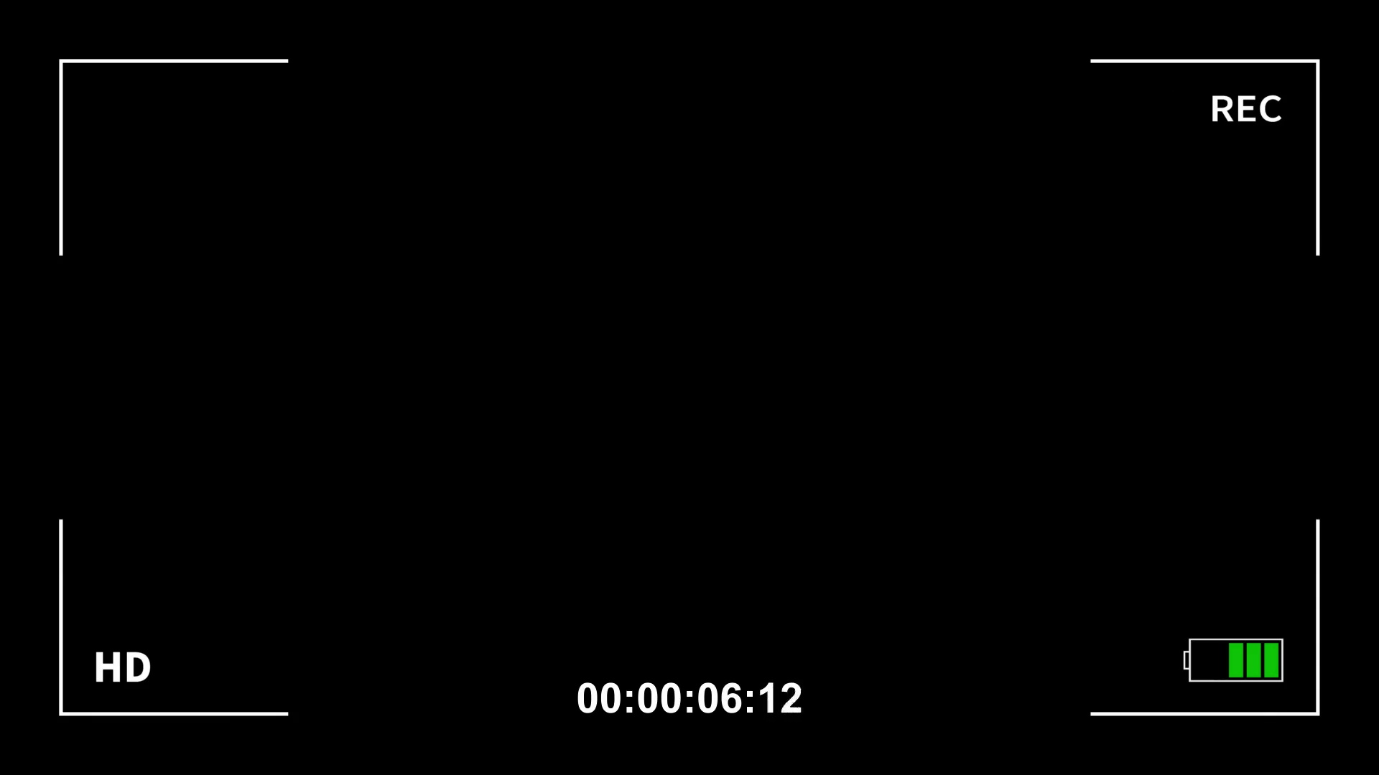
Topic T2: Importance of Decoupling Capacitors — score 90.0000
Description: The video discusses the significance of decoupling capacitors in reducing electrical noise and improving signal quality.
Reason: The comment directly discusses the importance of decoupling capacitors in reducing noise and improving signal quality, as described in the topic. It also mentions specific techniques such as shielding, filtering, and grounding, which are mentioned in the topic description.
 |  | 
Topic T1: Analyzing Electrical Noise — score 85.0000
Description: The video presents techniques for analyzing and eliminating electrical noise, including the use of decoupling capacitors.
Reason: The comment directly discusses decoupling capacitors and their importance in eliminating electrical noise, which is a key concept covered in the topic. The comment also mentions specific techniques for noise elimination, such as shielding and filtering, which are mentioned in the topic description.
Least correlated topics:
 |  | 
Topic T1: Analyzing Electrical Noise — score 85.0000
Description: The video presents techniques for analyzing and eliminating electrical noise, including the use of decoupling capacitors.
Reason: The comment directly discusses decoupling capacitors and their importance in eliminating electrical noise, which is a key concept covered in the topic. The comment also mentions specific techniques for noise elimination, such as shielding and filtering, which are mentioned in the topic description.
 |  | 
Topic T2: Importance of Decoupling Capacitors — score 90.0000
Description: The video discusses the significance of decoupling capacitors in reducing electrical noise and improving signal quality.
Reason: The comment directly discusses the importance of decoupling capacitors in reducing noise and improving signal quality, as described in the topic. It also mentions specific techniques such as shielding, filtering, and grounding, which are mentioned in the topic description.

Topic T1: Analyzing Electrical Noise
 |  | 
Description: The video presents techniques for analyzing and eliminating electrical noise, including the use of decoupling capacitors.
Comment (score 85): What I have learned from the video: I learned that adding a load can drastically increase noise in both the input and output source. Therefore, decoupling capacitors are very critical to the output sound of a speaker. The video explained several noise elimination techniques such as shielding, filtering, differential signaling, grounding, isolation, surge protection, and ground loop elimination. It was helpful for Phase 2 by showing how to test for noise sources and eliminate them effectively. Any questions not answered through the video: One question I had was why two parallel capacitors are used instead of one. This was answered—one filters low frequency noise, the other high. However, I didn’t fully understand some of the other noise elimination techniques.
Reason: The comment directly discusses decoupling capacitors and their importance in eliminating electrical noise, which is a key concept covered in the topic. The comment also mentions specific techniques for noise elimination, such as shielding and filtering, which are mentioned in the topic description.
Source: https://www.youtube.com/watch?v=u40kX1DYKdA: Decoupling Capacitors - And why they are important

Topic T2: Importance of Decoupling Capacitors
 |  | 
Description: The video discusses the significance of decoupling capacitors in reducing electrical noise and improving signal quality.
Comment (score 90): What I have learned from the video: I learned that adding a load can drastically increase noise in both the input and output source. Therefore, decoupling capacitors are very critical to the output sound of a speaker. The video explained several noise elimination techniques such as shielding, filtering, differential signaling, grounding, isolation, surge protection, and ground loop elimination. It was helpful for Phase 2 by showing how to test for noise sources and eliminate them effectively. Any questions not answered through the video: One question I had was why two parallel capacitors are used instead of one. This was answered—one filters low frequency noise, the other high. However, I didn’t fully understand some of the other noise elimination techniques.
Reason: The comment directly discusses the importance of decoupling capacitors in reducing noise and improving signal quality, as described in the topic. It also mentions specific techniques such as shielding, filtering, and grounding, which are mentioned in the topic description.
Source: https://www.youtube.com/watch?v=u40kX1DYKdA: Decoupling Capacitors - And why they are important

