Comment–Topic Correlation Report
Model: llama3

Summary
Topics processed: 1
Comments available for this video: 2
Comments correlated to ≥ 60: 1 (50.0%)
Total candidate pairs checked: 2

Most/Least correlated topics (by average score across correlated comments):
Top 3:
• Topic T1: Introduction — avg 80.00, contributions 1
Bottom 3:
• Topic T1: Introduction — avg 80.00, contributions 1
Correlated comment coverage (all comments):
- matched 1 topic(s), max score 80.0000: I learned what and where the connections on an IGBT amplifier are and what they should connect to. What made you confused is How soldering directly to the chip and other speaker components affects sound quality and potential noise.
Source: https://www.youtube.com/watch?v=w49SSxiPK_Q: Simple Super Power IGBT Bass Amplifier
Top correlated topics:
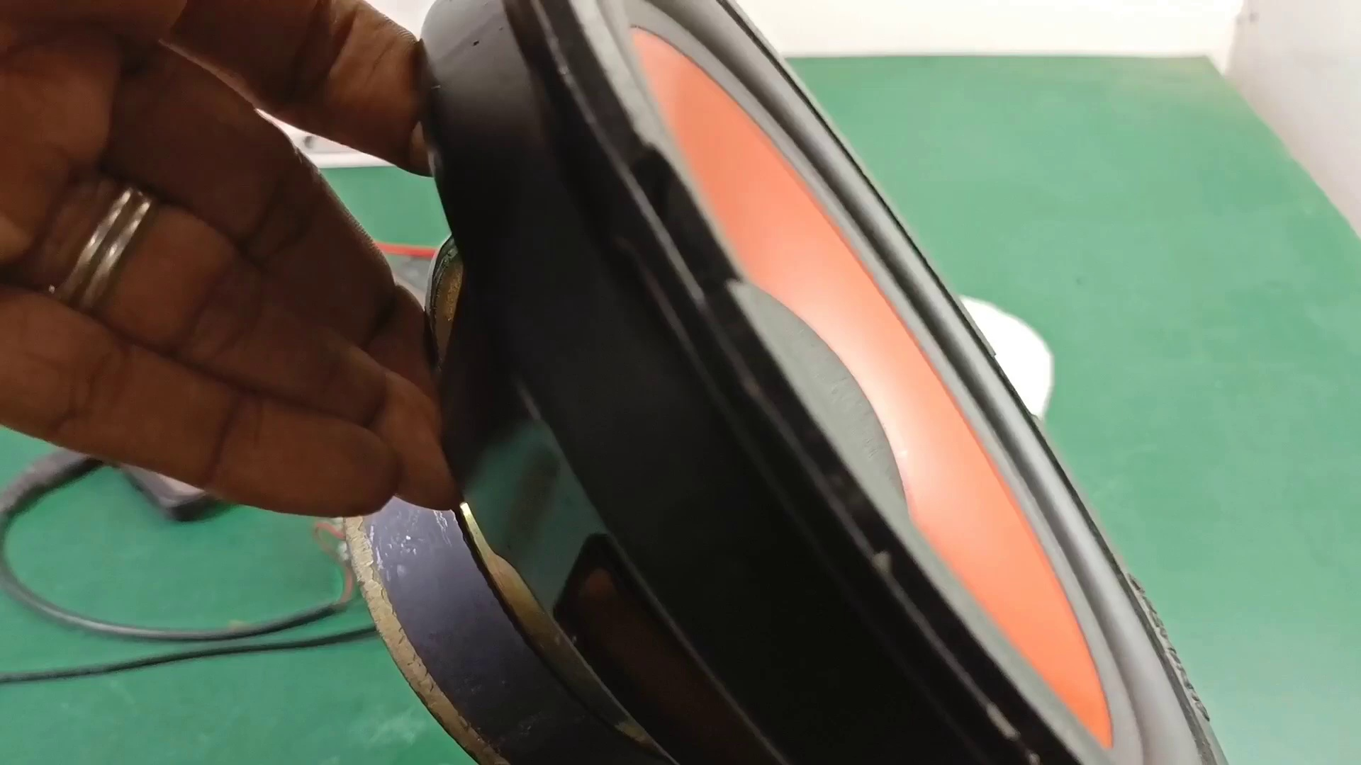 | 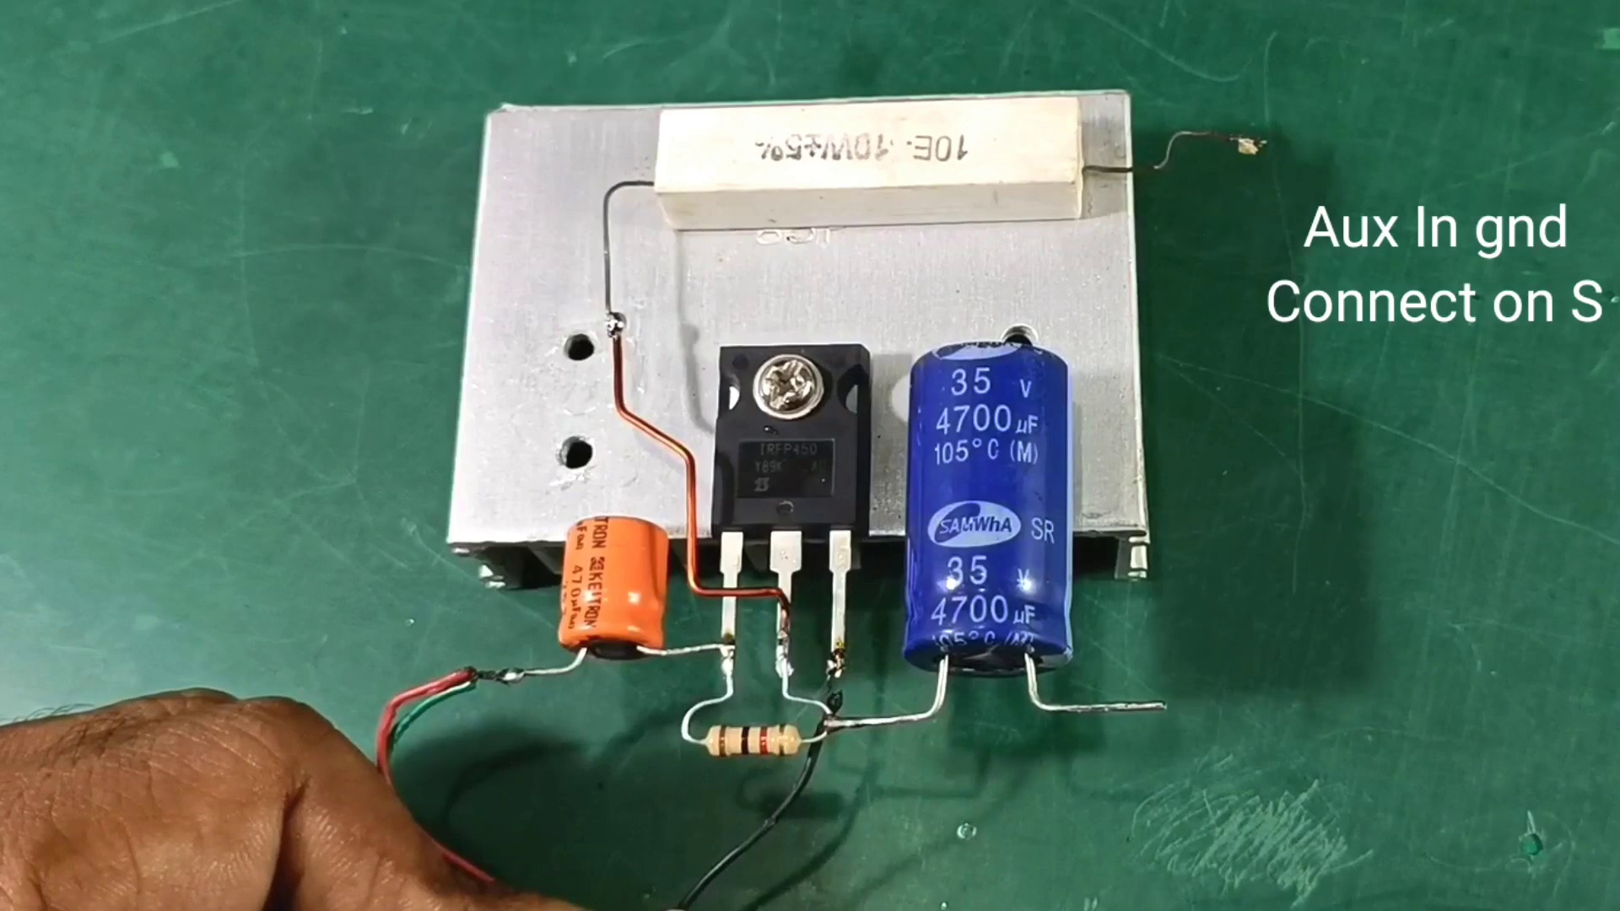 | 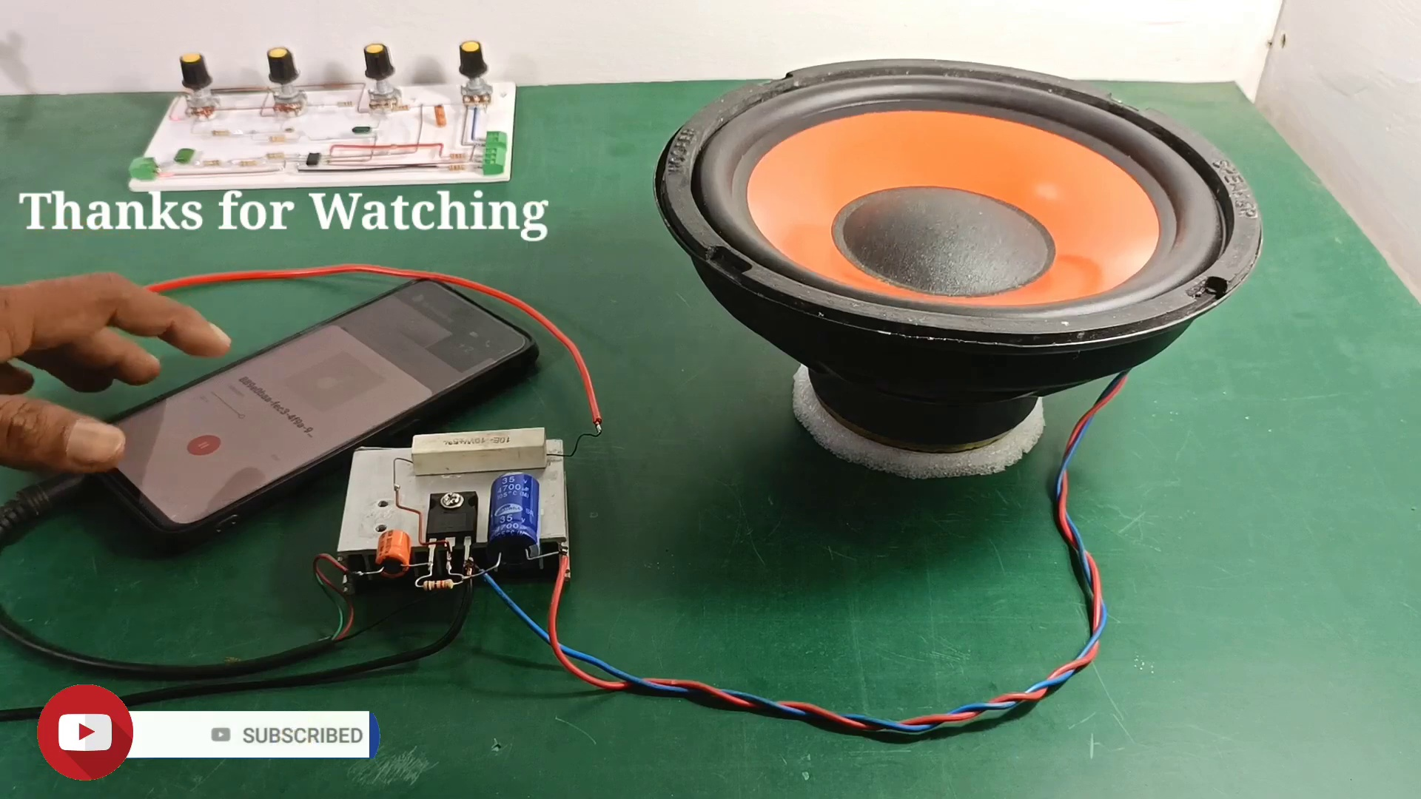
Topic T1: Introduction — score 80.0000
Description: The introduction is discussed.
Reason: The comment directly discusses the topic of an IGBT amplifier and its connections, which is a specific aspect of the introduction described in the topic.
Least correlated topics:
 |  | 
Topic T1: Introduction — score 80.0000
Description: The introduction is discussed.
Reason: The comment directly discusses the topic of an IGBT amplifier and its connections, which is a specific aspect of the introduction described in the topic.
- matched 0 topic(s), max score 0.0000: Useful Content: I found this video particularly interesting because of how simple the circuit is. With just a MOSFET, capacitor, resistor, and power you can make a powerful functioning audio amplifier circuit, which is pretty amazing.Confused Content: This video was very clear with all its components, so nothing was confusing.Future Use: This video was watched for Class Project Phase 2 inspiration.
Source: https://www.youtube.com/watch?v=w49SSxiPK_Q: Simple Super Power IGBT Bass Amplifier \\ How to Make Amplifier Without IC With IRFP450 – Powerful
Top correlated topics:
 |  | 
Topic T1: Introduction — score 0.0000
Description: The introduction is discussed.
Reason: The comment does not directly discuss the steps, objects, settings, parameters, claims, or goals described by the topic 'Introduction'. The comment is more focused on providing a subjective opinion about the video's content, mentioning its clarity and potential future use.
Least correlated topics:
 |  | 
Topic T1: Introduction — score 0.0000
Description: The introduction is discussed.
Reason: The comment does not directly discuss the steps, objects, settings, parameters, claims, or goals described by the topic 'Introduction'. The comment is more focused on providing a subjective opinion about the video's content, mentioning its clarity and potential future use.

Topic T1: Introduction
 |  | 
Description: The introduction is discussed.
Comment (score 80): I learned what and where the connections on an IGBT amplifier are and what they should connect to. What made you confused is How soldering directly to the chip and other speaker components affects sound quality and potential noise.
Reason: The comment directly discusses the topic of an IGBT amplifier and its connections, which is a specific aspect of the introduction described in the topic.
Source: https://www.youtube.com/watch?v=w49SSxiPK_Q: Simple Super Power IGBT Bass Amplifier

