Comment–Topic Correlation Report
Model: llama3

Summary
Topics processed: 7
Comments available for this video: 1
Comments correlated to ≥ 60: 0 (0.0%)
Total candidate pairs checked: 7

Most/Least correlated topics (by average score across correlated comments):
Top 3:
• Topic T7: Understanding Vo and Ground — avg 0.00, contributions 0
• Topic T6: Understanding Negative Numbers — avg 0.00, contributions 0
• Topic T5: Topic 3: Analyzing Graphs — avg 0.00, contributions 0
Bottom 3:
• Topic T1: Setting Up Resistor Values — avg 0.00, contributions 0
• Topic T2: Setting Up the Circuit — avg 0.00, contributions 0
• Topic T3: Topic 1: Inputting Values — avg 0.00, contributions 0
Correlated comment coverage (all comments):
- matched 0 topic(s), max score 0.0000: This was something I should have reviewed much sooner, we did the hard way to figure out how to use the MyDaq. I like how it does not charge you to use the tool, so I could use at home. This was very informative on how to use and test components that we do in lab every Friday. I would think this is something I will be using for a few more classes anyway, so I will have to save this video to remember how to use.
Source: https://www.youtube.com/watch?v=wmTlM5s2xTY: MyDaq Setup and Breadboard Tutorial
Top correlated topics:
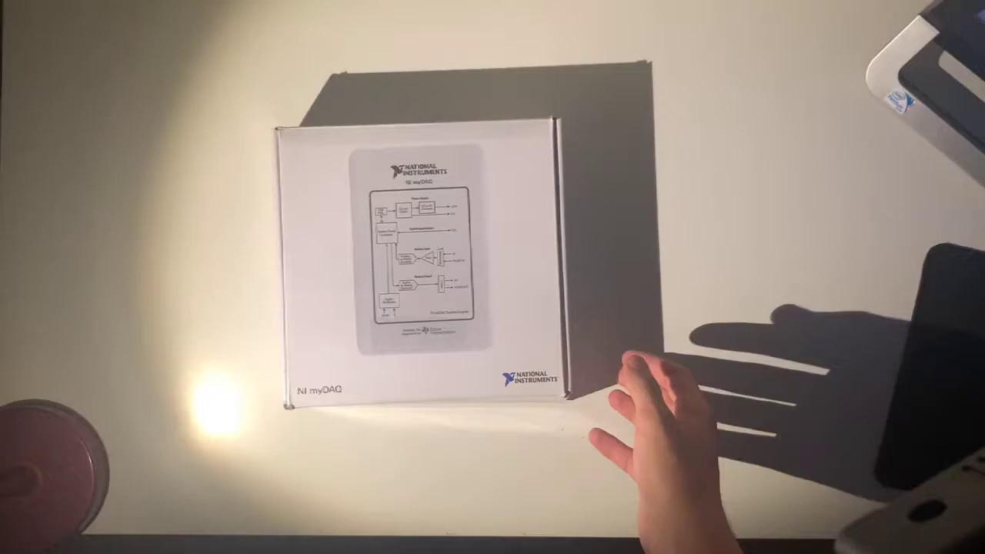 | 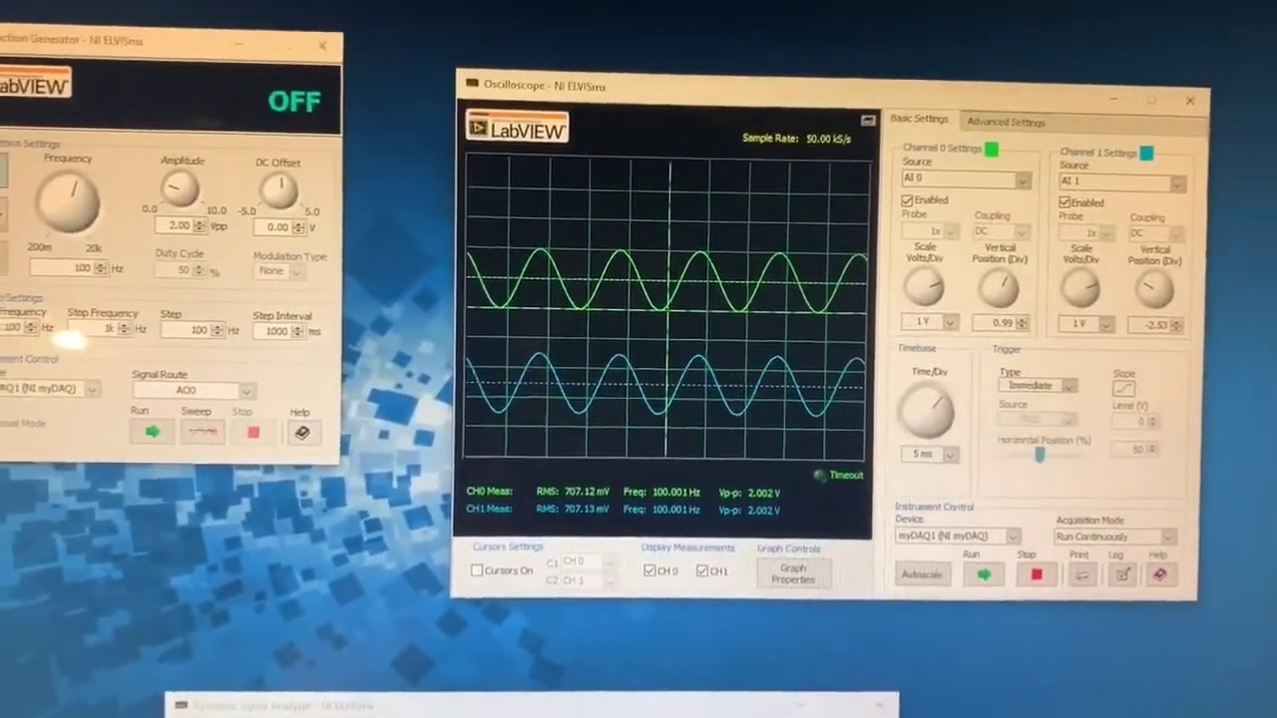 | 
Topic T7: Understanding Vo and Ground — score 20.0000
Description: The speaker explains how vo comes in at one zero and shows that ground is connected right here.
Reason: The comment does not directly discuss the topic of understanding Vo and Ground. Instead, it talks about a personal experience with using MyDaq tool in lab and its usefulness for future classes. There is no overlap between the topic and the comment.
 |  | 
Topic T5: Topic 3: Analyzing Graphs — score 20.0000
Description: How to analyze and identify patterns in the graph, including recognizing different values and identifying up amps.
Reason: The comment discusses using the MyDaq tool and testing components in lab, but does not directly discuss analyzing graphs or identifying patterns, unlike the topic. The mention of 'this video' suggests a general reference to the tutorial, rather than a specific analysis of graph patterns.
 |  | 
Topic T4: Topic 2: Understanding the Circuit — score 20.0000
Description: The basics of understanding how the circuit works, including the role of the resistor, capacitor, and ground.
Reason: The comment does not directly discuss the circuit or its components (resistor, capacitor, and ground), instead talking about a personal experience with the MyDaq tool and its usage. While it mentions using the tool in lab every Friday, this is not a direct discussion of the topic's described concepts.
 |  | 
Topic T3: Topic 1: Inputting Values — score 20.0000
Description: The importance of inputting values correctly for the circuit to work properly.
Reason: The comment does not directly discuss inputting values correctly for the circuit to work properly. Instead, it mentions using a tool called MyDaq and talks about its features and usage in lab.
 |  | 
Topic T2: Setting Up the Circuit — score 20.0000
Description: The speaker explains how to set up a circuit using zero as a reference point and shows where to plug in different components.
Reason: The comment mentions the tool (MyDaq) and its usage in a lab setting, but does not directly discuss the steps or components mentioned in the topic description.
 |  | 
Topic T1: Setting Up Resistor Values — score 20.0000
Description: The speaker shows how to set up resistor values and explains that this is two resistor six.
Reason: The comment mentions a specific tool (MyDaq) and its usage in lab every Friday, but does not directly discuss setting up resistor values. The topic is only briefly mentioned as something to be saved for future reference.
 |  | 
Topic T6: Understanding Negative Numbers — score 0.0000
Description: The speaker discusses how negative numbers work and how they are connected to the ground.
Reason: The comment does not discuss negative numbers or any related concepts. It appears to be a personal reflection on the usefulness of the video and its potential long-term use, with no direct connection to the topic.
Least correlated topics:
 |  | 
Topic T6: Understanding Negative Numbers — score 0.0000
Description: The speaker discusses how negative numbers work and how they are connected to the ground.
Reason: The comment does not discuss negative numbers or any related concepts. It appears to be a personal reflection on the usefulness of the video and its potential long-term use, with no direct connection to the topic.
 |  | 
Topic T1: Setting Up Resistor Values — score 20.0000
Description: The speaker shows how to set up resistor values and explains that this is two resistor six.
Reason: The comment mentions a specific tool (MyDaq) and its usage in lab every Friday, but does not directly discuss setting up resistor values. The topic is only briefly mentioned as something to be saved for future reference.
 |  | 
Topic T2: Setting Up the Circuit — score 20.0000
Description: The speaker explains how to set up a circuit using zero as a reference point and shows where to plug in different components.
Reason: The comment mentions the tool (MyDaq) and its usage in a lab setting, but does not directly discuss the steps or components mentioned in the topic description.
 |  | 
Topic T3: Topic 1: Inputting Values — score 20.0000
Description: The importance of inputting values correctly for the circuit to work properly.
Reason: The comment does not directly discuss inputting values correctly for the circuit to work properly. Instead, it mentions using a tool called MyDaq and talks about its features and usage in lab.
 |  | 
Topic T4: Topic 2: Understanding the Circuit — score 20.0000
Description: The basics of understanding how the circuit works, including the role of the resistor, capacitor, and ground.
Reason: The comment does not directly discuss the circuit or its components (resistor, capacitor, and ground), instead talking about a personal experience with the MyDaq tool and its usage. While it mentions using the tool in lab every Friday, this is not a direct discussion of the topic's described concepts.
 |  | 
Topic T5: Topic 3: Analyzing Graphs — score 20.0000
Description: How to analyze and identify patterns in the graph, including recognizing different values and identifying up amps.
Reason: The comment discusses using the MyDaq tool and testing components in lab, but does not directly discuss analyzing graphs or identifying patterns, unlike the topic. The mention of 'this video' suggests a general reference to the tutorial, rather than a specific analysis of graph patterns.
 |  | 
Topic T7: Understanding Vo and Ground — score 20.0000
Description: The speaker explains how vo comes in at one zero and shows that ground is connected right here.
Reason: The comment does not directly discuss the topic of understanding Vo and Ground. Instead, it talks about a personal experience with using MyDaq tool in lab and its usefulness for future classes. There is no overlap between the topic and the comment.

Topic T1: Setting Up Resistor Values
 |  | 
Description: The speaker shows how to set up resistor values and explains that this is two resistor six.
No strongly correlated comments found for this topic.

Topic T2: Setting Up the Circuit
 |  | 
Description: The speaker explains how to set up a circuit using zero as a reference point and shows where to plug in different components.
No strongly correlated comments found for this topic.

Topic T3: Topic 1: Inputting Values
 |  | 
Description: The importance of inputting values correctly for the circuit to work properly.
No strongly correlated comments found for this topic.

Topic T4: Topic 2: Understanding the Circuit
 |  | 
Description: The basics of understanding how the circuit works, including the role of the resistor, capacitor, and ground.
No strongly correlated comments found for this topic.

Topic T5: Topic 3: Analyzing Graphs
 |  | 
Description: How to analyze and identify patterns in the graph, including recognizing different values and identifying up amps.
No strongly correlated comments found for this topic.

Topic T6: Understanding Negative Numbers
 |  | 
Description: The speaker discusses how negative numbers work and how they are connected to the ground.
No strongly correlated comments found for this topic.

Topic T7: Understanding Vo and Ground
 |  | 
Description: The speaker explains how vo comes in at one zero and shows that ground is connected right here.
No strongly correlated comments found for this topic.

