Comment–Topic Correlation Report
Model: llama3

Summary
Topics processed: 7
Comments available for this video: 1
Comments correlated to ≥ 60: 1 (100.0%)
Total candidate pairs checked: 7

Most/Least correlated topics (by average score across correlated comments):
Top 3:
• Topic T3: Noise Reduction via Uneven Blade Spacing — avg 80.00, contributions 1
• Topic T1: Introduction — avg 80.00, contributions 1
• Topic T2: Unveiling the Zipline Propellers — avg 0.00, contributions 0
Bottom 3:
• Topic T7: Conclusion and Future Work — avg 0.00, contributions 0
• Topic T6: Efficiency Comparison: Uneven vs. Even Blade Spacing — avg 0.00, contributions 0
• Topic T5: SimScale Simulation: Real Physics in Action — avg 0.00, contributions 0
Correlated comment coverage (all comments):
- matched 2 topic(s), max score 80.0000: Stemming off from the previous Zipline drone. This video discusses how the drones are so silent. This is due to the uneven spacing of the drone’s propellers. When the propellers of the drones are spaced unevenly, it admit a lower frequency than if they were spaced proportionally to one another. This lower frequency is proposed as being quieter to the human ear, and therefore less annoying than the higher-pitched sound of a regular drone. However, the downside of this is that the wind speed of the drone is slower due to the turbulent flow being decreased. MIT is already researching this and has come up with several solutions to increase the turbulent flow while still maintaining the noise reduction.
Source: https://www.youtube.com/watch?v=z58RORCUTao: How Do Zipline's Silent Propellers Work?
Top correlated topics:
 | 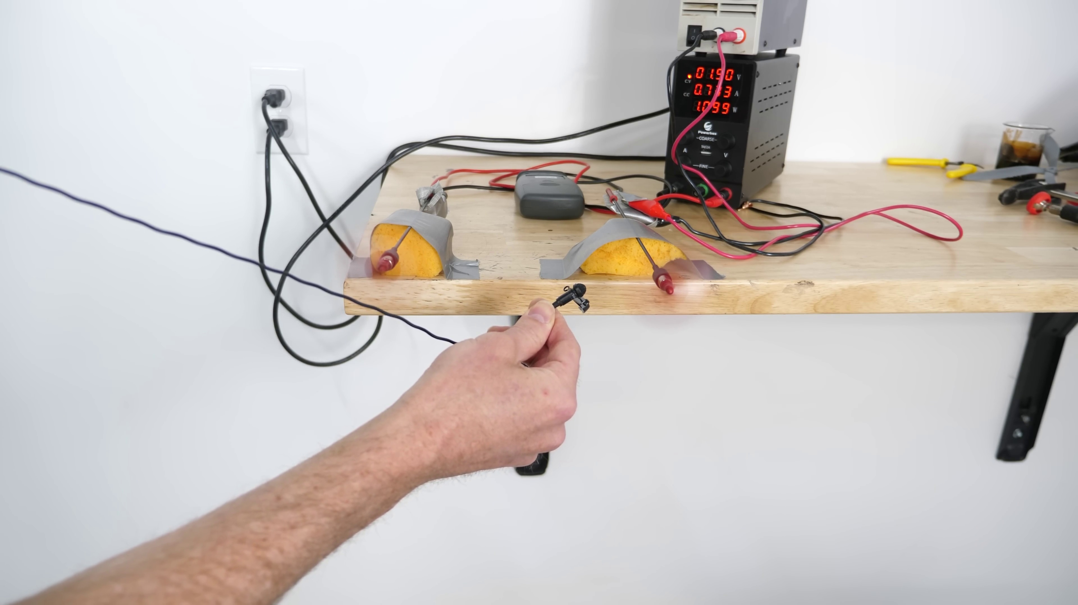 | 
Topic T3: Noise Reduction via Uneven Blade Spacing — score 80.0000
Description: How uneven blade spacing can reduce noise levels
Reason: The comment directly discusses the same concept of uneven blade spacing reducing noise levels, citing specific examples and scientific research (MIT) to support its claims.
 |  | 
Topic T1: Introduction — score 80.0000
Description: Overview of the video and its topics
Reason: The comment directly discusses the same topic (drone propellers and noise reduction) described in the introduction, mentioning specific details such as uneven spacing and lower frequency.
 |  | 
Topic T6: Efficiency Comparison: Uneven vs. Even Blade Spacing — score 20.0000
Description: The pros and cons of uneven blade spacing in terms of efficiency
Reason: The comment discusses drone propellers and their spacing, but not the topic of uneven vs. even blade spacing in efficiency comparison. The only overlap is the mention of 'uneven spacing', but it's applied to a different context (drone propellers) rather than blades.
 |  | 
Topic T4: Toroidal Propellers: A Different Approach — score 20.0000
Description: The design and benefits of toroidal propellers
Reason: The comment discusses drone propellers and their spacing to reduce noise, whereas the topic is about toroidal propellers and their design benefits. Although both mention propellers, the context and specific details are unrelated.
 |  | 
Topic T2: Unveiling the Zipline Propellers — score 20.0000
Description: The concept of ziplines blades and their unique design
Reason: The comment discusses a related concept (silence of ziplines) but does not directly discuss the design of the propellers as described in the topic. The mention of uneven spacing is also mentioned in relation to drone's propellers, which is tangential to the topic.
 |  | 
Topic T5: SimScale Simulation: Real Physics in Action — score 10.0000
Description: Simulation results showing the effectiveness of toroidal propellers
Reason: The topic discusses SimScale simulations of toroidal propellers, while the comment talks about unevenly spaced propellers in drones and their effects on noise reduction. The topics are unrelated.
 |  | 
Topic T7: Conclusion and Future Work — score 0.0000
Description: Summary of the video's main points and potential future research directions
Reason: The topic is about conclusion and future work, while the comment discusses a specific technical aspect of drone design and noise reduction. There is no overlap in terms of steps, objects, settings, parameters, claims, or goals described by the topic.
Least correlated topics:
 |  | 
Topic T7: Conclusion and Future Work — score 0.0000
Description: Summary of the video's main points and potential future research directions
Reason: The topic is about conclusion and future work, while the comment discusses a specific technical aspect of drone design and noise reduction. There is no overlap in terms of steps, objects, settings, parameters, claims, or goals described by the topic.
 |  | 
Topic T5: SimScale Simulation: Real Physics in Action — score 10.0000
Description: Simulation results showing the effectiveness of toroidal propellers
Reason: The topic discusses SimScale simulations of toroidal propellers, while the comment talks about unevenly spaced propellers in drones and their effects on noise reduction. The topics are unrelated.
 |  | 
Topic T2: Unveiling the Zipline Propellers — score 20.0000
Description: The concept of ziplines blades and their unique design
Reason: The comment discusses a related concept (silence of ziplines) but does not directly discuss the design of the propellers as described in the topic. The mention of uneven spacing is also mentioned in relation to drone's propellers, which is tangential to the topic.
 |  | 
Topic T4: Toroidal Propellers: A Different Approach — score 20.0000
Description: The design and benefits of toroidal propellers
Reason: The comment discusses drone propellers and their spacing to reduce noise, whereas the topic is about toroidal propellers and their design benefits. Although both mention propellers, the context and specific details are unrelated.
 |  | 
Topic T6: Efficiency Comparison: Uneven vs. Even Blade Spacing — score 20.0000
Description: The pros and cons of uneven blade spacing in terms of efficiency
Reason: The comment discusses drone propellers and their spacing, but not the topic of uneven vs. even blade spacing in efficiency comparison. The only overlap is the mention of 'uneven spacing', but it's applied to a different context (drone propellers) rather than blades.
 |  | 
Topic T1: Introduction — score 80.0000
Description: Overview of the video and its topics
Reason: The comment directly discusses the same topic (drone propellers and noise reduction) described in the introduction, mentioning specific details such as uneven spacing and lower frequency.
 |  | 
Topic T3: Noise Reduction via Uneven Blade Spacing — score 80.0000
Description: How uneven blade spacing can reduce noise levels
Reason: The comment directly discusses the same concept of uneven blade spacing reducing noise levels, citing specific examples and scientific research (MIT) to support its claims.

Topic T1: Introduction
 |  | 
Description: Overview of the video and its topics
Comment (score 80): Stemming off from the previous Zipline drone. This video discusses how the drones are so silent. This is due to the uneven spacing of the drone’s propellers. When the propellers of the drones are spaced unevenly, it admit a lower frequency than if they were spaced proportionally to one another. This lower frequency is proposed as being quieter to the human ear, and therefore less annoying than the higher-pitched sound of a regular drone. However, the downside of this is that the wind speed of the drone is slower due to the turbulent flow being decreased. MIT is already researching this and has come up with several solutions to increase the turbulent flow while still maintaining the noise reduction.
Reason: The comment directly discusses the same topic (drone propellers and noise reduction) described in the introduction, mentioning specific details such as uneven spacing and lower frequency.
Source: https://www.youtube.com/watch?v=z58RORCUTao: How Do Zipline's Silent Propellers Work?

Topic T2: Unveiling the Zipline Propellers
 |  | 
Description: The concept of ziplines blades and their unique design
No strongly correlated comments found for this topic.

Topic T3: Noise Reduction via Uneven Blade Spacing
 |  | 
Description: How uneven blade spacing can reduce noise levels
Comment (score 80): Stemming off from the previous Zipline drone. This video discusses how the drones are so silent. This is due to the uneven spacing of the drone’s propellers. When the propellers of the drones are spaced unevenly, it admit a lower frequency than if they were spaced proportionally to one another. This lower frequency is proposed as being quieter to the human ear, and therefore less annoying than the higher-pitched sound of a regular drone. However, the downside of this is that the wind speed of the drone is slower due to the turbulent flow being decreased. MIT is already researching this and has come up with several solutions to increase the turbulent flow while still maintaining the noise reduction.
Reason: The comment directly discusses the same concept of uneven blade spacing reducing noise levels, citing specific examples and scientific research (MIT) to support its claims.
Source: https://www.youtube.com/watch?v=z58RORCUTao: How Do Zipline's Silent Propellers Work?

Topic T4: Toroidal Propellers: A Different Approach
 |  | 
Description: The design and benefits of toroidal propellers
No strongly correlated comments found for this topic.

Topic T5: SimScale Simulation: Real Physics in Action
 |  | 
Description: Simulation results showing the effectiveness of toroidal propellers
No strongly correlated comments found for this topic.

Topic T6: Efficiency Comparison: Uneven vs. Even Blade Spacing
 |  | 
Description: The pros and cons of uneven blade spacing in terms of efficiency
No strongly correlated comments found for this topic.

Topic T7: Conclusion and Future Work
 |  | 
Description: Summary of the video's main points and potential future research directions
No strongly correlated comments found for this topic.

