Comment–Topic Correlation Report
Model: llama3

Summary
Topics processed: 2
Comments available for this video: 1
Comments correlated to ≥ 60: 0 (0.0%)
Total candidate pairs checked: 2

Most/Least correlated topics (by average score across correlated comments):
Top 3:
• Topic T1: akan — avg 0.00, contributions 0
• Topic T2: Statistic — avg 0.00, contributions 0
Bottom 3:
• Topic T2: Statistic — avg 0.00, contributions 0
• Topic T1: akan — avg 0.00, contributions 0
Correlated comment coverage (all comments):
- matched 0 topic(s), max score 0.0000: Useful Content: I found the usage of four transistors in the circuit very interesting. The diode connection between the transistors was also fascinating from an electronics standpoint. The Circuit overall seems to work very well for its intended purpose.Confused Content: Some of the components used in the circuit were not clearly shown, so I am unsure about exactly what they are. Future Use: I chose this video to help get inspiration for Class Project Phase 2.
Source: https://www.youtube.com/watch?v=zZE4AejgDOA&t=12s: DIY Powerful Ultra Bass Amplifier Supply Transistor , New Circuit, How to Make Powerful Ultra Bass
Top correlated topics:
 | 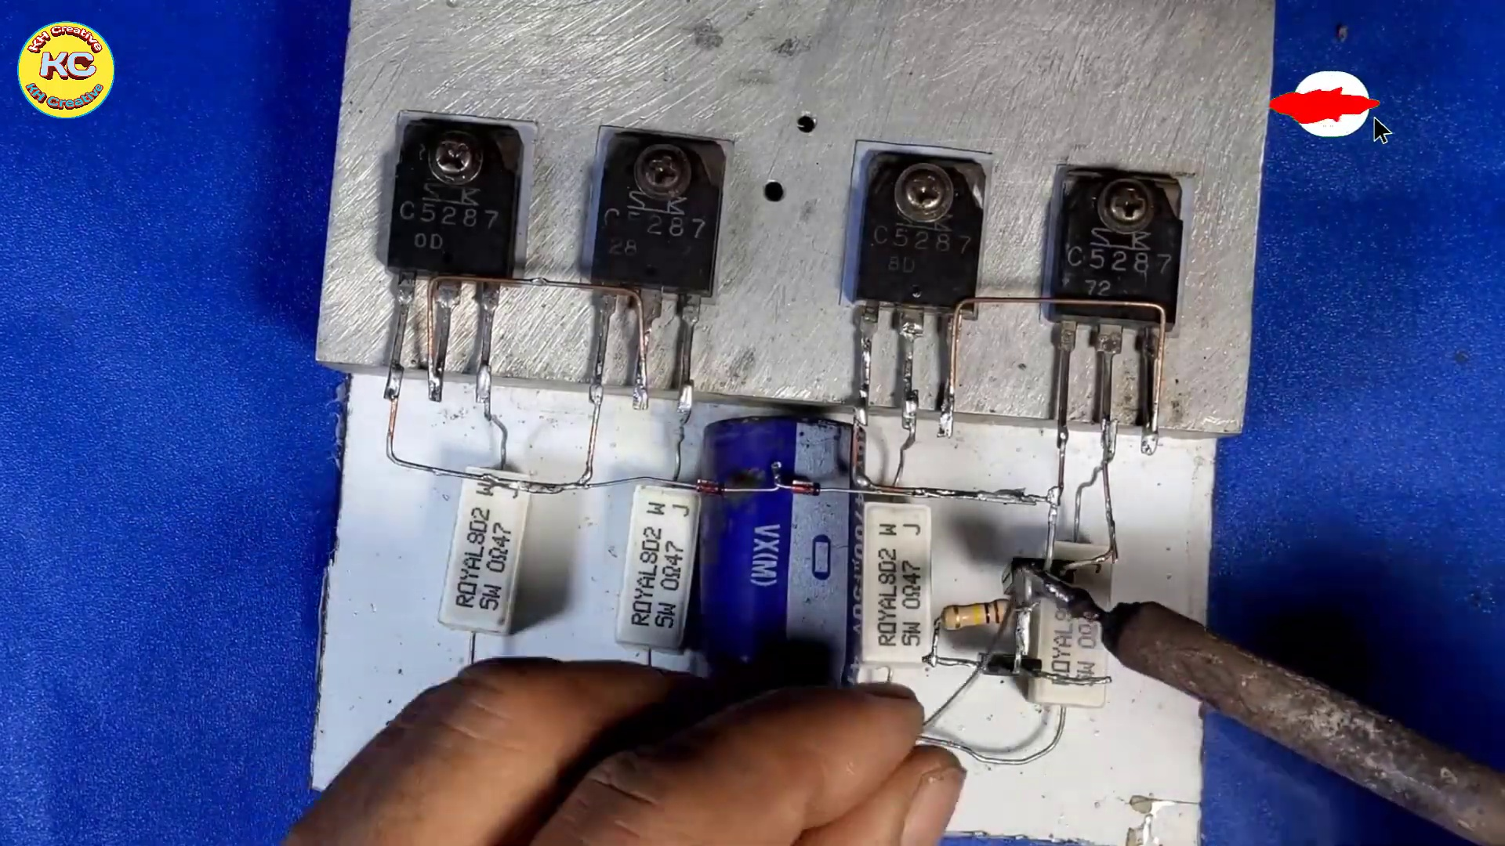 | 
Topic T2: Statistic — score 0.0000
Description: The speaker talks about statistics, specifically saying something.
Reason: The comment discusses electronics and circuit details, while the topic is about statistics. There are no overlaps between the two topics.
 |  | 
Topic T1: akan — score 0.0000
Description: The speaker mentions akan.
Reason: The comment does not mention 'akan' at all. Instead, it discusses electronics and circuit design, with no apparent connection to the topic.
Least correlated topics:
 |  | 
Topic T1: akan — score 0.0000
Description: The speaker mentions akan.
Reason: The comment does not mention 'akan' at all. Instead, it discusses electronics and circuit design, with no apparent connection to the topic.
 |  | 
Topic T2: Statistic — score 0.0000
Description: The speaker talks about statistics, specifically saying something.
Reason: The comment discusses electronics and circuit details, while the topic is about statistics. There are no overlaps between the two topics.

Topic T1: akan
 |  | 
Description: The speaker mentions akan.
No strongly correlated comments found for this topic.

Topic T2: Statistic
 |  | 
Description: The speaker talks about statistics, specifically saying something.
No strongly correlated comments found for this topic.

