Engagement Analysis: _HHxV-7alwE

Section 0: Introduction to Dronebot Workshop
Time: 0:00 - 0:45

Summary
The section introduces the Dronebot Workshop, a resource for drones and robotics. The host discusses various topics related to drone flying and content creation for YouTube.

Representative Frames
0:07  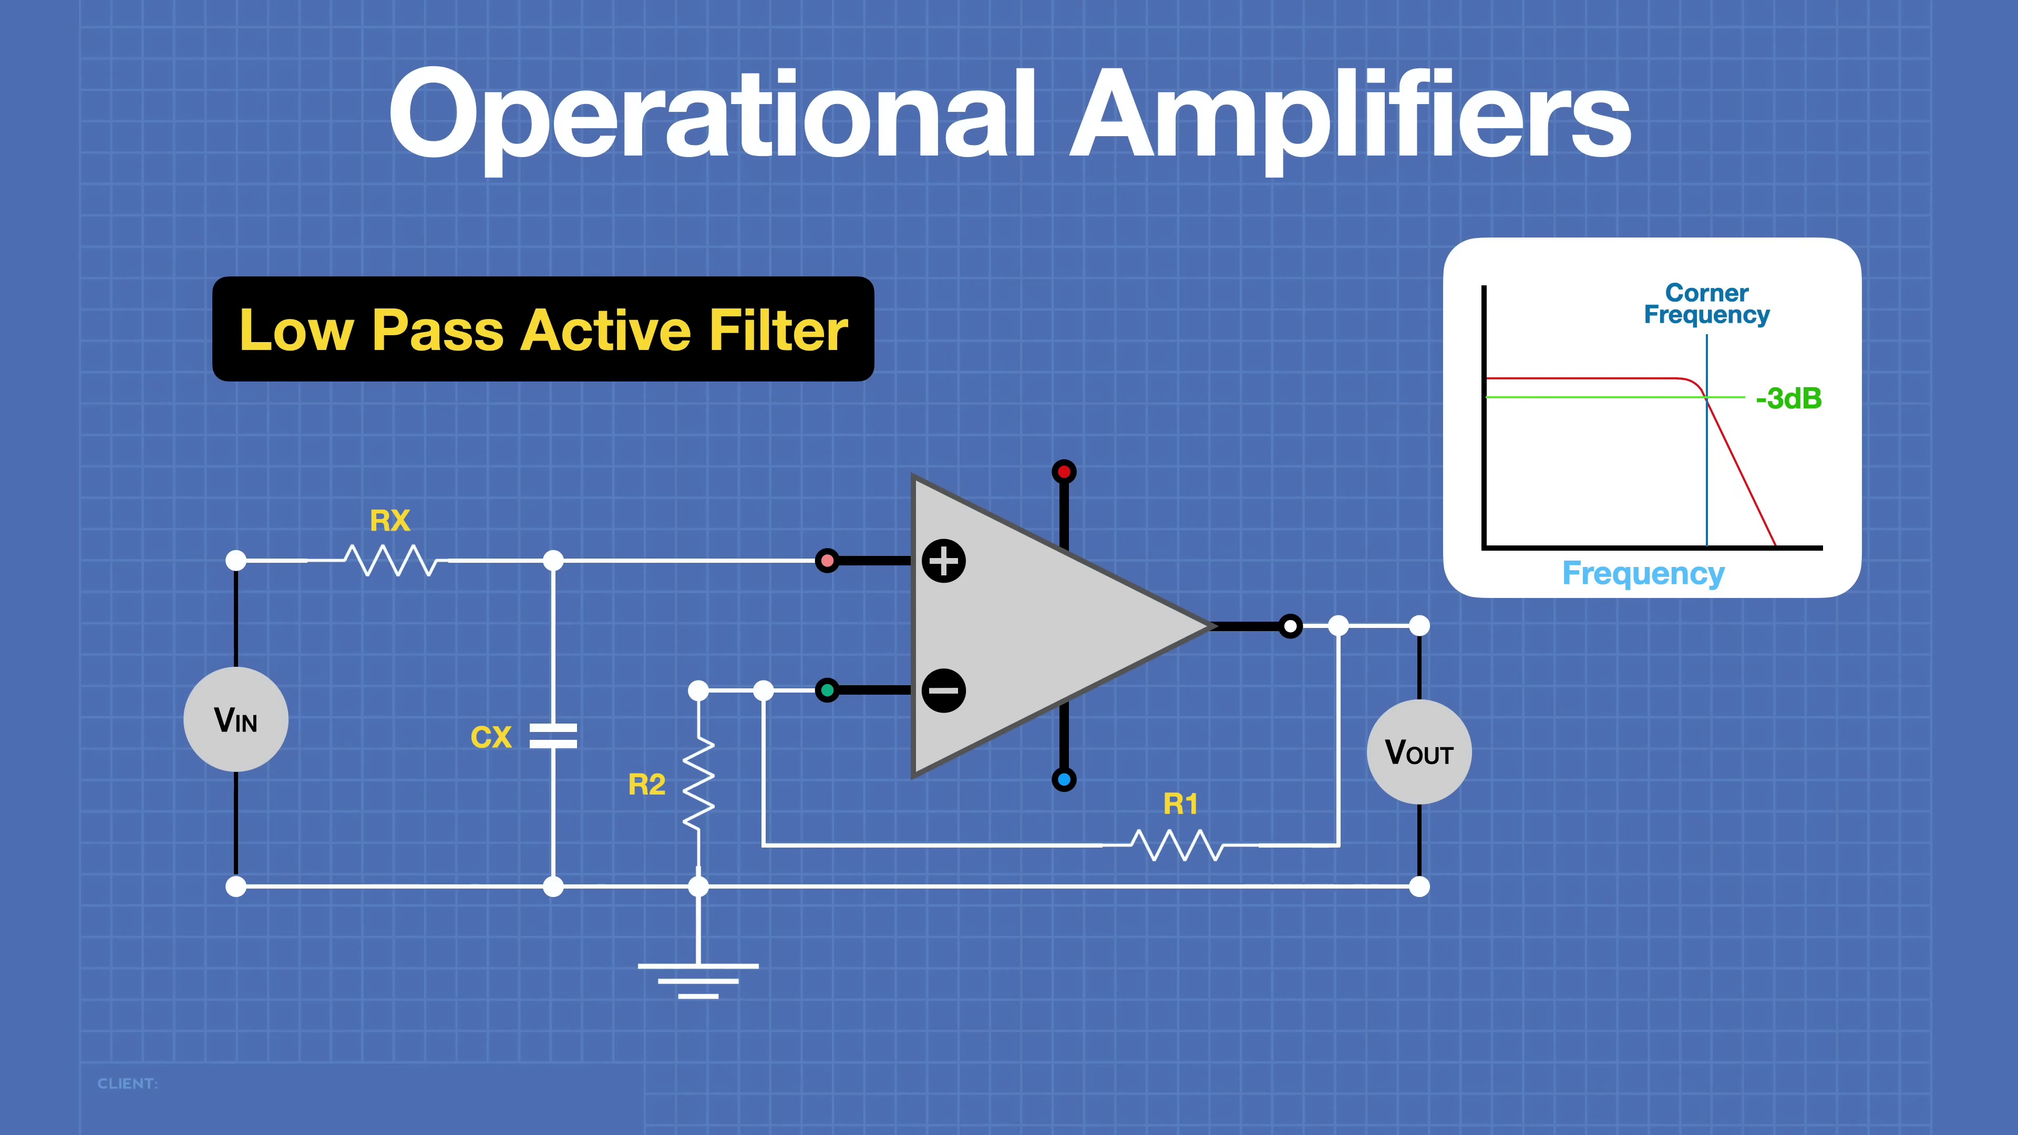 | 0:15  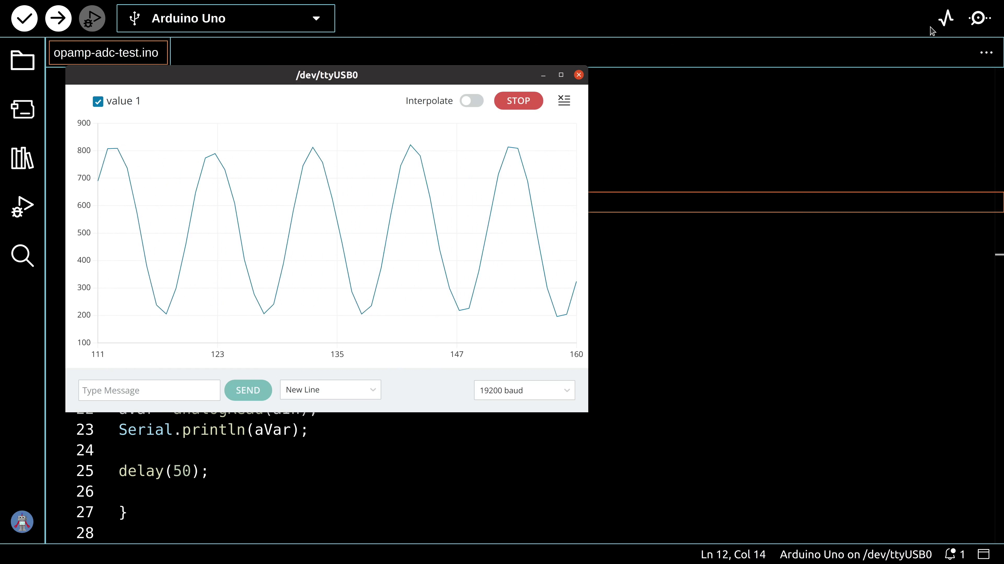 | 0:22  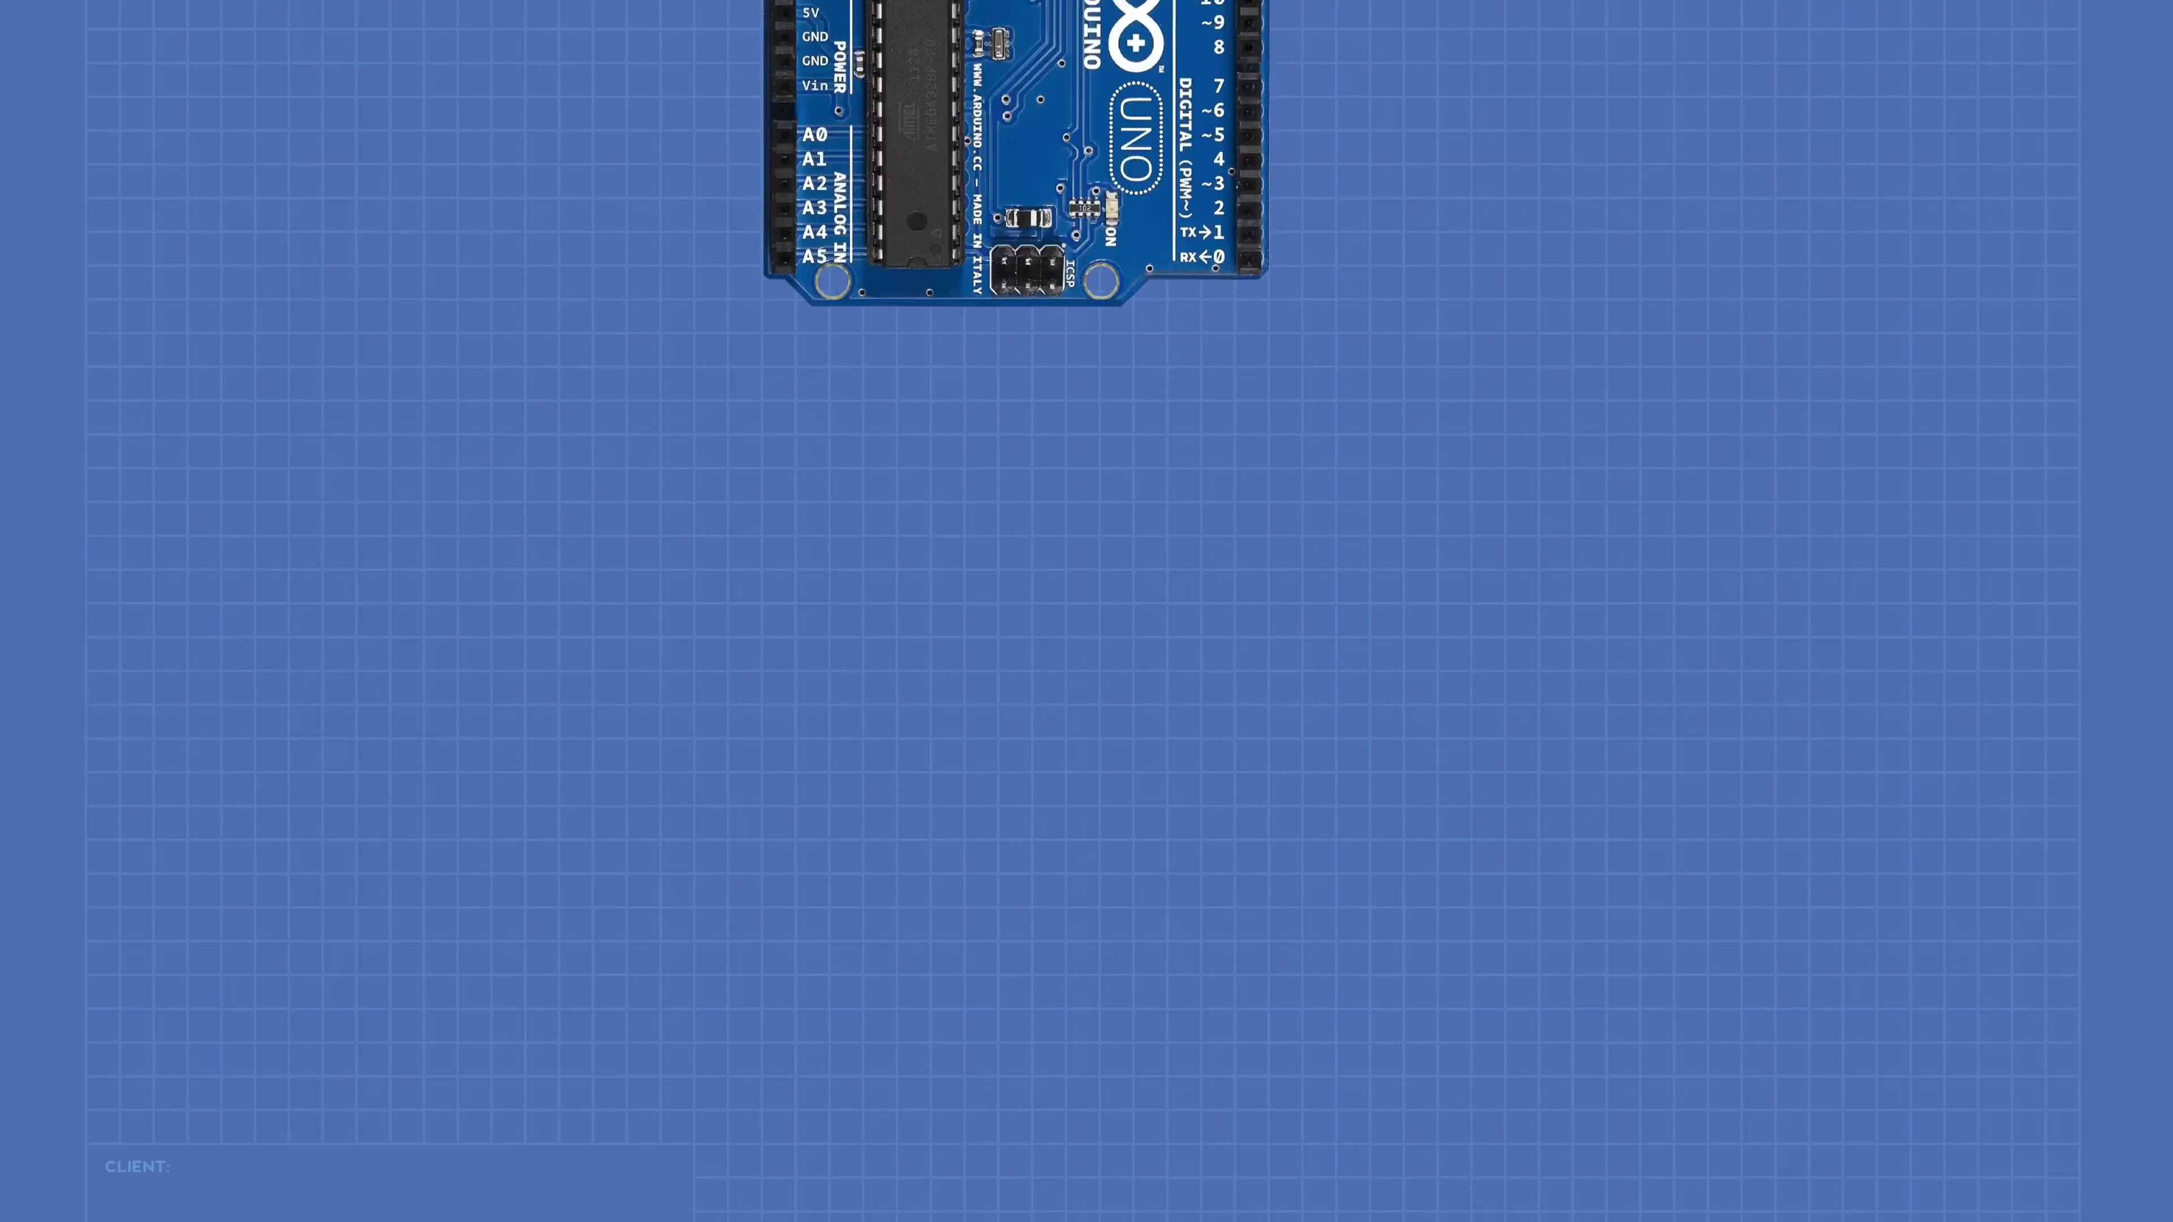 | 0:30   | 0:37  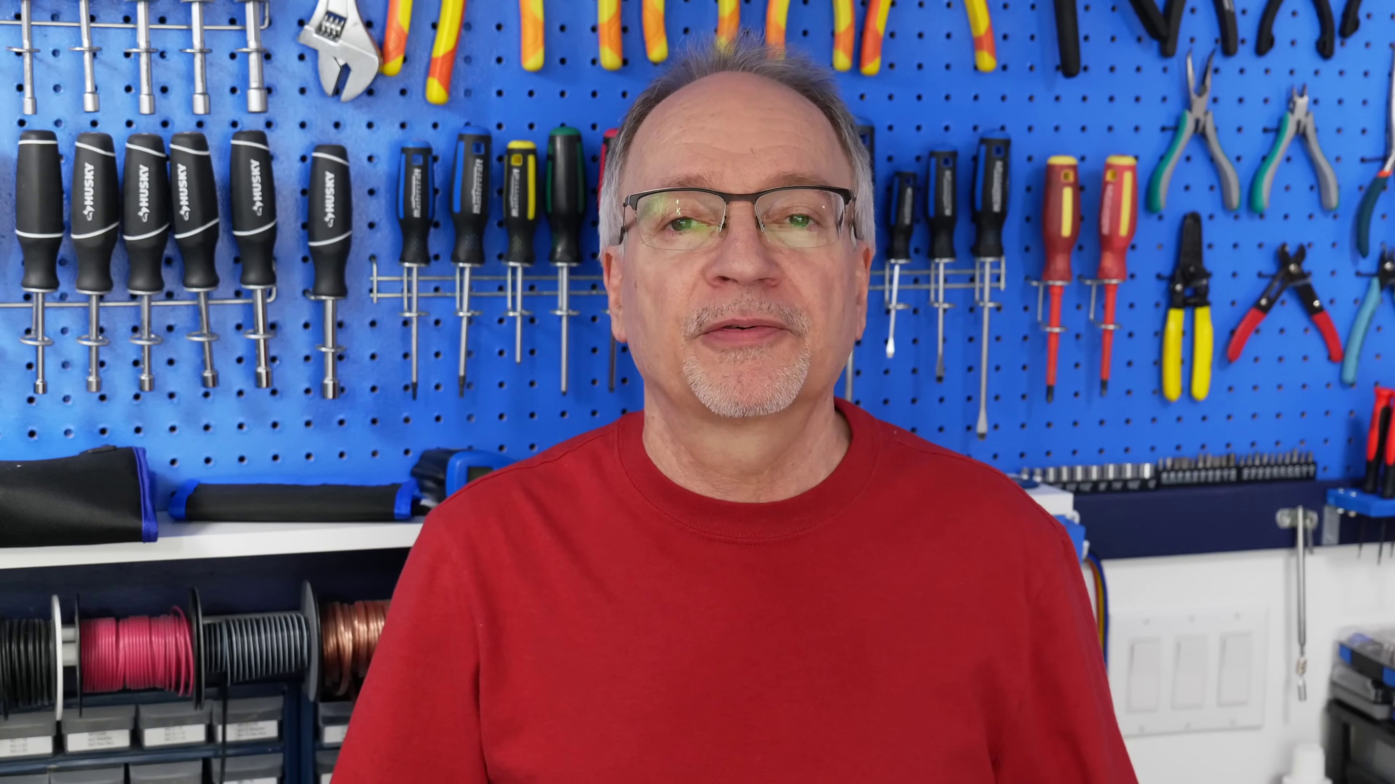

Transcript
[0:00] Today in the workshop we're working with operational amplifiers.
[0:03] You'll see how op amps work and how to use them in several popular configurations.
[0:08] We'll also build a light activated switch, a dual power supply,
[0:13] and we'll use op amps with an Arduino.
[0:15] We're back in operation today, so welcome to the workshop.
[0:30] Well, hello and welcome to the workshop,
[0:33] and today we're going to be working with operational amplifiers,
[0:37] more commonly known as op amps.
[0:39] Now, op amps have been available in integrated circuit format for about six decades now,

Section 0: Closing Remarks
Time: 0:45 - 0:50

Summary
The host thanks the audience and provides a call-to-action for viewers to take care of themselves and stay safe.

Representative Frames
0:46  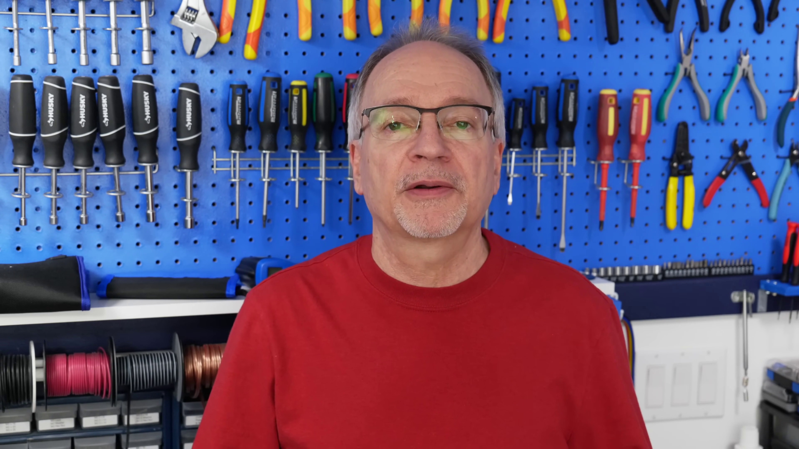 | 0:47  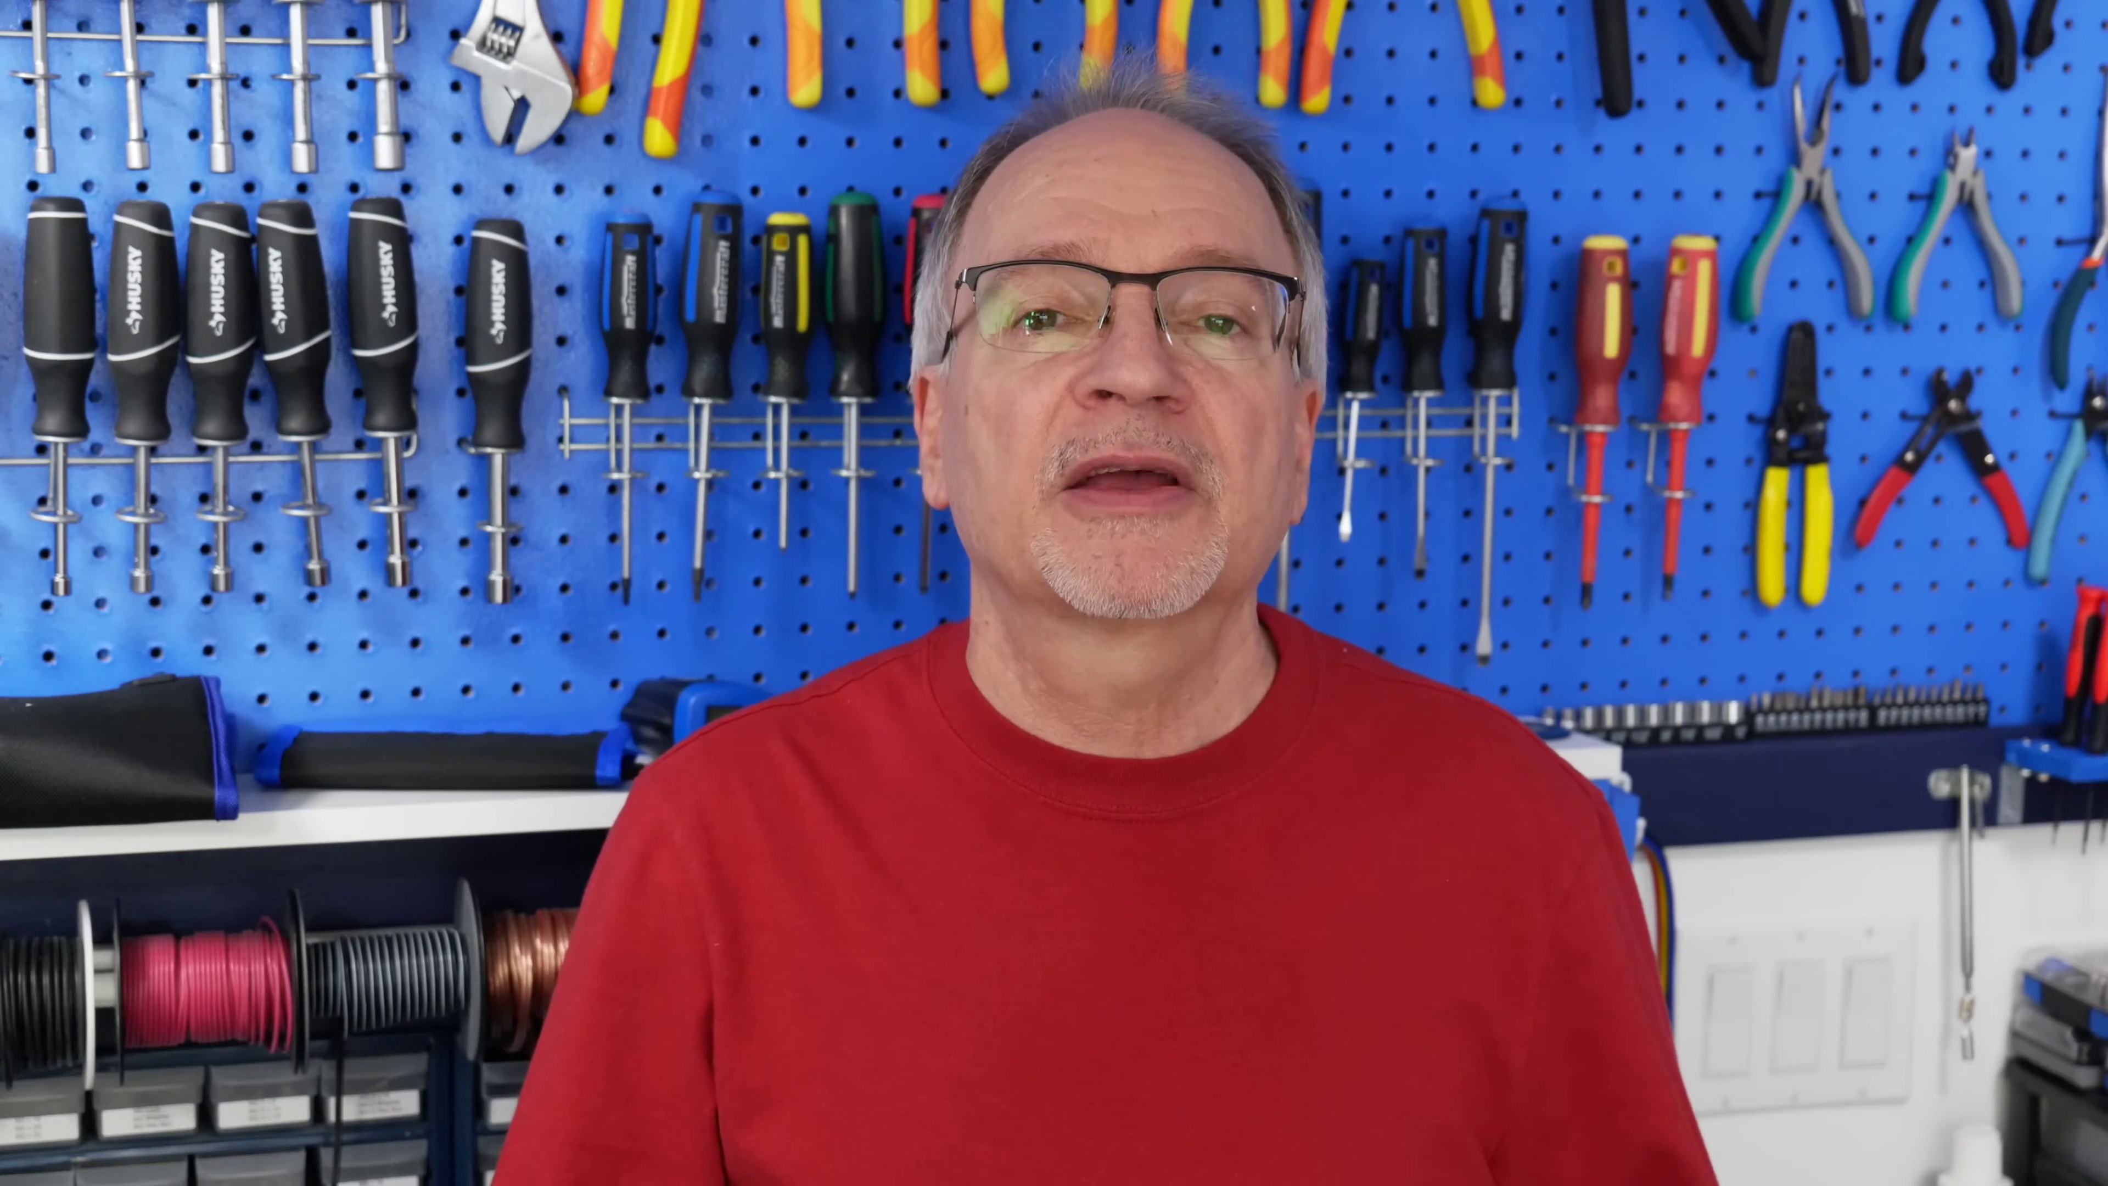 | 0:47   | 0:48   | 0:49  

Transcript
[0:45] and during that time they have been used in thousands and thousands of different analog designs.

Section 0: Graphical Representation
Time: 0:50 - 0:55

Summary
The section features a graphic design with various elements related to drone flying and content creation for YouTube.

Representative Frames
0:50  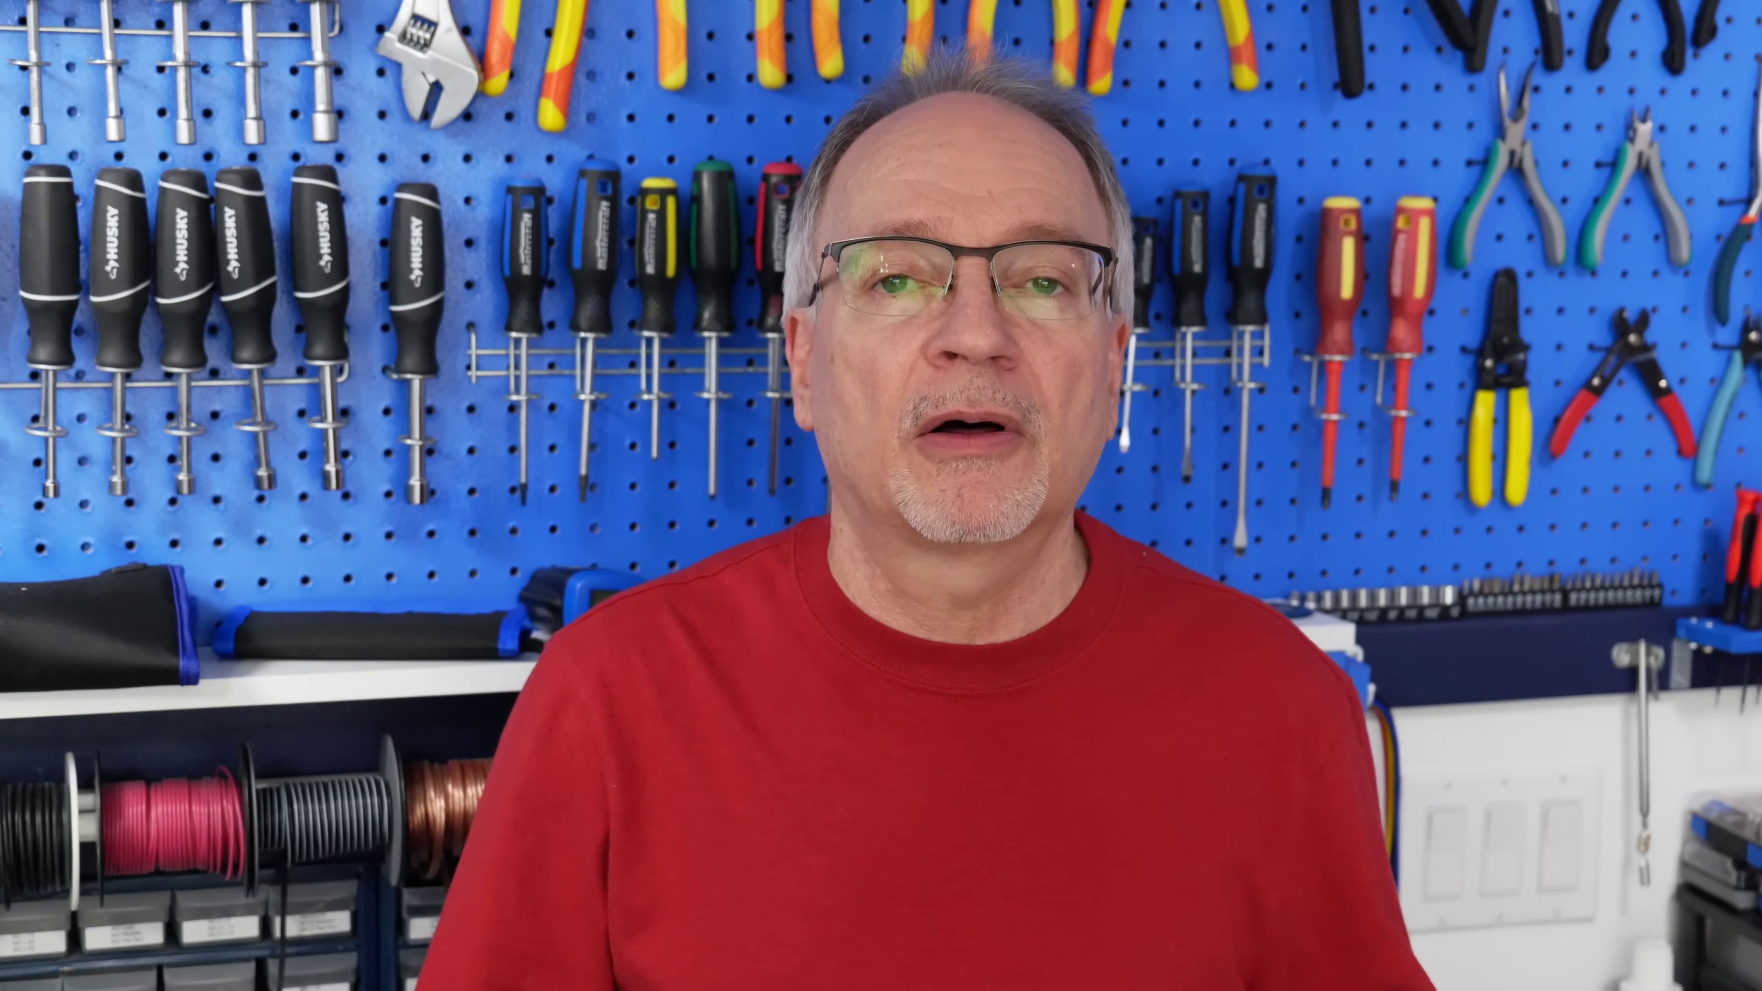 | 0:51   | 0:52   | 0:53   | 0:54  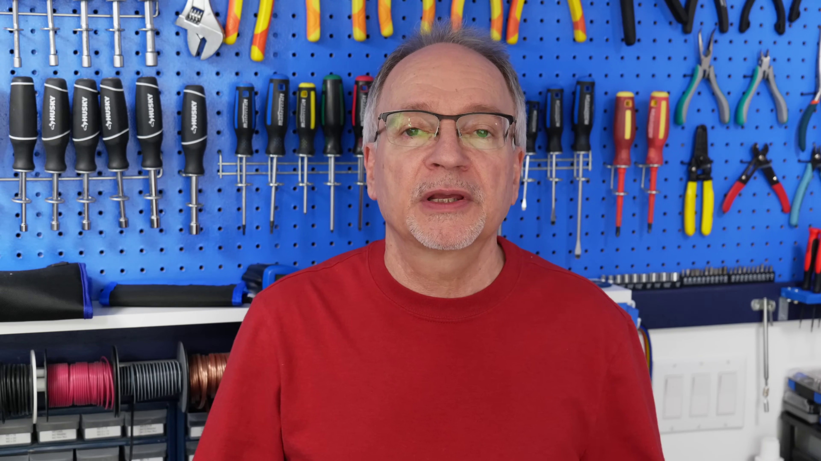

Transcript
[0:51] One of the reasons for their popularity is because they are so versatile.

