Engagement Analysis: hRnofMxEf3Q

Section 0: Introduction
Time: 0:00 - 0:04

Summary
A descriptive title for the first section.

Representative Frames
0:00  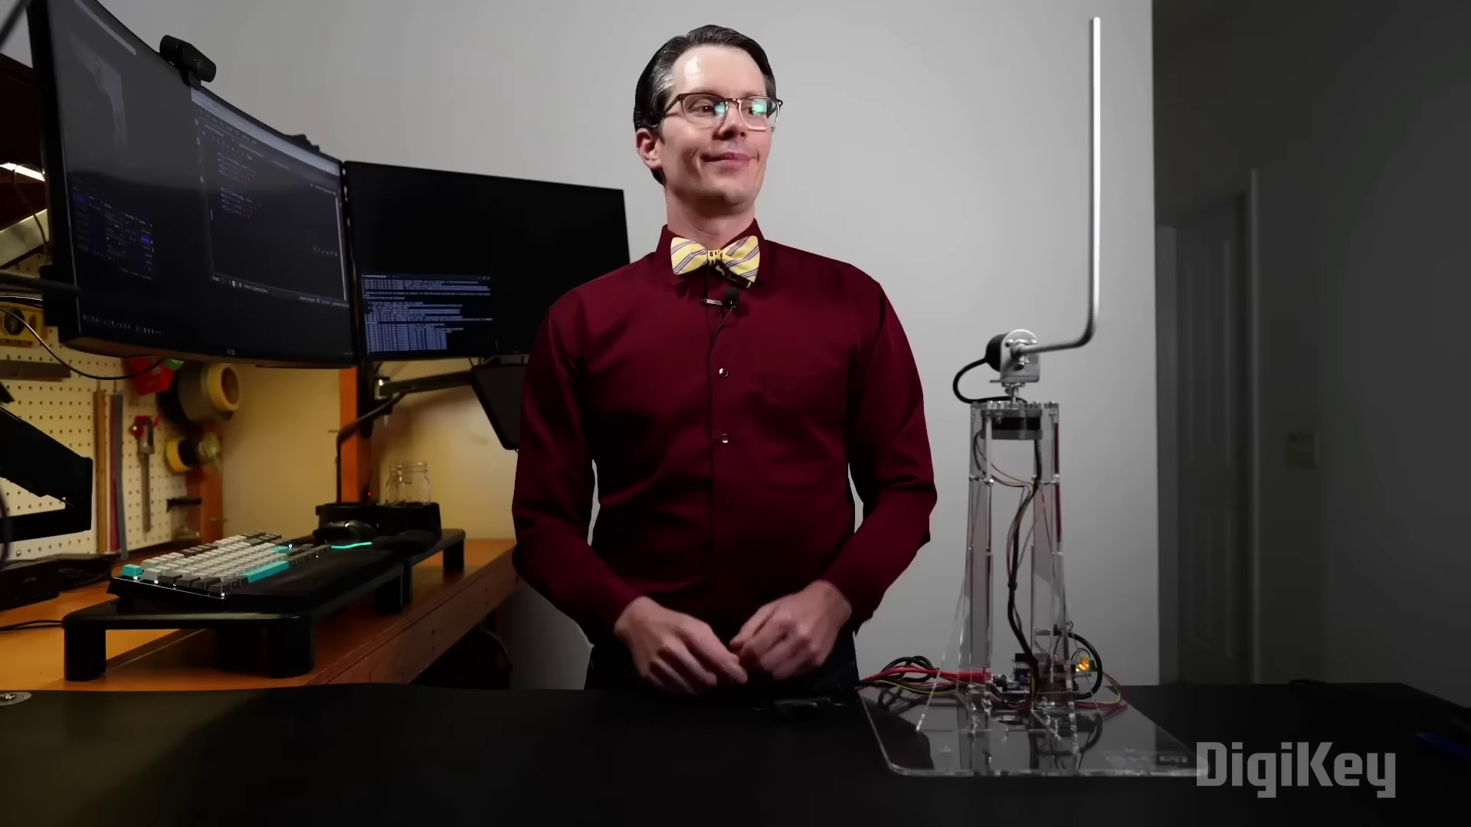 | 0:01   | 0:02   | 0:03   | 0:04  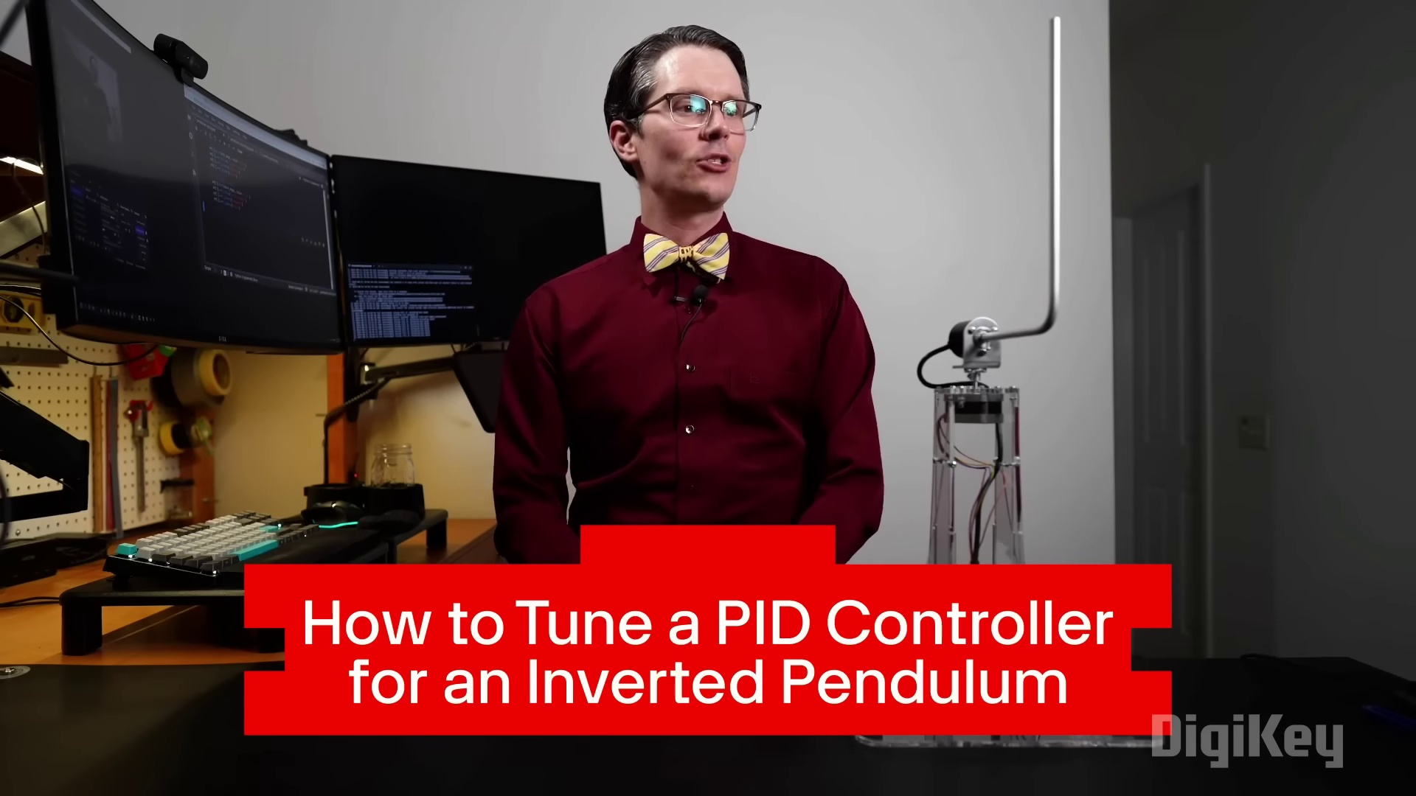

Transcript
[0:00] Ah, the inverted pendulum.

Section 0: Segment 1
Time: 0:05 - 0:14

Summary
The text describes a person sitting at a desk with various items around them.

Representative Frames
0:06   | 0:08  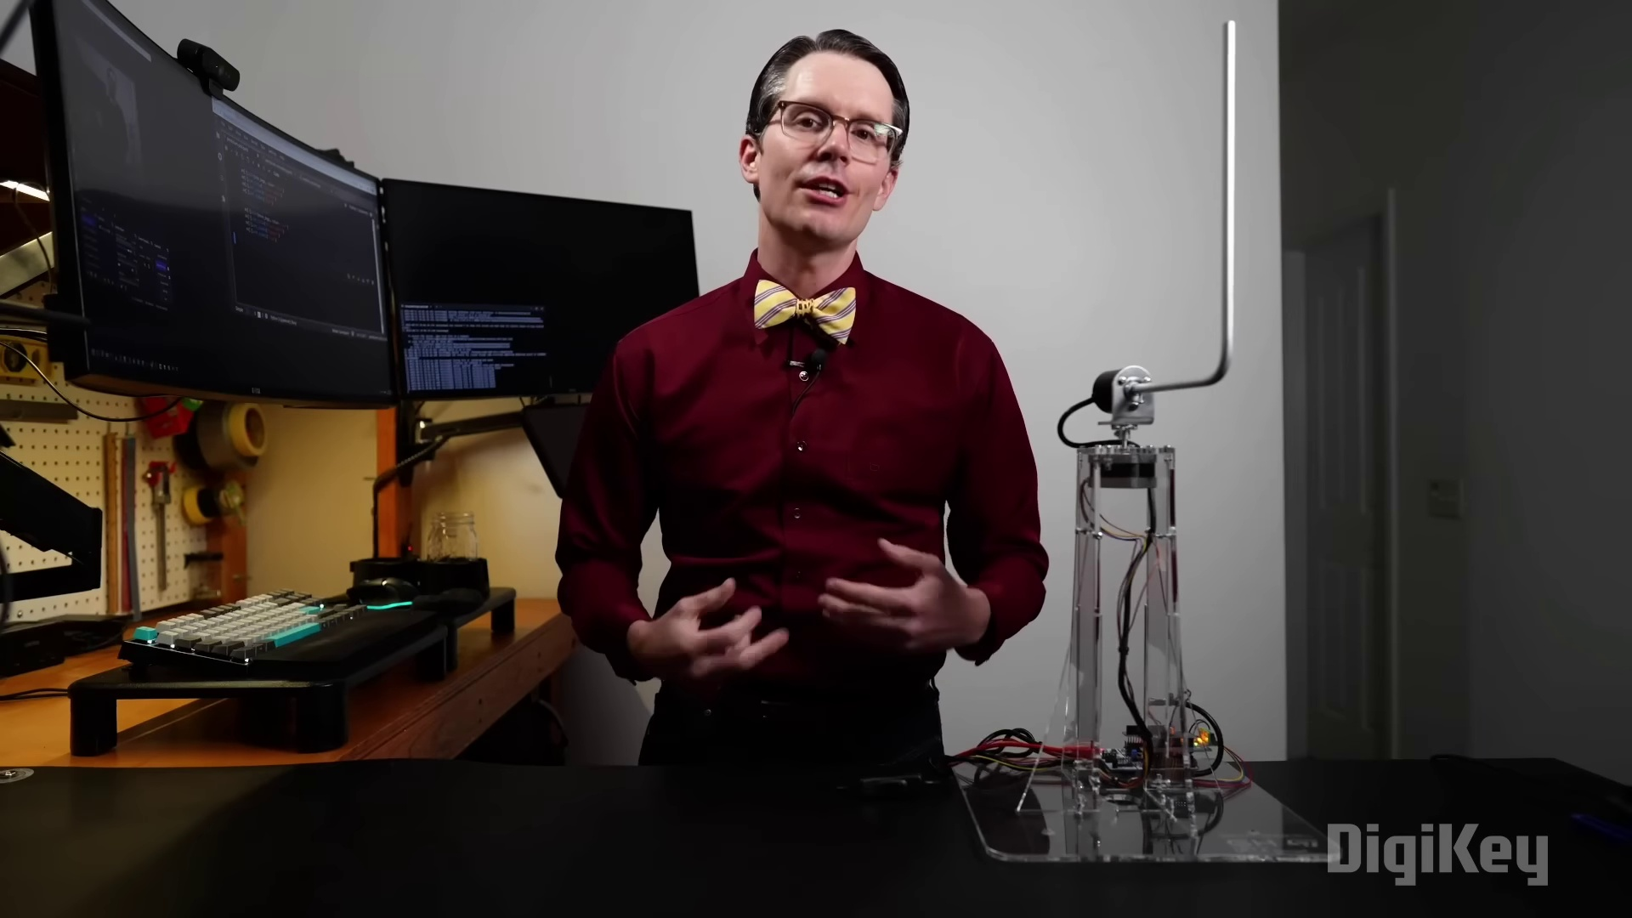 | 0:09   | 0:11  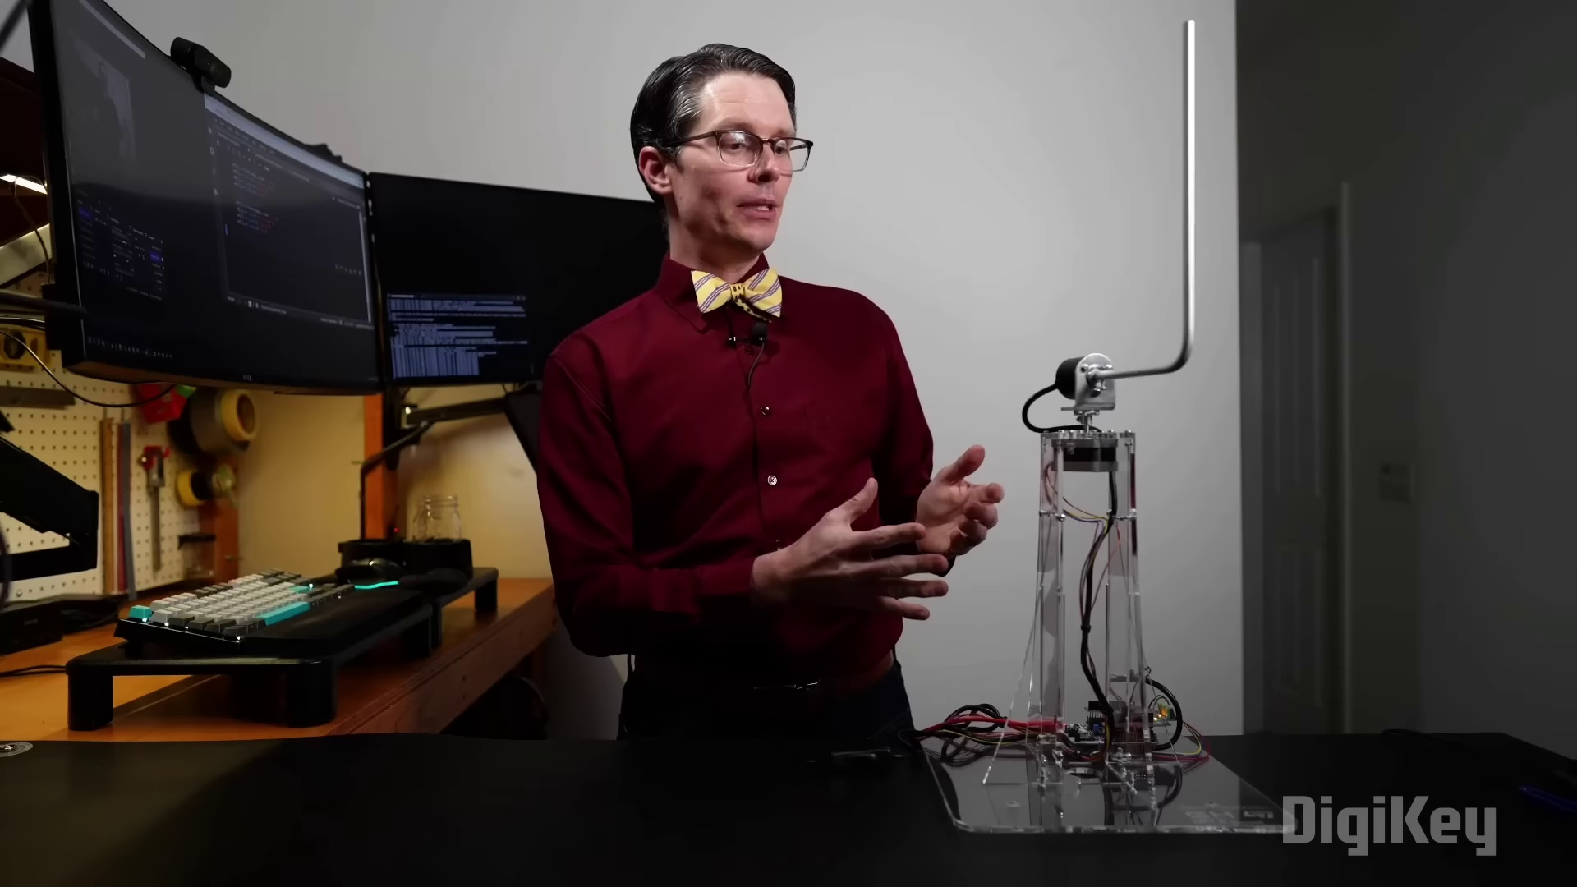 | 0:13  

Transcript
[0:02] Getting one of these to work is a little bit of a rite of passage if you're studying engineering or more specifically control theory.
[0:09] The concept is fairly straightforward.
[0:11] We have a weight or in this case a simple metal rod that can move freely about an axis.

Section 0: Segment 2
Time: 0:15 - 0:24

Summary
The text describes a scene with two figures and various objects around them.

Representative Frames
0:16  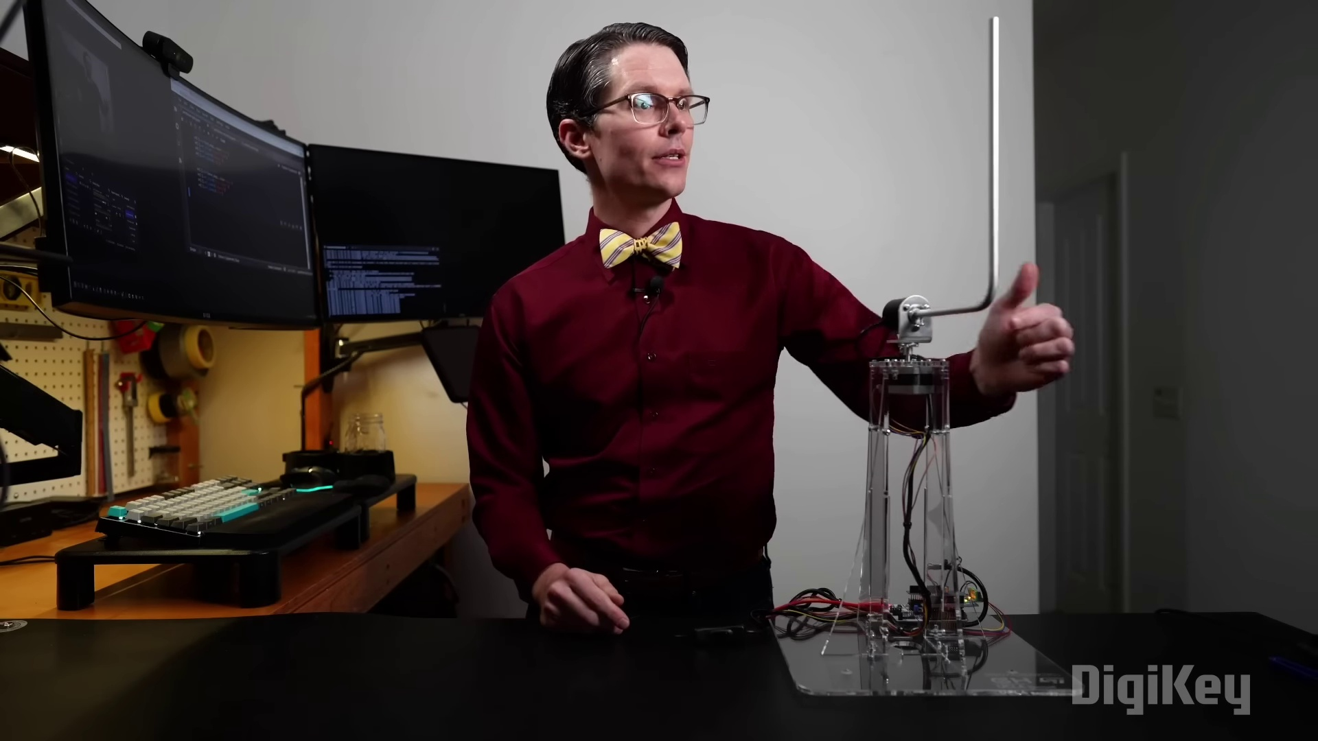 | 0:18  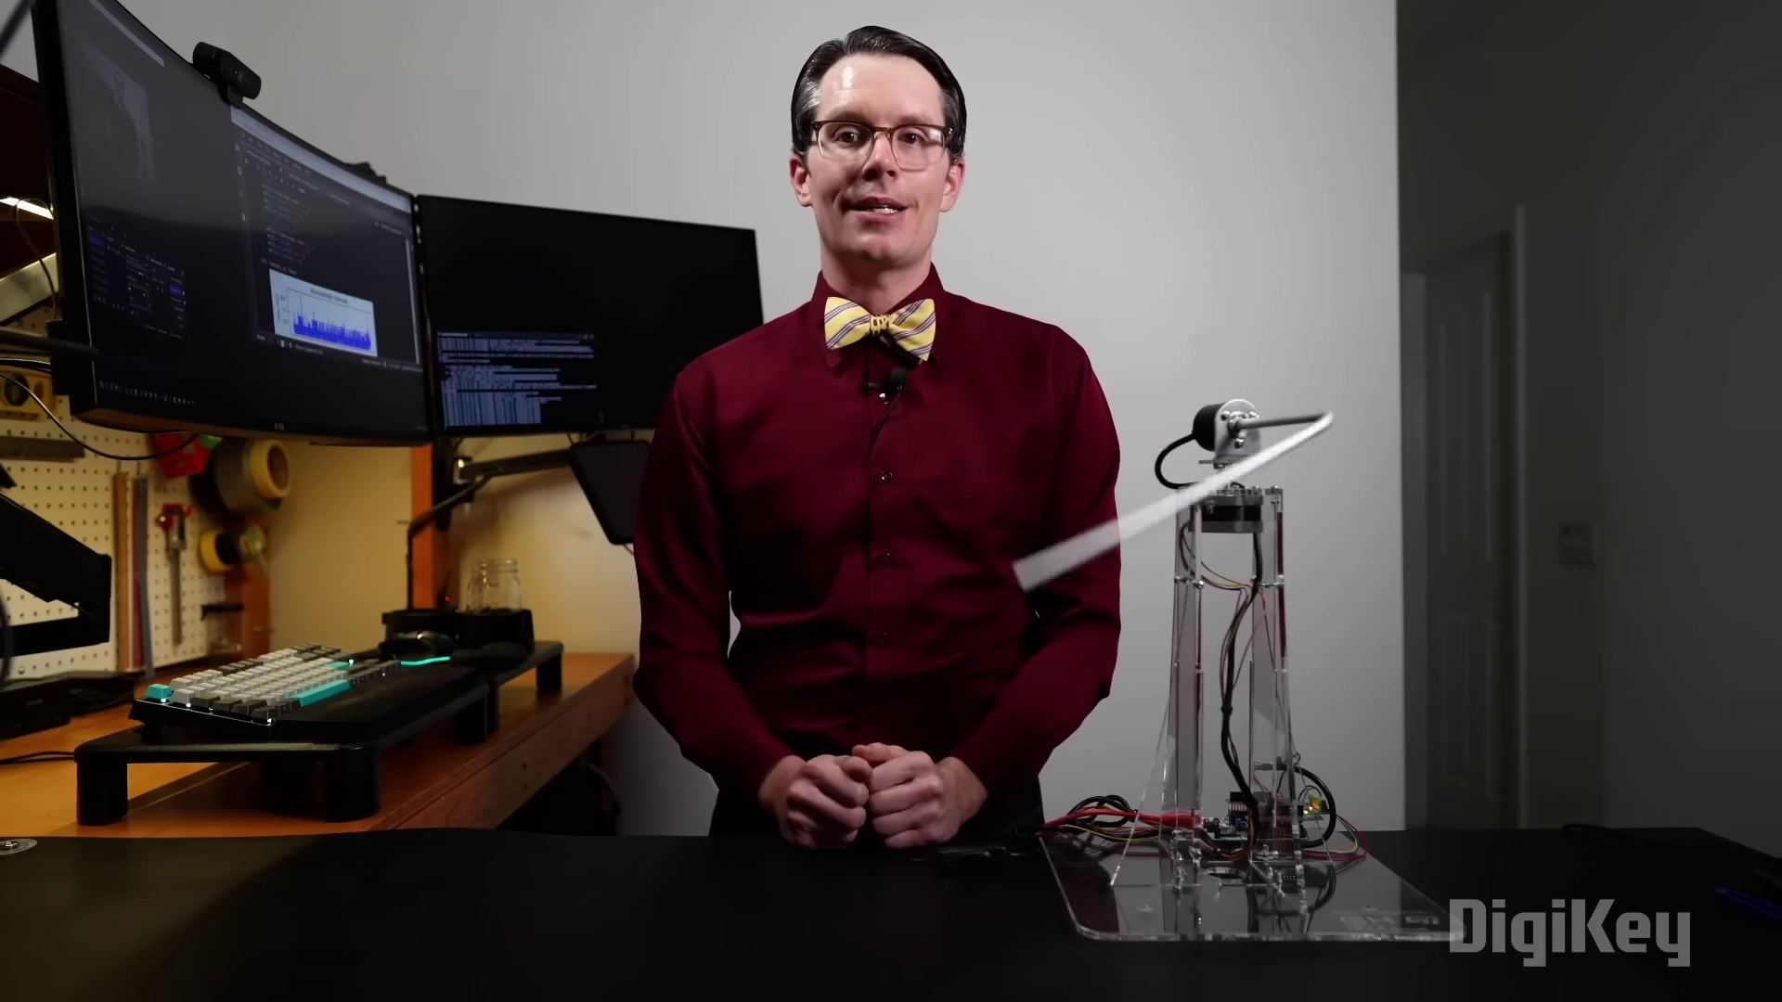 | 0:19   | 0:21  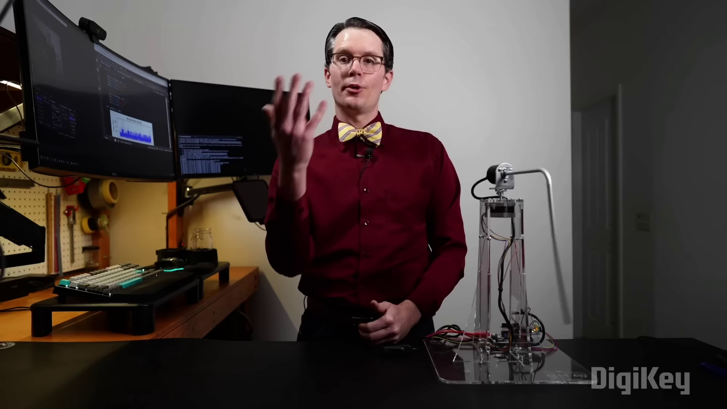 | 0:23  

Transcript
[0:17] And as you can see here, once the program stopped, it just freely fell over because it's in an unstable position when it's upright.

Section 0: Segment 3
Time: 0:25 - 0:34

Summary
The text describes an image with a dark background and two figures at desks.

Representative Frames
0:26  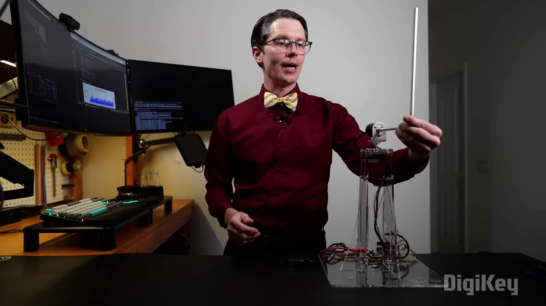 | 0:28  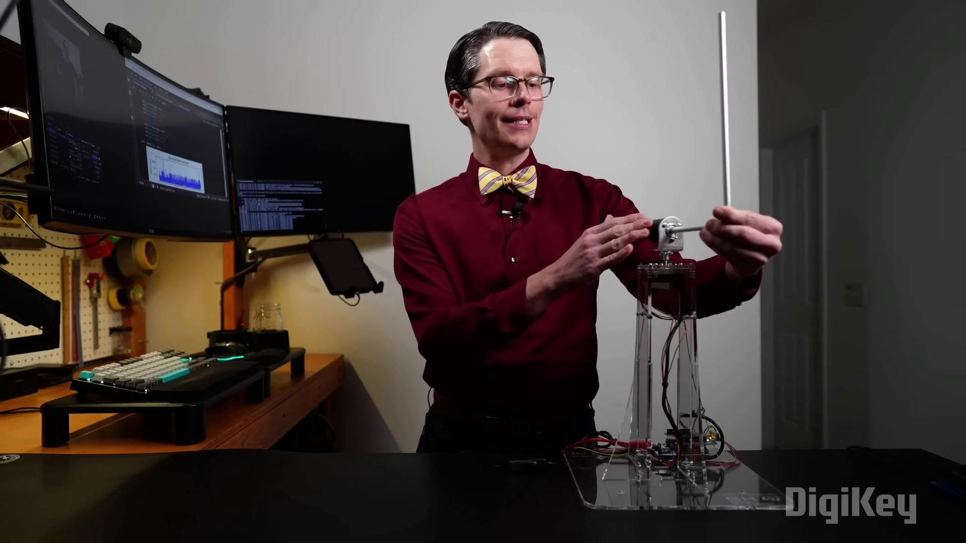 | 0:29   | 0:31  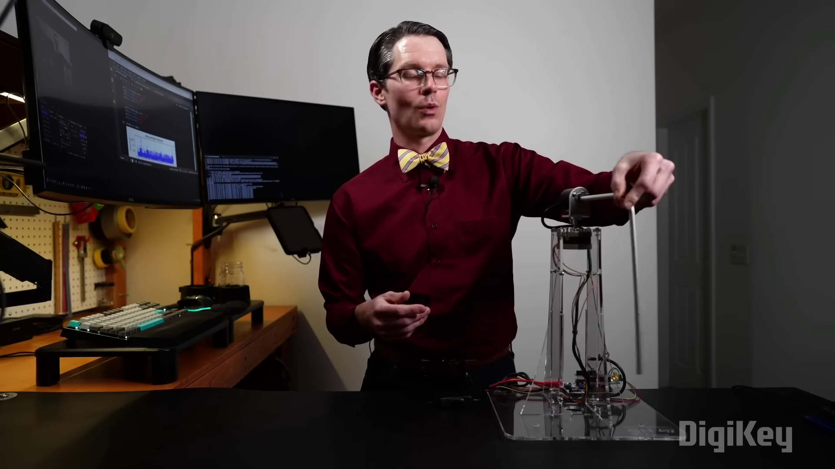 | 0:33  

Transcript
[0:23] But our job is to create a controller that takes in encoder values that is the angle in which this rod is pointing and then controls the stepper motor so that it stays upright.

Section 0: Segment 4
Time: 0:35 - 0:44

Summary
The text describes an image with a dark background and two figures at desks.

Representative Frames
0:36  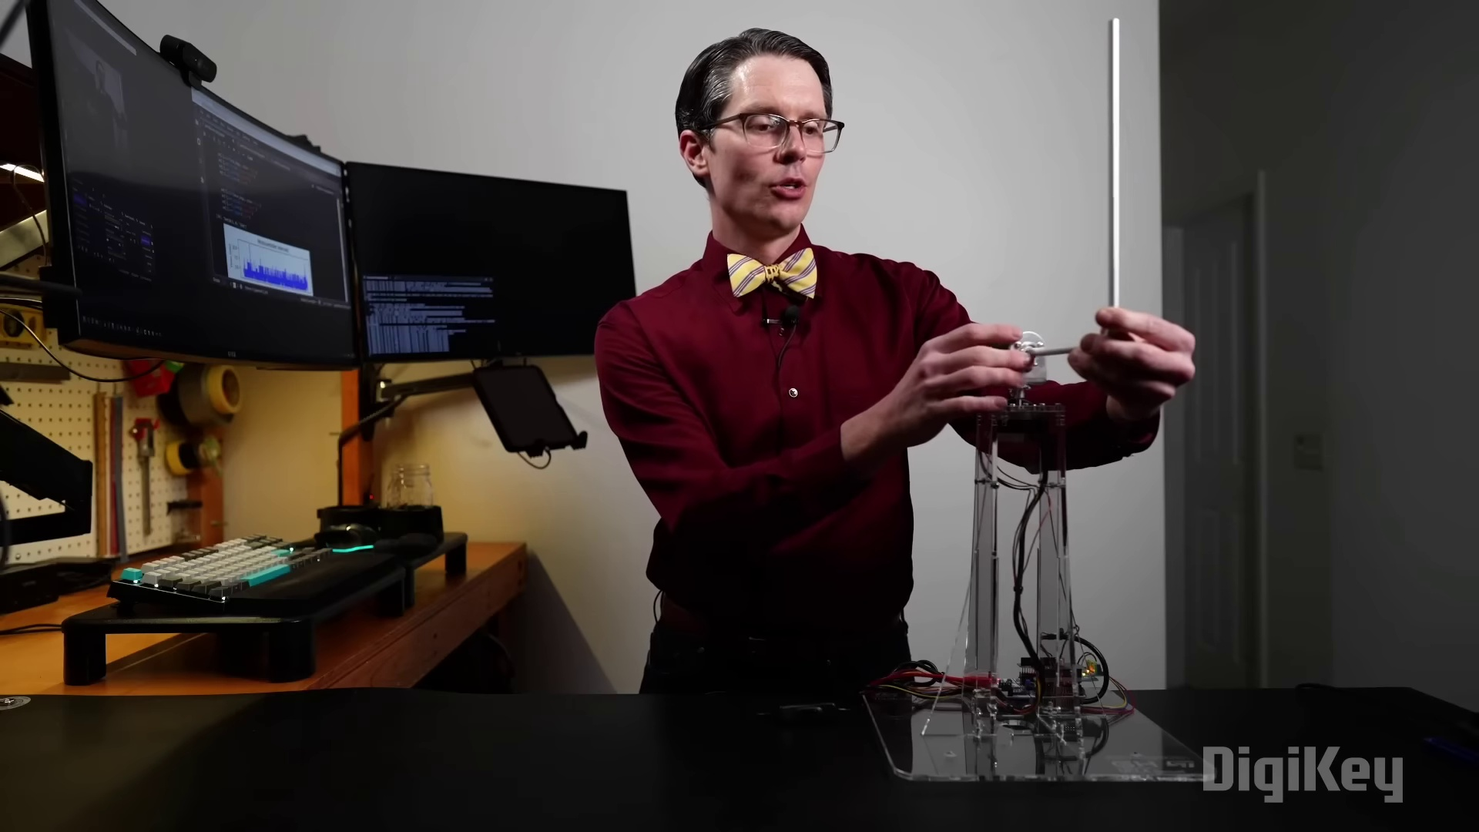 | 0:38  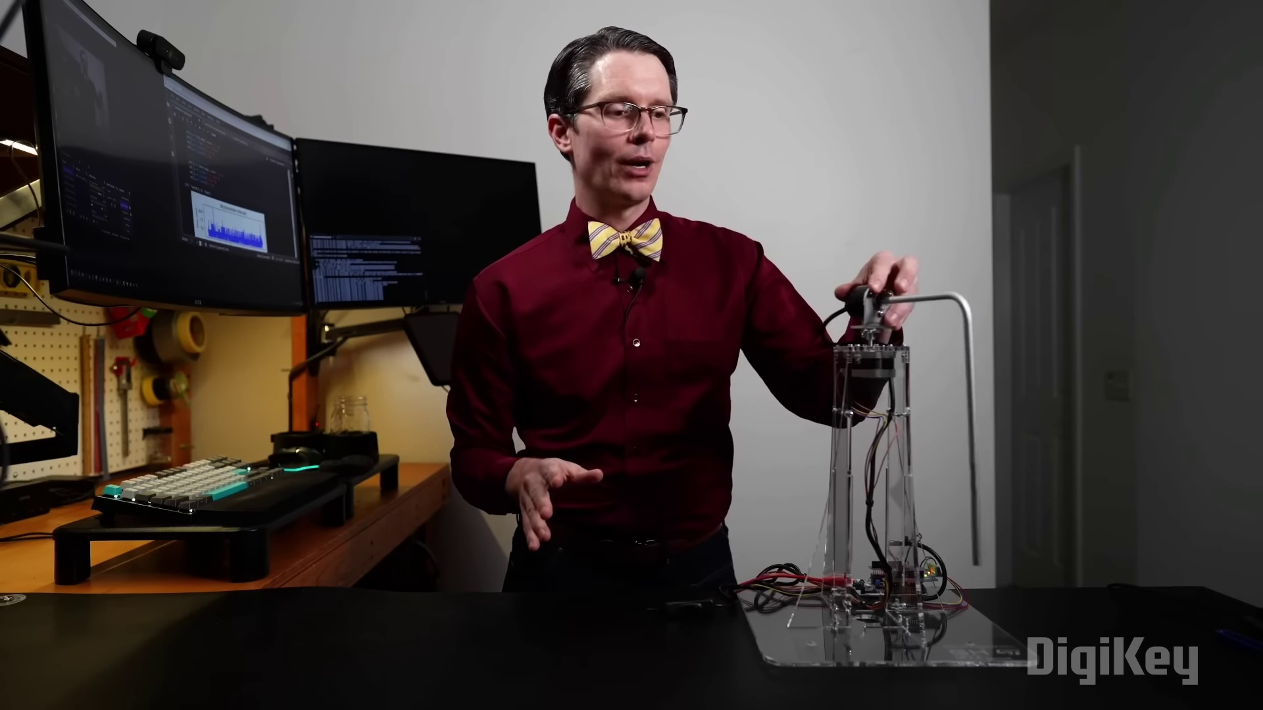 | 0:39   | 0:41  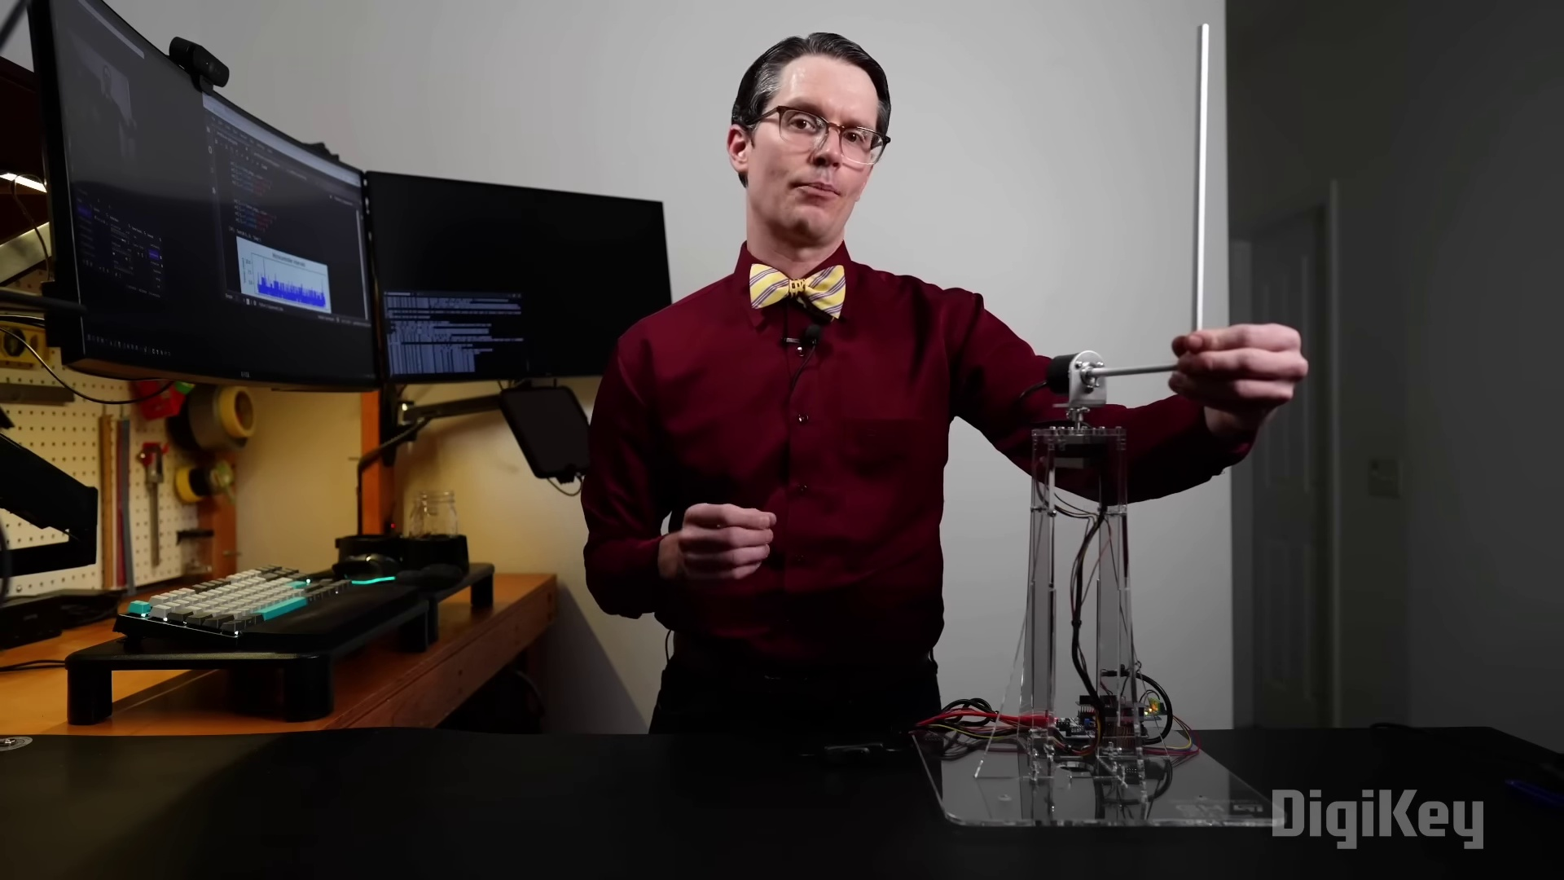 | 0:43  

Transcript
[0:35] We won't try to do the swing up where it gets it into that position.
[0:38] We'll just assume that it starts in the upright position in our controller.
[0:41] We'll need to keep it there.

Section 0: Conclusion
Time: 0:45 - 0:49

Summary
A final summary of the content.

Representative Frames
0:45  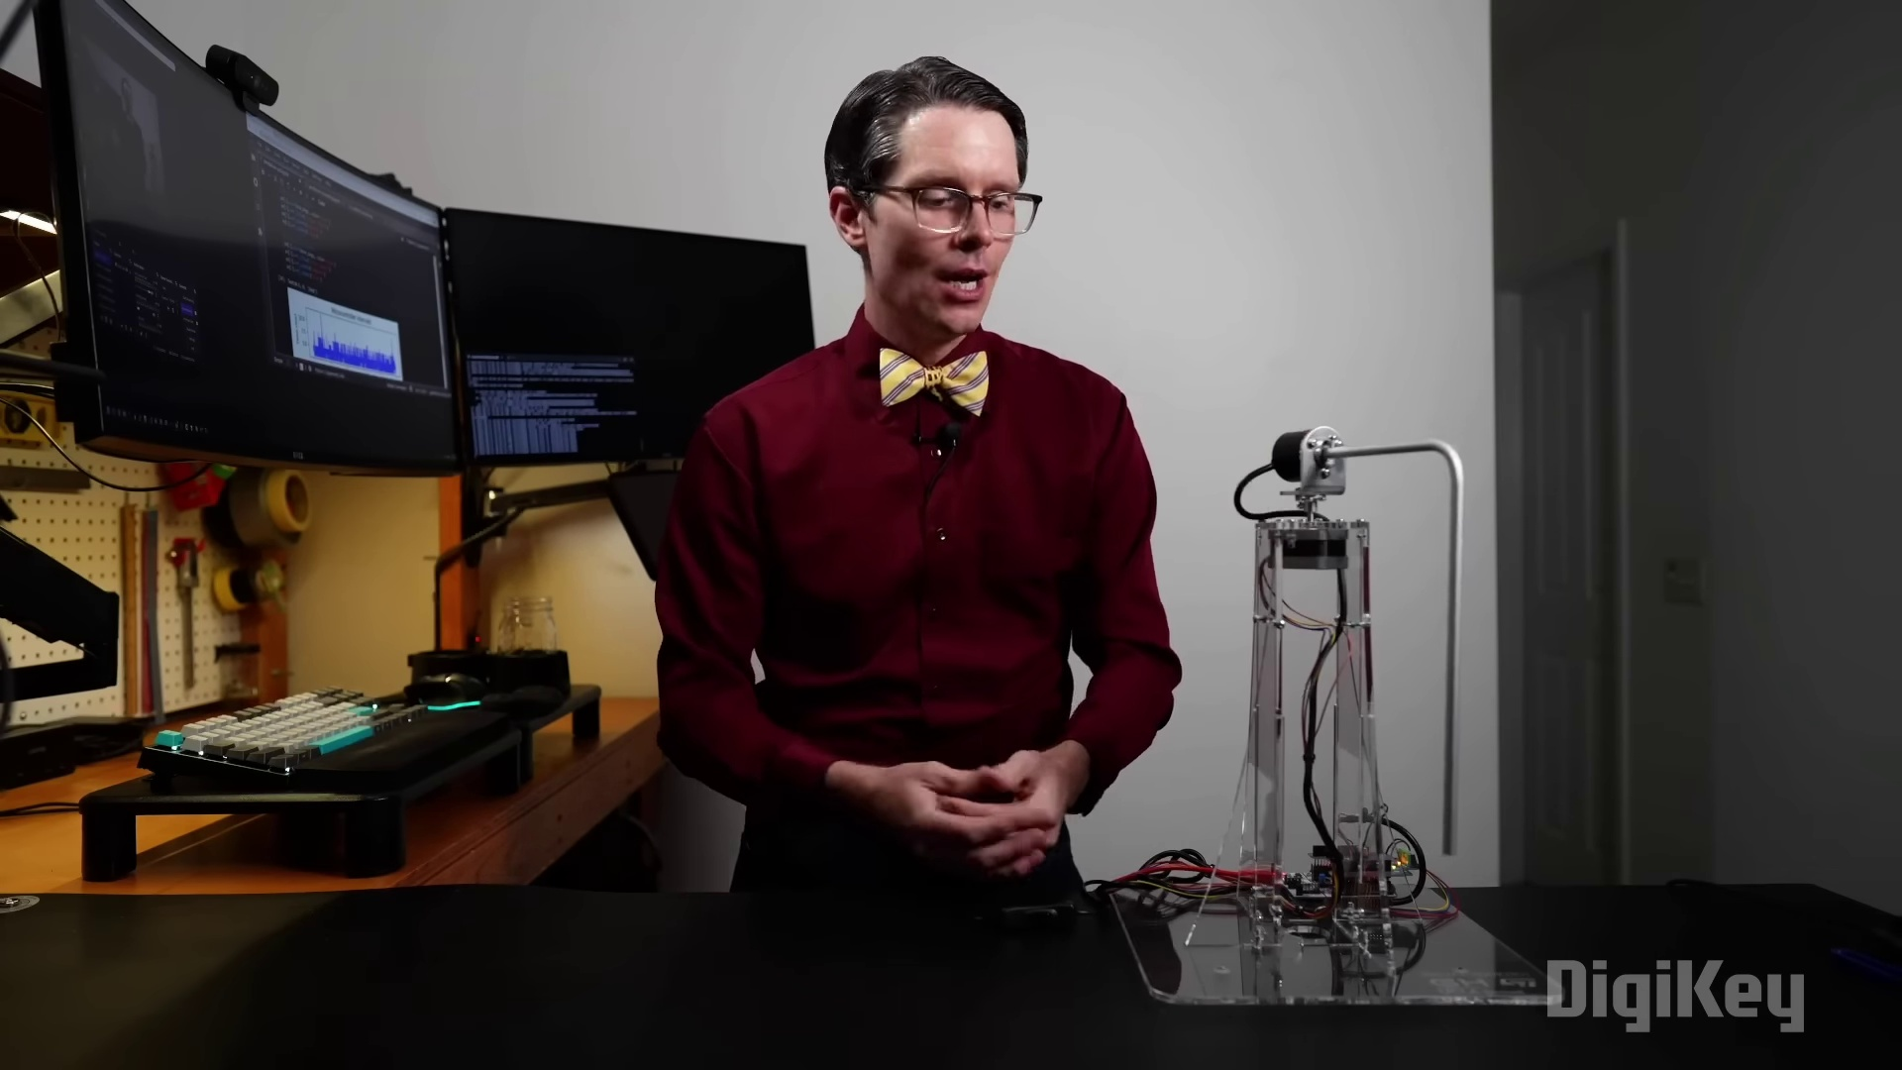 | 0:46   | 0:47  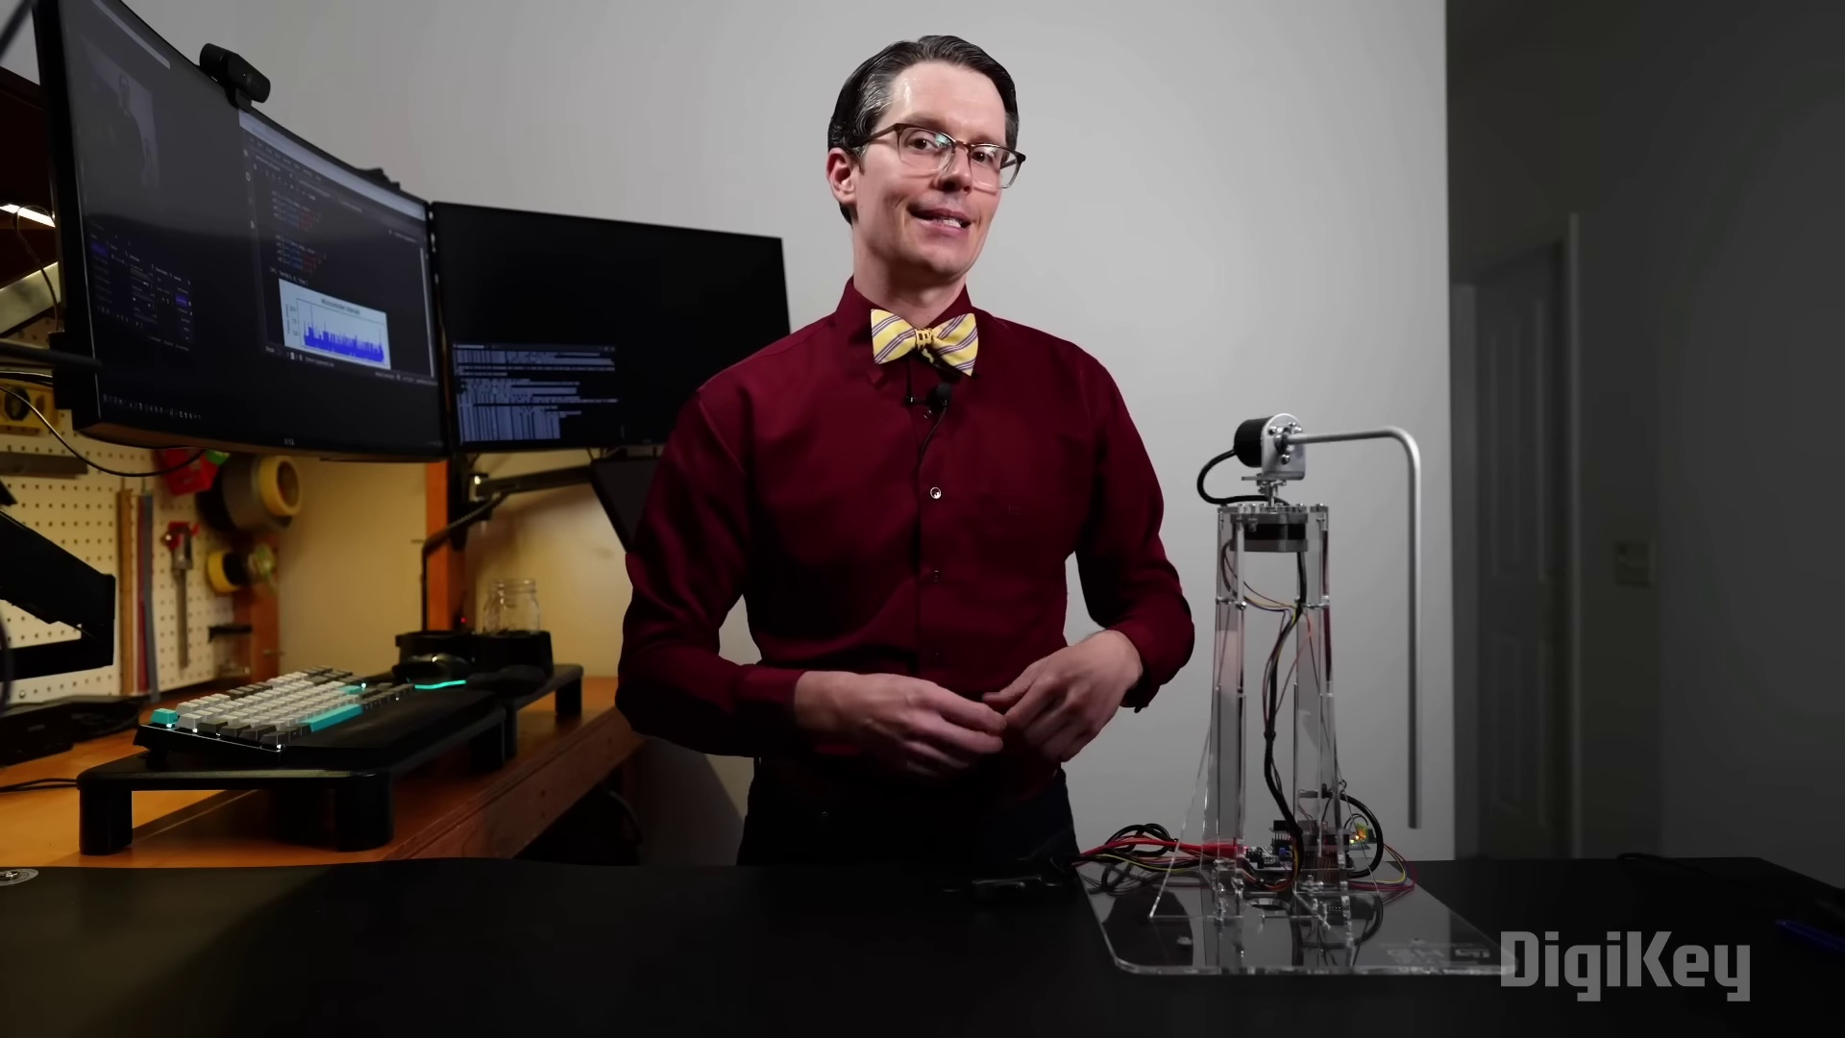 | 0:48   | 0:49  

Transcript
[0:43] The Arduino in this case is just going to act as an interface for us.

