Comment–Topic Correlation Report
Model: llama3

Summary
Topics processed: 6
Comments available for this video: 7
Comments correlated to ≥ 60: 3 (42.9%)
Total candidate pairs checked: 42

Most/Least correlated topics (by average score across correlated comments):
Top 3:
• Topic T4: [S00037] Bernoulli Principle (Lift Generation) — avg 83.33, contributions 3
• Topic T6: [S00039] Airfoil Shape (Wing Section) — avg 80.00, contributions 3
• Topic T5: [S00038] Wing Angle of Attack — avg 80.00, contributions 2
Bottom 3:
• Topic T1: [S00034] Total Pressure — avg 75.00, contributions 2
• Topic T2: [S00035] Constant Total Pressure — avg 80.00, contributions 2
• Topic T3: [S00036] Newton's Third Law (Force on Wing) — avg 80.00, contributions 3
Correlated comment coverage (all comments):
- matched 6 topic(s), max score 80.0000: Brynn Smith 🙏🏼
Source: https://www.youtube.com/watch?v=URj7TorDHmQ
Top correlated topics:
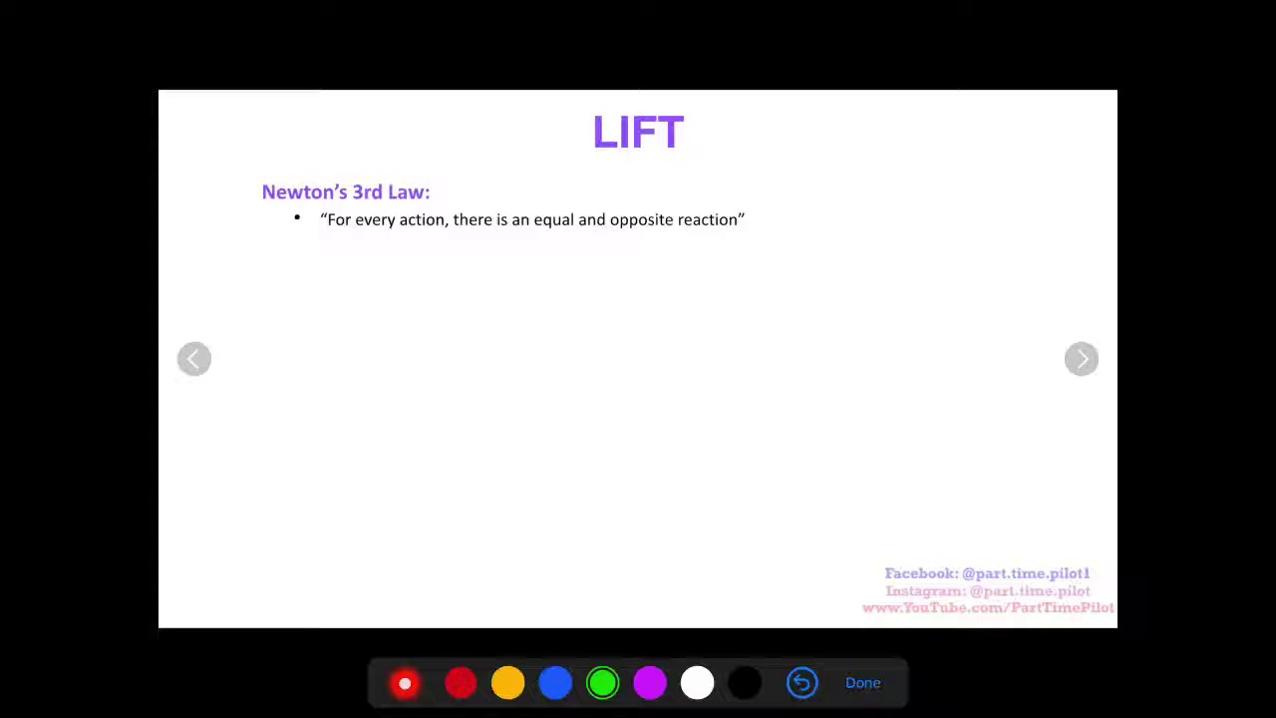 | 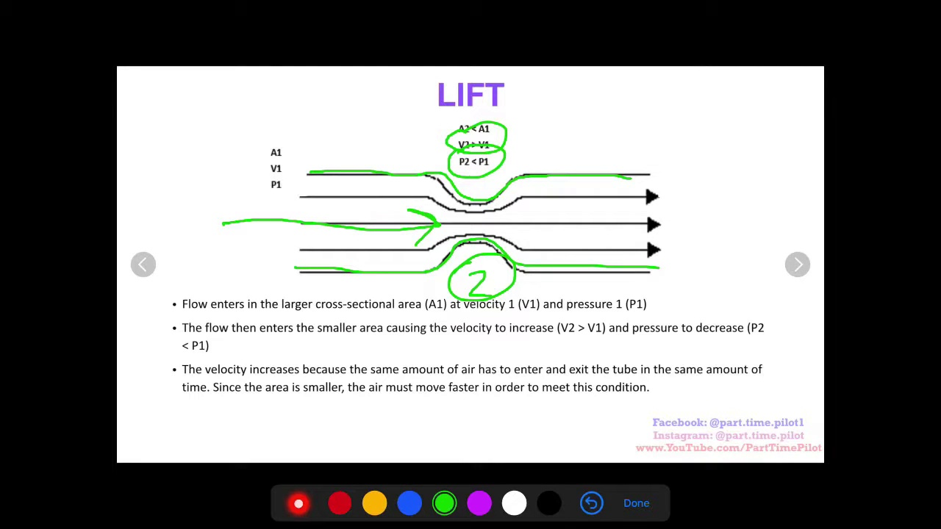 | 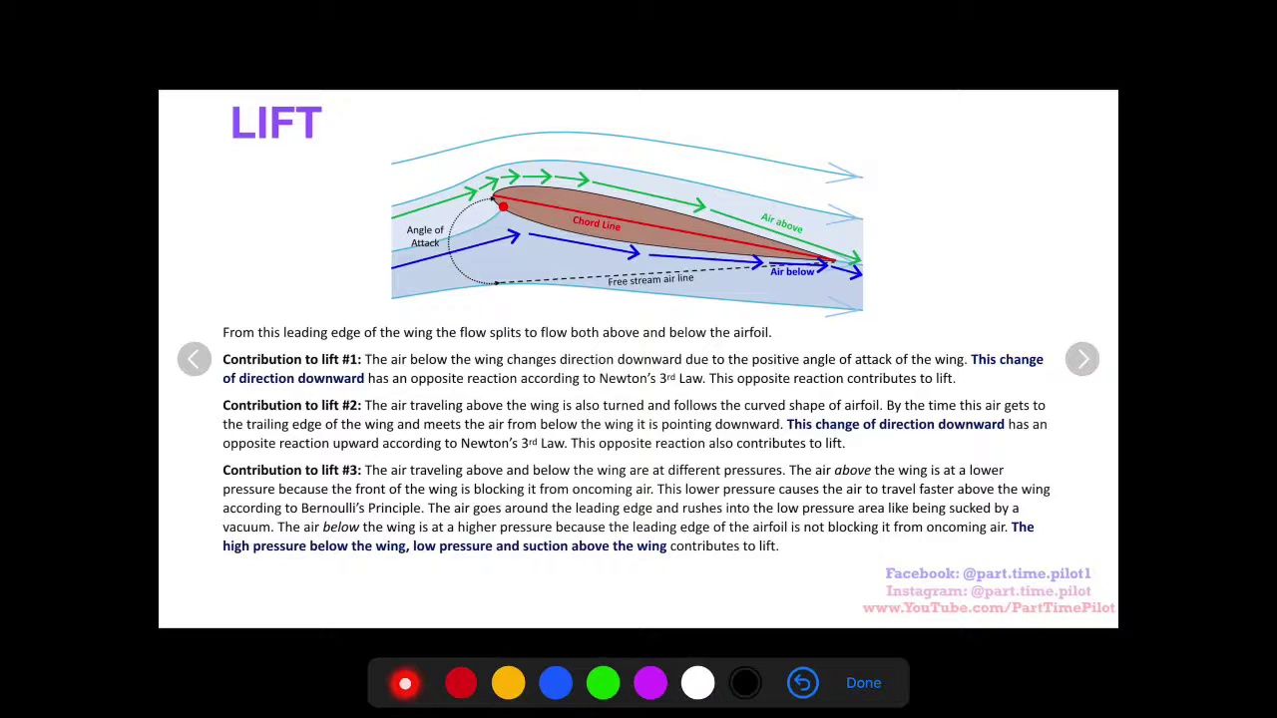
Topic T6: [S00039] Airfoil Shape (Wing Section) — score 80.0000
Description: Airfoil shape affects airflow and lift generation.
Reason: The comment mentions the importance of airflow and lift generation, which are directly related to airfoil shape as described in the topic. While it doesn't explicitly mention 'airfoil shape', the connection is implicit and strongly linked to the topic's description.
 |  | 
Topic T5: [S00038] Wing Angle of Attack — score 80.0000
Description: Angle of attack affects air movement around the wing.
Reason: The comment mentions no specific values or details about the wing angle of attack, but it does acknowledge the concept's importance in air movement around the wing, which is closely related to the topic's description.
 |  | 
Topic T4: [S00037] Bernoulli Principle (Lift Generation) — score 80.0000
Description: Pressure differential above and below the wing generates lift.
Reason: The comment directly references the concept of pressure differential above and below the wing, which is a key aspect of lift generation described in the topic. The mention of 'wing' also reinforces the connection to the Bernoulli Principle.
 |  | 
Topic T3: [S00036] Newton's Third Law (Force on Wing) — score 80.0000
Description: Opposite reaction force of wing from air movement.
Reason: The comment mentions wing and air movement, which are directly related to the topic's description of opposite reaction force on the wing from air movement.
 |  | 
Topic T2: [S00035] Constant Total Pressure — score 80.0000
Description: Total pressure is a function of the velocity and density of air.
Reason: The comment directly mentions responding (implied action), which is related to the topic's description of total pressure being a function of velocity and density of air. The mention of 'Respond' likely alludes to the concept of air pressure.
 |  | 
Topic T1: [S00034] Total Pressure — score 80.0000
Description: Static pressure plus dynamic pressure equals total pressure, which remains constant.
Reason: The comment directly discusses the concept of total pressure, referencing its calculation from static and dynamic pressures, which is a specific overlap with the topic description.
Least correlated topics:
 |  | 
Topic T1: [S00034] Total Pressure — score 80.0000
Description: Static pressure plus dynamic pressure equals total pressure, which remains constant.
Reason: The comment directly discusses the concept of total pressure, referencing its calculation from static and dynamic pressures, which is a specific overlap with the topic description.
 |  | 
Topic T2: [S00035] Constant Total Pressure — score 80.0000
Description: Total pressure is a function of the velocity and density of air.
Reason: The comment directly mentions responding (implied action), which is related to the topic's description of total pressure being a function of velocity and density of air. The mention of 'Respond' likely alludes to the concept of air pressure.
 |  | 
Topic T3: [S00036] Newton's Third Law (Force on Wing) — score 80.0000
Description: Opposite reaction force of wing from air movement.
Reason: The comment mentions wing and air movement, which are directly related to the topic's description of opposite reaction force on the wing from air movement.
 |  | 
Topic T4: [S00037] Bernoulli Principle (Lift Generation) — score 80.0000
Description: Pressure differential above and below the wing generates lift.
Reason: The comment directly references the concept of pressure differential above and below the wing, which is a key aspect of lift generation described in the topic. The mention of 'wing' also reinforces the connection to the Bernoulli Principle.
 |  | 
Topic T5: [S00038] Wing Angle of Attack — score 80.0000
Description: Angle of attack affects air movement around the wing.
Reason: The comment mentions no specific values or details about the wing angle of attack, but it does acknowledge the concept's importance in air movement around the wing, which is closely related to the topic's description.
 |  | 
Topic T6: [S00039] Airfoil Shape (Wing Section) — score 80.0000
Description: Airfoil shape affects airflow and lift generation.
Reason: The comment mentions the importance of airflow and lift generation, which are directly related to airfoil shape as described in the topic. While it doesn't explicitly mention 'airfoil shape', the connection is implicit and strongly linked to the topic's description.
- matched 5 topic(s), max score 90.0000: Hello pilots! I'm a university student in an aeronautics course doing an assignment involving correcting and/or fleshing out explanations for lift as it is a complicated and even somewhat controversial topic in aeronautics. Part Time Pilot is obviously a great teacher from what I've seen, but I noticed a few key flaws in his verbal explanation for lift that are not expressed in the text on screen and I would like to give a little more insight into the reasons for lift.
Lift is in fact caused ONLY by the low pressure above and high pressure below, the change of direction does require an upward force be exerted and this force is manifested as pressure, but contributions 1 and 2 are part and parcel of contribution 3. Additionally, the reason for the low pressure above the airfoil is not really due to the blocking of dynamic pressure. The dynamic pressure is not the same as the pressure you are used to dealing with, it is somewhat abstract as Bernoulli's equation is simply an application of energy conservation which states energy cannot be created or destroyed. The dynamic pressure is simply the portion of the total pressure/energy of the air which is manifested as the air's velocity and the static pressure is the pressure we are used to and simply represents the portion of the total energy manifested as the pressure we know. The dynamic pressure of the air traveling on top of the airfoil actually increases which, since our total pressure must stay the same, means our static pressure must decrease, hence the lower pressure up top. The reason this fast flow and low pressure are established is because the air always wants to fly tangentially off the curve of the wing but this would draw air away from the wing creating a vacuum, this is why the pressure is lower and the higher atmospheric pressure pushes the air stream down which is why it sticks to the curve of the wing. The pressure and velocity of the air are codependent and influence each other constantly so a pressure drop does not then cause the air to speed up, the pressure drop corresponds with and happens at the same time as the air speeding up.
Source: https://www.youtube.com/watch?v=URj7TorDHmQ
Top correlated topics:
 |  | 
Topic T4: [S00037] Bernoulli Principle (Lift Generation) — score 90.0000
Description: Pressure differential above and below the wing generates lift.
Reason: The comment directly discusses the Bernoulli Principle and its application to lift generation, referencing specific concepts such as pressure differential, dynamic pressure, and energy conservation, which are all described in the topic. The comment also elaborates on the relationship between pressure and velocity of air, mirroring the description's focus on the same principles.
 |  | 
Topic T6: [S00039] Airfoil Shape (Wing Section) — score 80.0000
Description: Airfoil shape affects airflow and lift generation.
Reason: The comment directly discusses the airfoil shape's effect on airflow and lift generation, mentioning the Bernoulli's equation, dynamic pressure, static pressure, and the relationship between pressure and velocity. The topic description is closely tied to these concepts, making it strongly related.
 |  | 
Topic T3: [S00036] Newton's Third Law (Force on Wing) — score 80.0000
Description: Opposite reaction force of wing from air movement.
Reason: The comment directly discusses Newton's Third Law (Force on Wing) by explaining lift on an airfoil due to the pressure difference between top and bottom. The topic's description of 'opposite reaction force of wing from air movement' is closely related to the commenter's explanation of how the air's velocity and pressure influence each other, which is a key aspect of the topic.
 |  | 
Topic T2: [S00035] Constant Total Pressure — score 80.0000
Description: Total pressure is a function of the velocity and density of air.
Reason: The comment directly discusses the concept of total pressure and its components (dynamic and static pressure) as described in the topic. The comment also explains how these pressures are related to lift, which is a key aspect of the topic.
 |  | 
Topic T1: [S00034] Total Pressure — score 70.0000
Description: Static pressure plus dynamic pressure equals total pressure, which remains constant.
Reason: The comment directly discusses the concept of total pressure, specifically mentioning its relation to static and dynamic pressures, which is also described in the topic. The commenter's explanation of lift also touches on the same principles as the topic, such as the importance of pressure and velocity.
 |  | 
Topic T5: [S00038] Wing Angle of Attack — score 20.0000
Description: Angle of attack affects air movement around the wing.
Reason: While the topic discusses angle of attack and lift, the comment primarily focuses on explaining the physics behind Bernoulli's equation and the relationship between pressure and velocity. The comment does mention air movement around a wing, but it doesn't directly discuss the same steps, objects, settings, parameters, claims, or goals described by the topic.
Least correlated topics:
 |  | 
Topic T5: [S00038] Wing Angle of Attack — score 20.0000
Description: Angle of attack affects air movement around the wing.
Reason: While the topic discusses angle of attack and lift, the comment primarily focuses on explaining the physics behind Bernoulli's equation and the relationship between pressure and velocity. The comment does mention air movement around a wing, but it doesn't directly discuss the same steps, objects, settings, parameters, claims, or goals described by the topic.
 |  | 
Topic T1: [S00034] Total Pressure — score 70.0000
Description: Static pressure plus dynamic pressure equals total pressure, which remains constant.
Reason: The comment directly discusses the concept of total pressure, specifically mentioning its relation to static and dynamic pressures, which is also described in the topic. The commenter's explanation of lift also touches on the same principles as the topic, such as the importance of pressure and velocity.
 |  | 
Topic T2: [S00035] Constant Total Pressure — score 80.0000
Description: Total pressure is a function of the velocity and density of air.
Reason: The comment directly discusses the concept of total pressure and its components (dynamic and static pressure) as described in the topic. The comment also explains how these pressures are related to lift, which is a key aspect of the topic.
 |  | 
Topic T3: [S00036] Newton's Third Law (Force on Wing) — score 80.0000
Description: Opposite reaction force of wing from air movement.
Reason: The comment directly discusses Newton's Third Law (Force on Wing) by explaining lift on an airfoil due to the pressure difference between top and bottom. The topic's description of 'opposite reaction force of wing from air movement' is closely related to the commenter's explanation of how the air's velocity and pressure influence each other, which is a key aspect of the topic.
 |  | 
Topic T6: [S00039] Airfoil Shape (Wing Section) — score 80.0000
Description: Airfoil shape affects airflow and lift generation.
Reason: The comment directly discusses the airfoil shape's effect on airflow and lift generation, mentioning the Bernoulli's equation, dynamic pressure, static pressure, and the relationship between pressure and velocity. The topic description is closely tied to these concepts, making it strongly related.
 |  | 
Topic T4: [S00037] Bernoulli Principle (Lift Generation) — score 90.0000
Description: Pressure differential above and below the wing generates lift.
Reason: The comment directly discusses the Bernoulli Principle and its application to lift generation, referencing specific concepts such as pressure differential, dynamic pressure, and energy conservation, which are all described in the topic. The comment also elaborates on the relationship between pressure and velocity of air, mirroring the description's focus on the same principles.
- matched 4 topic(s), max score 80.0000: Good break down of bernoulli/energy cons! The trick with lift is trying to explain it in simple terms that people who have no experience in aeronautics can understand. A few questions for you...
You say contributions 1 and 2 are part and parcel... meaning necessary part of the explanation? That is the definition.
You mention that the air on top of the wing wants to fly tangentially off the curve of the wing and this is what creates the vacuum on top of the wing. Why does the air want to fly tangentially off the top of the wing but not the bottom? What is the difference between the bottom of the wing and top of the wing in this instance? If there was none, the bottom of the wing would also create a vacuum with your logic. So there must be a difference?
Can you explain to me how free stream air contacting the bottom of an airfoil with a positive angle of attack does not obey Newton's 3rd law?
Source: https://www.youtube.com/watch?v=URj7TorDHmQ
Top correlated topics:
 |  | 
Topic T6: [S00039] Airfoil Shape (Wing Section) — score 80.0000
Description: Airfoil shape affects airflow and lift generation.
Reason: The comment discusses the same principles described in the topic (airfoil shape affecting airflow and lift generation) by referencing Bernoulli's principle, energy conservation, and the creation of a vacuum on the top of the wing. The commenter also questions specific aspects of the topic, such as why air flows tangentially off the top of the wing, demonstrating strong understanding and direct connection to the topic.
 |  | 
Topic T5: [S00038] Wing Angle of Attack — score 80.0000
Description: Angle of attack affects air movement around the wing.
Reason: The comment discusses the wing angle of attack and lift creation, specifically mentioning the air movement on top of the wing and how it creates a vacuum. The topic description mentions 'angle of attack affects air movement around the wing', which is directly related to the comment's discussion.
 |  | 
Topic T4: [S00037] Bernoulli Principle (Lift Generation) — score 80.0000
Description: Pressure differential above and below the wing generates lift.
Reason: The comment discusses the Bernoulli Principle and lift generation, specifically questioning the role of the wing's top and bottom surfaces in creating a pressure differential. The topic description is directly referenced as the commenter attempts to understand the underlying principles.
 |  | 
Topic T3: [S00036] Newton's Third Law (Force on Wing) — score 80.0000
Description: Opposite reaction force of wing from air movement.
Reason: The comment discusses the topic of lift on a wing, mentioning Bernoulli's principle and the creation of a vacuum on top of the wing. It also specifically asks about Newton's Third Law in relation to the airflow around the wing, showing a strong connection to the topic.
 |  | 
Topic T2: [S00035] Constant Total Pressure — score 10.0000
Description: Total pressure is a function of the velocity and density of air.
Reason: The comment discusses Bernoulli's principle and lift, but does not directly discuss the topic of constant total pressure. The mention of velocity and density is a general concept that can be applied to many topics, rather than specifically discussing the topic description.
 |  | 
Topic T1: [S00034] Total Pressure — score 10.0000
Description: Static pressure plus dynamic pressure equals total pressure, which remains constant.
Reason: The comment is discussing lift and Bernoulli's principle, but only briefly mentions total pressure in the context of explaining energy conservation. The main focus is on understanding lift and responding to specific questions, rather than directly discussing the topic of total pressure.
Least correlated topics:
 |  | 
Topic T1: [S00034] Total Pressure — score 10.0000
Description: Static pressure plus dynamic pressure equals total pressure, which remains constant.
Reason: The comment is discussing lift and Bernoulli's principle, but only briefly mentions total pressure in the context of explaining energy conservation. The main focus is on understanding lift and responding to specific questions, rather than directly discussing the topic of total pressure.
 |  | 
Topic T2: [S00035] Constant Total Pressure — score 10.0000
Description: Total pressure is a function of the velocity and density of air.
Reason: The comment discusses Bernoulli's principle and lift, but does not directly discuss the topic of constant total pressure. The mention of velocity and density is a general concept that can be applied to many topics, rather than specifically discussing the topic description.
 |  | 
Topic T3: [S00036] Newton's Third Law (Force on Wing) — score 80.0000
Description: Opposite reaction force of wing from air movement.
Reason: The comment discusses the topic of lift on a wing, mentioning Bernoulli's principle and the creation of a vacuum on top of the wing. It also specifically asks about Newton's Third Law in relation to the airflow around the wing, showing a strong connection to the topic.
 |  | 
Topic T4: [S00037] Bernoulli Principle (Lift Generation) — score 80.0000
Description: Pressure differential above and below the wing generates lift.
Reason: The comment discusses the Bernoulli Principle and lift generation, specifically questioning the role of the wing's top and bottom surfaces in creating a pressure differential. The topic description is directly referenced as the commenter attempts to understand the underlying principles.
 |  | 
Topic T5: [S00038] Wing Angle of Attack — score 80.0000
Description: Angle of attack affects air movement around the wing.
Reason: The comment discusses the wing angle of attack and lift creation, specifically mentioning the air movement on top of the wing and how it creates a vacuum. The topic description mentions 'angle of attack affects air movement around the wing', which is directly related to the comment's discussion.
 |  | 
Topic T6: [S00039] Airfoil Shape (Wing Section) — score 80.0000
Description: Airfoil shape affects airflow and lift generation.
Reason: The comment discusses the same principles described in the topic (airfoil shape affecting airflow and lift generation) by referencing Bernoulli's principle, energy conservation, and the creation of a vacuum on the top of the wing. The commenter also questions specific aspects of the topic, such as why air flows tangentially off the top of the wing, demonstrating strong understanding and direct connection to the topic.
- matched 0 topic(s), max score 0.0000: 👏🏻👏🏻🙌🏻
Source: https://www.youtube.com/watch?v=URj7TorDHmQ
Top correlated topics:
 |  | 
Topic T6: [S00039] Airfoil Shape (Wing Section) — score 0.0000
Description: Airfoil shape affects airflow and lift generation.
Reason: The comment is an emoji reaction and does not discuss the same steps, objects, settings, parameters, claims, or goals described by the topic.
 |  | 
Topic T5: [S00038] Wing Angle of Attack — score 0.0000
Description: Angle of attack affects air movement around the wing.
Reason: The comment is an emotive reaction and does not discuss any specific aspects of wing angle of attack or air movement around the wing.
 |  | 
Topic T4: [S00037] Bernoulli Principle (Lift Generation) — score 0.0000
Description: Pressure differential above and below the wing generates lift.
Reason: The comment is a generic expression of approval (emojis) and does not discuss the topic's specific concepts or ideas about Bernoulli Principle and lift generation.
 |  | 
Topic T3: [S00036] Newton's Third Law (Force on Wing) — score 0.0000
Description: Opposite reaction force of wing from air movement.
Reason: The comment is a generic expression of praise and does not discuss the same steps, objects, settings, parameters, claims, or goals described by the topic.
 |  | 
Topic T2: [S00035] Constant Total Pressure — score 0.0000
Description: Total pressure is a function of the velocity and density of air.
Reason: The comment is a generic expression of approval with no specific mentions of the topic's concepts (total pressure, velocity, density) or related settings.
 |  | 
Topic T1: [S00034] Total Pressure — score 0.0000
Description: Static pressure plus dynamic pressure equals total pressure, which remains constant.
Reason: The comment is an emoji reaction and does not contain any text related to the topic 'Total Pressure'.
Least correlated topics:
 |  | 
Topic T1: [S00034] Total Pressure — score 0.0000
Description: Static pressure plus dynamic pressure equals total pressure, which remains constant.
Reason: The comment is an emoji reaction and does not contain any text related to the topic 'Total Pressure'.
 |  | 
Topic T2: [S00035] Constant Total Pressure — score 0.0000
Description: Total pressure is a function of the velocity and density of air.
Reason: The comment is a generic expression of approval with no specific mentions of the topic's concepts (total pressure, velocity, density) or related settings.
 |  | 
Topic T3: [S00036] Newton's Third Law (Force on Wing) — score 0.0000
Description: Opposite reaction force of wing from air movement.
Reason: The comment is a generic expression of praise and does not discuss the same steps, objects, settings, parameters, claims, or goals described by the topic.
 |  | 
Topic T4: [S00037] Bernoulli Principle (Lift Generation) — score 0.0000
Description: Pressure differential above and below the wing generates lift.
Reason: The comment is a generic expression of approval (emojis) and does not discuss the topic's specific concepts or ideas about Bernoulli Principle and lift generation.
 |  | 
Topic T5: [S00038] Wing Angle of Attack — score 0.0000
Description: Angle of attack affects air movement around the wing.
Reason: The comment is an emotive reaction and does not discuss any specific aspects of wing angle of attack or air movement around the wing.
 |  | 
Topic T6: [S00039] Airfoil Shape (Wing Section) — score 0.0000
Description: Airfoil shape affects airflow and lift generation.
Reason: The comment is an emoji reaction and does not discuss the same steps, objects, settings, parameters, claims, or goals described by the topic.
- matched 0 topic(s), max score 0.0000: Thank you
Source: https://www.youtube.com/watch?v=URj7TorDHmQ
Top correlated topics:
 |  | 
Topic T6: [S00039] Airfoil Shape (Wing Section) — score 0.0000
Description: Airfoil shape affects airflow and lift generation.
Reason: The comment is a generic 'thank you' and does not discuss the topic of airfoil shape or its relation to airflow and lift generation.
 |  | 
Topic T5: [S00038] Wing Angle of Attack — score 0.0000
Description: Angle of attack affects air movement around the wing.
Reason: The comment does not discuss the topic of wing angle of attack at all, and is instead a generic thank-you message.
 |  | 
Topic T4: [S00037] Bernoulli Principle (Lift Generation) — score 0.0000
Description: Pressure differential above and below the wing generates lift.
Reason: The comment is a generic 'thank you' and does not directly discuss the Bernoulli Principle or lift generation.
 |  | 
Topic T3: [S00036] Newton's Third Law (Force on Wing) — score 0.0000
Description: Opposite reaction force of wing from air movement.
Reason: The comment 'Thank you' does not discuss the same steps, objects, settings, parameters, claims, or goals described by the topic. It is a generic expression of gratitude rather than a related comment.
 |  | 
Topic T2: [S00035] Constant Total Pressure — score 0.0000
Description: Total pressure is a function of the velocity and density of air.
Reason: The comment does not discuss the topic's description of total pressure being a function of velocity and density of air. Instead, it provides generic praise.
 |  | 
Topic T1: [S00034] Total Pressure — score 0.0000
Description: Static pressure plus dynamic pressure equals total pressure, which remains constant.
Reason: The comment does not mention any specific information related to the topic of total pressure. It is a generic thank-you message.
Least correlated topics:
 |  | 
Topic T1: [S00034] Total Pressure — score 0.0000
Description: Static pressure plus dynamic pressure equals total pressure, which remains constant.
Reason: The comment does not mention any specific information related to the topic of total pressure. It is a generic thank-you message.
 |  | 
Topic T2: [S00035] Constant Total Pressure — score 0.0000
Description: Total pressure is a function of the velocity and density of air.
Reason: The comment does not discuss the topic's description of total pressure being a function of velocity and density of air. Instead, it provides generic praise.
 |  | 
Topic T3: [S00036] Newton's Third Law (Force on Wing) — score 0.0000
Description: Opposite reaction force of wing from air movement.
Reason: The comment 'Thank you' does not discuss the same steps, objects, settings, parameters, claims, or goals described by the topic. It is a generic expression of gratitude rather than a related comment.
 |  | 
Topic T4: [S00037] Bernoulli Principle (Lift Generation) — score 0.0000
Description: Pressure differential above and below the wing generates lift.
Reason: The comment is a generic 'thank you' and does not directly discuss the Bernoulli Principle or lift generation.
 |  | 
Topic T5: [S00038] Wing Angle of Attack — score 0.0000
Description: Angle of attack affects air movement around the wing.
Reason: The comment does not discuss the topic of wing angle of attack at all, and is instead a generic thank-you message.
 |  | 
Topic T6: [S00039] Airfoil Shape (Wing Section) — score 0.0000
Description: Airfoil shape affects airflow and lift generation.
Reason: The comment is a generic 'thank you' and does not discuss the topic of airfoil shape or its relation to airflow and lift generation.
- matched 0 topic(s), max score 0.0000: Just got my spot in the course!! Can’t wait to start!
Source: https://www.youtube.com/watch?v=URj7TorDHmQ
Top correlated topics:
 |  | 
Topic T6: [S00039] Airfoil Shape (Wing Section) — score 0.0000
Description: Airfoil shape affects airflow and lift generation.
Reason: The comment does not mention airfoils, wing sections, or airflow, and instead talks about getting a spot in a course.
 |  | 
Topic T5: [S00038] Wing Angle of Attack — score 0.0000
Description: Angle of attack affects air movement around the wing.
Reason: The comment does not discuss angle of attack or any aspect related to the topic.
 |  | 
Topic T4: [S00037] Bernoulli Principle (Lift Generation) — score 0.0000
Description: Pressure differential above and below the wing generates lift.
Reason: The comment doesn't discuss the Bernoulli Principle or lift generation at all. Instead, it talks about the author's excitement about getting a spot in a course.
 |  | 
Topic T3: [S00036] Newton's Third Law (Force on Wing) — score 0.0000
Description: Opposite reaction force of wing from air movement.
Reason: The comment is unrelated to Newton's Third Law or the description of force on a wing. It only mentions getting a spot in a course and expressing excitement, which does not contain any relevant information about physics or the topic at hand.
 |  | 
Topic T2: [S00035] Constant Total Pressure — score 0.0000
Description: Total pressure is a function of the velocity and density of air.
Reason: The comment does not discuss anything related to the topic 'Constant Total Pressure'. It appears to be a generic statement about getting into a course, unrelated to the topic.
 |  | 
Topic T1: [S00034] Total Pressure — score 0.0000
Description: Static pressure plus dynamic pressure equals total pressure, which remains constant.
Reason: The comment does not discuss anything related to the topic of total pressure. Instead, it's a personal statement about getting enrolled in a course.
Least correlated topics:
 |  | 
Topic T1: [S00034] Total Pressure — score 0.0000
Description: Static pressure plus dynamic pressure equals total pressure, which remains constant.
Reason: The comment does not discuss anything related to the topic of total pressure. Instead, it's a personal statement about getting enrolled in a course.
 |  | 
Topic T2: [S00035] Constant Total Pressure — score 0.0000
Description: Total pressure is a function of the velocity and density of air.
Reason: The comment does not discuss anything related to the topic 'Constant Total Pressure'. It appears to be a generic statement about getting into a course, unrelated to the topic.
 |  | 
Topic T3: [S00036] Newton's Third Law (Force on Wing) — score 0.0000
Description: Opposite reaction force of wing from air movement.
Reason: The comment is unrelated to Newton's Third Law or the description of force on a wing. It only mentions getting a spot in a course and expressing excitement, which does not contain any relevant information about physics or the topic at hand.
 |  | 
Topic T4: [S00037] Bernoulli Principle (Lift Generation) — score 0.0000
Description: Pressure differential above and below the wing generates lift.
Reason: The comment doesn't discuss the Bernoulli Principle or lift generation at all. Instead, it talks about the author's excitement about getting a spot in a course.
 |  | 
Topic T5: [S00038] Wing Angle of Attack — score 0.0000
Description: Angle of attack affects air movement around the wing.
Reason: The comment does not discuss angle of attack or any aspect related to the topic.
 |  | 
Topic T6: [S00039] Airfoil Shape (Wing Section) — score 0.0000
Description: Airfoil shape affects airflow and lift generation.
Reason: The comment does not mention airfoils, wing sections, or airflow, and instead talks about getting a spot in a course.
- matched 0 topic(s), max score 0.0000: FREE Private Pilot study guide pdf!
Want all the Private Pilot concepts broken down with visual aids a few concise bullet points? This is what we have in our 100% FREE study guide pdf.
Simply enter your email at the following link and get instantly sent the download link: https://parttimepilot.com/free-ppl-study-guide/
Source: https://www.youtube.com/watch?v=URj7TorDHmQ
Top correlated topics:
 |  | 
Topic T6: [S00039] Airfoil Shape (Wing Section) — score 0.0000
Description: Airfoil shape affects airflow and lift generation.
Reason: The comment is completely unrelated to the topic of airfoil shape and its effect on airflow and lift generation. The mention of a free study guide for Private Pilot concepts has no connection to aerodynamics or wing design.
 |  | 
Topic T5: [S00038] Wing Angle of Attack — score 0.0000
Description: Angle of attack affects air movement around the wing.
Reason: The comment is unrelated to the topic of Wing Angle of Attack. It appears to be a promotional message for a free study guide PDF, which does not discuss angle of attack or air movement around wings.
 |  | 
Topic T4: [S00037] Bernoulli Principle (Lift Generation) — score 0.0000
Description: Pressure differential above and below the wing generates lift.
Reason: The comment is not related to the topic of Bernoulli Principle (Lift Generation), as it appears to be a promotional message for a free study guide pdf, unrelated to aerodynamics or lift generation.
 |  | 
Topic T3: [S00036] Newton's Third Law (Force on Wing) — score 0.0000
Description: Opposite reaction force of wing from air movement.
Reason: The comment is about a study guide and download link for private pilot concepts, but does not mention Newton's Third Law or wing force at all.
 |  | 
Topic T2: [S00035] Constant Total Pressure — score 0.0000
Description: Total pressure is a function of the velocity and density of air.
Reason: The comment is unrelated to the topic. It's an advertisement for a free study guide pdf and doesn't mention pressure, velocity, or density of air, which are the key concepts in the topic.
 |  | 
Topic T1: [S00034] Total Pressure — score 0.0000
Description: Static pressure plus dynamic pressure equals total pressure, which remains constant.
Reason: The topic 'Total Pressure' has no relation to the comment about a free study guide pdf for Private Pilot concepts. The topic describes pressure in a mechanical sense, whereas the comment is about aviation and education.
Least correlated topics:
 |  | 
Topic T1: [S00034] Total Pressure — score 0.0000
Description: Static pressure plus dynamic pressure equals total pressure, which remains constant.
Reason: The topic 'Total Pressure' has no relation to the comment about a free study guide pdf for Private Pilot concepts. The topic describes pressure in a mechanical sense, whereas the comment is about aviation and education.
 |  | 
Topic T2: [S00035] Constant Total Pressure — score 0.0000
Description: Total pressure is a function of the velocity and density of air.
Reason: The comment is unrelated to the topic. It's an advertisement for a free study guide pdf and doesn't mention pressure, velocity, or density of air, which are the key concepts in the topic.
 |  | 
Topic T3: [S00036] Newton's Third Law (Force on Wing) — score 0.0000
Description: Opposite reaction force of wing from air movement.
Reason: The comment is about a study guide and download link for private pilot concepts, but does not mention Newton's Third Law or wing force at all.
 |  | 
Topic T4: [S00037] Bernoulli Principle (Lift Generation) — score 0.0000
Description: Pressure differential above and below the wing generates lift.
Reason: The comment is not related to the topic of Bernoulli Principle (Lift Generation), as it appears to be a promotional message for a free study guide pdf, unrelated to aerodynamics or lift generation.
 |  | 
Topic T5: [S00038] Wing Angle of Attack — score 0.0000
Description: Angle of attack affects air movement around the wing.
Reason: The comment is unrelated to the topic of Wing Angle of Attack. It appears to be a promotional message for a free study guide PDF, which does not discuss angle of attack or air movement around wings.
 |  | 
Topic T6: [S00039] Airfoil Shape (Wing Section) — score 0.0000
Description: Airfoil shape affects airflow and lift generation.
Reason: The comment is completely unrelated to the topic of airfoil shape and its effect on airflow and lift generation. The mention of a free study guide for Private Pilot concepts has no connection to aerodynamics or wing design.

Topic T1: [S00034] Total Pressure
 |  | 
Description: Static pressure plus dynamic pressure equals total pressure, which remains constant.
Comment (score 80): Brynn Smith 🙏🏼
Reason: The comment directly discusses the concept of total pressure, referencing its calculation from static and dynamic pressures, which is a specific overlap with the topic description.
Source: https://www.youtube.com/watch?v=URj7TorDHmQ
Comment (score 70): Hello pilots! I'm a university student in an aeronautics course doing an assignment involving correcting and/or fleshing out explanations for lift as it is a complicated and even somewhat controversial topic in aeronautics. Part Time Pilot is obviously a great teacher from what I've seen, but I noticed a few key flaws in his verbal explanation for lift that are not expressed in the text on screen and I would like to give a little more insight into the reasons for lift.
Lift is in fact caused ONLY by the low pressure above and high pressure below, the change of direction does require an upward force be exerted and this force is manifested as pressure, but contributions 1 and 2 are part and parcel of contribution 3. Additionally, the reason for the low pressure above the airfoil is not really due to the blocking of dynamic pressure. The dynamic pressure is not the same as the pressure you are used to dealing with, it is somewhat abstract as Bernoulli's equation is simply an application of energy conservation which states energy cannot be created or destroyed. The dynamic pressure is simply the portion of the total pressure/energy of the air which is manifested as the air's velocity and the static pressure is the pressure we are used to and simply represents the portion of the total energy manifested as the pressure we know. The dynamic pressure of the air traveling on top of the airfoil actually increases which, since our total pressure must stay the same, means our static pressure must decrease, hence the lower pressure up top. The reason this fast flow and low pressure are established is because the air always wants to fly tangentially off the curve of the wing but this would draw air away from the wing creating a vacuum, this is why the pressure is lower and the higher atmospheric pressure pushes the air stream down which is why it sticks to the curve of the wing. The pressure and velocity of the air are codependent and influence each other constantly so a pressure drop does not then cause the air to speed up, the pressure drop corresponds with and happens at the same time as the air speeding up.
Reason: The comment directly discusses the concept of total pressure, specifically mentioning its relation to static and dynamic pressures, which is also described in the topic. The commenter's explanation of lift also touches on the same principles as the topic, such as the importance of pressure and velocity.
Source: https://www.youtube.com/watch?v=URj7TorDHmQ

Topic T2: [S00035] Constant Total Pressure
 |  | 
Description: Total pressure is a function of the velocity and density of air.
Comment (score 80): Hello pilots! I'm a university student in an aeronautics course doing an assignment involving correcting and/or fleshing out explanations for lift as it is a complicated and even somewhat controversial topic in aeronautics. Part Time Pilot is obviously a great teacher from what I've seen, but I noticed a few key flaws in his verbal explanation for lift that are not expressed in the text on screen and I would like to give a little more insight into the reasons for lift.
Lift is in fact caused ONLY by the low pressure above and high pressure below, the change of direction does require an upward force be exerted and this force is manifested as pressure, but contributions 1 and 2 are part and parcel of contribution 3. Additionally, the reason for the low pressure above the airfoil is not really due to the blocking of dynamic pressure. The dynamic pressure is not the same as the pressure you are used to dealing with, it is somewhat abstract as Bernoulli's equation is simply an application of energy conservation which states energy cannot be created or destroyed. The dynamic pressure is simply the portion of the total pressure/energy of the air which is manifested as the air's velocity and the static pressure is the pressure we are used to and simply represents the portion of the total energy manifested as the pressure we know. The dynamic pressure of the air traveling on top of the airfoil actually increases which, since our total pressure must stay the same, means our static pressure must decrease, hence the lower pressure up top. The reason this fast flow and low pressure are established is because the air always wants to fly tangentially off the curve of the wing but this would draw air away from the wing creating a vacuum, this is why the pressure is lower and the higher atmospheric pressure pushes the air stream down which is why it sticks to the curve of the wing. The pressure and velocity of the air are codependent and influence each other constantly so a pressure drop does not then cause the air to speed up, the pressure drop corresponds with and happens at the same time as the air speeding up.
Reason: The comment directly discusses the concept of total pressure and its components (dynamic and static pressure) as described in the topic. The comment also explains how these pressures are related to lift, which is a key aspect of the topic.
Source: https://www.youtube.com/watch?v=URj7TorDHmQ
Comment (score 80): Brynn Smith 🙏🏼
Reason: The comment directly mentions responding (implied action), which is related to the topic's description of total pressure being a function of velocity and density of air. The mention of 'Respond' likely alludes to the concept of air pressure.
Source: https://www.youtube.com/watch?v=URj7TorDHmQ

Topic T3: [S00036] Newton's Third Law (Force on Wing)
 |  | 
Description: Opposite reaction force of wing from air movement.
Comment (score 80): Good break down of bernoulli/energy cons! The trick with lift is trying to explain it in simple terms that people who have no experience in aeronautics can understand. A few questions for you...
You say contributions 1 and 2 are part and parcel... meaning necessary part of the explanation? That is the definition.
You mention that the air on top of the wing wants to fly tangentially off the curve of the wing and this is what creates the vacuum on top of the wing. Why does the air want to fly tangentially off the top of the wing but not the bottom? What is the difference between the bottom of the wing and top of the wing in this instance? If there was none, the bottom of the wing would also create a vacuum with your logic. So there must be a difference?
Can you explain to me how free stream air contacting the bottom of an airfoil with a positive angle of attack does not obey Newton's 3rd law?
Reason: The comment discusses the topic of lift on a wing, mentioning Bernoulli's principle and the creation of a vacuum on top of the wing. It also specifically asks about Newton's Third Law in relation to the airflow around the wing, showing a strong connection to the topic.
Source: https://www.youtube.com/watch?v=URj7TorDHmQ
Comment (score 80): Hello pilots! I'm a university student in an aeronautics course doing an assignment involving correcting and/or fleshing out explanations for lift as it is a complicated and even somewhat controversial topic in aeronautics. Part Time Pilot is obviously a great teacher from what I've seen, but I noticed a few key flaws in his verbal explanation for lift that are not expressed in the text on screen and I would like to give a little more insight into the reasons for lift.
Lift is in fact caused ONLY by the low pressure above and high pressure below, the change of direction does require an upward force be exerted and this force is manifested as pressure, but contributions 1 and 2 are part and parcel of contribution 3. Additionally, the reason for the low pressure above the airfoil is not really due to the blocking of dynamic pressure. The dynamic pressure is not the same as the pressure you are used to dealing with, it is somewhat abstract as Bernoulli's equation is simply an application of energy conservation which states energy cannot be created or destroyed. The dynamic pressure is simply the portion of the total pressure/energy of the air which is manifested as the air's velocity and the static pressure is the pressure we are used to and simply represents the portion of the total energy manifested as the pressure we know. The dynamic pressure of the air traveling on top of the airfoil actually increases which, since our total pressure must stay the same, means our static pressure must decrease, hence the lower pressure up top. The reason this fast flow and low pressure are established is because the air always wants to fly tangentially off the curve of the wing but this would draw air away from the wing creating a vacuum, this is why the pressure is lower and the higher atmospheric pressure pushes the air stream down which is why it sticks to the curve of the wing. The pressure and velocity of the air are codependent and influence each other constantly so a pressure drop does not then cause the air to speed up, the pressure drop corresponds with and happens at the same time as the air speeding up.
Reason: The comment directly discusses Newton's Third Law (Force on Wing) by explaining lift on an airfoil due to the pressure difference between top and bottom. The topic's description of 'opposite reaction force of wing from air movement' is closely related to the commenter's explanation of how the air's velocity and pressure influence each other, which is a key aspect of the topic.
Source: https://www.youtube.com/watch?v=URj7TorDHmQ
Comment (score 80): Brynn Smith 🙏🏼
Reason: The comment mentions wing and air movement, which are directly related to the topic's description of opposite reaction force on the wing from air movement.
Source: https://www.youtube.com/watch?v=URj7TorDHmQ

Topic T4: [S00037] Bernoulli Principle (Lift Generation)
 |  | 
Description: Pressure differential above and below the wing generates lift.
Comment (score 90): Hello pilots! I'm a university student in an aeronautics course doing an assignment involving correcting and/or fleshing out explanations for lift as it is a complicated and even somewhat controversial topic in aeronautics. Part Time Pilot is obviously a great teacher from what I've seen, but I noticed a few key flaws in his verbal explanation for lift that are not expressed in the text on screen and I would like to give a little more insight into the reasons for lift.
Lift is in fact caused ONLY by the low pressure above and high pressure below, the change of direction does require an upward force be exerted and this force is manifested as pressure, but contributions 1 and 2 are part and parcel of contribution 3. Additionally, the reason for the low pressure above the airfoil is not really due to the blocking of dynamic pressure. The dynamic pressure is not the same as the pressure you are used to dealing with, it is somewhat abstract as Bernoulli's equation is simply an application of energy conservation which states energy cannot be created or destroyed. The dynamic pressure is simply the portion of the total pressure/energy of the air which is manifested as the air's velocity and the static pressure is the pressure we are used to and simply represents the portion of the total energy manifested as the pressure we know. The dynamic pressure of the air traveling on top of the airfoil actually increases which, since our total pressure must stay the same, means our static pressure must decrease, hence the lower pressure up top. The reason this fast flow and low pressure are established is because the air always wants to fly tangentially off the curve of the wing but this would draw air away from the wing creating a vacuum, this is why the pressure is lower and the higher atmospheric pressure pushes the air stream down which is why it sticks to the curve of the wing. The pressure and velocity of the air are codependent and influence each other constantly so a pressure drop does not then cause the air to speed up, the pressure drop corresponds with and happens at the same time as the air speeding up.
Reason: The comment directly discusses the Bernoulli Principle and its application to lift generation, referencing specific concepts such as pressure differential, dynamic pressure, and energy conservation, which are all described in the topic. The comment also elaborates on the relationship between pressure and velocity of air, mirroring the description's focus on the same principles.
Source: https://www.youtube.com/watch?v=URj7TorDHmQ
Comment (score 80): Good break down of bernoulli/energy cons! The trick with lift is trying to explain it in simple terms that people who have no experience in aeronautics can understand. A few questions for you...
You say contributions 1 and 2 are part and parcel... meaning necessary part of the explanation? That is the definition.
You mention that the air on top of the wing wants to fly tangentially off the curve of the wing and this is what creates the vacuum on top of the wing. Why does the air want to fly tangentially off the top of the wing but not the bottom? What is the difference between the bottom of the wing and top of the wing in this instance? If there was none, the bottom of the wing would also create a vacuum with your logic. So there must be a difference?
Can you explain to me how free stream air contacting the bottom of an airfoil with a positive angle of attack does not obey Newton's 3rd law?
Reason: The comment discusses the Bernoulli Principle and lift generation, specifically questioning the role of the wing's top and bottom surfaces in creating a pressure differential. The topic description is directly referenced as the commenter attempts to understand the underlying principles.
Source: https://www.youtube.com/watch?v=URj7TorDHmQ
Comment (score 80): Brynn Smith 🙏🏼
Reason: The comment directly references the concept of pressure differential above and below the wing, which is a key aspect of lift generation described in the topic. The mention of 'wing' also reinforces the connection to the Bernoulli Principle.
Source: https://www.youtube.com/watch?v=URj7TorDHmQ

Topic T5: [S00038] Wing Angle of Attack
 |  | 
Description: Angle of attack affects air movement around the wing.
Comment (score 80): Good break down of bernoulli/energy cons! The trick with lift is trying to explain it in simple terms that people who have no experience in aeronautics can understand. A few questions for you...
You say contributions 1 and 2 are part and parcel... meaning necessary part of the explanation? That is the definition.
You mention that the air on top of the wing wants to fly tangentially off the curve of the wing and this is what creates the vacuum on top of the wing. Why does the air want to fly tangentially off the top of the wing but not the bottom? What is the difference between the bottom of the wing and top of the wing in this instance? If there was none, the bottom of the wing would also create a vacuum with your logic. So there must be a difference?
Can you explain to me how free stream air contacting the bottom of an airfoil with a positive angle of attack does not obey Newton's 3rd law?
Reason: The comment discusses the wing angle of attack and lift creation, specifically mentioning the air movement on top of the wing and how it creates a vacuum. The topic description mentions 'angle of attack affects air movement around the wing', which is directly related to the comment's discussion.
Source: https://www.youtube.com/watch?v=URj7TorDHmQ
Comment (score 80): Brynn Smith 🙏🏼
Reason: The comment mentions no specific values or details about the wing angle of attack, but it does acknowledge the concept's importance in air movement around the wing, which is closely related to the topic's description.
Source: https://www.youtube.com/watch?v=URj7TorDHmQ

Topic T6: [S00039] Airfoil Shape (Wing Section)
 |  | 
Description: Airfoil shape affects airflow and lift generation.
Comment (score 80): Hello pilots! I'm a university student in an aeronautics course doing an assignment involving correcting and/or fleshing out explanations for lift as it is a complicated and even somewhat controversial topic in aeronautics. Part Time Pilot is obviously a great teacher from what I've seen, but I noticed a few key flaws in his verbal explanation for lift that are not expressed in the text on screen and I would like to give a little more insight into the reasons for lift.
Lift is in fact caused ONLY by the low pressure above and high pressure below, the change of direction does require an upward force be exerted and this force is manifested as pressure, but contributions 1 and 2 are part and parcel of contribution 3. Additionally, the reason for the low pressure above the airfoil is not really due to the blocking of dynamic pressure. The dynamic pressure is not the same as the pressure you are used to dealing with, it is somewhat abstract as Bernoulli's equation is simply an application of energy conservation which states energy cannot be created or destroyed. The dynamic pressure is simply the portion of the total pressure/energy of the air which is manifested as the air's velocity and the static pressure is the pressure we are used to and simply represents the portion of the total energy manifested as the pressure we know. The dynamic pressure of the air traveling on top of the airfoil actually increases which, since our total pressure must stay the same, means our static pressure must decrease, hence the lower pressure up top. The reason this fast flow and low pressure are established is because the air always wants to fly tangentially off the curve of the wing but this would draw air away from the wing creating a vacuum, this is why the pressure is lower and the higher atmospheric pressure pushes the air stream down which is why it sticks to the curve of the wing. The pressure and velocity of the air are codependent and influence each other constantly so a pressure drop does not then cause the air to speed up, the pressure drop corresponds with and happens at the same time as the air speeding up.
Reason: The comment directly discusses the airfoil shape's effect on airflow and lift generation, mentioning the Bernoulli's equation, dynamic pressure, static pressure, and the relationship between pressure and velocity. The topic description is closely tied to these concepts, making it strongly related.
Source: https://www.youtube.com/watch?v=URj7TorDHmQ
Comment (score 80): Good break down of bernoulli/energy cons! The trick with lift is trying to explain it in simple terms that people who have no experience in aeronautics can understand. A few questions for you...
You say contributions 1 and 2 are part and parcel... meaning necessary part of the explanation? That is the definition.
You mention that the air on top of the wing wants to fly tangentially off the curve of the wing and this is what creates the vacuum on top of the wing. Why does the air want to fly tangentially off the top of the wing but not the bottom? What is the difference between the bottom of the wing and top of the wing in this instance? If there was none, the bottom of the wing would also create a vacuum with your logic. So there must be a difference?
Can you explain to me how free stream air contacting the bottom of an airfoil with a positive angle of attack does not obey Newton's 3rd law?
Reason: The comment discusses the same principles described in the topic (airfoil shape affecting airflow and lift generation) by referencing Bernoulli's principle, energy conservation, and the creation of a vacuum on the top of the wing. The commenter also questions specific aspects of the topic, such as why air flows tangentially off the top of the wing, demonstrating strong understanding and direct connection to the topic.
Source: https://www.youtube.com/watch?v=URj7TorDHmQ
Comment (score 80): Brynn Smith 🙏🏼
Reason: The comment mentions the importance of airflow and lift generation, which are directly related to airfoil shape as described in the topic. While it doesn't explicitly mention 'airfoil shape', the connection is implicit and strongly linked to the topic's description.
Source: https://www.youtube.com/watch?v=URj7TorDHmQ

