Comment–Topic Correlation Report
Model: llama3

Summary
Topics processed: 3
Comments available for this video: 14
Comments correlated to ≥ 60: 3 (21.4%)
Total candidate pairs checked: 42

Most/Least correlated topics (by average score across correlated comments):
Top 3:
• Topic T2: GPS Configuration and Troubleshooting — avg 80.00, contributions 3
• Topic T3: OSD and Modes — avg 0.00, contributions 0
• Topic T1: Introduction and Overview — avg 0.00, contributions 0
Bottom 3:
• Topic T1: Introduction and Overview — avg 0.00, contributions 0
• Topic T3: OSD and Modes — avg 0.00, contributions 0
• Topic T2: GPS Configuration and Troubleshooting — avg 80.00, contributions 3
Correlated comment coverage (all comments):
- matched 1 topic(s), max score 80.0000: you have to calibrate the compass in the GPS....I do not like GPS with compass...so much stuff interferes with them....not worth the hassle.
Source: https://www.youtube.com/watch?v=aXTtu4n37WI
Top correlated topics:
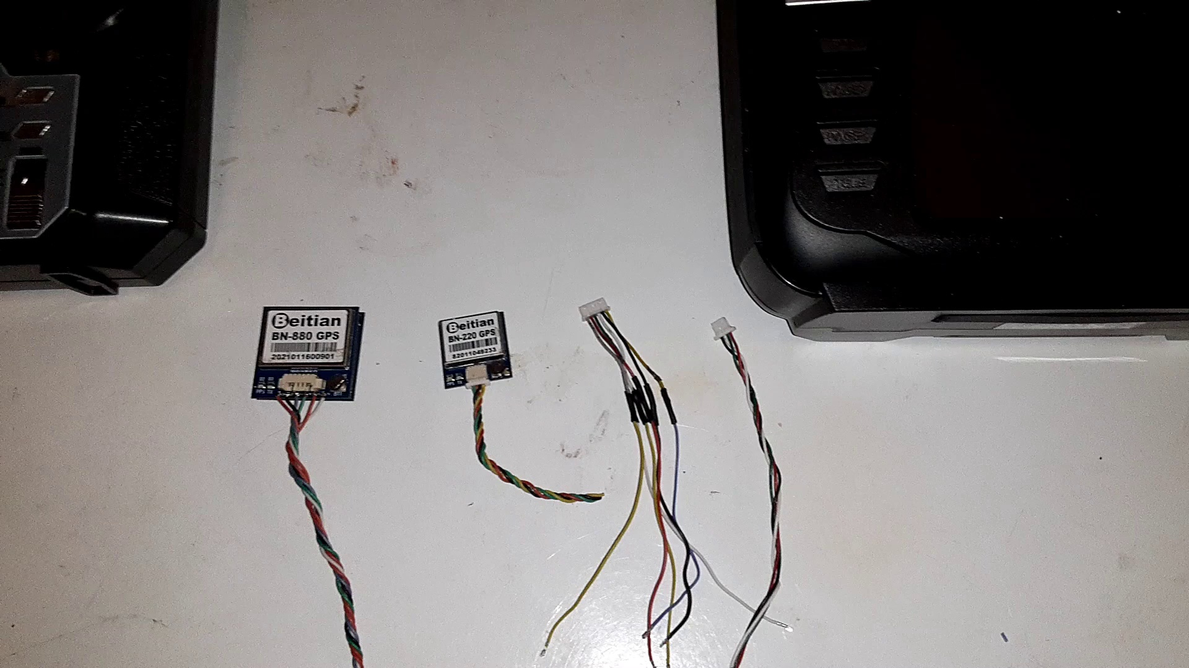 | 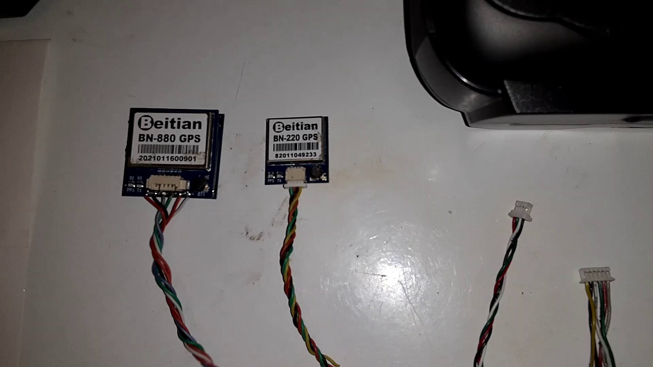 | 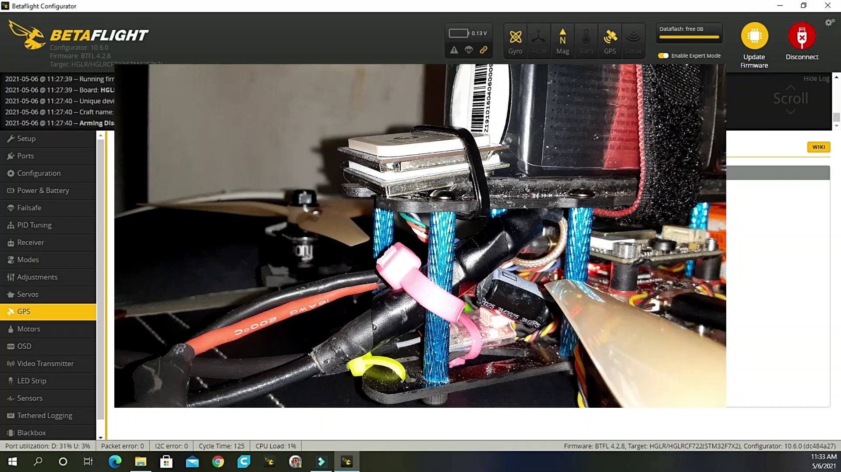
Topic T2: GPS Configuration and Troubleshooting — score 80.0000
Description: The speaker explains how to configure GPS settings on the Zeus board and troubleshoot common issues.
Reason: The comment directly discusses configuring GPS settings and mentions calibrating the compass, which is a specific step described in the topic. Although the tone is negative, the content still strongly relates to the topic's focus on GPS configuration and troubleshooting.
 |  | 
Topic T1: Introduction and Overview — score 20.0000
Description: The speaker discusses their experience with the Zeus board and its overheating issues.
Reason: The comment mentions GPS and compass calibration, but it doesn't directly discuss the Zeus board or its overheating issues. The topic is about the Zeus board's experience and overheating, while the comment is more focused on a general dislike of GPS with compass.
 |  | 
Topic T3: OSD and Modes — score 0.0000
Description: The speaker explains the OSD settings on the Zeus board and how to configure modes.
Reason: The comment discusses GPS and compass calibration, which is unrelated to OSD settings and modes on the Zeus board.
Least correlated topics:
 |  | 
Topic T3: OSD and Modes — score 0.0000
Description: The speaker explains the OSD settings on the Zeus board and how to configure modes.
Reason: The comment discusses GPS and compass calibration, which is unrelated to OSD settings and modes on the Zeus board.
 |  | 
Topic T1: Introduction and Overview — score 20.0000
Description: The speaker discusses their experience with the Zeus board and its overheating issues.
Reason: The comment mentions GPS and compass calibration, but it doesn't directly discuss the Zeus board or its overheating issues. The topic is about the Zeus board's experience and overheating, while the comment is more focused on a general dislike of GPS with compass.
 |  | 
Topic T2: GPS Configuration and Troubleshooting — score 80.0000
Description: The speaker explains how to configure GPS settings on the Zeus board and troubleshoot common issues.
Reason: The comment directly discusses configuring GPS settings and mentions calibrating the compass, which is a specific step described in the topic. Although the tone is negative, the content still strongly relates to the topic's focus on GPS configuration and troubleshooting.
- matched 1 topic(s), max score 80.0000: Thank you so much. It finally worked. The protocol was the problem. I had it on NMEA
Source: https://www.youtube.com/watch?v=aXTtu4n37WI
Top correlated topics:
 |  | 
Topic T2: GPS Configuration and Troubleshooting — score 80.0000
Description: The speaker explains how to configure GPS settings on the Zeus board and troubleshoot common issues.
Reason: The comment mentions 'protocol' which is a key aspect of GPS configuration and troubleshooting, as described in the topic.
 |  | 
Topic T1: Introduction and Overview — score 20.0000
Description: The speaker discusses their experience with the Zeus board and its overheating issues.
Reason: The comment does not directly discuss the Zeus board or overheating issues, instead mentioning a protocol and NMEA setting. The topic is about introduction and overview of the Zeus board, which is not mentioned in the comment.
 |  | 
Topic T3: OSD and Modes — score 0.0000
Description: The speaker explains the OSD settings on the Zeus board and how to configure modes.
Reason: No specific overlap between OSD settings and mode configuration with the viewer's comment about NMEA protocol issue and it finally working.
Least correlated topics:
 |  | 
Topic T3: OSD and Modes — score 0.0000
Description: The speaker explains the OSD settings on the Zeus board and how to configure modes.
Reason: No specific overlap between OSD settings and mode configuration with the viewer's comment about NMEA protocol issue and it finally working.
 |  | 
Topic T1: Introduction and Overview — score 20.0000
Description: The speaker discusses their experience with the Zeus board and its overheating issues.
Reason: The comment does not directly discuss the Zeus board or overheating issues, instead mentioning a protocol and NMEA setting. The topic is about introduction and overview of the Zeus board, which is not mentioned in the comment.
 |  | 
Topic T2: GPS Configuration and Troubleshooting — score 80.0000
Description: The speaker explains how to configure GPS settings on the Zeus board and troubleshoot common issues.
Reason: The comment mentions 'protocol' which is a key aspect of GPS configuration and troubleshooting, as described in the topic.
- matched 1 topic(s), max score 80.0000: So I got to wait for that gps tab to say not false ? Before it works?
Source: https://www.youtube.com/watch?v=aXTtu4n37WI
Top correlated topics:
 |  | 
Topic T2: GPS Configuration and Troubleshooting — score 80.0000
Description: The speaker explains how to configure GPS settings on the Zeus board and troubleshoot common issues.
Reason: The comment directly references a specific setting (the GPS tab) and its status, which is related to the topic's description of configuring GPS settings on the Zeus board.
 |  | 
Topic T3: OSD and Modes — score 20.0000
Description: The speaker explains the OSD settings on the Zeus board and how to configure modes.
Reason: The comment mentions a GPS tab and a specific condition to wait for, which is not related to the topic of OSD settings and modes on the Zeus board.
 |  | 
Topic T1: Introduction and Overview — score 20.0000
Description: The speaker discusses their experience with the Zeus board and its overheating issues.
Reason: The comment discusses GPS issues and a 'not false' status, which is unrelated to the topic's description of overheating issues with the Zeus board.
Least correlated topics:
 |  | 
Topic T1: Introduction and Overview — score 20.0000
Description: The speaker discusses their experience with the Zeus board and its overheating issues.
Reason: The comment discusses GPS issues and a 'not false' status, which is unrelated to the topic's description of overheating issues with the Zeus board.
 |  | 
Topic T3: OSD and Modes — score 20.0000
Description: The speaker explains the OSD settings on the Zeus board and how to configure modes.
Reason: The comment mentions a GPS tab and a specific condition to wait for, which is not related to the topic of OSD settings and modes on the Zeus board.
 |  | 
Topic T2: GPS Configuration and Troubleshooting — score 80.0000
Description: The speaker explains how to configure GPS settings on the Zeus board and troubleshoot common issues.
Reason: The comment directly references a specific setting (the GPS tab) and its status, which is related to the topic's description of configuring GPS settings on the Zeus board.
- matched 0 topic(s), max score 0.0000: @M-H433 They break down easily.
Source: https://www.youtube.com/watch?v=aXTtu4n37WI
Top correlated topics:
 |  | 
Topic T3: OSD and Modes — score 0.0000
Description: The speaker explains the OSD settings on the Zeus board and how to configure modes.
Reason: The comment does not discuss OSD settings or mode configuration, and the phrase 'They break down easily' is unrelated to the topic.
 |  | 
Topic T2: GPS Configuration and Troubleshooting — score 0.0000
Description: The speaker explains how to configure GPS settings on the Zeus board and troubleshoot common issues.
Reason: The comment does not discuss GPS configuration or troubleshooting, but rather mentions the breakdown of an unknown object.
 |  | 
Topic T1: Introduction and Overview — score 0.0000
Description: The speaker discusses their experience with the Zeus board and its overheating issues.
Reason: The comment mentions a generic statement about something breaking down, which is not related to the topic's discussion of Zeus board overheating issues.
Least correlated topics:
 |  | 
Topic T1: Introduction and Overview — score 0.0000
Description: The speaker discusses their experience with the Zeus board and its overheating issues.
Reason: The comment mentions a generic statement about something breaking down, which is not related to the topic's discussion of Zeus board overheating issues.
 |  | 
Topic T2: GPS Configuration and Troubleshooting — score 0.0000
Description: The speaker explains how to configure GPS settings on the Zeus board and troubleshoot common issues.
Reason: The comment does not discuss GPS configuration or troubleshooting, but rather mentions the breakdown of an unknown object.
 |  | 
Topic T3: OSD and Modes — score 0.0000
Description: The speaker explains the OSD settings on the Zeus board and how to configure modes.
Reason: The comment does not discuss OSD settings or mode configuration, and the phrase 'They break down easily' is unrelated to the topic.
- matched 0 topic(s), max score 0.0000: You might want to blur out the Lat. Long. numbers. Everyone knows where your house is now. If you care about that. Thank you for the help with this.
Source: https://www.youtube.com/watch?v=aXTtu4n37WI
Top correlated topics:
 |  | 
Topic T2: GPS Configuration and Troubleshooting — score 20.0000
Description: The speaker explains how to configure GPS settings on the Zeus board and troubleshoot common issues.
Reason: The comment mentions GPS settings and configuration, but does not directly discuss the same steps, objects, or parameters described in the topic. Instead, it provides a tangential remark about privacy concerns related to GPS location sharing.
 |  | 
Topic T3: OSD and Modes — score 0.0000
Description: The speaker explains the OSD settings on the Zeus board and how to configure modes.
Reason: The comment does not discuss OSD settings or modes, and instead brings up a personal concern about privacy.
 |  | 
Topic T1: Introduction and Overview — score 0.0000
Description: The speaker discusses their experience with the Zeus board and its overheating issues.
Reason: The comment does not discuss Zeus board overheating issues or any specific topic mentioned in the description. Instead, it mentions blurring out Lat. Long. numbers and concerns about privacy.
Least correlated topics:
 |  | 
Topic T1: Introduction and Overview — score 0.0000
Description: The speaker discusses their experience with the Zeus board and its overheating issues.
Reason: The comment does not discuss Zeus board overheating issues or any specific topic mentioned in the description. Instead, it mentions blurring out Lat. Long. numbers and concerns about privacy.
 |  | 
Topic T3: OSD and Modes — score 0.0000
Description: The speaker explains the OSD settings on the Zeus board and how to configure modes.
Reason: The comment does not discuss OSD settings or modes, and instead brings up a personal concern about privacy.
 |  | 
Topic T2: GPS Configuration and Troubleshooting — score 20.0000
Description: The speaker explains how to configure GPS settings on the Zeus board and troubleshoot common issues.
Reason: The comment mentions GPS settings and configuration, but does not directly discuss the same steps, objects, or parameters described in the topic. Instead, it provides a tangential remark about privacy concerns related to GPS location sharing.
- matched 0 topic(s), max score 0.0000: You don't know what your talking about.
Source: https://www.youtube.com/watch?v=aXTtu4n37WI
Top correlated topics:
 |  | 
Topic T3: OSD and Modes — score 0.0000
Description: The speaker explains the OSD settings on the Zeus board and how to configure modes.
Reason: The comment does not discuss the OSD settings or modes on the Zeus board, and instead appears to be a generic negative statement.
 |  | 
Topic T2: GPS Configuration and Troubleshooting — score 0.0000
Description: The speaker explains how to configure GPS settings on the Zeus board and troubleshoot common issues.
Reason: The comment does not discuss any specific steps, objects, settings, parameters, claims, or goals related to GPS configuration and troubleshooting, instead it's a generic negative statement.
 |  | 
Topic T1: Introduction and Overview — score 0.0000
Description: The speaker discusses their experience with the Zeus board and its overheating issues.
Reason: The comment does not discuss the Zeus board or its overheating issues, and instead expresses disagreement without providing any specific information related to the topic.
Least correlated topics:
 |  | 
Topic T1: Introduction and Overview — score 0.0000
Description: The speaker discusses their experience with the Zeus board and its overheating issues.
Reason: The comment does not discuss the Zeus board or its overheating issues, and instead expresses disagreement without providing any specific information related to the topic.
 |  | 
Topic T2: GPS Configuration and Troubleshooting — score 0.0000
Description: The speaker explains how to configure GPS settings on the Zeus board and troubleshoot common issues.
Reason: The comment does not discuss any specific steps, objects, settings, parameters, claims, or goals related to GPS configuration and troubleshooting, instead it's a generic negative statement.
 |  | 
Topic T3: OSD and Modes — score 0.0000
Description: The speaker explains the OSD settings on the Zeus board and how to configure modes.
Reason: The comment does not discuss the OSD settings or modes on the Zeus board, and instead appears to be a generic negative statement.
- matched 0 topic(s), max score 0.0000: Why?
Source: https://www.youtube.com/watch?v=aXTtu4n37WI
Top correlated topics:
 |  | 
Topic T2: GPS Configuration and Troubleshooting — score 20.0000
Description: The speaker explains how to configure GPS settings on the Zeus board and troubleshoot common issues.
Reason: The comment 'Why?' does not directly discuss the same steps, objects, settings, parameters, claims, or goals described by the topic. The topic is about configuring and troubleshooting GPS settings on a Zeus board, whereas the comment is an inquiry without any specific relation to those topics.
 |  | 
Topic T3: OSD and Modes — score 0.0000
Description: The speaker explains the OSD settings on the Zeus board and how to configure modes.
Reason: The comment asks 'Why?' which does not directly discuss the same steps, objects, settings, parameters, claims, or goals described by the topic.
 |  | 
Topic T1: Introduction and Overview — score 0.0000
Description: The speaker discusses their experience with the Zeus board and its overheating issues.
Reason: The comment 'Why?' does not directly discuss the Zeus board or its overheating issues, instead it appears to be a question seeking clarification.
Least correlated topics:
 |  | 
Topic T1: Introduction and Overview — score 0.0000
Description: The speaker discusses their experience with the Zeus board and its overheating issues.
Reason: The comment 'Why?' does not directly discuss the Zeus board or its overheating issues, instead it appears to be a question seeking clarification.
 |  | 
Topic T3: OSD and Modes — score 0.0000
Description: The speaker explains the OSD settings on the Zeus board and how to configure modes.
Reason: The comment asks 'Why?' which does not directly discuss the same steps, objects, settings, parameters, claims, or goals described by the topic.
 |  | 
Topic T2: GPS Configuration and Troubleshooting — score 20.0000
Description: The speaker explains how to configure GPS settings on the Zeus board and troubleshoot common issues.
Reason: The comment 'Why?' does not directly discuss the same steps, objects, settings, parameters, claims, or goals described by the topic. The topic is about configuring and troubleshooting GPS settings on a Zeus board, whereas the comment is an inquiry without any specific relation to those topics.
- matched 0 topic(s), max score 0.0000: True. Telemetry is a communications system. 880 have a compass.
Source: https://www.youtube.com/watch?v=aXTtu4n37WI
Top correlated topics:
 |  | 
Topic T2: GPS Configuration and Troubleshooting — score 20.0000
Description: The speaker explains how to configure GPS settings on the Zeus board and troubleshoot common issues.
Reason: The comment mentions telemetry and compass, which are not directly related to GPS configuration and troubleshooting on the Zeus board. The topic is specific to configuring settings and troubleshooting issues for a GPS system, whereas the comment is discussing a general concept of telemetry and mentioning a compass model (880), which is not directly relevant.
 |  | 
Topic T3: OSD and Modes — score 0.0000
Description: The speaker explains the OSD settings on the Zeus board and how to configure modes.
Reason: The comment discusses telemetry and a compass, which is unrelated to OSD settings and modes on the Zeus board.
 |  | 
Topic T1: Introduction and Overview — score 0.0000
Description: The speaker discusses their experience with the Zeus board and its overheating issues.
Reason: The comment does not discuss the Zeus board or overheating issues mentioned in the topic description. Instead, it appears to be unrelated and generic.
Least correlated topics:
 |  | 
Topic T1: Introduction and Overview — score 0.0000
Description: The speaker discusses their experience with the Zeus board and its overheating issues.
Reason: The comment does not discuss the Zeus board or overheating issues mentioned in the topic description. Instead, it appears to be unrelated and generic.
 |  | 
Topic T3: OSD and Modes — score 0.0000
Description: The speaker explains the OSD settings on the Zeus board and how to configure modes.
Reason: The comment discusses telemetry and a compass, which is unrelated to OSD settings and modes on the Zeus board.
 |  | 
Topic T2: GPS Configuration and Troubleshooting — score 20.0000
Description: The speaker explains how to configure GPS settings on the Zeus board and troubleshoot common issues.
Reason: The comment mentions telemetry and compass, which are not directly related to GPS configuration and troubleshooting on the Zeus board. The topic is specific to configuring settings and troubleshooting issues for a GPS system, whereas the comment is discussing a general concept of telemetry and mentioning a compass model (880), which is not directly relevant.
- matched 0 topic(s), max score 0.0000: Thank you so much.
Source: https://www.youtube.com/watch?v=aXTtu4n37WI
Top correlated topics:
 |  | 
Topic T3: OSD and Modes — score 0.0000
Description: The speaker explains the OSD settings on the Zeus board and how to configure modes.
Reason: The comment does not discuss the OSD settings or modes on the Zeus board at all. Instead, it's a generic expression of gratitude.
 |  | 
Topic T2: GPS Configuration and Troubleshooting — score 0.0000
Description: The speaker explains how to configure GPS settings on the Zeus board and troubleshoot common issues.
Reason: The comment does not discuss GPS configuration or troubleshooting, but rather expresses generic gratitude.
 |  | 
Topic T1: Introduction and Overview — score 0.0000
Description: The speaker discusses their experience with the Zeus board and its overheating issues.
Reason: The comment is a generic thank-you message that does not discuss the Zeus board or overheating issues mentioned in the topic.
Least correlated topics:
 |  | 
Topic T1: Introduction and Overview — score 0.0000
Description: The speaker discusses their experience with the Zeus board and its overheating issues.
Reason: The comment is a generic thank-you message that does not discuss the Zeus board or overheating issues mentioned in the topic.
 |  | 
Topic T2: GPS Configuration and Troubleshooting — score 0.0000
Description: The speaker explains how to configure GPS settings on the Zeus board and troubleshoot common issues.
Reason: The comment does not discuss GPS configuration or troubleshooting, but rather expresses generic gratitude.
 |  | 
Topic T3: OSD and Modes — score 0.0000
Description: The speaker explains the OSD settings on the Zeus board and how to configure modes.
Reason: The comment does not discuss the OSD settings or modes on the Zeus board at all. Instead, it's a generic expression of gratitude.
- matched 0 topic(s), max score 0.0000: Sat id Oty
12. 1
12. 1
12. 1
Source: https://www.youtube.com/watch?v=aXTtu4n37WI
Top correlated topics:
 |  | 
Topic T3: OSD and Modes — score 0.0000
Description: The speaker explains the OSD settings on the Zeus board and how to configure modes.
Reason: The comment appears to be a numerical sequence with no clear relation to the topic 'OSD and Modes' or its description about configuring modes on a Zeus board.
 |  | 
Topic T2: GPS Configuration and Troubleshooting — score 0.0000
Description: The speaker explains how to configure GPS settings on the Zeus board and troubleshoot common issues.
Reason: The comment appears to be a table of satellite IDs and counts, unrelated to GPS configuration or troubleshooting.
 |  | 
Topic T1: Introduction and Overview — score 0.0000
Description: The speaker discusses their experience with the Zeus board and its overheating issues.
Reason: The comment appears to be a series of numbers and does not directly discuss the Zeus board or its overheating issues.
Least correlated topics:
 |  | 
Topic T1: Introduction and Overview — score 0.0000
Description: The speaker discusses their experience with the Zeus board and its overheating issues.
Reason: The comment appears to be a series of numbers and does not directly discuss the Zeus board or its overheating issues.
 |  | 
Topic T2: GPS Configuration and Troubleshooting — score 0.0000
Description: The speaker explains how to configure GPS settings on the Zeus board and troubleshoot common issues.
Reason: The comment appears to be a table of satellite IDs and counts, unrelated to GPS configuration or troubleshooting.
 |  | 
Topic T3: OSD and Modes — score 0.0000
Description: The speaker explains the OSD settings on the Zeus board and how to configure modes.
Reason: The comment appears to be a numerical sequence with no clear relation to the topic 'OSD and Modes' or its description about configuring modes on a Zeus board.
- matched 0 topic(s), max score 0.0000: I have had the 880 for over a year I am wanting to put it in my wing. This was a helpful, good video man!
Source: https://www.youtube.com/watch?v=aXTtu4n37WI
Top correlated topics:
 |  | 
Topic T2: GPS Configuration and Troubleshooting — score 10.0000
Description: The speaker explains how to configure GPS settings on the Zeus board and troubleshoot common issues.
Reason: The comment does not discuss GPS configuration or troubleshooting, and only mentions the Zeus board in passing. The topic is unrelated to the viewer's experience with a device they've had for over a year.
 |  | 
Topic T1: Introduction and Overview — score 10.0000
Description: The speaker discusses their experience with the Zeus board and its overheating issues.
Reason: The comment mentions a different board (880) and its intended use in a wing, whereas the topic discusses Zeus board and overheating issues. The comment does not directly discuss the topic's claims or goals.
 |  | 
Topic T3: OSD and Modes — score 0.0000
Description: The speaker explains the OSD settings on the Zeus board and how to configure modes.
Reason: The comment does not discuss OSD settings or modes at all. It only mentions the Zeus board and a previous experience with an 880, but does not relate to the topic of configuring OSD settings or modes.
Least correlated topics:
 |  | 
Topic T3: OSD and Modes — score 0.0000
Description: The speaker explains the OSD settings on the Zeus board and how to configure modes.
Reason: The comment does not discuss OSD settings or modes at all. It only mentions the Zeus board and a previous experience with an 880, but does not relate to the topic of configuring OSD settings or modes.
 |  | 
Topic T1: Introduction and Overview — score 10.0000
Description: The speaker discusses their experience with the Zeus board and its overheating issues.
Reason: The comment mentions a different board (880) and its intended use in a wing, whereas the topic discusses Zeus board and overheating issues. The comment does not directly discuss the topic's claims or goals.
 |  | 
Topic T2: GPS Configuration and Troubleshooting — score 10.0000
Description: The speaker explains how to configure GPS settings on the Zeus board and troubleshoot common issues.
Reason: The comment does not discuss GPS configuration or troubleshooting, and only mentions the Zeus board in passing. The topic is unrelated to the viewer's experience with a device they've had for over a year.
- matched 0 topic(s), max score 0.0000: I believe is not telemetry but compass instead.
Source: https://www.youtube.com/watch?v=aXTtu4n37WI
Top correlated topics:
 |  | 
Topic T2: GPS Configuration and Troubleshooting — score 20.0000
Description: The speaker explains how to configure GPS settings on the Zeus board and troubleshoot common issues.
Reason: The comment appears to be discussing a specific concept (compass) that is not directly related to the GPS configuration and troubleshooting topic. The topic description mentions Zeus board settings and troubleshooting common issues, which are not mentioned in the comment.
 |  | 
Topic T3: OSD and Modes — score 0.0000
Description: The speaker explains the OSD settings on the Zeus board and how to configure modes.
Reason: The comment doesn't discuss OSD settings or mode configuration at all. Instead, it raises a specific question about telemetry vs compass.
 |  | 
Topic T1: Introduction and Overview — score 0.0000
Description: The speaker discusses their experience with the Zeus board and its overheating issues.
Reason: The comment does not discuss the Zeus board or its overheating issues, which are central to the topic. Instead, it raises a new point about telemetry vs compass, showing no direct connection to the topic.
Least correlated topics:
 |  | 
Topic T1: Introduction and Overview — score 0.0000
Description: The speaker discusses their experience with the Zeus board and its overheating issues.
Reason: The comment does not discuss the Zeus board or its overheating issues, which are central to the topic. Instead, it raises a new point about telemetry vs compass, showing no direct connection to the topic.
 |  | 
Topic T3: OSD and Modes — score 0.0000
Description: The speaker explains the OSD settings on the Zeus board and how to configure modes.
Reason: The comment doesn't discuss OSD settings or mode configuration at all. Instead, it raises a specific question about telemetry vs compass.
 |  | 
Topic T2: GPS Configuration and Troubleshooting — score 20.0000
Description: The speaker explains how to configure GPS settings on the Zeus board and troubleshoot common issues.
Reason: The comment appears to be discussing a specific concept (compass) that is not directly related to the GPS configuration and troubleshooting topic. The topic description mentions Zeus board settings and troubleshooting common issues, which are not mentioned in the comment.
- matched 0 topic(s), max score 0.0000: Don't buy Beitian BN-880Q, Beitian 880.
Source: https://www.youtube.com/watch?v=aXTtu4n37WI
Top correlated topics:
 |  | 
Topic T3: OSD and Modes — score 0.0000
Description: The speaker explains the OSD settings on the Zeus board and how to configure modes.
Reason: The comment does not discuss the OSD settings or modes on the Zeus board, but instead appears to be a product recommendation.
 |  | 
Topic T2: GPS Configuration and Troubleshooting — score 0.0000
Description: The speaker explains how to configure GPS settings on the Zeus board and troubleshoot common issues.
Reason: The comment does not discuss GPS configuration or troubleshooting, and the mentioned product names (Beitian BN-880Q and Beitian 880) are not related to the topic of GPS configuration on the Zeus board.
 |  | 
Topic T1: Introduction and Overview — score 0.0000
Description: The speaker discusses their experience with the Zeus board and its overheating issues.
Reason: The topic describes Zeus board and overheating issues, while the comment mentions Beitian BN-880Q and 880. No overlap in topics or descriptions.
Least correlated topics:
 |  | 
Topic T1: Introduction and Overview — score 0.0000
Description: The speaker discusses their experience with the Zeus board and its overheating issues.
Reason: The topic describes Zeus board and overheating issues, while the comment mentions Beitian BN-880Q and 880. No overlap in topics or descriptions.
 |  | 
Topic T2: GPS Configuration and Troubleshooting — score 0.0000
Description: The speaker explains how to configure GPS settings on the Zeus board and troubleshoot common issues.
Reason: The comment does not discuss GPS configuration or troubleshooting, and the mentioned product names (Beitian BN-880Q and Beitian 880) are not related to the topic of GPS configuration on the Zeus board.
 |  | 
Topic T3: OSD and Modes — score 0.0000
Description: The speaker explains the OSD settings on the Zeus board and how to configure modes.
Reason: The comment does not discuss the OSD settings or modes on the Zeus board, but instead appears to be a product recommendation.
- matched 0 topic(s), max score 0.0000: Baud rate for BN 880 is 38400
Baud rate for BN 880Q is 9600
Just a fyi
Source: https://www.youtube.com/watch?v=aXTtu4n37WI
Top correlated topics:
 |  | 
Topic T2: GPS Configuration and Troubleshooting — score 20.0000
Description: The speaker explains how to configure GPS settings on the Zeus board and troubleshoot common issues.
Reason: The comment only provides specific baud rate information for two models (BN 880 and BN 880Q), which is not directly related to GPS configuration and troubleshooting on the Zeus board.
 |  | 
Topic T3: OSD and Modes — score 0.0000
Description: The speaker explains the OSD settings on the Zeus board and how to configure modes.
Reason: The comment discusses specific baud rates for BN 880 and BN 880Q, which is not related to the topic of OSD settings on the Zeus board and configuring modes.
 |  | 
Topic T1: Introduction and Overview — score 0.0000
Description: The speaker discusses their experience with the Zeus board and its overheating issues.
Reason: The comment discusses baud rates for BN 880 and BN 880Q, which is unrelated to the topic about Zeus board overheating issues.
Least correlated topics:
 |  | 
Topic T1: Introduction and Overview — score 0.0000
Description: The speaker discusses their experience with the Zeus board and its overheating issues.
Reason: The comment discusses baud rates for BN 880 and BN 880Q, which is unrelated to the topic about Zeus board overheating issues.
 |  | 
Topic T3: OSD and Modes — score 0.0000
Description: The speaker explains the OSD settings on the Zeus board and how to configure modes.
Reason: The comment discusses specific baud rates for BN 880 and BN 880Q, which is not related to the topic of OSD settings on the Zeus board and configuring modes.
 |  | 
Topic T2: GPS Configuration and Troubleshooting — score 20.0000
Description: The speaker explains how to configure GPS settings on the Zeus board and troubleshoot common issues.
Reason: The comment only provides specific baud rate information for two models (BN 880 and BN 880Q), which is not directly related to GPS configuration and troubleshooting on the Zeus board.

Topic T1: Introduction and Overview
 |  | 
Description: The speaker discusses their experience with the Zeus board and its overheating issues.
No strongly correlated comments found for this topic.

Topic T2: GPS Configuration and Troubleshooting
 |  | 
Description: The speaker explains how to configure GPS settings on the Zeus board and troubleshoot common issues.
Comment (score 80): you have to calibrate the compass in the GPS....I do not like GPS with compass...so much stuff interferes with them....not worth the hassle.
Reason: The comment directly discusses configuring GPS settings and mentions calibrating the compass, which is a specific step described in the topic. Although the tone is negative, the content still strongly relates to the topic's focus on GPS configuration and troubleshooting.
Source: https://www.youtube.com/watch?v=aXTtu4n37WI
Comment (score 80): So I got to wait for that gps tab to say not false ? Before it works?
Reason: The comment directly references a specific setting (the GPS tab) and its status, which is related to the topic's description of configuring GPS settings on the Zeus board.
Source: https://www.youtube.com/watch?v=aXTtu4n37WI
Comment (score 80): Thank you so much. It finally worked. The protocol was the problem. I had it on NMEA
Reason: The comment mentions 'protocol' which is a key aspect of GPS configuration and troubleshooting, as described in the topic.
Source: https://www.youtube.com/watch?v=aXTtu4n37WI

Topic T3: OSD and Modes
 |  | 
Description: The speaker explains the OSD settings on the Zeus board and how to configure modes.
No strongly correlated comments found for this topic.

