Comment–Topic Correlation Report
Model: llama3

Summary
Topics processed: 3
Comments available for this video: 8
Comments correlated to ≥ 60: 3 (37.5%)
Total candidate pairs checked: 24

Most/Least correlated topics (by average score across correlated comments):
Top 3:
• Topic T3: Quadrotor Dynamics — avg 83.33, contributions 3
• Topic T2: Equilibrium Configuration — avg 0.00, contributions 0
• Topic T1: Defining a State Vector — avg 0.00, contributions 0
Bottom 3:
• Topic T1: Defining a State Vector — avg 0.00, contributions 0
• Topic T2: Equilibrium Configuration — avg 0.00, contributions 0
• Topic T3: Quadrotor Dynamics — avg 83.33, contributions 3
Correlated comment coverage (all comments):
- matched 1 topic(s), max score 90.0000: This is professor Vijay Kumar.
Source: https://www.youtube.com/watch?v=lAVYDUeqdW4
Top correlated topics:
 | 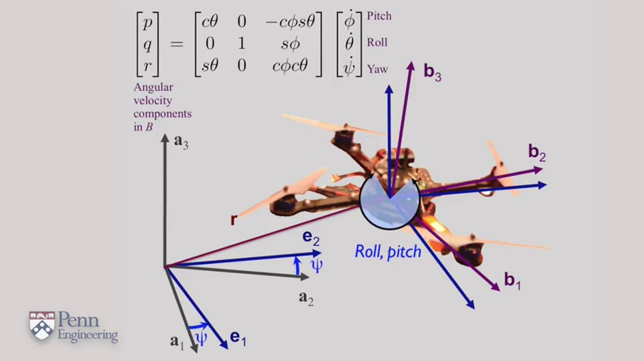 | 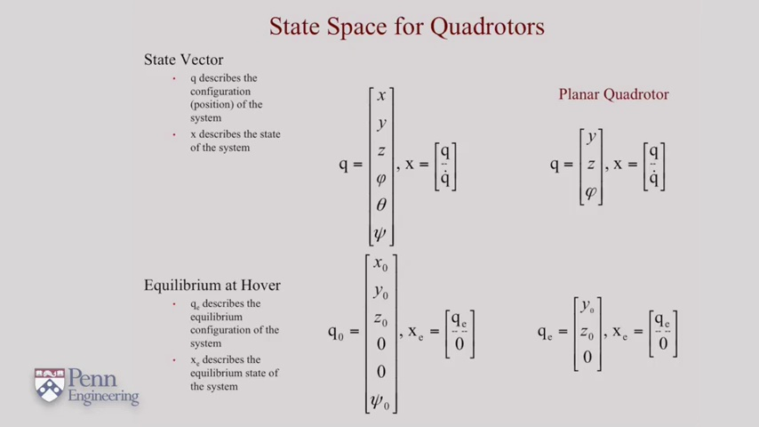
Topic T3: Quadrotor Dynamics — score 90.0000
Description: The speaker discusses the equations of motion for a quadrotor, including the net force and moment. They show how to combine these with the Newton-Euler equations to develop controllers and planners.
Reason: The comment mentions the speaker's name and title ('professor Vijay Kumar'), which is a strong overlap with the topic 'Quadrotor Dynamics'. The fact that it responds to the speaker also suggests a direct connection to the topic.
 |  | 
Topic T2: Equilibrium Configuration — score 0.0000
Description: The speaker discusses the equilibrium configuration for a quadrotor, including its position, velocity, and orientation.
Reason: The comment does not directly discuss the equilibrium configuration of a quadrotor or any specific details mentioned in the topic description.
 |  | 
Topic T1: Defining a State Vector — score 0.0000
Description: The speaker defines a state vector to describe the configuration and its derivative for a robot.
Reason: The comment does not discuss the topic of defining a state vector or its application to describe the configuration and derivative for a robot. The mention of Professor Vijay Kumar is likely unrelated to the topic.
Least correlated topics:
 |  | 
Topic T1: Defining a State Vector — score 0.0000
Description: The speaker defines a state vector to describe the configuration and its derivative for a robot.
Reason: The comment does not discuss the topic of defining a state vector or its application to describe the configuration and derivative for a robot. The mention of Professor Vijay Kumar is likely unrelated to the topic.
 |  | 
Topic T2: Equilibrium Configuration — score 0.0000
Description: The speaker discusses the equilibrium configuration for a quadrotor, including its position, velocity, and orientation.
Reason: The comment does not directly discuss the equilibrium configuration of a quadrotor or any specific details mentioned in the topic description.
 |  | 
Topic T3: Quadrotor Dynamics — score 90.0000
Description: The speaker discusses the equations of motion for a quadrotor, including the net force and moment. They show how to combine these with the Newton-Euler equations to develop controllers and planners.
Reason: The comment mentions the speaker's name and title ('professor Vijay Kumar'), which is a strong overlap with the topic 'Quadrotor Dynamics'. The fact that it responds to the speaker also suggests a direct connection to the topic.
- matched 1 topic(s), max score 80.0000: bunu matlabde nasıl yapabilirim?
how can I make this in matlab?
Source: https://www.youtube.com/watch?v=lAVYDUeqdW4
Top correlated topics:
 |  | 
Topic T3: Quadrotor Dynamics — score 80.0000
Description: The speaker discusses the equations of motion for a quadrotor, including the net force and moment. They show how to combine these with the Newton-Euler equations to develop controllers and planners.
Reason: The commenter asks how to implement the quadrotor dynamics in MATLAB, which directly relates to the topic of developing controllers and planners using the Newton-Euler equations.
 |  | 
Topic T2: Equilibrium Configuration — score 20.0000
Description: The speaker discusses the equilibrium configuration for a quadrotor, including its position, velocity, and orientation.
Reason: The comment asks a general question about how to implement something in MATLAB, but does not directly discuss the equilibrium configuration for a quadrotor or any specific details mentioned in the topic description.
 |  | 
Topic T1: Defining a State Vector — score 20.0000
Description: The speaker defines a state vector to describe the configuration and its derivative for a robot.
Reason: The comment asks about implementing the concept in MATLAB, but does not directly discuss the definition of a state vector or its application to a robot.
Least correlated topics:
 |  | 
Topic T1: Defining a State Vector — score 20.0000
Description: The speaker defines a state vector to describe the configuration and its derivative for a robot.
Reason: The comment asks about implementing the concept in MATLAB, but does not directly discuss the definition of a state vector or its application to a robot.
 |  | 
Topic T2: Equilibrium Configuration — score 20.0000
Description: The speaker discusses the equilibrium configuration for a quadrotor, including its position, velocity, and orientation.
Reason: The comment asks a general question about how to implement something in MATLAB, but does not directly discuss the equilibrium configuration for a quadrotor or any specific details mentioned in the topic description.
 |  | 
Topic T3: Quadrotor Dynamics — score 80.0000
Description: The speaker discusses the equations of motion for a quadrotor, including the net force and moment. They show how to combine these with the Newton-Euler equations to develop controllers and planners.
Reason: The commenter asks how to implement the quadrotor dynamics in MATLAB, which directly relates to the topic of developing controllers and planners using the Newton-Euler equations.
- matched 1 topic(s), max score 80.0000: Could you please help me to establish UAVs mathematical modeling?
Source: https://www.youtube.com/watch?v=lAVYDUeqdW4
Top correlated topics:
 |  | 
Topic T3: Quadrotor Dynamics — score 80.0000
Description: The speaker discusses the equations of motion for a quadrotor, including the net force and moment. They show how to combine these with the Newton-Euler equations to develop controllers and planners.
Reason: The comment requests help with establishing the mathematical modeling of UAVs, which is directly related to the topic of quadrotor dynamics and its equations of motion, making it strongly correlated.
 |  | 
Topic T2: Equilibrium Configuration — score 20.0000
Description: The speaker discusses the equilibrium configuration for a quadrotor, including its position, velocity, and orientation.
Reason: The comment asks for general help with mathematical modeling of UAVs, which does not directly discuss the same steps, objects, settings, parameters, claims, or goals described by the topic (equilibrium configuration for a quadrotor).
 |  | 
Topic T1: Defining a State Vector — score 20.0000
Description: The speaker defines a state vector to describe the configuration and its derivative for a robot.
Reason: The comment asks for help with establishing mathematical modeling for UAVs, which is a broader topic that doesn't directly discuss the specific concept of defining a state vector for a robot.
Least correlated topics:
 |  | 
Topic T1: Defining a State Vector — score 20.0000
Description: The speaker defines a state vector to describe the configuration and its derivative for a robot.
Reason: The comment asks for help with establishing mathematical modeling for UAVs, which is a broader topic that doesn't directly discuss the specific concept of defining a state vector for a robot.
 |  | 
Topic T2: Equilibrium Configuration — score 20.0000
Description: The speaker discusses the equilibrium configuration for a quadrotor, including its position, velocity, and orientation.
Reason: The comment asks for general help with mathematical modeling of UAVs, which does not directly discuss the same steps, objects, settings, parameters, claims, or goals described by the topic (equilibrium configuration for a quadrotor).
 |  | 
Topic T3: Quadrotor Dynamics — score 80.0000
Description: The speaker discusses the equations of motion for a quadrotor, including the net force and moment. They show how to combine these with the Newton-Euler equations to develop controllers and planners.
Reason: The comment requests help with establishing the mathematical modeling of UAVs, which is directly related to the topic of quadrotor dynamics and its equations of motion, making it strongly correlated.
- matched 0 topic(s), max score 0.0000: what is Ixx ?
Source: https://www.youtube.com/watch?v=lAVYDUeqdW4
Top correlated topics:
 |  | 
Topic T3: Quadrotor Dynamics — score 20.0000
Description: The speaker discusses the equations of motion for a quadrotor, including the net force and moment. They show how to combine these with the Newton-Euler equations to develop controllers and planners.
Reason: The comment asks a specific question about the moment of inertia (Ixx) which is not directly discussed in the topic about quadrotor dynamics. While it may be related to the topic, the connection is indirect and the score reflects this.
 |  | 
Topic T2: Equilibrium Configuration — score 20.0000
Description: The speaker discusses the equilibrium configuration for a quadrotor, including its position, velocity, and orientation.
Reason: The comment asks about a moment of inertia (Ixx), which is not directly related to the equilibrium configuration or parameters described in the topic. While the topic mentions orientation, it does not specify moments of inertia.
 |  | 
Topic T1: Defining a State Vector — score 20.0000
Description: The speaker defines a state vector to describe the configuration and its derivative for a robot.
Reason: The comment asks about Ixx, which is not directly related to the topic of defining a state vector for a robot. The topic focuses on describing configuration and derivative for a robot's state, while the comment seems unrelated.
Least correlated topics:
 |  | 
Topic T1: Defining a State Vector — score 20.0000
Description: The speaker defines a state vector to describe the configuration and its derivative for a robot.
Reason: The comment asks about Ixx, which is not directly related to the topic of defining a state vector for a robot. The topic focuses on describing configuration and derivative for a robot's state, while the comment seems unrelated.
 |  | 
Topic T2: Equilibrium Configuration — score 20.0000
Description: The speaker discusses the equilibrium configuration for a quadrotor, including its position, velocity, and orientation.
Reason: The comment asks about a moment of inertia (Ixx), which is not directly related to the equilibrium configuration or parameters described in the topic. While the topic mentions orientation, it does not specify moments of inertia.
 |  | 
Topic T3: Quadrotor Dynamics — score 20.0000
Description: The speaker discusses the equations of motion for a quadrotor, including the net force and moment. They show how to combine these with the Newton-Euler equations to develop controllers and planners.
Reason: The comment asks a specific question about the moment of inertia (Ixx) which is not directly discussed in the topic about quadrotor dynamics. While it may be related to the topic, the connection is indirect and the score reflects this.
- matched 0 topic(s), max score 0.0000: Sir may I get your email ID please!
Source: https://www.youtube.com/watch?v=lAVYDUeqdW4
Top correlated topics:
 |  | 
Topic T3: Quadrotor Dynamics — score 0.0000
Description: The speaker discusses the equations of motion for a quadrotor, including the net force and moment. They show how to combine these with the Newton-Euler equations to develop controllers and planners.
Reason: The comment does not discuss quadrotor dynamics or any related concepts, but instead requests the speaker's email ID.
 |  | 
Topic T2: Equilibrium Configuration — score 0.0000
Description: The speaker discusses the equilibrium configuration for a quadrotor, including its position, velocity, and orientation.
Reason: The comment does not discuss the equilibrium configuration of a quadrotor or any related topics. It is an unrelated request for the speaker's email ID.
 |  | 
Topic T1: Defining a State Vector — score 0.0000
Description: The speaker defines a state vector to describe the configuration and its derivative for a robot.
Reason: The comment does not discuss the topic of defining a state vector or any related concepts. Instead, it is a request for personal contact information.
Least correlated topics:
 |  | 
Topic T1: Defining a State Vector — score 0.0000
Description: The speaker defines a state vector to describe the configuration and its derivative for a robot.
Reason: The comment does not discuss the topic of defining a state vector or any related concepts. Instead, it is a request for personal contact information.
 |  | 
Topic T2: Equilibrium Configuration — score 0.0000
Description: The speaker discusses the equilibrium configuration for a quadrotor, including its position, velocity, and orientation.
Reason: The comment does not discuss the equilibrium configuration of a quadrotor or any related topics. It is an unrelated request for the speaker's email ID.
 |  | 
Topic T3: Quadrotor Dynamics — score 0.0000
Description: The speaker discusses the equations of motion for a quadrotor, including the net force and moment. They show how to combine these with the Newton-Euler equations to develop controllers and planners.
Reason: The comment does not discuss quadrotor dynamics or any related concepts, but instead requests the speaker's email ID.
- matched 0 topic(s), max score 0.0000: INERTIA ABOUT X AXIS
Source: https://www.youtube.com/watch?v=lAVYDUeqdW4
Top correlated topics:
 |  | 
Topic T3: Quadrotor Dynamics — score 20.0000
Description: The speaker discusses the equations of motion for a quadrotor, including the net force and moment. They show how to combine these with the Newton-Euler equations to develop controllers and planners.
Reason: The comment only mentions a specific axis (X) and inertia, which is not directly related to the topic of quadrotor dynamics, equations of motion, or controllers/planners.
 |  | 
Topic T2: Equilibrium Configuration — score 20.0000
Description: The speaker discusses the equilibrium configuration for a quadrotor, including its position, velocity, and orientation.
Reason: The comment discusses inertia about the x-axis, which is a physical property related to the quadrotor's movement. However, it does not directly discuss the equilibrium configuration, position, velocity, or orientation mentioned in the topic description.
 |  | 
Topic T1: Defining a State Vector — score 20.0000
Description: The speaker defines a state vector to describe the configuration and its derivative for a robot.
Reason: The comment 'INERTIA ABOUT X AXIS' is unrelated to the topic of defining a state vector for a robot. The topic discusses configuration and derivative, whereas the comment appears to be discussing inertial properties in relation to an axis, which is not directly related.
Least correlated topics:
 |  | 
Topic T1: Defining a State Vector — score 20.0000
Description: The speaker defines a state vector to describe the configuration and its derivative for a robot.
Reason: The comment 'INERTIA ABOUT X AXIS' is unrelated to the topic of defining a state vector for a robot. The topic discusses configuration and derivative, whereas the comment appears to be discussing inertial properties in relation to an axis, which is not directly related.
 |  | 
Topic T2: Equilibrium Configuration — score 20.0000
Description: The speaker discusses the equilibrium configuration for a quadrotor, including its position, velocity, and orientation.
Reason: The comment discusses inertia about the x-axis, which is a physical property related to the quadrotor's movement. However, it does not directly discuss the equilibrium configuration, position, velocity, or orientation mentioned in the topic description.
 |  | 
Topic T3: Quadrotor Dynamics — score 20.0000
Description: The speaker discusses the equations of motion for a quadrotor, including the net force and moment. They show how to combine these with the Newton-Euler equations to develop controllers and planners.
Reason: The comment only mentions a specific axis (X) and inertia, which is not directly related to the topic of quadrotor dynamics, equations of motion, or controllers/planners.
- matched 0 topic(s), max score 0.0000: Can't digest the the equations presented quickly in a flash.
Source: https://www.youtube.com/watch?v=lAVYDUeqdW4
Top correlated topics:
 |  | 
Topic T3: Quadrotor Dynamics — score 10.0000
Description: The speaker discusses the equations of motion for a quadrotor, including the net force and moment. They show how to combine these with the Newton-Euler equations to develop controllers and planners.
Reason: The comment does not discuss the quadrotor dynamics or any specific equations presented in the topic. Instead, it expresses frustration with the pace of information.
 |  | 
Topic T2: Equilibrium Configuration — score 0.0000
Description: The speaker discusses the equilibrium configuration for a quadrotor, including its position, velocity, and orientation.
Reason: The comment does not discuss the equilibrium configuration or any related concepts. It appears to be a personal complaint about understanding equations.
 |  | 
Topic T1: Defining a State Vector — score 0.0000
Description: The speaker defines a state vector to describe the configuration and its derivative for a robot.
Reason: The comment does not discuss any specific steps, objects, settings, parameters, claims, or goals related to 'Defining a State Vector', instead it expresses difficulty in understanding equations presented. The topic is about defining a state vector for a robot, whereas the comment is unrelated.
Least correlated topics:
 |  | 
Topic T1: Defining a State Vector — score 0.0000
Description: The speaker defines a state vector to describe the configuration and its derivative for a robot.
Reason: The comment does not discuss any specific steps, objects, settings, parameters, claims, or goals related to 'Defining a State Vector', instead it expresses difficulty in understanding equations presented. The topic is about defining a state vector for a robot, whereas the comment is unrelated.
 |  | 
Topic T2: Equilibrium Configuration — score 0.0000
Description: The speaker discusses the equilibrium configuration for a quadrotor, including its position, velocity, and orientation.
Reason: The comment does not discuss the equilibrium configuration or any related concepts. It appears to be a personal complaint about understanding equations.
 |  | 
Topic T3: Quadrotor Dynamics — score 10.0000
Description: The speaker discusses the equations of motion for a quadrotor, including the net force and moment. They show how to combine these with the Newton-Euler equations to develop controllers and planners.
Reason: The comment does not discuss the quadrotor dynamics or any specific equations presented in the topic. Instead, it expresses frustration with the pace of information.
- matched 0 topic(s), max score 0.0000: 1:59 daki matris yanlış değil mi ya
Source: https://www.youtube.com/watch?v=lAVYDUeqdW4
Top correlated topics:
 |  | 
Topic T3: Quadrotor Dynamics — score 0.0000
Description: The speaker discusses the equations of motion for a quadrotor, including the net force and moment. They show how to combine these with the Newton-Euler equations to develop controllers and planners.
Reason: The comment appears to be a Turkish question about a matrix being incorrect, which has no direct relation to the topic of quadrotor dynamics or its descriptions.
 |  | 
Topic T2: Equilibrium Configuration — score 0.0000
Description: The speaker discusses the equilibrium configuration for a quadrotor, including its position, velocity, and orientation.
Reason: The comment appears to be a Turkish phrase ('daki' means 'in the', and 'matris' likely refers to a matrix) that does not relate to the topic of equilibrium configuration for a quadrotor.
 |  | 
Topic T1: Defining a State Vector — score 0.0000
Description: The speaker defines a state vector to describe the configuration and its derivative for a robot.
Reason: The comment appears to be a Turkish phrase discussing matrix or error, unrelated to the topic of defining a state vector for a robot.
Least correlated topics:
 |  | 
Topic T1: Defining a State Vector — score 0.0000
Description: The speaker defines a state vector to describe the configuration and its derivative for a robot.
Reason: The comment appears to be a Turkish phrase discussing matrix or error, unrelated to the topic of defining a state vector for a robot.
 |  | 
Topic T2: Equilibrium Configuration — score 0.0000
Description: The speaker discusses the equilibrium configuration for a quadrotor, including its position, velocity, and orientation.
Reason: The comment appears to be a Turkish phrase ('daki' means 'in the', and 'matris' likely refers to a matrix) that does not relate to the topic of equilibrium configuration for a quadrotor.
 |  | 
Topic T3: Quadrotor Dynamics — score 0.0000
Description: The speaker discusses the equations of motion for a quadrotor, including the net force and moment. They show how to combine these with the Newton-Euler equations to develop controllers and planners.
Reason: The comment appears to be a Turkish question about a matrix being incorrect, which has no direct relation to the topic of quadrotor dynamics or its descriptions.

Topic T1: Defining a State Vector
 |  | 
Description: The speaker defines a state vector to describe the configuration and its derivative for a robot.
No strongly correlated comments found for this topic.

Topic T2: Equilibrium Configuration
 |  | 
Description: The speaker discusses the equilibrium configuration for a quadrotor, including its position, velocity, and orientation.
No strongly correlated comments found for this topic.

Topic T3: Quadrotor Dynamics
 |  | 
Description: The speaker discusses the equations of motion for a quadrotor, including the net force and moment. They show how to combine these with the Newton-Euler equations to develop controllers and planners.
Comment (score 90): This is professor Vijay Kumar.
Reason: The comment mentions the speaker's name and title ('professor Vijay Kumar'), which is a strong overlap with the topic 'Quadrotor Dynamics'. The fact that it responds to the speaker also suggests a direct connection to the topic.
Source: https://www.youtube.com/watch?v=lAVYDUeqdW4
Comment (score 80): Could you please help me to establish UAVs mathematical modeling?
Reason: The comment requests help with establishing the mathematical modeling of UAVs, which is directly related to the topic of quadrotor dynamics and its equations of motion, making it strongly correlated.
Source: https://www.youtube.com/watch?v=lAVYDUeqdW4
Comment (score 80): bunu matlabde nasıl yapabilirim?
how can I make this in matlab?
Reason: The commenter asks how to implement the quadrotor dynamics in MATLAB, which directly relates to the topic of developing controllers and planners using the Newton-Euler equations.
Source: https://www.youtube.com/watch?v=lAVYDUeqdW4

