Comment–Topic Correlation Report
Model: llama3

Summary
Topics processed: 5
Comments available for this video: 3
Comments correlated to ≥ 60: 0 (0.0%)
Total candidate pairs checked: 15

Most/Least correlated topics (by average score across correlated comments):
Top 3:
• Topic T2: What is a Stall? — avg 0.00, contributions 0
• Topic T4: What Happens During a Stall? — avg 0.00, contributions 0
• Topic T5: Recovering from a Stall — avg 0.00, contributions 0
Bottom 3:
• Topic T3: Airfoil Perspective — avg 0.00, contributions 0
• Topic T1: Introduction and Context — avg 0.00, contributions 0
• Topic T5: Recovering from a Stall — avg 0.00, contributions 0
Correlated comment coverage (all comments):
- matched 0 topic(s), max score 0.0000: Thanks for the free study guide as well.Excellent.
Source: https://www.youtube.com/watch?v=wKyt5ssrDQ8
Top correlated topics:
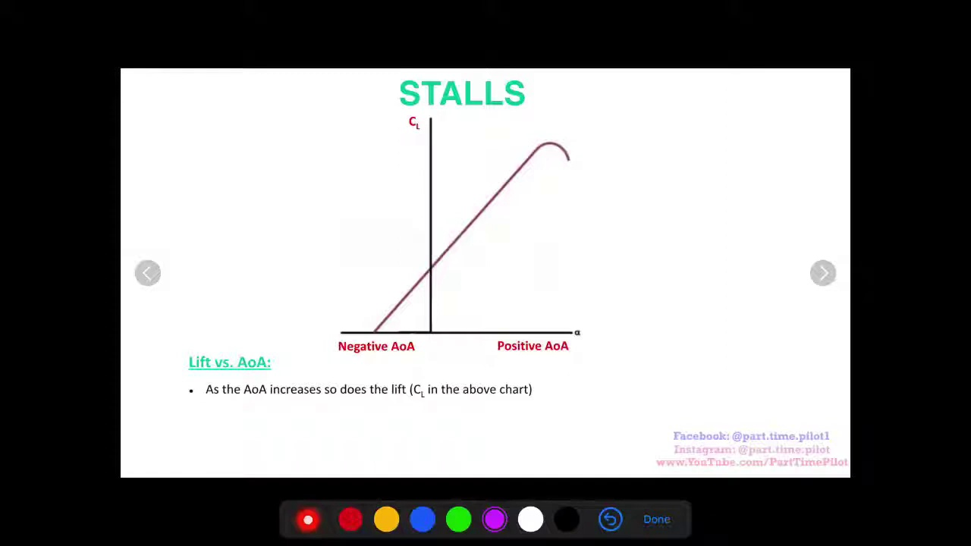 | 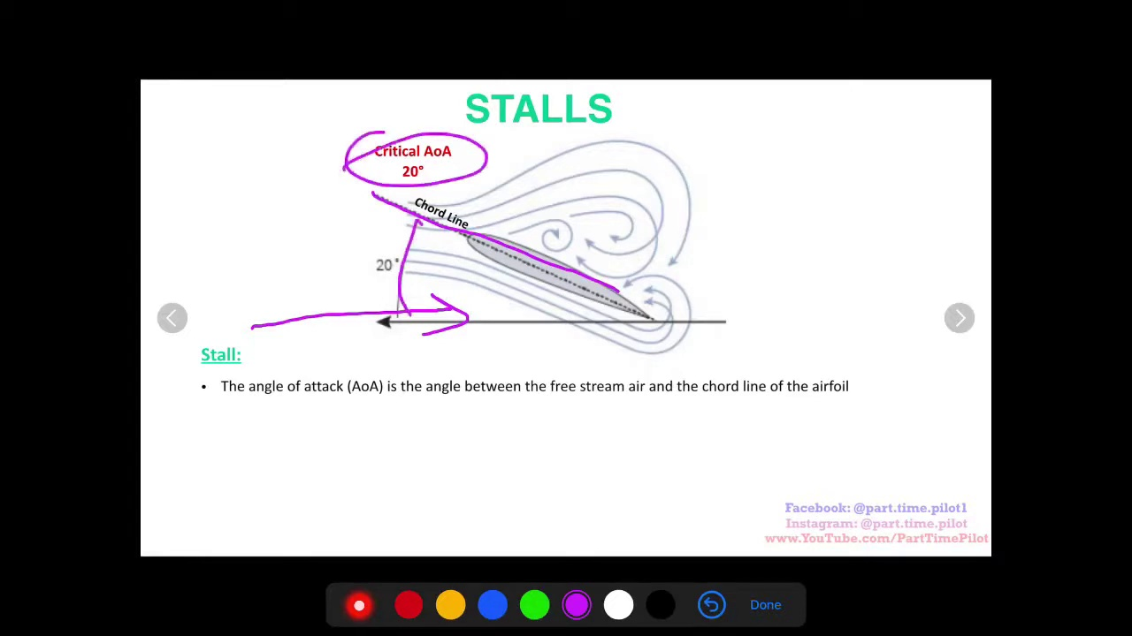 | 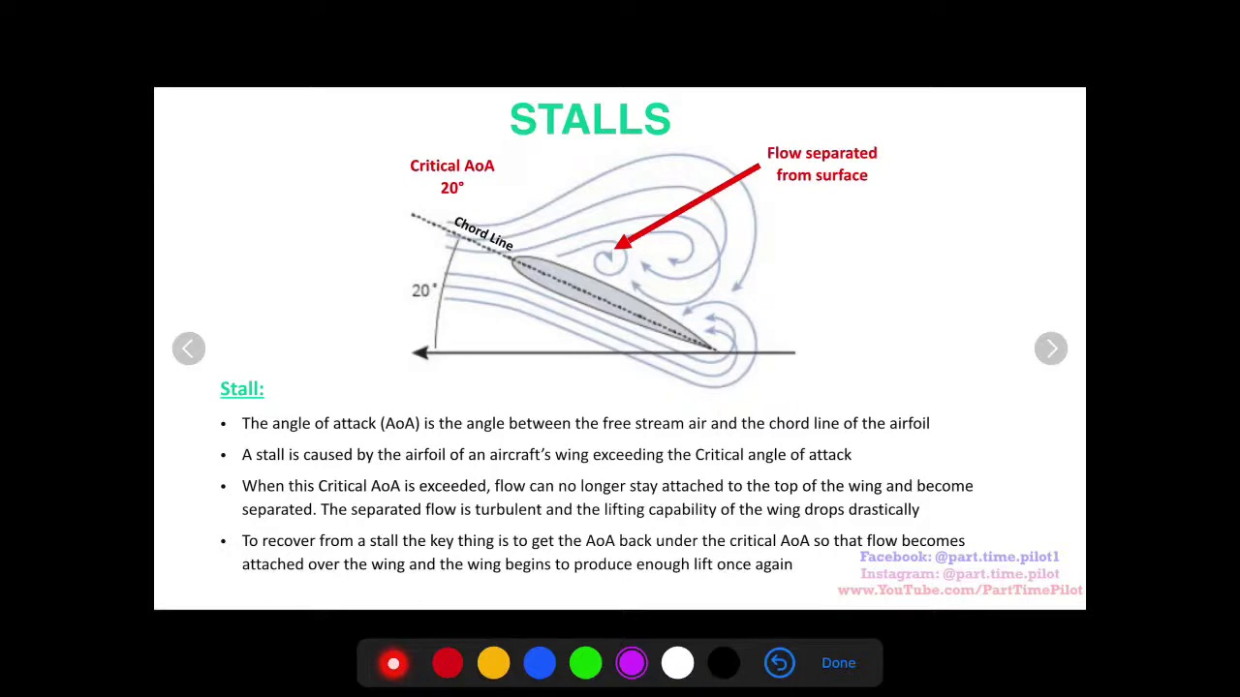
Topic T5: Recovering from a Stall — score 0.0000
Description: Pitching down to regain lift below the critical angle of attack.
Reason: The comment does not directly discuss the same steps, objects, settings, parameters, claims, or goals described by the topic. It's a generic thank-you message that doesn't relate to the topic of recovering from a stall.
 |  | 
Topic T4: What Happens During a Stall? — score 0.0000
Description: Flow separation and the impact on lift.
Reason: The comment does not discuss flow separation or lift, and instead expresses general gratitude. There is no overlap between the topic and the comment.
 |  | 
Topic T3: Airfoil Perspective — score 0.0000
Description: Looking at stalls from an airfoil's perspective.
Reason: The comment does not directly discuss the same steps, objects, settings, parameters, claims, or goals described by the topic. Instead, it expresses gratitude and provides a general statement of praise.
 |  | 
Topic T2: What is a Stall? — score 0.0000
Description: Explaining lift, coefficient of lift, and the critical angle of attack.
Reason: The comment does not directly discuss the topic of stall or lift, instead expressing generic praise for a study guide.
 |  | 
Topic T1: Introduction and Context — score 0.0000
Description: Setting the stage for the topic of stalls.
Reason: The comment only expresses gratitude and praise, but does not discuss the same steps, objects, settings, parameters, claims, or goals described by the topic.
Least correlated topics:
 |  | 
Topic T1: Introduction and Context — score 0.0000
Description: Setting the stage for the topic of stalls.
Reason: The comment only expresses gratitude and praise, but does not discuss the same steps, objects, settings, parameters, claims, or goals described by the topic.
 |  | 
Topic T2: What is a Stall? — score 0.0000
Description: Explaining lift, coefficient of lift, and the critical angle of attack.
Reason: The comment does not directly discuss the topic of stall or lift, instead expressing generic praise for a study guide.
 |  | 
Topic T3: Airfoil Perspective — score 0.0000
Description: Looking at stalls from an airfoil's perspective.
Reason: The comment does not directly discuss the same steps, objects, settings, parameters, claims, or goals described by the topic. Instead, it expresses gratitude and provides a general statement of praise.
 |  | 
Topic T4: What Happens During a Stall? — score 0.0000
Description: Flow separation and the impact on lift.
Reason: The comment does not discuss flow separation or lift, and instead expresses general gratitude. There is no overlap between the topic and the comment.
 |  | 
Topic T5: Recovering from a Stall — score 0.0000
Description: Pitching down to regain lift below the critical angle of attack.
Reason: The comment does not directly discuss the same steps, objects, settings, parameters, claims, or goals described by the topic. It's a generic thank-you message that doesn't relate to the topic of recovering from a stall.
- matched 0 topic(s), max score 0.0000: No problem! Let me know if you have questions
Source: https://www.youtube.com/watch?v=wKyt5ssrDQ8
Top correlated topics:
 |  | 
Topic T5: Recovering from a Stall — score 0.0000
Description: Pitching down to regain lift below the critical angle of attack.
Reason: The comment does not discuss the topic's description of pitching down to regain lift, and instead provides a generic response offering help.
 |  | 
Topic T4: What Happens During a Stall? — score 0.0000
Description: Flow separation and the impact on lift.
Reason: The comment does not discuss the topic's specific description of flow separation and its impact on lift, but instead provides a generic response offering help with questions.
 |  | 
Topic T3: Airfoil Perspective — score 0.0000
Description: Looking at stalls from an airfoil's perspective.
Reason: The comment does not mention or discuss anything related to airfoils, stalls, or perspective, making it unrelated to the topic.
 |  | 
Topic T2: What is a Stall? — score 0.0000
Description: Explaining lift, coefficient of lift, and the critical angle of attack.
Reason: The comment is a generic response offering to answer questions, but does not directly discuss the topic of stall or lift-related concepts.
 |  | 
Topic T1: Introduction and Context — score 0.0000
Description: Setting the stage for the topic of stalls.
Reason: The comment does not discuss the same steps, objects, settings, parameters, claims, or goals described by the topic. Instead, it's a general response indicating willingness to help.
Least correlated topics:
 |  | 
Topic T1: Introduction and Context — score 0.0000
Description: Setting the stage for the topic of stalls.
Reason: The comment does not discuss the same steps, objects, settings, parameters, claims, or goals described by the topic. Instead, it's a general response indicating willingness to help.
 |  | 
Topic T2: What is a Stall? — score 0.0000
Description: Explaining lift, coefficient of lift, and the critical angle of attack.
Reason: The comment is a generic response offering to answer questions, but does not directly discuss the topic of stall or lift-related concepts.
 |  | 
Topic T3: Airfoil Perspective — score 0.0000
Description: Looking at stalls from an airfoil's perspective.
Reason: The comment does not mention or discuss anything related to airfoils, stalls, or perspective, making it unrelated to the topic.
 |  | 
Topic T4: What Happens During a Stall? — score 0.0000
Description: Flow separation and the impact on lift.
Reason: The comment does not discuss the topic's specific description of flow separation and its impact on lift, but instead provides a generic response offering help with questions.
 |  | 
Topic T5: Recovering from a Stall — score 0.0000
Description: Pitching down to regain lift below the critical angle of attack.
Reason: The comment does not discuss the topic's description of pitching down to regain lift, and instead provides a generic response offering help.
- matched 0 topic(s), max score 0.0000: FREE Private Pilot study guide pdf!
Want all the Private Pilot concepts broken down with visual aids a few concise bullet points? This is what we have in our 100% FREE study guide pdf.
Simply enter your email at the following link and get instantly sent the download link: https://parttimepilot.com/free-ppl-study-guide/
Source: https://www.youtube.com/watch?v=wKyt5ssrDQ8
Top correlated topics:
 |  | 
Topic T1: Introduction and Context — score 20.0000
Description: Setting the stage for the topic of stalls.
Reason: The comment is about a free study guide pdf for private pilots, which is not related to the topic of stalls. The only overlap is the mention of 'Private Pilot', but it's not discussing the same steps, objects, settings, parameters, claims, or goals described in the topic.
 |  | 
Topic T5: Recovering from a Stall — score 0.0000
Description: Pitching down to regain lift below the critical angle of attack.
Reason: The comment is not related to the topic. It appears to be a promotional message for a free study guide PDF, which does not discuss pitching down or recovering from a stall.
 |  | 
Topic T4: What Happens During a Stall? — score 0.0000
Description: Flow separation and the impact on lift.
Reason: The comment does not discuss flow separation or lift, which are the main topics described in the original topic. Instead, it provides a link to a study guide for private pilots, unrelated to the topic.
 |  | 
Topic T3: Airfoil Perspective — score 0.0000
Description: Looking at stalls from an airfoil's perspective.
Reason: The comment is unrelated to the topic. The topic discusses airfoil perspectives and stalls, while the comment promotes a free study guide pdf for private pilots, which has no direct connection to the topic.
 |  | 
Topic T2: What is a Stall? — score 0.0000
Description: Explaining lift, coefficient of lift, and the critical angle of attack.
Reason: The comment is unrelated to the topic of explaining lift, coefficient of lift, and critical angle of attack. It appears to be an advertisement for a free study guide pdf that has no connection to the topic.
Least correlated topics:
 |  | 
Topic T2: What is a Stall? — score 0.0000
Description: Explaining lift, coefficient of lift, and the critical angle of attack.
Reason: The comment is unrelated to the topic of explaining lift, coefficient of lift, and critical angle of attack. It appears to be an advertisement for a free study guide pdf that has no connection to the topic.
 |  | 
Topic T3: Airfoil Perspective — score 0.0000
Description: Looking at stalls from an airfoil's perspective.
Reason: The comment is unrelated to the topic. The topic discusses airfoil perspectives and stalls, while the comment promotes a free study guide pdf for private pilots, which has no direct connection to the topic.
 |  | 
Topic T4: What Happens During a Stall? — score 0.0000
Description: Flow separation and the impact on lift.
Reason: The comment does not discuss flow separation or lift, which are the main topics described in the original topic. Instead, it provides a link to a study guide for private pilots, unrelated to the topic.
 |  | 
Topic T5: Recovering from a Stall — score 0.0000
Description: Pitching down to regain lift below the critical angle of attack.
Reason: The comment is not related to the topic. It appears to be a promotional message for a free study guide PDF, which does not discuss pitching down or recovering from a stall.
 |  | 
Topic T1: Introduction and Context — score 20.0000
Description: Setting the stage for the topic of stalls.
Reason: The comment is about a free study guide pdf for private pilots, which is not related to the topic of stalls. The only overlap is the mention of 'Private Pilot', but it's not discussing the same steps, objects, settings, parameters, claims, or goals described in the topic.

Topic T1: Introduction and Context
 |  | 
Description: Setting the stage for the topic of stalls.
No strongly correlated comments found for this topic.

Topic T2: What is a Stall?
 |  | 
Description: Explaining lift, coefficient of lift, and the critical angle of attack.
No strongly correlated comments found for this topic.

Topic T3: Airfoil Perspective
 |  | 
Description: Looking at stalls from an airfoil's perspective.
No strongly correlated comments found for this topic.

Topic T4: What Happens During a Stall?
 |  | 
Description: Flow separation and the impact on lift.
No strongly correlated comments found for this topic.

Topic T5: Recovering from a Stall
 |  | 
Description: Pitching down to regain lift below the critical angle of attack.
No strongly correlated comments found for this topic.

