Comment–Topic Correlation Report
Model: llama3

Summary
Topics processed: 1
Comments available for this video: 16
Comments correlated to ≥ 60: 1 (6.2%)
Total candidate pairs checked: 16

Most/Least correlated topics (by average score across correlated comments):
Top 3:
• Topic T1: RLC Circuit with Op-Amp — avg 80.00, contributions 1
Bottom 3:
• Topic T1: RLC Circuit with Op-Amp — avg 80.00, contributions 1
Correlated comment coverage (all comments):
- matched 1 topic(s), max score 80.0000: The 16 ohm is the Xc (capacitor impedance at 1 Mhz). Please review the video at 1:36
Source: https://www.youtube.com/watch?v=zUyj7Xn9-sk
Top correlated topics:
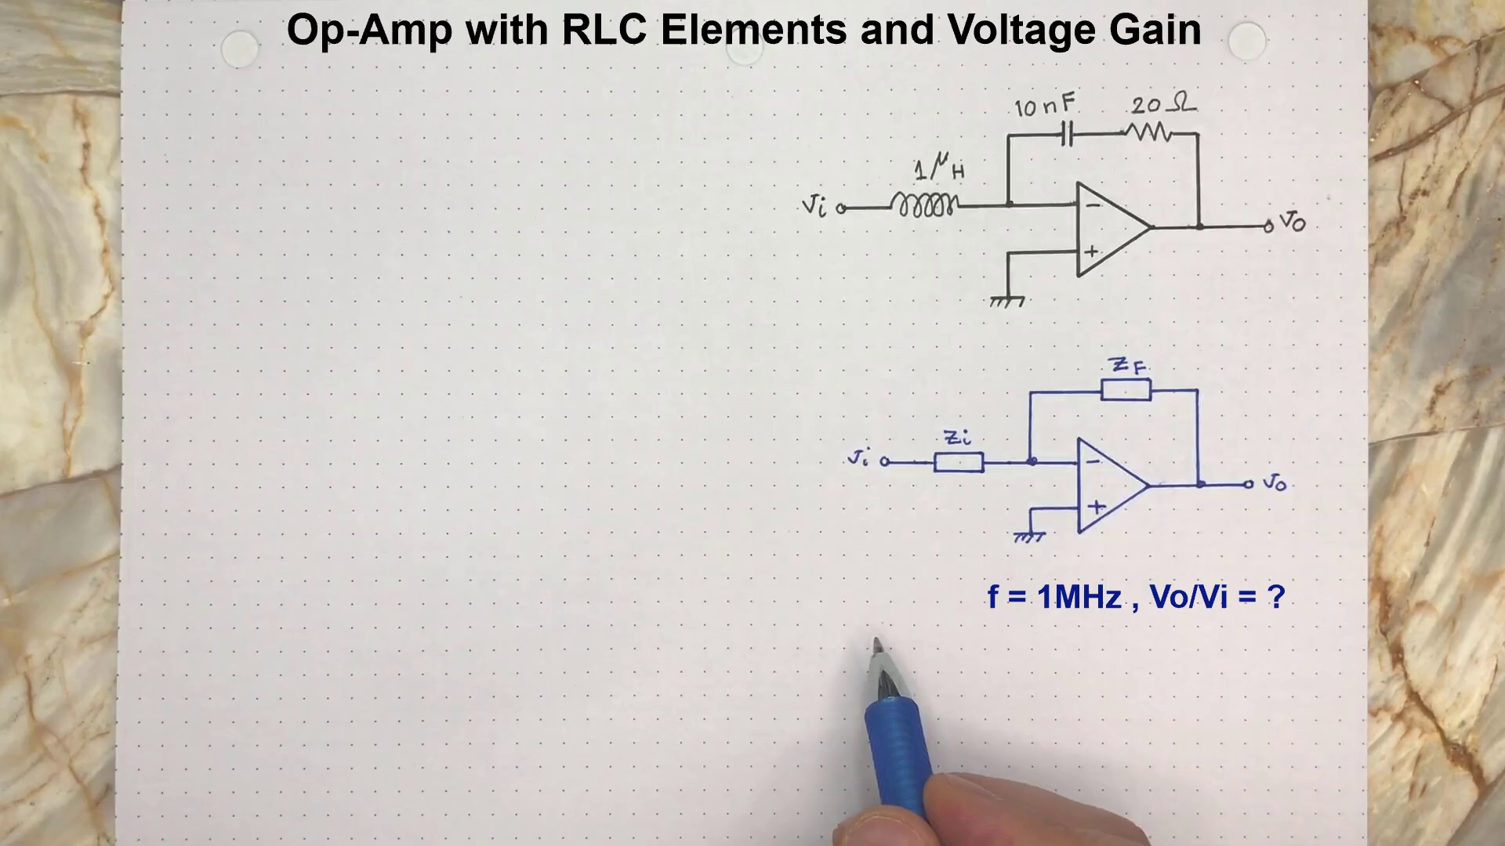 | 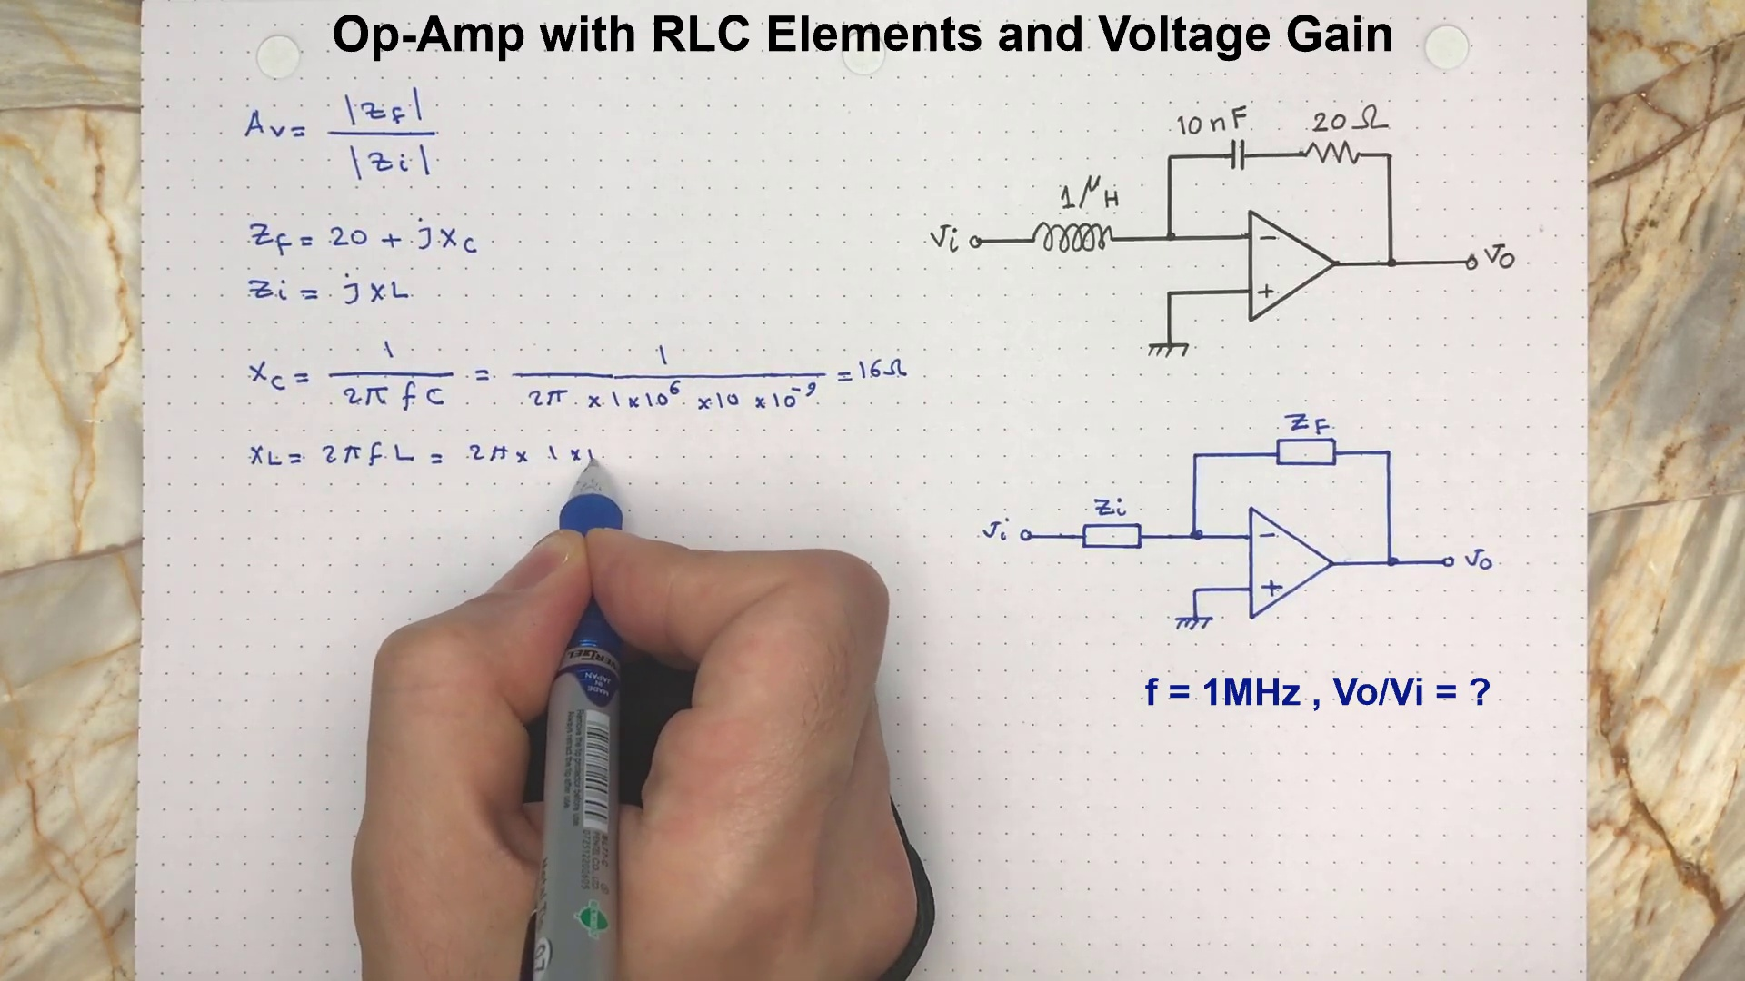 | 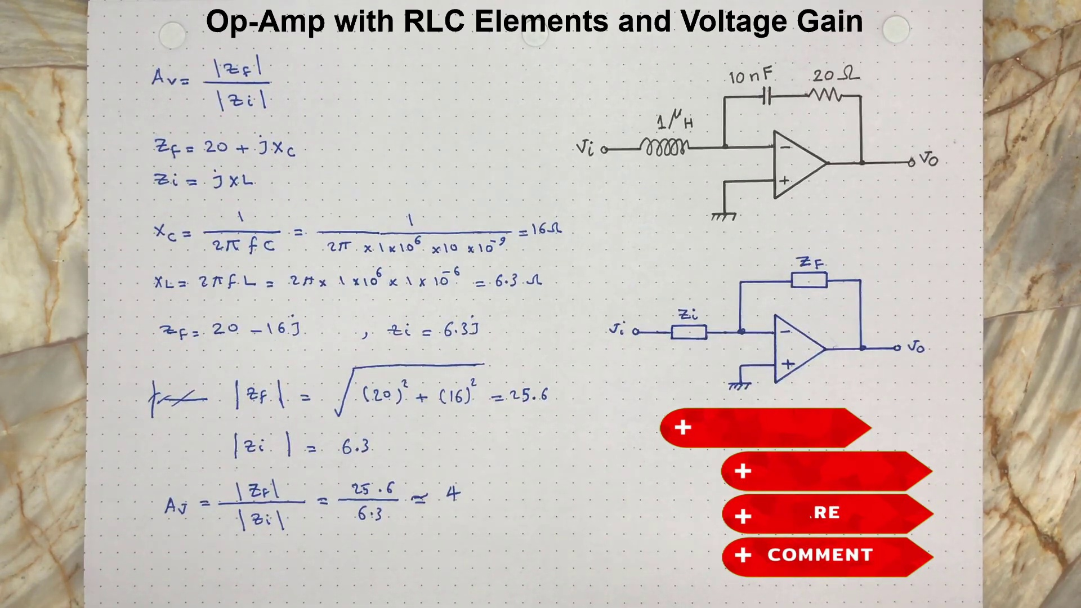
Topic T1: RLC Circuit with Op-Amp — score 80.0000
Description: The speaker introduces a RLC circuit with an op-amp and discusses determining system voltage gain at a frequency of 1 MHz, disregarding phase change effects.
Reason: The comment specifically mentions the frequency of interest (1 MHz) and references a video timestamp where RLC circuit analysis is discussed, which aligns with the topic's description on determining system voltage gain at that frequency.
Least correlated topics:
 |  | 
Topic T1: RLC Circuit with Op-Amp — score 80.0000
Description: The speaker introduces a RLC circuit with an op-amp and discusses determining system voltage gain at a frequency of 1 MHz, disregarding phase change effects.
Reason: The comment specifically mentions the frequency of interest (1 MHz) and references a video timestamp where RLC circuit analysis is discussed, which aligns with the topic's description on determining system voltage gain at that frequency.
- matched 0 topic(s), max score 0.0000: 😅😅😅well information good show you 😅
Source: https://www.youtube.com/watch?v=zUyj7Xn9-sk
Top correlated topics:
 |  | 
Topic T1: RLC Circuit with Op-Amp — score 0.0000
Description: The speaker introduces a RLC circuit with an op-amp and discusses determining system voltage gain at a frequency of 1 MHz, disregarding phase change effects.
Reason: The comment does not discuss any specific details about the topic, such as RLC circuit with op-amp or determining system voltage gain. It only contains generic praise and emojis.
Least correlated topics:
 |  | 
Topic T1: RLC Circuit with Op-Amp — score 0.0000
Description: The speaker introduces a RLC circuit with an op-amp and discusses determining system voltage gain at a frequency of 1 MHz, disregarding phase change effects.
Reason: The comment does not discuss any specific details about the topic, such as RLC circuit with op-amp or determining system voltage gain. It only contains generic praise and emojis.
- matched 0 topic(s), max score 0.0000: @EngineeringinDepth thank you sir.
Source: https://www.youtube.com/watch?v=zUyj7Xn9-sk
Top correlated topics:
 |  | 
Topic T1: RLC Circuit with Op-Amp — score 0.0000
Description: The speaker introduces a RLC circuit with an op-amp and discusses determining system voltage gain at a frequency of 1 MHz, disregarding phase change effects.
Reason: The comment is a generic thank-you message and does not directly discuss the topic of RLC circuit with Op-Amp or its concepts, such as determining system voltage gain at a frequency of 1 MHz.
Least correlated topics:
 |  | 
Topic T1: RLC Circuit with Op-Amp — score 0.0000
Description: The speaker introduces a RLC circuit with an op-amp and discusses determining system voltage gain at a frequency of 1 MHz, disregarding phase change effects.
Reason: The comment is a generic thank-you message and does not directly discuss the topic of RLC circuit with Op-Amp or its concepts, such as determining system voltage gain at a frequency of 1 MHz.
- matched 0 topic(s), max score 0.0000: @EngineeringinDepth thank you..got it..
Source: https://www.youtube.com/watch?v=zUyj7Xn9-sk
Top correlated topics:
 |  | 
Topic T1: RLC Circuit with Op-Amp — score 0.0000
Description: The speaker introduces a RLC circuit with an op-amp and discusses determining system voltage gain at a frequency of 1 MHz, disregarding phase change effects.
Reason: The comment is a simple acknowledgement of understanding, but does not directly discuss the same steps, objects, settings, parameters, claims, or goals described by the topic.
Least correlated topics:
 |  | 
Topic T1: RLC Circuit with Op-Amp — score 0.0000
Description: The speaker introduces a RLC circuit with an op-amp and discusses determining system voltage gain at a frequency of 1 MHz, disregarding phase change effects.
Reason: The comment is a simple acknowledgement of understanding, but does not directly discuss the same steps, objects, settings, parameters, claims, or goals described by the topic.
- matched 0 topic(s), max score 0.0000: please add english subtitle
Source: https://www.youtube.com/watch?v=zUyj7Xn9-sk
Top correlated topics:
 |  | 
Topic T1: RLC Circuit with Op-Amp — score 20.0000
Description: The speaker introduces a RLC circuit with an op-amp and discusses determining system voltage gain at a frequency of 1 MHz, disregarding phase change effects.
Reason: The comment 'please add English subtitle' does not discuss the same steps, objects, settings, parameters, claims, or goals described by the topic. The topic is about a RLC circuit with an op-amp and determining system voltage gain at 1 MHz, whereas the comment requests subtitles in English, which is unrelated to the topic.
Least correlated topics:
 |  | 
Topic T1: RLC Circuit with Op-Amp — score 20.0000
Description: The speaker introduces a RLC circuit with an op-amp and discusses determining system voltage gain at a frequency of 1 MHz, disregarding phase change effects.
Reason: The comment 'please add English subtitle' does not discuss the same steps, objects, settings, parameters, claims, or goals described by the topic. The topic is about a RLC circuit with an op-amp and determining system voltage gain at 1 MHz, whereas the comment requests subtitles in English, which is unrelated to the topic.
- matched 0 topic(s), max score 0.0000: Why is Zf = 20 - 16j and not 20+16j ?
Source: https://www.youtube.com/watch?v=zUyj7Xn9-sk
Top correlated topics:
 |  | 
Topic T1: RLC Circuit with Op-Amp — score 10.0000
Description: The speaker introduces a RLC circuit with an op-amp and discusses determining system voltage gain at a frequency of 1 MHz, disregarding phase change effects.
Reason: The topic is about a RLC circuit with an op-amp and determining system voltage gain at a frequency of 1 MHz, while the comment is asking about a specific complex impedance value (Zf) and its phase. The topics don't overlap in terms of discussing the same steps, objects, settings, parameters, claims, or goals.
Least correlated topics:
 |  | 
Topic T1: RLC Circuit with Op-Amp — score 10.0000
Description: The speaker introduces a RLC circuit with an op-amp and discusses determining system voltage gain at a frequency of 1 MHz, disregarding phase change effects.
Reason: The topic is about a RLC circuit with an op-amp and determining system voltage gain at a frequency of 1 MHz, while the comment is asking about a specific complex impedance value (Zf) and its phase. The topics don't overlap in terms of discussing the same steps, objects, settings, parameters, claims, or goals.
- matched 0 topic(s), max score 0.0000: Thanks for your feedback! I am adding subtitle and commentaries in my recent videos.
Source: https://www.youtube.com/watch?v=zUyj7Xn9-sk
Top correlated topics:
 |  | 
Topic T1: RLC Circuit with Op-Amp — score 0.0000
Description: The speaker introduces a RLC circuit with an op-amp and discusses determining system voltage gain at a frequency of 1 MHz, disregarding phase change effects.
Reason: The comment does not discuss the topic of RLC circuit with op-amp or determining system voltage gain at a frequency of 1 MHz. Instead, it is a general statement about adding subtitles and commentaries to videos.
Least correlated topics:
 |  | 
Topic T1: RLC Circuit with Op-Amp — score 0.0000
Description: The speaker introduces a RLC circuit with an op-amp and discusses determining system voltage gain at a frequency of 1 MHz, disregarding phase change effects.
Reason: The comment does not discuss the topic of RLC circuit with op-amp or determining system voltage gain at a frequency of 1 MHz. Instead, it is a general statement about adding subtitles and commentaries to videos.
- matched 0 topic(s), max score 0.0000: Thanks
Source: https://www.youtube.com/watch?v=zUyj7Xn9-sk
Top correlated topics:
 |  | 
Topic T1: RLC Circuit with Op-Amp — score 0.0000
Description: The speaker introduces a RLC circuit with an op-amp and discusses determining system voltage gain at a frequency of 1 MHz, disregarding phase change effects.
Reason: The comment does not mention RLC circuit, op-amp, frequency gain or any specific technical details from the topic, it only contains generic thanks.
Least correlated topics:
 |  | 
Topic T1: RLC Circuit with Op-Amp — score 0.0000
Description: The speaker introduces a RLC circuit with an op-amp and discusses determining system voltage gain at a frequency of 1 MHz, disregarding phase change effects.
Reason: The comment does not mention RLC circuit, op-amp, frequency gain or any specific technical details from the topic, it only contains generic thanks.
- matched 0 topic(s), max score 0.0000: Thank you for your videos. But it would much better and informative if you speak or subtitle. It is hard to follow with no comments.
Source: https://www.youtube.com/watch?v=zUyj7Xn9-sk
Top correlated topics:
 |  | 
Topic T1: RLC Circuit with Op-Amp — score 0.0000
Description: The speaker introduces a RLC circuit with an op-amp and discusses determining system voltage gain at a frequency of 1 MHz, disregarding phase change effects.
Reason: No overlap in content; the comment is about providing subtitles or captions, not discussing RLC circuits with op-amps.
Least correlated topics:
 |  | 
Topic T1: RLC Circuit with Op-Amp — score 0.0000
Description: The speaker introduces a RLC circuit with an op-amp and discusses determining system voltage gain at a frequency of 1 MHz, disregarding phase change effects.
Reason: No overlap in content; the comment is about providing subtitles or captions, not discussing RLC circuits with op-amps.
- matched 0 topic(s), max score 0.0000: Thank you for your feedback!
Source: https://www.youtube.com/watch?v=zUyj7Xn9-sk
Top correlated topics:
 |  | 
Topic T1: RLC Circuit with Op-Amp — score 0.0000
Description: The speaker introduces a RLC circuit with an op-amp and discusses determining system voltage gain at a frequency of 1 MHz, disregarding phase change effects.
Reason: The comment does not discuss the topic of RLC circuit with Op-Amp or determining system voltage gain at a frequency of 1 MHz. Instead, it appears to be a generic thank-you message unrelated to the topic.
Least correlated topics:
 |  | 
Topic T1: RLC Circuit with Op-Amp — score 0.0000
Description: The speaker introduces a RLC circuit with an op-amp and discusses determining system voltage gain at a frequency of 1 MHz, disregarding phase change effects.
Reason: The comment does not discuss the topic of RLC circuit with Op-Amp or determining system voltage gain at a frequency of 1 MHz. Instead, it appears to be a generic thank-you message unrelated to the topic.
- matched 0 topic(s), max score 0.0000: Thank you for the feedback. I will try to add more commentary in future videos.
Source: https://www.youtube.com/watch?v=zUyj7Xn9-sk
Top correlated topics:
 |  | 
Topic T1: RLC Circuit with Op-Amp — score 0.0000
Description: The speaker introduces a RLC circuit with an op-amp and discusses determining system voltage gain at a frequency of 1 MHz, disregarding phase change effects.
Reason: The comment does not discuss the topic's specific steps, objects, settings, parameters, claims, or goals about RLC circuits with op-amps. Instead, it is a generic expression of gratitude for feedback.
Least correlated topics:
 |  | 
Topic T1: RLC Circuit with Op-Amp — score 0.0000
Description: The speaker introduces a RLC circuit with an op-amp and discusses determining system voltage gain at a frequency of 1 MHz, disregarding phase change effects.
Reason: The comment does not discuss the topic's specific steps, objects, settings, parameters, claims, or goals about RLC circuits with op-amps. Instead, it is a generic expression of gratitude for feedback.
- matched 0 topic(s), max score 0.0000: Note, ZF = 20 - jXc
Electronic Circuit Analysis Playlist: https://www.youtube.com/playlist?list=PLLA_QJ8rHZBh5LqrY41bCvKgreRDRWrBQ
Control System Playlist: https://www.youtube.com/playlist?list=PLLA_QJ8rHZBjS_S6WPkmUweF5NbImvSqf
Circuit Analysis playlist: https://www.youtube.com/playlist?list=PLLA_QJ8rHZBj8qPBFArjveEustxuToLDw
Electricity and Magnetism Playlist: https://www.youtube.com/playlist?list=PLLA_QJ8rHZBhQ7ykCkWBI8sbphMA_Rf_1
Source: https://www.youtube.com/watch?v=zUyj7Xn9-sk
Top correlated topics:
 |  | 
Topic T1: RLC Circuit with Op-Amp — score 20.0000
Description: The speaker introduces a RLC circuit with an op-amp and discusses determining system voltage gain at a frequency of 1 MHz, disregarding phase change effects.
Reason: The comment provides a mathematical formula for impedance ZF, which is unrelated to the topic of RLC circuit with op-amp. The URLs provided are playlists and not specific to the topic.
Least correlated topics:
 |  | 
Topic T1: RLC Circuit with Op-Amp — score 20.0000
Description: The speaker introduces a RLC circuit with an op-amp and discusses determining system voltage gain at a frequency of 1 MHz, disregarding phase change effects.
Reason: The comment provides a mathematical formula for impedance ZF, which is unrelated to the topic of RLC circuit with op-amp. The URLs provided are playlists and not specific to the topic.
- matched 0 topic(s), max score 0.0000: It was a typo. the correct expression is : ZF = 20 - jXc. The rest of calculation and the result are correct.
Source: https://www.youtube.com/watch?v=zUyj7Xn9-sk
Top correlated topics:
 |  | 
Topic T1: RLC Circuit with Op-Amp — score 10.0000
Description: The speaker introduces a RLC circuit with an op-amp and discusses determining system voltage gain at a frequency of 1 MHz, disregarding phase change effects.
Reason: The comment discusses a typo in the expression for impedance (ZF), which is not related to the topic's description of determining system voltage gain at 1 MHz.
Least correlated topics:
 |  | 
Topic T1: RLC Circuit with Op-Amp — score 10.0000
Description: The speaker introduces a RLC circuit with an op-amp and discusses determining system voltage gain at a frequency of 1 MHz, disregarding phase change effects.
Reason: The comment discusses a typo in the expression for impedance (ZF), which is not related to the topic's description of determining system voltage gain at 1 MHz.
- matched 0 topic(s), max score 0.0000: In your calculation of Zf, you just found a minus sign from somewhere. Where did it come from?
Source: https://www.youtube.com/watch?v=zUyj7Xn9-sk
Top correlated topics:
 |  | 
Topic T1: RLC Circuit with Op-Amp — score 20.0000
Description: The speaker introduces a RLC circuit with an op-amp and discusses determining system voltage gain at a frequency of 1 MHz, disregarding phase change effects.
Reason: The comment asks about the origin of a minus sign in a calculation (Zf), which does not directly discuss the topic's description of determining system voltage gain at a frequency of 1 MHz or the RLC circuit with an op-amp. The topic and comment are only tangentially related.
Least correlated topics:
 |  | 
Topic T1: RLC Circuit with Op-Amp — score 20.0000
Description: The speaker introduces a RLC circuit with an op-amp and discusses determining system voltage gain at a frequency of 1 MHz, disregarding phase change effects.
Reason: The comment asks about the origin of a minus sign in a calculation (Zf), which does not directly discuss the topic's description of determining system voltage gain at a frequency of 1 MHz or the RLC circuit with an op-amp. The topic and comment are only tangentially related.
- matched 0 topic(s), max score 0.0000: I do not see where you get the number 16 perhaps you could speak as you are writing the equations.
Source: https://www.youtube.com/watch?v=zUyj7Xn9-sk
Top correlated topics:
 |  | 
Topic T1: RLC Circuit with Op-Amp — score 20.0000
Description: The speaker introduces a RLC circuit with an op-amp and discusses determining system voltage gain at a frequency of 1 MHz, disregarding phase change effects.
Reason: The comment does not discuss the same steps, objects, settings, parameters, claims, or goals described by the topic. It only mentions a possible issue with the provided number 16 and requests clarification on how equations are being written, but does not relate to the RLC circuit with op-amp or determining system voltage gain.
Least correlated topics:
 |  | 
Topic T1: RLC Circuit with Op-Amp — score 20.0000
Description: The speaker introduces a RLC circuit with an op-amp and discusses determining system voltage gain at a frequency of 1 MHz, disregarding phase change effects.
Reason: The comment does not discuss the same steps, objects, settings, parameters, claims, or goals described by the topic. It only mentions a possible issue with the provided number 16 and requests clarification on how equations are being written, but does not relate to the RLC circuit with op-amp or determining system voltage gain.
- matched 0 topic(s), max score 0.0000: A capacitor has [ 1/jCw ] impedance where w = 2πf and f is the operating frequency. When we bring the j from denominator to numerator, then it changes its sign from positive to negative. So, in a short, a capacitance always has a negative sign (-j). In other hand, an inductor always has a +j because its impedance is calculated by [ jLw ]. I hope it helps.
Source: https://www.youtube.com/watch?v=zUyj7Xn9-sk
Top correlated topics:
 |  | 
Topic T1: RLC Circuit with Op-Amp — score 80.0000
Description: The speaker introduces a RLC circuit with an op-amp and discusses determining system voltage gain at a frequency of 1 MHz, disregarding phase change effects.
Reason: {
"correlated": true,
"score": 80,
"reason": "The comment discusses the impedance of a capacitor ([-j] in the frequency domain) and an inductor ([+j] in the frequency domain), which are relevant components used in the RLC circuit with an op-amp topic. The comment's focus on the j-operator and its effect on impedance is also related to the topic's description, as it disregards phase change effects.
Least correlated topics:
 |  | 
Topic T1: RLC Circuit with Op-Amp — score 80.0000
Description: The speaker introduces a RLC circuit with an op-amp and discusses determining system voltage gain at a frequency of 1 MHz, disregarding phase change effects.
Reason: {
"correlated": true,
"score": 80,
"reason": "The comment discusses the impedance of a capacitor ([-j] in the frequency domain) and an inductor ([+j] in the frequency domain), which are relevant components used in the RLC circuit with an op-amp topic. The comment's focus on the j-operator and its effect on impedance is also related to the topic's description, as it disregards phase change effects.

Topic T1: RLC Circuit with Op-Amp
 |  | 
Description: The speaker introduces a RLC circuit with an op-amp and discusses determining system voltage gain at a frequency of 1 MHz, disregarding phase change effects.
Comment (score 80): The 16 ohm is the Xc (capacitor impedance at 1 Mhz). Please review the video at 1:36
Reason: The comment specifically mentions the frequency of interest (1 MHz) and references a video timestamp where RLC circuit analysis is discussed, which aligns with the topic's description on determining system voltage gain at that frequency.
Source: https://www.youtube.com/watch?v=zUyj7Xn9-sk

