Comment–Topic Correlation Report
Model: llama3

Summary
Topics processed: 1
Comments available for this video: 238
Comments with correlated=True: 5 (2.1%)
Comments with score >= 60: 5 (2.1%)
Total candidate pairs checked: 200
----------------------------------------

Topic T1: No Specific Topic Discussed
 | 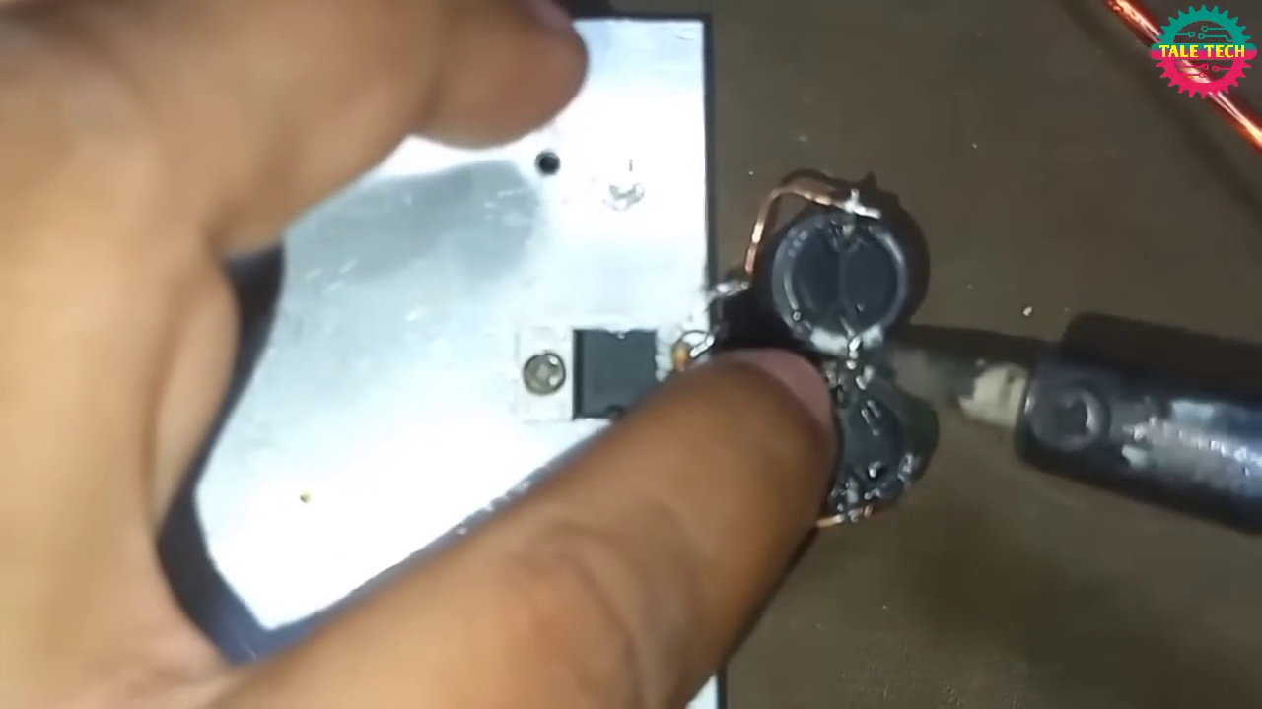 | 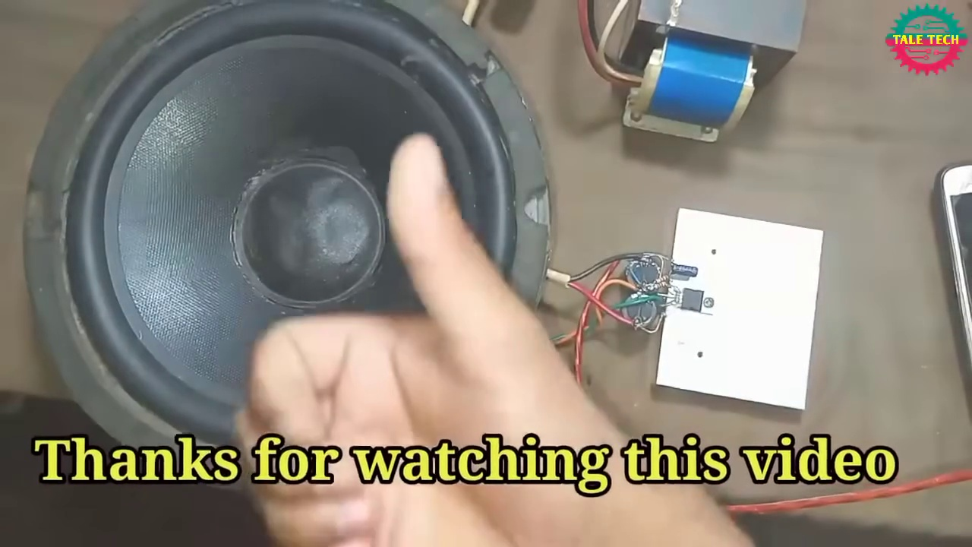
Description: The speaker only says 'Thank you' repeatedly without discussing any specific topic.
Correlated (true): 6 (2.5%)
Score >= 60: 6 (2.5%)
Average Score (of valid matches): 96.67

Top 5 Correlated Comments:
Score: 100
Comment: Thank you
Reason: The comment exactly matches the description's content, which is solely 'Thank you', and also matches the topic title's lack of specific discussion.
Source: https://www.youtube.com/watch?v=-qCO7NUpLc0

Score: 100
Comment: Thanks
Reason: The comment directly matches the topic description by repeating 'Thank you', which is the only content in the topic.
Source: https://www.youtube.com/watch?v=-qCO7NUpLc0

Score: 100
Comment: Thanks
Reason: The comment is a direct repetition of the thank you phrases in the topic description.
Source: https://www.youtube.com/watch?v=-qCO7NUpLc0

Score: 100
Comment: Thank you 💞
Reason: The comment directly responds to the topic description by also expressing gratitude with 'Thank you', demonstrating a strong correlation.
Source: https://www.youtube.com/watch?v=-qCO7NUpLc0

Score: 100
Comment: Thank you! 😊
Reason: The comment directly responds to the topic by thanking, which matches the description of the speaker only saying 'Thank you' repeatedly.
Source: https://www.youtube.com/watch?v=-qCO7NUpLc0

