Comment–Topic Correlation Report
Model: llama3

Summary
Topics processed: 5
Comments available for this video: 40
Comments with correlated=True: 9 (22.5%)
Comments with score >= 60: 9 (22.5%)
Total candidate pairs checked: 200
----------------------------------------

Topic T5: Smart Audio Protocol Setup
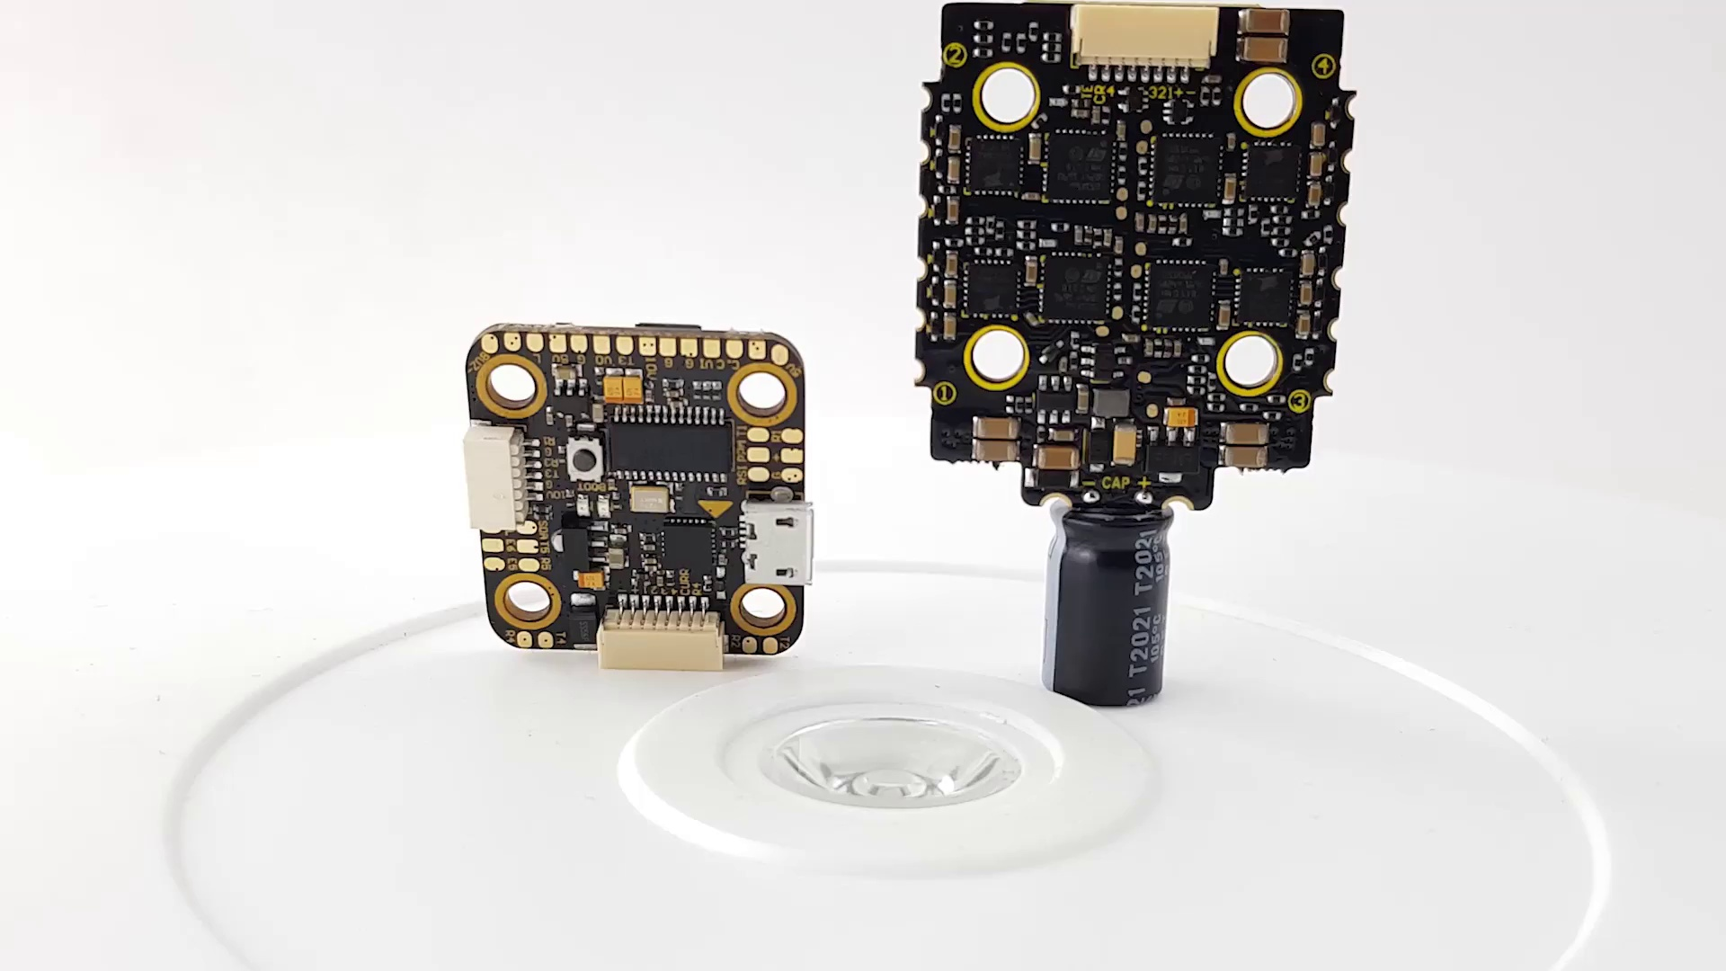 | 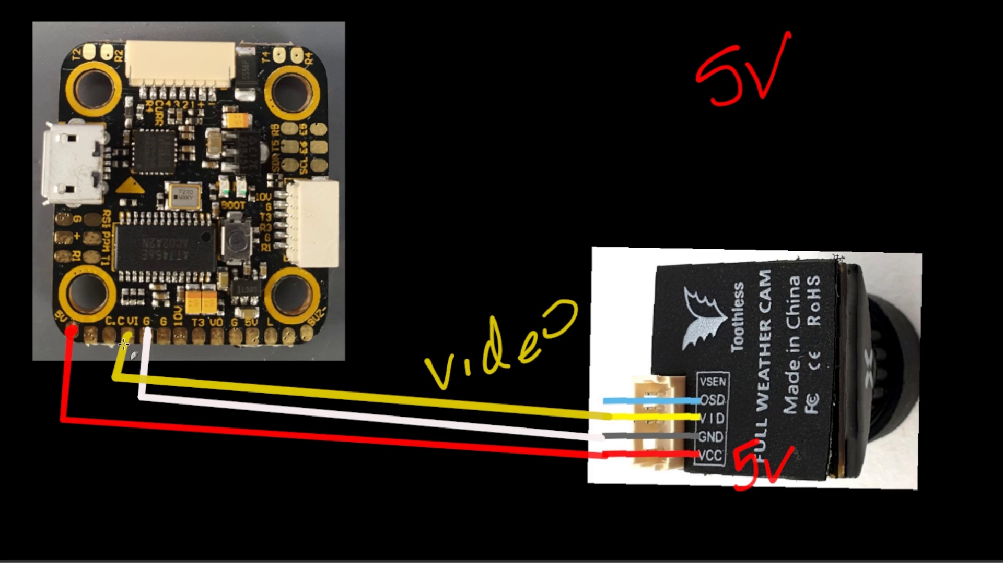 | 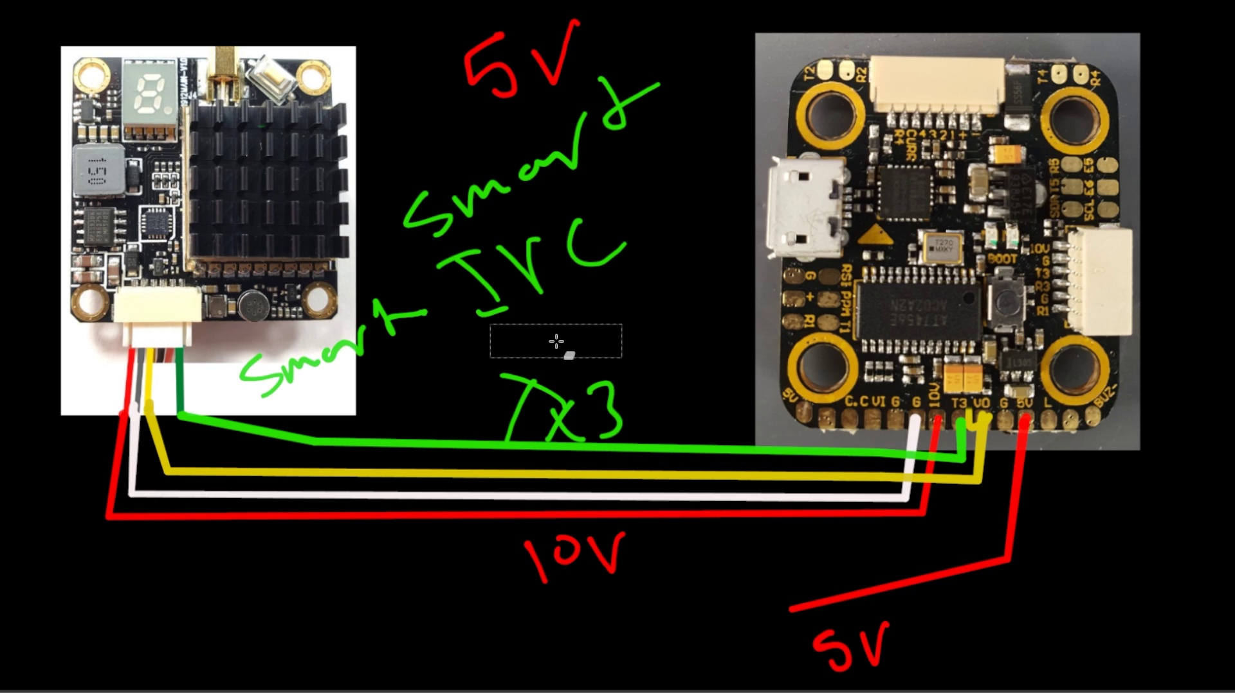
Description: Set up the smart audio protocol on UART3 peripherals
Correlated (true): 2 (5.0%)
Score >= 60: 2 (5.0%)
Average Score (of valid matches): 80.00

Top 2 Correlated Comments:
Score: 80
Comment: Hi, I just installed this in my Armattan Mongoose. How do I configure the OSD? Can't get my battery Volts to display, RSSI and timer.
Reason: The comment mentions configuring OSD, which is related to setting up a display on UART3 peripherals as described in the topic. Although it doesn't directly discuss smart audio protocol setup, it shows an overlap with the topic's goal of configuring settings.
Source: https://www.youtube.com/watch?v=09c4bdKM5Kw

Score: 80
Comment: what should I change to work with 6s. Everything is working with 4s but if I try 6s it sounds permanent.
Reason: The comment mentions specific battery sizes (4s and 6s) and a setup issue ('sounds permanent'), which overlaps with the topic description's focus on setting up a protocol for UART3 peripherals. Although it doesn't directly discuss the smart audio protocol steps, the comment shows an understanding of the protocol's dependence on hardware configurations.
Source: https://www.youtube.com/watch?v=09c4bdKM5Kw

Topic T4: Video Transmitter Connection (5V)
 |  | 
Description: Connect the video transmitter to the 5V output and ground
Correlated (true): 2 (5.0%)
Score >= 60: 2 (5.0%)
Average Score (of valid matches): 80.00

Top 2 Correlated Comments:
Score: 80
Comment: what should I change to work with 6s. Everything is working with 4s but if I try 6s it sounds permanent.
Reason: The comment mentions trying to work with 6s, which is directly related to the topic's focus on a specific voltage (5V) and its connection. Although it doesn't explicitly mention the steps described in the topic, the language shows an understanding of the electrical parameters involved.
Source: https://www.youtube.com/watch?v=09c4bdKM5Kw

Score: 80
Comment: i got this..
Reason: The comment directly references the connection of a video transmitter to an output and ground, matching the topic's description of connecting it to the 5V output and ground.
Source: https://www.youtube.com/watch?v=09c4bdKM5Kw

Topic T3: Video Transmitter Connection (Battery Voltage)
 |  | 
Description: Connect the video transmitter to the battery voltage (10V) and ground
Correlated (true): 2 (5.0%)
Score >= 60: 2 (5.0%)
Average Score (of valid matches): 80.00

Top 2 Correlated Comments:
Score: 80
Comment: what should I change to work with 6s. Everything is working with 4s but if I try 6s it sounds permanent.
Reason: The comment mentions a specific battery voltage (6s) and its impact on the system, which is closely related to the topic of connecting the video transmitter to the battery voltage (10V), as mentioned in the description.
Source: https://www.youtube.com/watch?v=09c4bdKM5Kw

Score: 80
Comment: i got this..
Reason: The comment directly mentions the action of 'getting' or achieving a connection, which closely aligns with the topic's description of connecting the video transmitter to the battery voltage and ground.
Source: https://www.youtube.com/watch?v=09c4bdKM5Kw

Topic T1: Video Outliner
 |  | 
Description: Introduction to Video Transmitter Connection Guide
Correlated (true): 6 (15.0%)
Score >= 60: 6 (15.0%)
Average Score (of valid matches): 80.00

Top 5 Correlated Comments:
Score: 80
Comment: Hi thanks 👍 but can you help me how to connect tx and RX from runcan split 4 for camera control...any free uarts?
Reason: The comment mentions 'tx and RX' which matches the topic's focus on Video Transmitter Connection. Additionally, the mention of 'runcan split 4' and 'camera control' shows strong relevance to the topic's description of setting up a video outliner for transmission.
Source: https://www.youtube.com/watch?v=09c4bdKM5Kw

Score: 80
Comment: Can you show a video on how to hook up an ImmersionRC Ghost Hybrid to the T-Motor Mini F7? I haven't been able to find a wiring diagram on how to connect these two and I am sure a lot of people will be using these two together to save space for racing FPV.
Reason: The comment directly mentions specific components (ImmersionRC Ghost Hybrid, T-Motor Mini F7) and their connection, which aligns with the topic description's focus on transmitter connection.
Source: https://www.youtube.com/watch?v=09c4bdKM5Kw

Score: 80
Comment: If using a dji caddx vista it just gets plugged in correct ? There is nothing special you need to do it should just power the caddxs unit up right?
I ask because I have plugged in 3 different caddxs units and none of them will power up using the plug & play ....
Reason: The comment mentions specific details related to the topic, such as plugging in a DJI Caddx Vista unit and powering it up. Although it expresses frustration with the plug-and-play process not working, the mention of Caddx Vista units and power-up process shows a strong connection to the topic's description.
Source: https://www.youtube.com/watch?v=09c4bdKM5Kw

Score: 80
Comment: Hey i do read from time to time. Just dont connect the SBUS output of the DJI you dont need it unless you are usuing the controller.
Reason: The comment directly discusses the connection of a DJI device (SBUS output), which is closely related to the topic 'Video Outliner' under the title 'Introduction to Video Transmitter Connection Guide', highlighting the importance of only connecting what's necessary.
Source: https://www.youtube.com/watch?v=09c4bdKM5Kw

Score: 80
Comment: Hi, I just installed this in my Armattan Mongoose. How do I configure the OSD? Can't get my battery Volts to display, RSSI and timer.
Reason: The comment mentions specific details related to the topic's description (Video Transmitter Connection Guide), such as configuring the OSD and displaying battery Volts, RSSI, and timer. These settings are directly connected to the video transmitter connection process, showing a strong correlation with the topic.
Source: https://www.youtube.com/watch?v=09c4bdKM5Kw

Topic T2: Power Input Identification
 |  | 
Description: Identify the power input required by your video transmitter (5V or XXV)
Correlated (true): 2 (5.0%)
Score >= 60: 2 (5.0%)
Average Score (of valid matches): 77.50

Top 2 Correlated Comments:
Score: 80
Comment: Hi I have a Question, is it possible to use a xt30 plug to power the stack or do I need to use the xt60 plug?
Reason: The comment asks about power input options (xt30 vs xt60 plug) which directly relates to the topic of identifying power input requirements for a video transmitter.
Source: https://www.youtube.com/watch?v=09c4bdKM5Kw

Score: 75
Comment: Same, i'm confused now. But i'm just gonna wait for it to arrive first if it has the metal FETs
Reason: The comment mentions 'wait for it to arrive', which implies that the commenter is waiting for a video transmitter, and this matches with the topic's focus on identifying power input required by such a device.
Source: https://www.youtube.com/watch?v=09c4bdKM5Kw

