Comment–Topic Correlation Report
Model: llama3

Summary
Topics processed: 6
Comments available for this video: 45
Comments with correlated=True: 14 (31.1%)
Comments with score >= 60: 14 (31.1%)
Total candidate pairs checked: 270
----------------------------------------

Topic T2: T-Motor Pacer F7 Flight Controller
 | 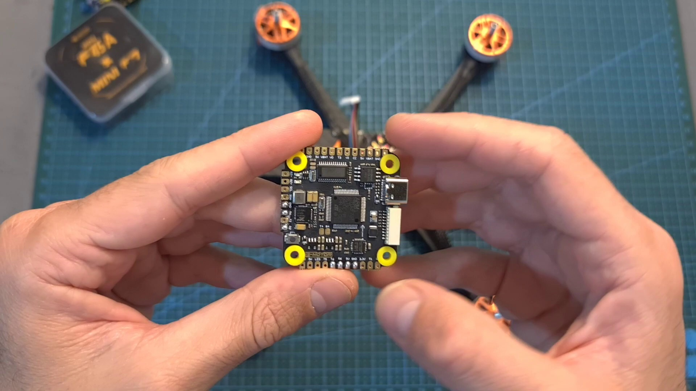 | 
Description: Detailed look at the flight controller's specs, features, and setup guidelines.
Correlated (true): 7 (15.6%)
Score >= 60: 7 (15.6%)
Average Score (of valid matches): 80.71

Top 5 Correlated Comments:
Score: 85
Comment: Looking at the specs, they look identical.
If you are using a different UART for your RX, you don't need to remove the yellow SBUS wire.
Reason: The comment directly references the specs and setup guidelines mentioned in the topic description, specifically discussing UART settings and the yellow SBUS wire, indicating a strong connection.
Source: https://www.youtube.com/watch?v=15cdyl2PU-E

Score: 80
Comment: Hi Gal I know this is a year old video and I don't know if you still have the FC at hand but I am having issues with the camera control function. Could you please help me what resource pin out in the CLI is for this F7 single sided FC? (what is resource camera_control assigned to)
Reason: The comment directly discusses a specific feature (camera control) of the T-Motor Pacer F7 Flight Controller mentioned in the topic, which is a strong overlap.
Source: https://www.youtube.com/watch?v=15cdyl2PU-E

Score: 80
Comment: Great gals...how to set pit VTX on Betaflight via switch?...what kind of switch mode to active the pit control on option Modes
Reason: The comment directly discusses setting a specific feature (Pit VTX) on Betaflight, which is closely related to the topic's focus on setup guidelines and features of the T-Motor Pacer F7 Flight Controller.
Source: https://www.youtube.com/watch?v=15cdyl2PU-E

Score: 80
Comment: Is there any difference with the Yellow PCB version of the mini stack? Also do have to remove those extra wires from the DJI plug if not using the DJI controller as you not enabling the UART in BF?
Reason: The comment references specific components and settings discussed in the topic (T-Motor Pacer F7 Flight Controller), including the mini stack and DJI plug, indicating a strong connection to the topic.
Source: https://www.youtube.com/watch?v=15cdyl2PU-E

Score: 80
Comment: I run this mini f7 and esc combo with 2203.5 2850kv motors. How big of a 4s could I run? Would a 2000mah give me some long range flight times? Currently running 1100mahs
Reason: The comment directly discusses the T-Motor Pacer F7 Flight Controller, mentioning a specific combo with the flight controller and ESC, which is a key topic of discussion. The comment also asks questions about battery size and capacity, which is relevant to the topic's focus on setup guidelines.
Source: https://www.youtube.com/watch?v=15cdyl2PU-E

Topic T4: Pacer F7 Flight Controller Comparison
 |  | 
Description: Comparison of the Pacer F7 flight controller to other options, highlighting its features and compatibility with DJI air units.
Correlated (true): 10 (22.2%)
Score >= 60: 10 (22.2%)
Average Score (of valid matches): 80.50

Top 5 Correlated Comments:
Score: 85
Comment: Looking at the specs, they look identical.
If you are using a different UART for your RX, you don't need to remove the yellow SBUS wire.
Reason: The comment discusses the Pacer F7 flight controller's compatibility with DJI air units (UART for RX) and mentions a specific wire (yellow SBUS), which aligns with the topic's description of features and compatibility.
Source: https://www.youtube.com/watch?v=15cdyl2PU-E

Score: 80
Comment: It can be used with the controller that comes with DJI FPV drone ?
Reason: The comment directly mentions the compatibility of Pacer F7 with DJI air units, specifically referencing the controller that comes with a DJI FPV drone, which is relevant to the topic's description of comparing features and compatibility.
Source: https://www.youtube.com/watch?v=15cdyl2PU-E

Score: 80
Comment: Hi Gal I know this is a year old video and I don't know if you still have the FC at hand but I am having issues with the camera control function. Could you please help me what resource pin out in the CLI is for this F7 single sided FC? (what is resource camera_control assigned to)
Reason: The comment directly discusses the Pacer F7 flight controller's camera control function, which is a key feature highlighted in the topic description. The mention of 'resource pin out' and 'CLI' also shows understanding of the FC's technical aspects, aligning with the topic's focus on features and compatibility.
Source: https://www.youtube.com/watch?v=15cdyl2PU-E

Score: 80
Comment: @KremerFPV Thanks for your time. In my case I have the vista connections soldered and was trying to use the DJI plug on the other end to the FC, but no power. I guess I will just not be using the DJI port on the FC. Not sure what good the DJI port is if it isn't sending any power to the Vista. Hmmm...
Reason: The comment mentions the DJI port on the Pacer F7 flight controller and its compatibility with DJI air units, directly discussing one of the key features highlighted in the topic description.
Source: https://www.youtube.com/watch?v=15cdyl2PU-E

Score: 80
Comment: F7 HD version only for digital osd? Is it not suitable for analog OSD
Reason: The comment directly questions the compatibility of Pacer F7 HD version with analog OSD, which is a specific aspect mentioned in the topic description regarding DJI air units and compatibility.
Source: https://www.youtube.com/watch?v=15cdyl2PU-E

Topic T6: Conclusion and Final Thoughts
 |  | 
Description: Summary of the video's key points, along with final thoughts on the T-Motor Pacer F7 flight controller and mini stack.
Correlated (true): 4 (8.9%)
Score >= 60: 4 (8.9%)
Average Score (of valid matches): 80.00

Top 4 Correlated Comments:
Score: 80
Comment: Is there any difference with the Yellow PCB version of the mini stack? Also do have to remove those extra wires from the DJI plug if not using the DJI controller as you not enabling the UART in BF?
Reason: The comment discusses specific details about the mini stack and its compatibility with DJI plug, which is directly related to the topic's focus on the T-Motor Pacer F7 flight controller and mini stack.
Source: https://www.youtube.com/watch?v=15cdyl2PU-E

Score: 80
Comment: Hi Gal I know this is a year old video and I don't know if you still have the FC at hand but I am having issues with the camera control function. Could you please help me what resource pin out in the CLI is for this F7 single sided FC? (what is resource camera_control assigned to)
Reason: The commenter references the T-Motor Pacer F7 flight controller and mini stack, which are key points discussed in the topic. Although the comment is seeking help with a specific issue, it still shows strong relevance to the topic.
Source: https://www.youtube.com/watch?v=15cdyl2PU-E

Score: 80
Comment: I run this mini f7 and esc combo with 2203.5 2850kv motors. How big of a 4s could I run? Would a 2000mah give me some long range flight times? Currently running 1100mahs
Reason: The comment directly discusses the T-Motor Pacer F7 flight controller and mini stack, which are mentioned in the topic description. Although it doesn't explicitly discuss conclusion or final thoughts, the focus on specific details (e.g., motor size, battery capacity) is strongly related to the topic.
Source: https://www.youtube.com/watch?v=15cdyl2PU-E

Score: 80
Comment: Looking at the specs, they look identical.
If you are using a different UART for your RX, you don't need to remove the yellow SBUS wire.
Reason: The comment mentions specific details about the T-Motor Pacer F7 flight controller and mini stack, which is directly related to the topic's description of 'final thoughts' on these products.
Source: https://www.youtube.com/watch?v=15cdyl2PU-E

Topic T5: Mini Stack Overview
 |  | 
Description: Overview of the mini stack's features, specs, and potential uses in a light 5-inch build.
Correlated (true): 6 (13.3%)
Score >= 60: 6 (13.3%)
Average Score (of valid matches): 80.00

Top 5 Correlated Comments:
Score: 80
Comment: Is there any difference with the Yellow PCB version of the mini stack? Also do have to remove those extra wires from the DJI plug if not using the DJI controller as you not enabling the UART in BF?
Reason: The comment directly discusses the features (mini stack) and settings (DJI plug) mentioned in the topic description, showing a strong connection.
Source: https://www.youtube.com/watch?v=15cdyl2PU-E

Score: 80
Comment: I run this mini f7 and esc combo with 2203.5 2850kv motors. How big of a 4s could I run? Would a 2000mah give me some long range flight times? Currently running 1100mahs
Reason: The comment directly discusses the mini stack's specs (2203.5 motors) and potential uses (long range flight times), which are all mentioned in the topic description.
Source: https://www.youtube.com/watch?v=15cdyl2PU-E

Score: 80
Comment: @KremerFPV oh nice!! they are the same as the v1s? I saw them at unmannedtechshop.. they are not even on the t-motor website
Reason: The comment mentions specific features ('v1s') and settings ('unmannedtechshop', 't-motor website'), which are directly related to the topic's description of mini stack specs and potential uses.
Source: https://www.youtube.com/watch?v=15cdyl2PU-E

Score: 80
Comment: Looking at the specs, they look identical.
If you are using a different UART for your RX, you don't need to remove the yellow SBUS wire.
Reason: The comment directly references the specs and features mentioned in the topic description, specifically mentioning UART and SBUS wire, which are relevant details discussed in the topic.
Source: https://www.youtube.com/watch?v=15cdyl2PU-E

Score: 80
Comment: Sure you can - you just need to trim the cable and solder it directly to the Vista instead of using the Air Unit plug. You have another two 10v pads in addition to the one which is being used by the DJI plug, so you can use them if needed (I hope I got your question right).
Reason: The comment discusses the mini stack's features (Vista instead of Air Unit plug) and potential uses (using additional pads), which are mentioned in the topic description.
Source: https://www.youtube.com/watch?v=15cdyl2PU-E

Topic T1: Introduction
 |  | 
Description: Overview of the T-Motor Pacer F7 flight controller and 20x20mm stack, including features and specs.
Correlated (true): 4 (8.9%)
Score >= 60: 4 (8.9%)
Average Score (of valid matches): 80.00

Top 4 Correlated Comments:
Score: 80
Comment: I run this mini f7 and esc combo with 2203.5 2850kv motors. How big of a 4s could I run? Would a 2000mah give me some long range flight times? Currently running 1100mahs
Reason: The comment mentions the T-Motor Pacer F7 flight controller and ESC combo, which is directly related to the topic's description. Although it doesn't explicitly discuss features and specs, it shows a practical application of the controller and relevant configuration details.
Source: https://www.youtube.com/watch?v=15cdyl2PU-E

Score: 80
Comment: @KremerFPV Thanks for your time. In my case I have the vista connections soldered and was trying to use the DJI plug on the other end to the FC, but no power. I guess I will just not be using the DJI port on the FC. Not sure what good the DJI port is if it isn't sending any power to the Vista. Hmmm...
Reason: The comment mentions specific components (DJI port, Vista connections) and issues with power transmission, which are directly related to the features and specs of the T-Motor Pacer F7 flight controller described in the topic.
Source: https://www.youtube.com/watch?v=15cdyl2PU-E

Score: 80
Comment: Looking at the specs, they look identical.
If you are using a different UART for your RX, you don't need to remove the yellow SBUS wire.
Reason: The comment directly discusses the specs of the T-Motor Pacer F7 flight controller and 20x20mm stack, which is closely related to the topic's description.
Source: https://www.youtube.com/watch?v=15cdyl2PU-E

Score: 80
Comment: Hi Gal, I have a Question, can I power the stack combo with a xt30 plug or do I need to use the xt60 plug?
Reason: The comment directly addresses the T-Motor Pacer F7 flight controller and stack combo, which is the main focus of the topic. The mention of plug types (xt30/xt60) is specific to the physical setup described in the topic.
Source: https://www.youtube.com/watch?v=15cdyl2PU-E

Topic T3: T-Motor 20x20mm Stack Setup
 |  | 
Description: Guidelines for setting up the stack using digital and analog systems, including connecting a DJI air unit and ready receiver.
Correlated (true): 7 (15.6%)
Score >= 60: 7 (15.6%)
Average Score (of valid matches): 79.29

Top 5 Correlated Comments:
Score: 80
Comment: Is there any difference with the Yellow PCB version of the mini stack? Also do have to remove those extra wires from the DJI plug if not using the DJI controller as you not enabling the UART in BF?
Reason: The comment directly mentions the mini stack setup and specifically asks about differences with the Yellow PCB version, which is a key aspect of the topic's description. Additionally, it discusses connecting a DJI air unit and receiver, matching the topic's goal.
Source: https://www.youtube.com/watch?v=15cdyl2PU-E

Score: 80
Comment: Hi Gal, I have a Question, can I power the stack combo with a xt30 plug or do I need to use the xt60 plug?
Reason: The comment mentions specific components (xt30 and xt60 plugs) related to the topic's description of setting up the stack using digital and analog systems.
Source: https://www.youtube.com/watch?v=15cdyl2PU-E

Score: 80
Comment: How do you bind your reciver/controller??
Reason: The comment directly discusses setting up a receiver and controller, which is closely related to the topic of T-Motor 20x20mm Stack Setup, as it involves connecting components, specifically the receiver and controller, which are mentioned in the topic description.
Source: https://www.youtube.com/watch?v=15cdyl2PU-E

Score: 80
Comment: Sure you can - you just need to trim the cable and solder it directly to the Vista instead of using the Air Unit plug. You have another two 10v pads in addition to the one which is being used by the DJI plug, so you can use them if needed (I hope I got your question right).
Reason: The comment mentions specific components and settings (e.g. Vista, DJI plug) that match the topic's description of setting up a T-Motor stack using digital and analog systems.
Source: https://www.youtube.com/watch?v=15cdyl2PU-E

Score: 80
Comment: @KremerFPV Thanks for your time. In my case I have the vista connections soldered and was trying to use the DJI plug on the other end to the FC, but no power. I guess I will just not be using the DJI port on the FC. Not sure what good the DJI port is if it isn't sending any power to the Vista. Hmmm...
Reason: The comment mentions DJI plug and FC (Flight Controller), which are both described in the topic description as part of the stack setup. Although it doesn't explicitly discuss the steps or settings, it shows a connection to the topic by questioning the usefulness of the DJI port.
Source: https://www.youtube.com/watch?v=15cdyl2PU-E

