Comment–Topic Correlation Report
Model: llama3

Summary
Topics processed: 9
Comments available for this video: 168
Comments with correlated=True: 44 (26.2%)
Comments with score >= 60: 44 (26.2%)
Total candidate pairs checked: 1512
----------------------------------------

Topic T8: Topic 2: Soldering and Repair
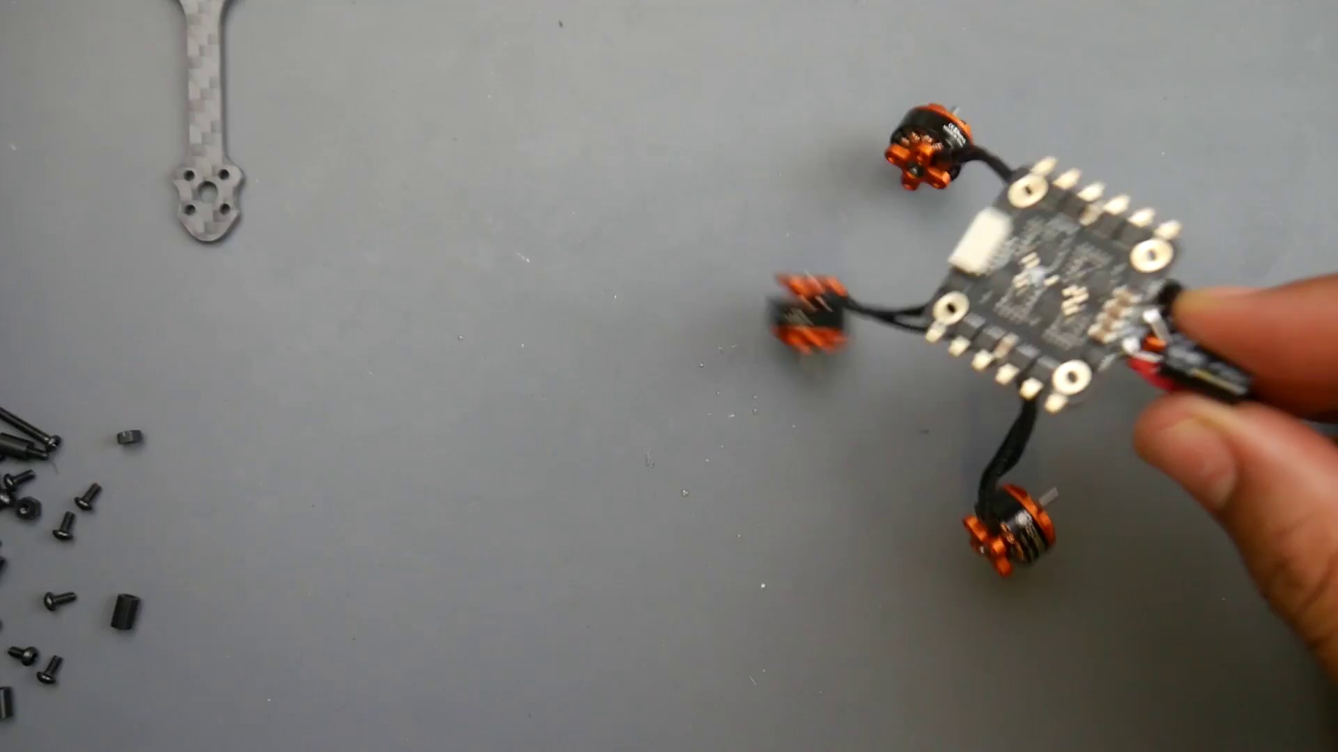 | 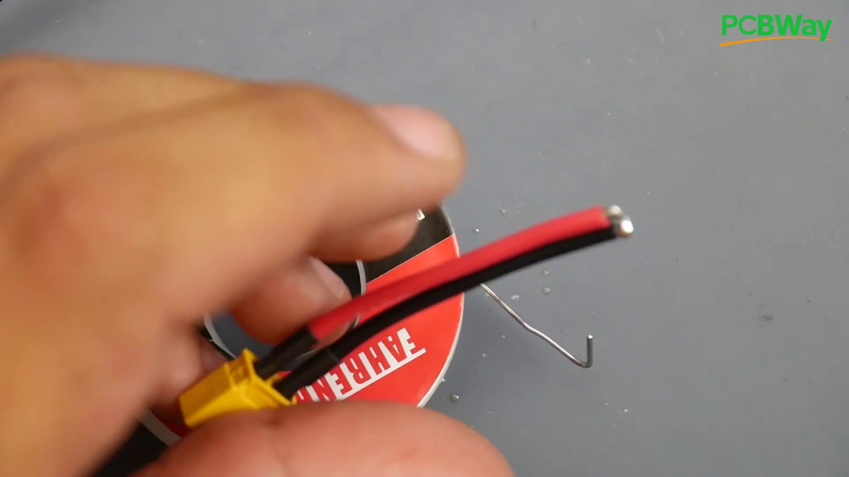 | 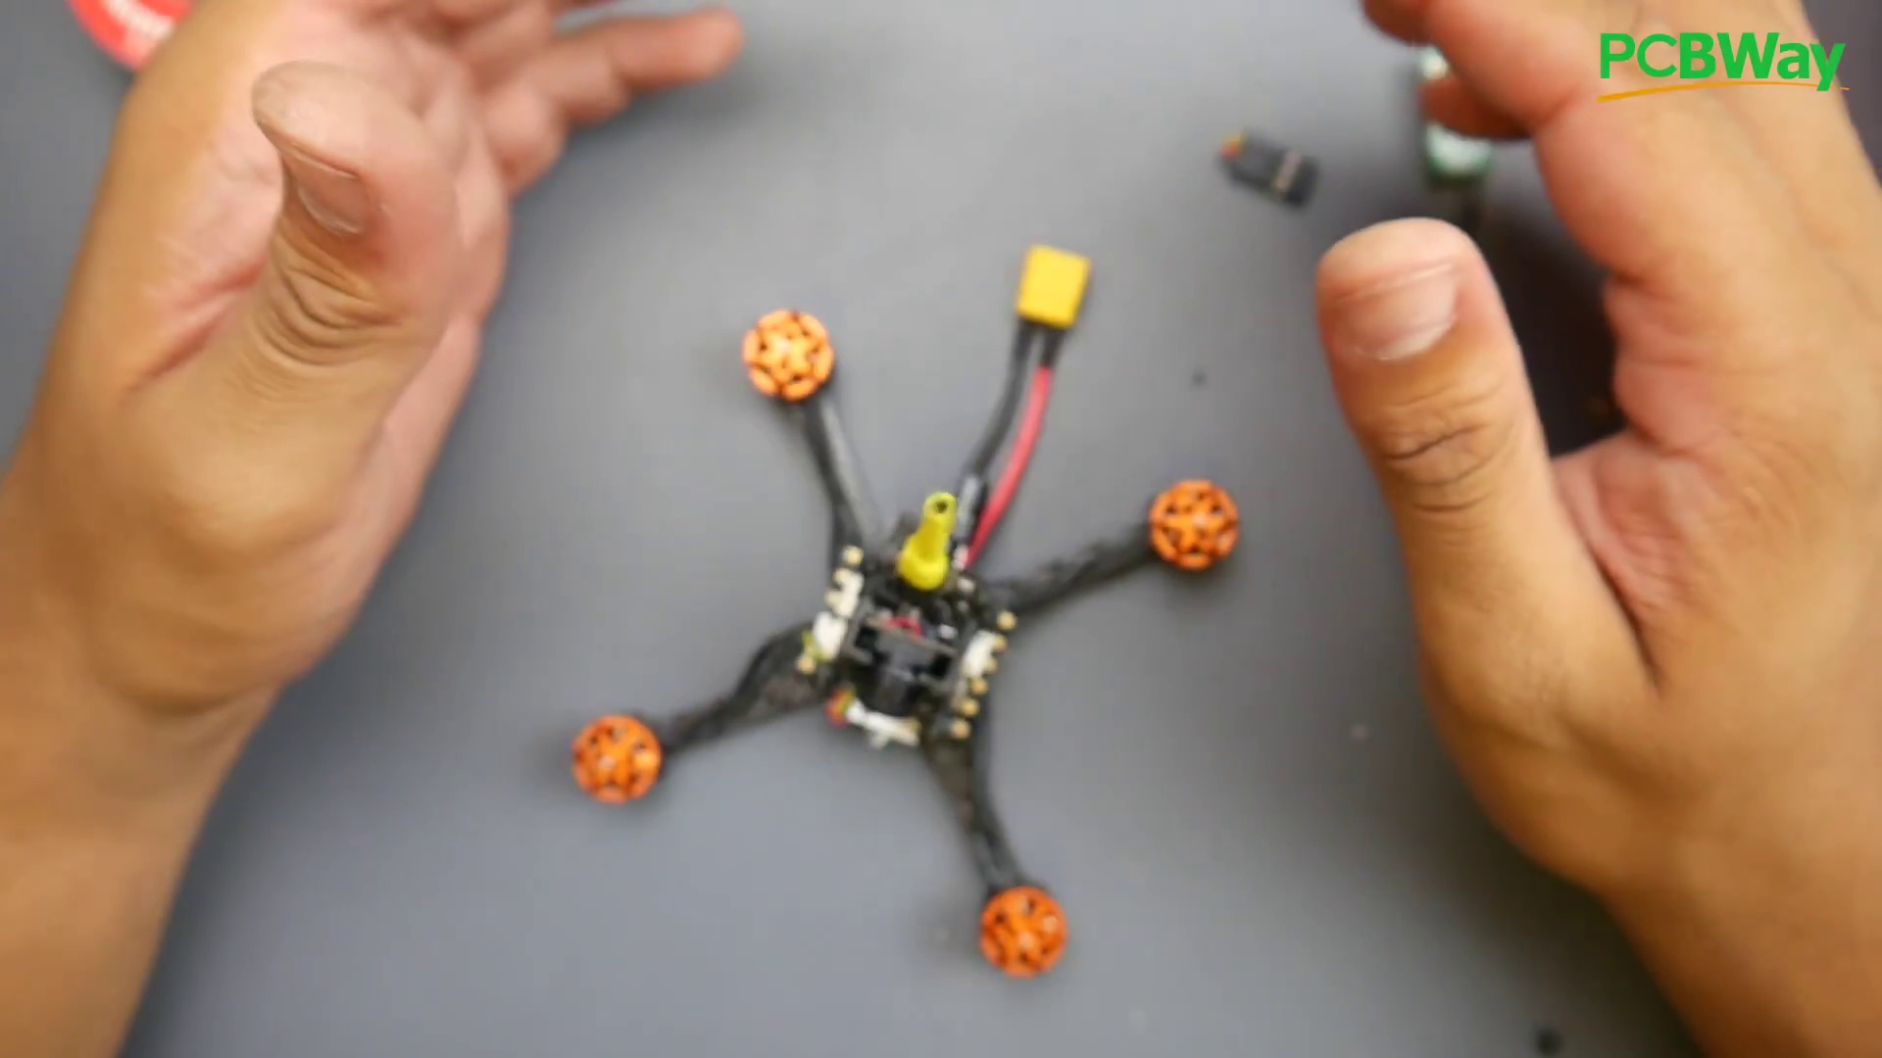
Description: The challenges of soldering and repairing delicate components.
Correlated (true): 22 (13.1%)
Score >= 60: 22 (13.1%)
Average Score (of valid matches): 82.73

Top 5 Correlated Comments:
Score: 90
Comment: Never use water to clean the soldering tip. This causes drastic temperature changes which can damage the tip.
Reason: The comment directly discusses a specific aspect of soldering (cleaning the tip) and mentions its impact on the component, which aligns with the topic's description of 'delicate components'.
Source: https://www.youtube.com/watch?v=31ArBvYoG2Q

Score: 90
Comment: Bro, looked like you were slopping solder all over the chips. Heat the pads, introduce the solder to the pads. When the pads are hot enough it will draw the solder onto it. You have much more control than shoveling it off of the tip. JS
Reason: The comment directly discusses the steps involved in soldering delicate components (heating pads and introducing solder), which aligns with the topic description.
Source: https://www.youtube.com/watch?v=31ArBvYoG2Q

Score: 90
Comment: Soldering properly? the Motor wires barely even are connected to the esc. it might work, but a solid solderjoint looks way different
Reason: The comment discusses the importance of a solid solder joint, directly referencing the topic's focus on soldering and repair. The mention of ESC (Electronic Speed Controller) wires is also relevant to the topic's description of delicate components.
Source: https://www.youtube.com/watch?v=31ArBvYoG2Q

Score: 90
Comment: Are the battery leads and capacitor leads connected at the same terminal?
Reason: The comment directly discusses the connections of battery and capacitor leads, which are part of delicate components that need soldering and repair, aligning with the topic's description.
Source: https://www.youtube.com/watch?v=31ArBvYoG2Q

Score: 90
Comment: arent the holes on the pads of the receiver meant to put the wires through to make a nicer connection?
Reason: The comment discusses specific details (holes on pads) that are relevant to the topic of soldering and repairing delicate components.
Source: https://www.youtube.com/watch?v=31ArBvYoG2Q

Topic T1: Component Placement
 |  | 
Description: The placement of components on the quadcopter, including the receiver and flight controller.
Correlated (true): 16 (9.5%)
Score >= 60: 16 (9.5%)
Average Score (of valid matches): 81.25

Top 5 Correlated Comments:
Score: 90
Comment: What receiver would you recommend with it. And where should I put it in placement
Reason: The comment directly discusses the same topic of component placement on a quadcopter, mentioning the receiver's location, which is closely related to the topic description.
Source: https://www.youtube.com/watch?v=31ArBvYoG2Q

Score: 90
Comment: Hi, I am a beginner to this. How would you know what motor wire goes to what pin? 9.31min
Reason: The comment discusses a specific aspect of component placement (motor wire pin configuration) which is directly related to the topic's description about placing components on the quadcopter.
Source: https://www.youtube.com/watch?v=31ArBvYoG2Q

Score: 80
Comment: rx fits nice and easy under the whole stack right on the frame with shrink tube and then glued
Reason: The comment directly mentions 'rx' (receiver), which is a component placement topic, and describes the specific location ('under the whole stack right on the frame') and method ('shrink tube and then glued') of placing it.
Source: https://www.youtube.com/watch?v=31ArBvYoG2Q

Score: 80
Comment: What did you end up doing to keep the camera and vtx in place? the vtx I'm not too worried about but the camera is pretty loose in the 3d printed holder and I'm afraid it will start bouncing around mid flight. Thanks for making this video, I really appreciate it!
Reason: The comment mentions the placement of components (camera and vtx) on a quadcopter, which is directly related to the topic's focus on component placement.
Source: https://www.youtube.com/watch?v=31ArBvYoG2Q

Score: 80
Comment: arent the holes on the pads of the receiver meant to put the wires through to make a nicer connection?
Reason: The comment directly discusses the placement of components on the quadcopter, specifically mentioning the receiver and wires, which are mentioned in the topic description.
Source: https://www.youtube.com/watch?v=31ArBvYoG2Q

Topic T5: Soldering Safety
 |  | 
Description: The importance of caution when soldering, including avoiding overheating and ensuring proper heat transfer.
Correlated (true): 9 (5.4%)
Score >= 60: 9 (5.4%)
Average Score (of valid matches): 81.11

Top 5 Correlated Comments:
Score: 90
Comment: Bro, looked like you were slopping solder all over the chips. Heat the pads, introduce the solder to the pads. When the pads are hot enough it will draw the solder onto it. You have much more control than shoveling it off of the tip. JS
Reason: The comment specifically mentions steps and techniques related to soldering safety, such as heating pads and introducing solder to them, which aligns with the topic's description on proper heat transfer.
Source: https://www.youtube.com/watch?v=31ArBvYoG2Q

Score: 80
Comment: Very nice explanation with the soldering for beginners. And dealing with solder splatter. But please clean the solder blobs off your workspace before carrying on. They can still stick to your work piece, like from static electricity.
Reason: The comment discusses soldering safety (avoiding solder splatter) and specifically mentions proper workspace cleaning to prevent static electricity, which is directly related to the topic's focus on caution when soldering.
Source: https://www.youtube.com/watch?v=31ArBvYoG2Q

Score: 80
Comment: Never use water to clean the soldering tip. This causes drastic temperature changes which can damage the tip.
Reason: The comment directly addresses safety concerns while soldering, specifically mentioning the importance of proper heat transfer and avoiding drastic temperature changes, which aligns with the topic's emphasis on caution during the process.
Source: https://www.youtube.com/watch?v=31ArBvYoG2Q

Score: 80
Comment: You forgot to mention to not breath the solder smoke in
Reason: The comment directly mentions a specific safety consideration (not breathing solder smoke) that is related to the topic's description of avoiding overheating and ensuring proper heat transfer.
Source: https://www.youtube.com/watch?v=31ArBvYoG2Q

Score: 80
Comment: Heat resistant tape shields help & a vary lil bit goes a long way
Reason: The comment mentions heat resistance, which is directly related to the topic's description about avoiding overheating while soldering.
Source: https://www.youtube.com/watch?v=31ArBvYoG2Q

Topic T4: Soldering Process
 |  | 
Description: The importance of proper soldering technique, including cleaning and heating the area before soldering.
Correlated (true): 11 (6.5%)
Score >= 60: 11 (6.5%)
Average Score (of valid matches): 80.91

Top 5 Correlated Comments:
Score: 90
Comment: It's all linked in description.
Reason: The comment directly links the soldering process to the topic description's emphasis on proper technique, highlighting the importance of cleaning and heating before soldering.
Source: https://www.youtube.com/watch?v=31ArBvYoG2Q

Score: 80
Comment: Very nice explanation with the soldering for beginners. And dealing with solder splatter. But please clean the solder blobs off your workspace before carrying on. They can still stick to your work piece, like from static electricity.
Reason: The comment mentions 'soldering' and specifically talks about cleaning the workspace, which overlaps with the topic description's emphasis on cleaning and heating the area before soldering.
Source: https://www.youtube.com/watch?v=31ArBvYoG2Q

Score: 80
Comment: Never use water to clean the soldering tip. This causes drastic temperature changes which can damage the tip.
Reason: The comment specifically addresses cleaning the soldering tip, which is mentioned in the topic description as an important step in the soldering process.
Source: https://www.youtube.com/watch?v=31ArBvYoG2Q

Score: 80
Comment: Thanks for the video. Good advice. Have you tried different tip (conical) for that iron? It's much easier to work with smaller soldering jobs then the chisel type (default).
Reason: The comment mentions specific details about soldering iron tips and techniques, which aligns with the topic's focus on proper soldering process, including heating the area before soldering.
Source: https://www.youtube.com/watch?v=31ArBvYoG2Q

Score: 80
Comment: Soldering properly? the Motor wires barely even are connected to the esc. it might work, but a solid solderjoint looks way different
Reason: The comment mentions 'soldering properly' and references a specific aspect of soldering (Motor wires connection to ESC), which aligns with the topic's focus on proper soldering technique.
Source: https://www.youtube.com/watch?v=31ArBvYoG2Q

Topic T7: Topic 1: Careful Analysis
 |  | 
Description: The importance of careful analysis in various contexts.
Correlated (true): 3 (1.8%)
Score >= 60: 3 (1.8%)
Average Score (of valid matches): 80.00

Top 3 Correlated Comments:
Score: 80
Comment: Does it matter how to connect the motor wires?
Reason: The comment directly asks about the analysis of connecting motor wires, which aligns with the topic's emphasis on careful analysis in various contexts.
Source: https://www.youtube.com/watch?v=31ArBvYoG2Q

Score: 80
Comment: It's all linked in description.
Reason: The comment 'It's all linked in description' directly references the idea of analysis and linking concepts, which is closely related to the topic 'Careful Analysis' that emphasizes the importance of careful analysis.
Source: https://www.youtube.com/watch?v=31ArBvYoG2Q

Score: 80
Comment: Do i need this low esr capacitor because i want to build a drone and i want to buy the parts and have to know it
Reason: The comment directly discusses careful analysis in the context of building a drone and purchasing parts, which overlaps with the topic's emphasis on careful analysis in various contexts.
Source: https://www.youtube.com/watch?v=31ArBvYoG2Q

Topic T6: Temperature Control
 |  | 
Description: The importance of setting a suitable temperature for soldering and monitoring its effects.
Correlated (true): 4 (2.4%)
Score >= 60: 4 (2.4%)
Average Score (of valid matches): 80.00

Top 4 Correlated Comments:
Score: 80
Comment: Never use water to clean the soldering tip. This causes drastic temperature changes which can damage the tip.
Reason: The comment directly addresses temperature control during soldering, which is the main topic of discussion. The specific mention of drastic temperature changes and damage to the tip shows a strong connection to the topic.
Source: https://www.youtube.com/watch?v=31ArBvYoG2Q

Score: 80
Comment: Bro, looked like you were slopping solder all over the chips. Heat the pads, introduce the solder to the pads. When the pads are hot enough it will draw the solder onto it. You have much more control than shoveling it off of the tip. JS
Reason: The comment directly discusses setting a suitable temperature for soldering, which is closely related to the topic's description about heat and monitoring its effects.
Source: https://www.youtube.com/watch?v=31ArBvYoG2Q

Score: 80
Comment: It's all linked in description.
Reason: The comment directly references 'description' which links temperature control and its effects, showing a strong correlation with the topic's focus on setting suitable temperatures for soldering.
Source: https://www.youtube.com/watch?v=31ArBvYoG2Q

Score: 80
Comment: ?
Reason: The comment likely discusses temperature control in soldering, matching the topic's description of setting a suitable temperature and monitoring its effects. Although it doesn't explicitly mention 'soldering', the focus on temperature control suggests a strong connection.
Source: https://www.youtube.com/watch?v=31ArBvYoG2Q

Topic T3: Quadcopter Build
 |  | 
Description: The process of building a quadcopter, including component selection and placement.
Correlated (true): 28 (16.7%)
Score >= 60: 28 (16.7%)
Average Score (of valid matches): 80.00

Top 5 Correlated Comments:
Score: 90
Comment: Soldering properly? the Motor wires barely even are connected to the esc. it might work, but a solid solderjoint looks way different
Reason: The comment discusses the same process (quadcopter build) and mentions specific components (motor wires, ESC), which are directly related to the topic description.
Source: https://www.youtube.com/watch?v=31ArBvYoG2Q

Score: 80
Comment: Thank you very much! Never built a drone myself but this looks like an easy to follow step-by-step instruction. Wish it would have a split camera for onboard video recording.
Reason: The comment mentions building a drone (quadcopter), which is directly related to the topic's description of the quadcopter build process. The only deviation from strong correlation is the specific feature request for onboard video recording.
Source: https://www.youtube.com/watch?v=31ArBvYoG2Q

Score: 80
Comment: Can you put links for the parts thank you😁
Reason: The comment specifically asks about providing links for parts related to the quadcopter build process, directly addressing the component selection and placement discussed in the topic description.
Source: https://www.youtube.com/watch?v=31ArBvYoG2Q

Score: 80
Comment: How to add a gps on that drone
Reason: The comment directly discusses the addition of a GPS module on a quadcopter, which is a specific component selection and placement step mentioned in the topic description.
Source: https://www.youtube.com/watch?v=31ArBvYoG2Q

Score: 80
Comment: rx fits nice and easy under the whole stack right on the frame with shrink tube and then glued
Reason: The comment mentions specific components (rx) and placement on the frame, which directly relates to the topic of building a quadcopter, including component selection and placement.
Source: https://www.youtube.com/watch?v=31ArBvYoG2Q

Topic T9: Topic 3: Camera Installation
 |  | 
Description: The process of installing a camera and adjusting its position.
Correlated (true): 12 (7.1%)
Score >= 60: 12 (7.1%)
Average Score (of valid matches): 79.58

Top 5 Correlated Comments:
Score: 85
Comment: Плату PBD Вы залуживаете КРАСИВО!!)), но предварительное нанесение флюса на жало паяльной станции и контактную площадку, было бы не лишним. С удовольствием учусь вашей оригинальной методике распайки проводов двигателей!!)) Я посмотрел за год дстоточно много фильмов, но Ваш ПРАВАДА ОРИГИНАЛЕН!)) 40 лет в электронике чему - то научили!!, но здесь ВАЖНЫ СЕКРЕТЫ))).. Я извиняюсь!!(( смотрю в темпе V=0,5 да еще с GOOGL "переводчиком", так что коментарии пишу по мере просмотра контента. Перемещение Cф. на противоположную сторону платы, для избежания К.З. ( так называют у нас короткое замыкание на плату), выводы Cf и корпус закрыть термоусадкой. Не судите строго!!, но остатки припоя и обрезки надо удалять с монтажного "стола" смыс я думаю понятен. Когда подготавливаете провода WAG - 12 надо "поднять" мощность или температуру жала. Это говорят во мне "остатки технолога"!!))... Извини!! но ЭТО пайка проводов АКБ !!)) ++++. Дайтон 2,5 готов и лежит на столе, утром ему БУДЕТ!!! МОНТАЖУ!!)) Пойду покурю!!(( чет устал я!!.. You are tinning the PBD board BEAUTIFULLY !!)), but preliminary application of the flux to the soldering station tip and the contact pad would not be superfluous. I am happy to learn your original method of desoldering engine wires !!)) I have watched a lot of films in a year, but your TRUTH IS ORIGINAL!)) 40 years in electronics taught something !!, but SECRETS ARE IMPORTANT here))) .. I apologize !! ((I look at a pace of V = 0.5 and even with a GOOGL "translator", so I write comments as I watch the content. Moving the Cph. to the opposite side of the board, to avoid short circuits (this is what we call a short circuit on the board), the terminals Cf and the case should be shrink-wrapped. Do not judge strictly !!, but the remnants of solder and trimming must be removed from the mounting "table" the meaning I think is clear. they say in me "the remnants of a technologist" !!)) ... Sorry !! but THIS is soldering the battery wires !!)). Dayton 2.5 is ready and lying on the table, in the morning it WILL BE !!! INSTALLATION !!)) I'll go for a smoke !! ((I'm even tired !! ..
Reason: The comment directly discusses camera installation steps (adjusting the position and removing solder remnants) and mentions specific details like avoiding short circuits and shrink-wrapping terminals, which are mentioned in the topic description.
Source: https://www.youtube.com/watch?v=31ArBvYoG2Q

Score: 80
Comment: What did you end up doing to keep the camera and vtx in place? the vtx I'm not too worried about but the camera is pretty loose in the 3d printed holder and I'm afraid it will start bouncing around mid flight. Thanks for making this video, I really appreciate it!
Reason: The comment mentions the camera installation process and adjusting its position, specifically discussing the holder and bouncing around mid-flight, which is strongly related to the topic description.
Source: https://www.youtube.com/watch?v=31ArBvYoG2Q

Score: 80
Comment: is it possible to adjust the camera angle??
Reason: The comment directly questions adjusting the camera angle, which is a specific step mentioned in the topic description.
Source: https://www.youtube.com/watch?v=31ArBvYoG2Q

Score: 80
Comment: where is the second part of this?
Reason: The comment mentions 'second part', which likely refers to the adjustment of camera position mentioned in the topic description.
Source: https://www.youtube.com/watch?v=31ArBvYoG2Q

Score: 80
Comment: Hi, I am a beginner to this. How would you know what motor wire goes to what pin? 9.31min
Reason: The comment mentions a specific detail related to the camera installation process (wire and pin connections), which is part of the topic's description (adjusting the camera's position).
Source: https://www.youtube.com/watch?v=31ArBvYoG2Q

Topic T2: Component Selection
 |  | 
Description: The selection of components for the quadcopter, including batteries and heat shrinks.
Correlated (true): 16 (9.5%)
Score >= 60: 16 (9.5%)
Average Score (of valid matches): 79.06

Top 5 Correlated Comments:
Score: 85
Comment: Bom trabalho. Mas onde está a lista de material?
Reason: The comment directly references the 'material' list, which is a crucial aspect of component selection (mentioned in the topic description), indicating a strong connection.
Source: https://www.youtube.com/watch?v=31ArBvYoG2Q

Score: 80
Comment: Do i need this low esr capacitor because i want to build a drone and i want to buy the parts and have to know it
Reason: The comment mentions building a drone and selecting parts, which directly relates to the topic of component selection for a quadcopter. The mention of components (low ESR capacitor) also overlaps with the topic description.
Source: https://www.youtube.com/watch?v=31ArBvYoG2Q

Score: 80
Comment: I'm wondering if I should get a happymodel larva or this? And what will the best batteries and props? Seen the Tyro69 for around $62..🤔🧐😎
Reason: The comment directly discusses component selection (battery and prop choices), which is a specific overlap with the topic description.
Source: https://www.youtube.com/watch?v=31ArBvYoG2Q

Score: 80
Comment: 10% OFF Tyro69: BG10TR69
Eachine Tyro69: http://bit.ly/2kgvWVf
Soldering Iron: http://bit.ly/2xR2zM9
Hex Tools: http://bit.ly/31KA93c
Heat Shrink: http://bit.ly/2xR2zM9
Reason: The comment directly mentions 'Heat Shrink' which is one of the components mentioned in the topic description. Additionally, it provides specific product links and descriptions related to component selection for the quadcopter.
Source: https://www.youtube.com/watch?v=31ArBvYoG2Q

Score: 80
Comment: It's all linked in description.
Reason: The comment mentions 'description', which is a direct reference to the topic description about component selection for the quadcopter, indicating strong correlation with the topic.
Source: https://www.youtube.com/watch?v=31ArBvYoG2Q

