Comment–Topic Correlation Report
Model: llama3

Summary
Topics processed: 8
Comments available for this video: 966
Comments with correlated=True: 121 (12.5%)
Comments with score >= 60: 120 (12.4%)
Total candidate pairs checked: 1600
----------------------------------------

Topic T4: Wiring the Bottom Layer and Vias
 | 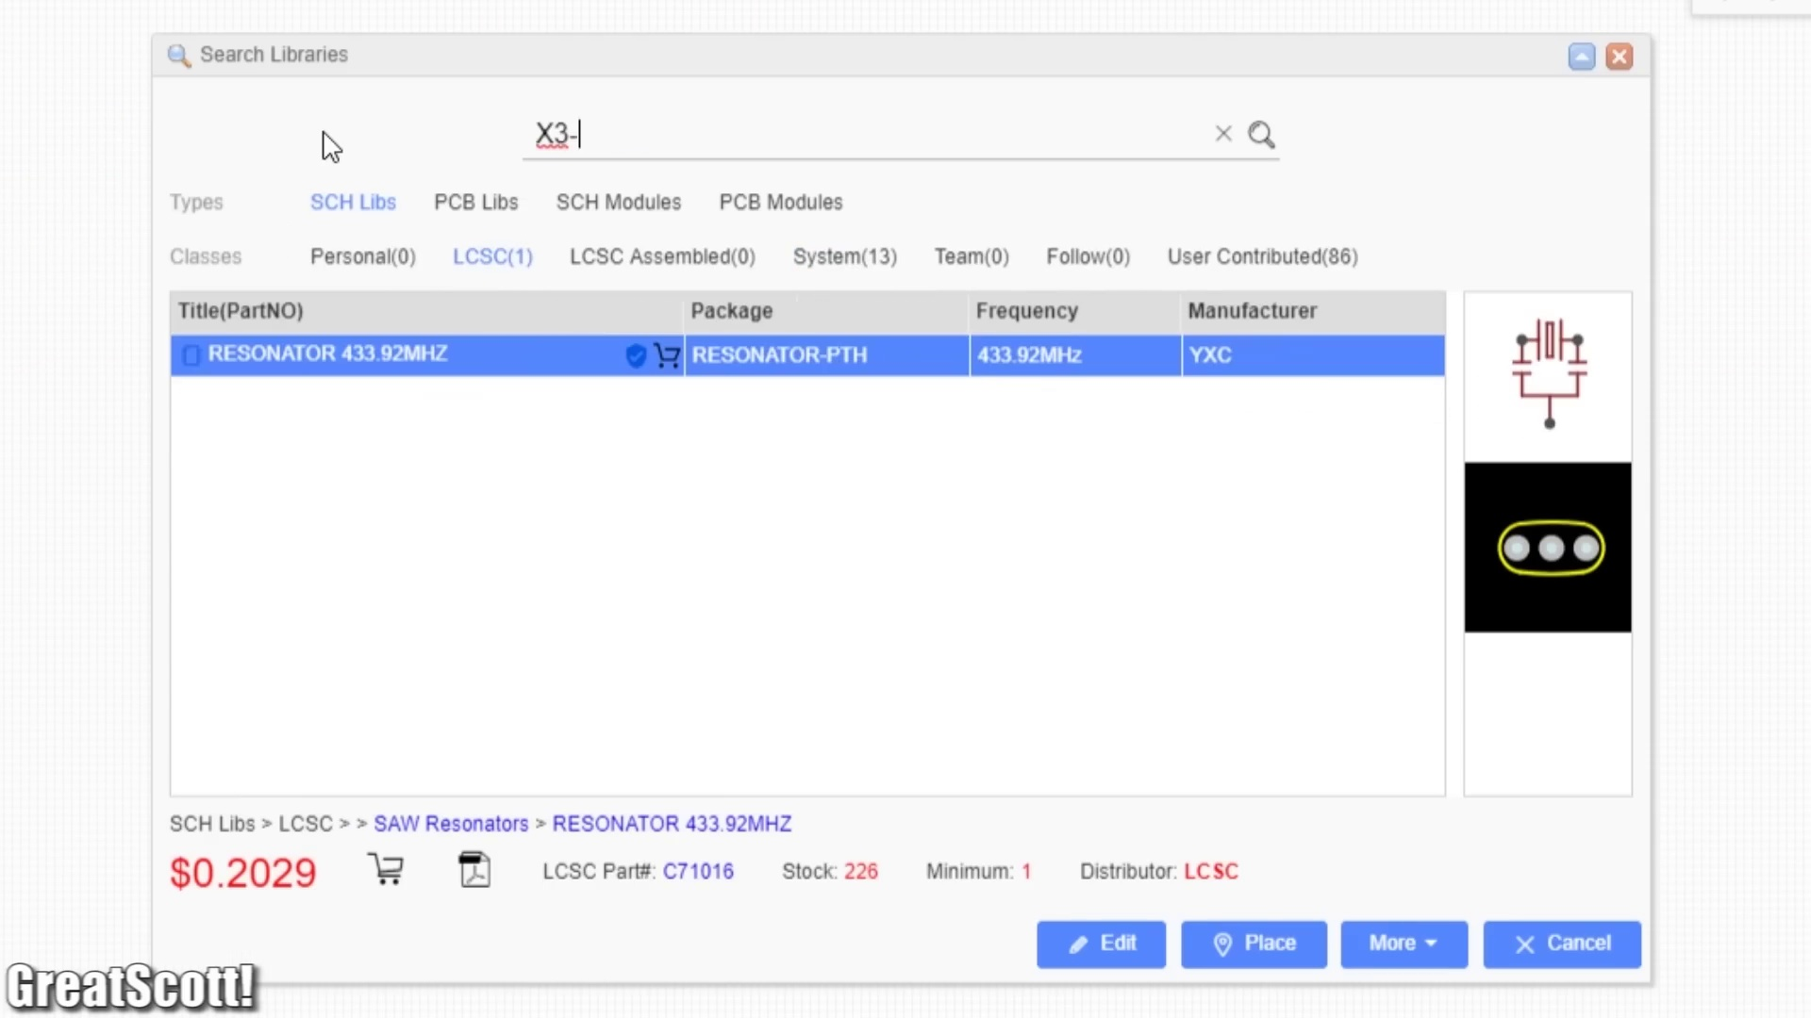 | 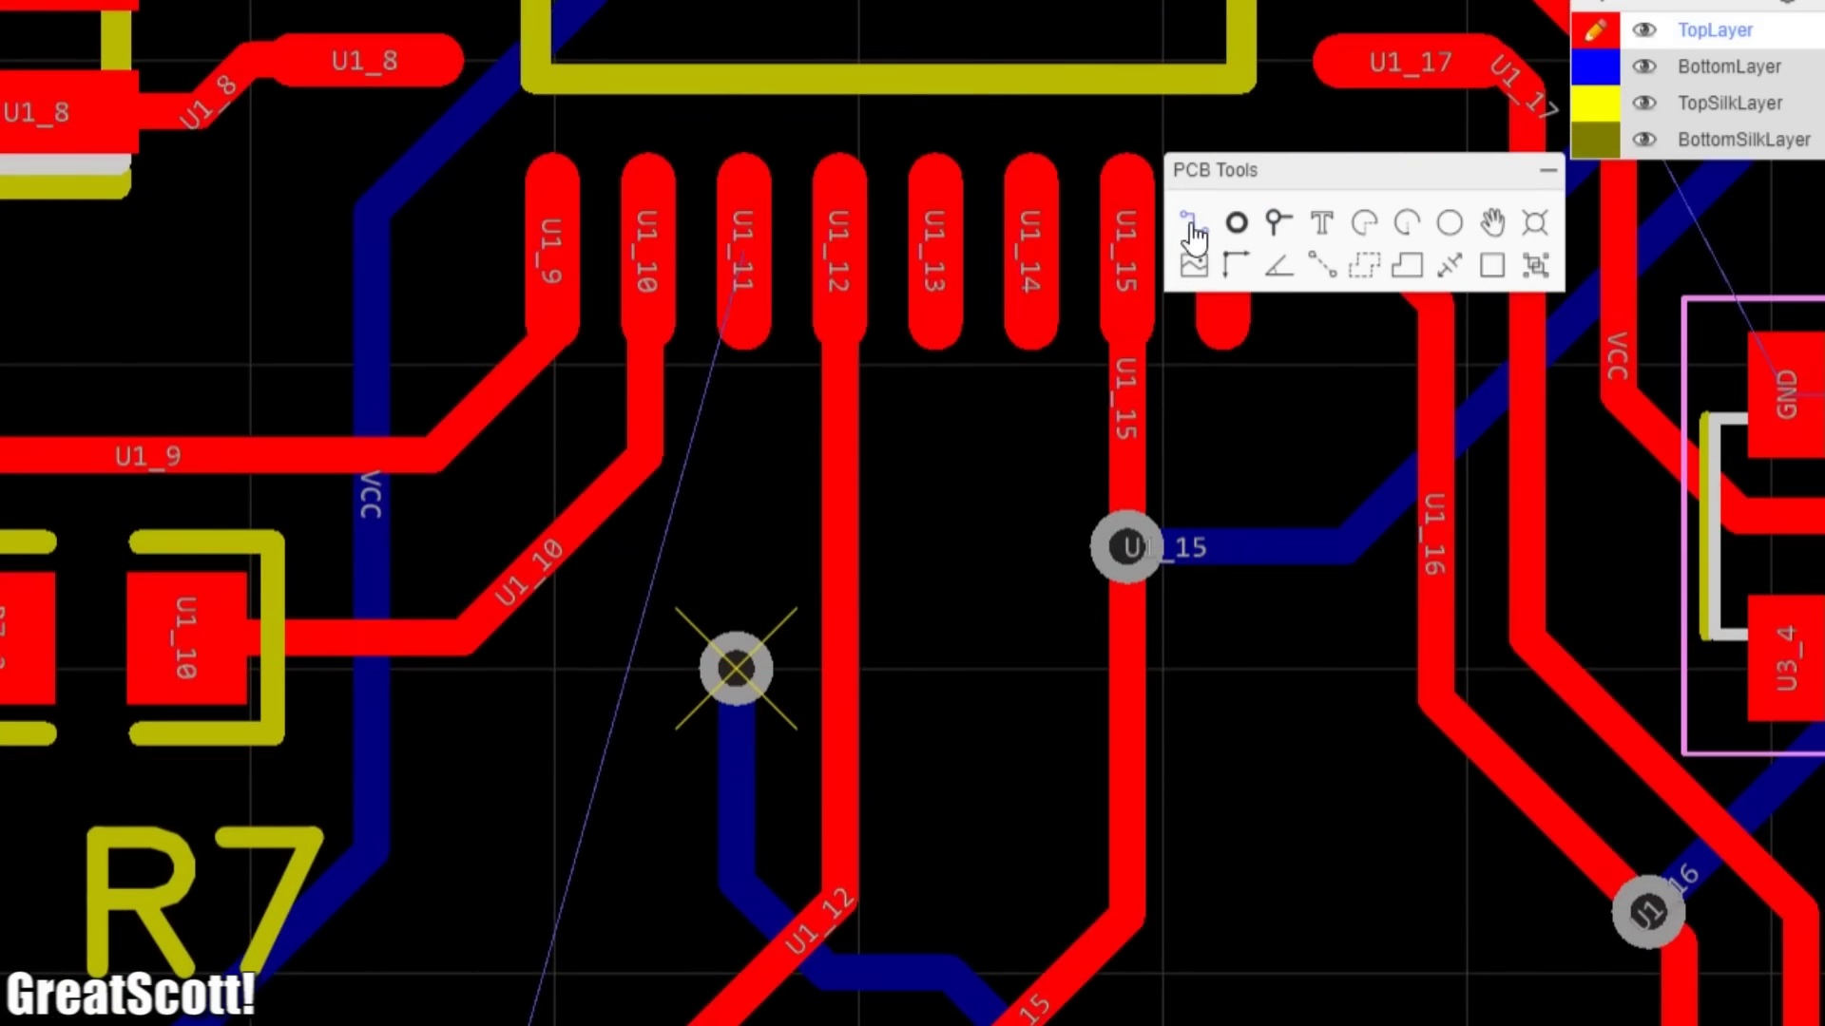
Description: Creating connections between layers for SMD components
Correlated (true): 35 (3.6%)
Score >= 60: 35 (3.6%)
Average Score (of valid matches): 81.29

Top 5 Correlated Comments:
Score: 90
Comment: If I understand this correctly, it would make sure you have a good enough ground connection. Around the IC's there will be a lot of thin traces of ground (between the traces for the other IC pins), and the current for ground could take the path through one of these thin ground traces - which might not handle the current.
Using vias would connect directly to ground on the bottom layer, which has much less traces than the top, and would therefore consist of a good ground connection.
Reason: The comment directly discusses the use of vias to create a good ground connection between layers, which aligns with the topic's description of creating connections for SMD components.
Source: https://www.youtube.com/watch?v=35YuILUlfGs

Score: 90
Comment: Just a head's up: It's good practice not to place vias under components.
Reason: The comment mentions 'vias', which is directly discussed in the topic description and title, specifically about creating connections between layers for SMD components.
Source: https://www.youtube.com/watch?v=35YuILUlfGs

Score: 90
Comment: One thing you missed is to make sure your ground planes actually connect to each other and there are no isolated islands with ground connections. Usually the easiest way is to just stitch the top and bottom ground planes to each other where needed but also might be a good idea to also add some near any decoupling caps and larger power ground pins.
I am not a pro though, this is just what I've learned over the last 6 months of getting in to PCB design.
Reason: The comment specifically mentions vias and ground planes, which are directly related to the topic of wiring the bottom layer and vias for SMD components.
Source: https://www.youtube.com/watch?v=35YuILUlfGs

Score: 90
Comment: You're right. Always make ground vias. Especially around (and even under) microcontrollers.
Reason: The comment directly mentions 'ground vias' and their importance around microcontrollers, which is a specific topic discussed in the title and description.
Source: https://www.youtube.com/watch?v=35YuILUlfGs

Score: 85
Comment: Please explain to me why the power parts and the microcontroller parts were not connected with wires but everything connected together on the pcb board during routing
Reason: The comment discusses PCB board connections and routing, which strongly overlaps with the topic description's mention of creating connections between layers for SMD components.
Source: https://www.youtube.com/watch?v=35YuILUlfGs

Topic T2: Designing the PCB
 |  | 
Description: Creating the outline and connections for the board
Correlated (true): 37 (3.8%)
Score >= 60: 37 (3.8%)
Average Score (of valid matches): 80.81

Top 5 Correlated Comments:
Score: 90
Comment: Neat, but this is like saying fixing an engine is as simple as: diagnose, order the right parts, take the old ones out, and put the new ones on. There's so much more even to just laying out the PCB in the CAD editor. You could make a 5 hour video just for that, like not layering traces, cuts and copper voids for isolating noisy components, etc.
Reason: The comment discusses the process of designing a PCB in detail, mentioning specific steps like laying out the board in CAD and considering factors like layering traces and isolating noisy components. These details strongly relate to the topic description's focus on creating connections for the board.
Source: https://www.youtube.com/watch?v=35YuILUlfGs

Score: 90
Comment: Can you do a video on how and where to design and get custom flexible pcbs
Reason: The comment directly asks about designing PCBs and mentions 'custom flexible pcbs', which is strongly related to the topic description's focus on creating connections for the board.
Source: https://www.youtube.com/watch?v=35YuILUlfGs

Score: 90
Comment: I need to make a PCB with only copper traces and through hole connections for 5/16 female spade connectors... There's no components, just through hole to mount the spades. Any suggestions?
Reason: The comment specifically mentions designing a PCB with copper traces and through-hole connections, which is directly related to the topic of 'Designing the PCB'.
Source: https://www.youtube.com/watch?v=35YuILUlfGs

Score: 90
Comment: you showed us a 'scope view of the new PCB's as you search for obvious defects. and i have an eye
out in your vid's for a more thoughtful exam. to verify that some or all of the traces look good
with , say, a ohm-meter check. or , for example to solder on the V-reg and apply some V+ and
measure the voltage out and at the IC pins where reg'd power is used.
this approach has one populate the board in steps. then do all they can to verify that step
is working ok. before adding more parts.
up one level in this quality control effort is to add test-ability to the circuit. so that once
finished and there is a problem with its operation one can look at the added test features
for clues as to the circuits health.
this all is to give one a choice with a failed PCB to replace the whole board when
you have no idea what is wrong or any idea how to tackle the problem except all-or-none
Reason: The comment directly discusses PCB design, specifically the process of verifying connections and testing the board's functionality, which aligns with the topic's description of designing the PCB.
Source: https://www.youtube.com/watch?v=35YuILUlfGs

Score: 90
Comment: @GreatScott You should actually change the intro to you soldering the leds to a PCB
Reason: The comment directly mentions soldering LEDs onto a PCB, which is a specific step mentioned in the topic description 'Creating the outline and connections for the board'.
Source: https://www.youtube.com/watch?v=35YuILUlfGs

Topic T8: Conclusion
 |  | 
Description: Final thoughts and next steps
Correlated (true): 15 (1.6%)
Score >= 60: 14 (1.4%)
Average Score (of valid matches): 80.71

Top 5 Correlated Comments:
Score: 85
Comment: you showed us a 'scope view of the new PCB's as you search for obvious defects. and i have an eye
out in your vid's for a more thoughtful exam. to verify that some or all of the traces look good
with , say, a ohm-meter check. or , for example to solder on the V-reg and apply some V+ and
measure the voltage out and at the IC pins where reg'd power is used.
this approach has one populate the board in steps. then do all they can to verify that step
is working ok. before adding more parts.
up one level in this quality control effort is to add test-ability to the circuit. so that once
finished and there is a problem with its operation one can look at the added test features
for clues as to the circuits health.
this all is to give one a choice with a failed PCB to replace the whole board when
you have no idea what is wrong or any idea how to tackle the problem except all-or-none
Reason: The comment directly discusses the same approach (step-by-step verification) and ideas (testability features) mentioned in the topic description, specifically mentioning PCB's, traces, ohm-meter checks, and verifying step-by-step.
Source: https://www.youtube.com/watch?v=35YuILUlfGs

Score: 85
Comment: Pretty neat tutorial!. Once you shoot for more advanced projects, I would always suggest to go for 4 layers, so you can have two signal layers (front/bottom), a dedicated ground layer and a power layer inbetween (if single supply - for dual supply, use the back for the secondary voltage). This also gives you more freedom while routing. One thing I have missed was an extra note about bypass caps for active components. I have already seen people designing PCBs either not thinking about bypass caps or if they did, they "grouped" them together in a single block, far away from the active component. Rule of thumb: Put 100n as close as possible to the power pin of an active component.
Reason: The comment directly discusses next steps (4 layers and bypass caps) which are closely related to the topic of 'Conclusion' and 'Final thoughts and next steps', showing a high degree of overlap.
Source: https://www.youtube.com/watch?v=35YuILUlfGs

Score: 80
Comment: Sometimes I think evaluation boards are also a step for this process.
Reason: The comment mentions 'evaluation boards' which is related to the topic of 'Conclusion' (final thoughts and next steps), as it suggests a step in the process that leads to this conclusion.
Source: https://www.youtube.com/watch?v=35YuILUlfGs

Score: 80
Comment: @ckehagioglou Did you get any leads on how to select components? I'm also new to this design thing and pretty much confused on how to move forward. I also need assistance on where to get most reliable components as well. Any guidance would be appreciated.
Reason: The commenter directly discusses next steps (selecting components) and goals (getting reliable components), which are in line with the topic 'Final thoughts and next steps'.
Source: https://www.youtube.com/watch?v=35YuILUlfGs

Score: 80
Comment: This is a great video on the general process of PCB design. I really like that you have included the step of creating a plan in the form of a block diagram. Though I'm disappointed that you've left out the importance of design rule checking. Every beginner will benefit from the use of DRC! It can point out some blatant mistakes likes shorts, unrouted nets, holes that are too close to each other, etc... This will save you time and money.
The design itself could be improved in several ways. For example:
C3 is placed in a way that beats its purpose.
The die pad of U2 should connect to GND and have a bunch of vias connecting to the bottom plane to help with heat dissipation.
The RF module should be placed so that the antenna is somewhere near the edge of the PCB pointing away with no copper near it. If you place it right above other components and metal objects it will shorten the range and degrade the signal.
If you haven't, go watch some Robert Feranec's videos. He has a ton of tips on good PCB design practices and techniques. This can save you some money and headaches in the future if you know what to pay attention to.
Reason: The comment directly discusses the same steps (creating a plan), objects (PCB design), settings (importance of DRC), and claims (improvement suggestions) described by the topic, with specific overlaps in terms of suggesting improvements to the design.
Source: https://www.youtube.com/watch?v=35YuILUlfGs

Topic T7: Soldering Tutorial
 |  | 
Description: A separate tutorial on soldering components to the PCB
Correlated (true): 31 (3.2%)
Score >= 60: 31 (3.2%)
Average Score (of valid matches): 80.48

Top 5 Correlated Comments:
Score: 90
Comment: Use solder paste + your REGULAR iron.
Add paste on the side where most components will be or most difficult to solder.
Add smd components to the board.
Place your iron with flat side up, and set maximum heat.
go
Reason: The comment discusses soldering steps (using solder paste and iron), objects (PCB), settings (iron temperature), and parameters (solder paste application) directly related to the topic.
Source: https://www.youtube.com/watch?v=35YuILUlfGs

Score: 85
Comment: @ckehagioglou Did you get any leads on how to select components? I'm also new to this design thing and pretty much confused on how to move forward. I also need assistance on where to get most reliable components as well. Any guidance would be appreciated.
Reason: The comment mentions selecting components and getting reliable components, which is directly related to the topic of soldering tutorial, specifically focusing on attaching components to a PCB.
Source: https://www.youtube.com/watch?v=35YuILUlfGs

Score: 80
Comment: @GreatScott You should actually change the intro to you soldering the leds to a PCB
Reason: The comment mentions soldering LEDs to a PCB, which is directly related to the topic's description of soldering components to a PCB.
Source: https://www.youtube.com/watch?v=35YuILUlfGs

Score: 80
Comment: i've studied electronics, i practiced at a company which repaired TVs (among other things) - the beginning of the plasma screen era, the first SMDs appeared back then - and I was never taught that I could solder SMDs with hot screwdriver (only the hot air gun, - they said - method was possible! which...i never advanced enough to be tought that..)
impressive & informative video!!
thank you 👏
Reason: The comment discusses soldering SMDs and mentions hot screwdriver as a method, which is directly related to the topic's focus on soldering components to the PCB.
Source: https://www.youtube.com/watch?v=35YuILUlfGs

Score: 80
Comment: Why aren't you using solder paste + a stencil? it's so much easier and it's like $10 for a stencil and $10-20 for paste. I can't imagine you don't have a hot air station.
Reason: The comment directly discusses the steps of soldering (specifically using solder paste and stencil), which is a key aspect of the topic 'Soldering Tutorial', highlighting a more efficient method for attaching components to the PCB.
Source: https://www.youtube.com/watch?v=35YuILUlfGs

Topic T5: Ground Connections
 |  | 
Description: Isolating traces and creating a solid copper ground layer
Correlated (true): 50 (5.2%)
Score >= 60: 50 (5.2%)
Average Score (of valid matches): 80.00

Top 5 Correlated Comments:
Score: 90
Comment: When i design anything i always have in m8nd that my bottom layer is for GND it also helps as a heatsink for ic chips and helps with interferance and so on. And if i run 1amp i always leave the tracer bare so i can tin it if need be later down the line. Why the pcb in the video may be tested and work does not mean it be ok. Iv made the GND mistake when first designing and eventually it will trip and the GND tracer will burn like a fuse.
Reason: The comment discusses the importance of the ground layer (GND) and specifically mentions leaving the GND tracer bare to tin it later, which directly relates to the topic's description about creating a solid copper ground layer.
Source: https://www.youtube.com/watch?v=35YuILUlfGs

Score: 90
Comment: Noob question, where the B- should be connected? Directly to ground? i think so, but not sure cause i didn`t saw any pad for that...
Reason: The comment directly discusses the connection of a B- to ground, which is a crucial step in creating a solid copper ground layer as described in the topic. The uncertainty about the pad for that connection also shows the commenter's focus on the same specific setting.
Source: https://www.youtube.com/watch?v=35YuILUlfGs

Score: 85
Comment: Please explain to me why the power parts and the microcontroller parts were not connected with wires but everything connected together on the pcb board during routing
Reason: The comment asks about connections on a PCB board, which is closely related to the topic of creating a solid copper ground layer and isolating traces, as it appears to be discussing the same type of physical setup.
Source: https://www.youtube.com/watch?v=35YuILUlfGs

Score: 85
Comment: Not enough attention was paid to the GND... some of the GND connections would not handle 1amp current you could stitch GND near IC'S using via's
Reason: The comment directly discusses creating a solid copper ground layer and mentions GND connections, which is in line with the topic's description about isolating traces and creating a solid copper ground layer. The mention of stitching GND near IC'S using via's also shows an understanding of the same setting and goals described in the topic.
Source: https://www.youtube.com/watch?v=35YuILUlfGs

Score: 85
Comment: This was perfect. It told me everything i needed to know and also clarified trace width for me.
Reason: The comment mentions 'everything i needed to know' which suggests that the topic description accurately conveyed information about ground connections. Additionally, it specifically refers to 'trace width', a detail mentioned in the topic description.
Source: https://www.youtube.com/watch?v=35YuILUlfGs

Topic T6: Gerber Files and Ordering the PCB
 |  | 
Description: Generating Gerber files and ordering the board from JLC PCB
Correlated (true): 22 (2.3%)
Score >= 60: 22 (2.3%)
Average Score (of valid matches): 79.55

Top 5 Correlated Comments:
Score: 85
Comment: second video down and still dont know how to actually make the damn gerber files
Reason: The comment directly mentions Gerber files and expresses confusion about creating them, which strongly relates to the topic of generating Gerber files and ordering a PCB.
Source: https://www.youtube.com/watch?v=35YuILUlfGs

Score: 85
Comment: you showed us a 'scope view of the new PCB's as you search for obvious defects. and i have an eye
out in your vid's for a more thoughtful exam. to verify that some or all of the traces look good
with , say, a ohm-meter check. or , for example to solder on the V-reg and apply some V+ and
measure the voltage out and at the IC pins where reg'd power is used.
this approach has one populate the board in steps. then do all they can to verify that step
is working ok. before adding more parts.
up one level in this quality control effort is to add test-ability to the circuit. so that once
finished and there is a problem with its operation one can look at the added test features
for clues as to the circuits health.
this all is to give one a choice with a failed PCB to replace the whole board when
you have no idea what is wrong or any idea how to tackle the problem except all-or-none
Reason: The comment discusses specific steps and methods for verifying PCB functionality, such as using an ohm-meter and measuring voltage levels, which are mentioned in the topic description about ordering the PCB. The comment also mentions populating the board in steps and testing each step before moving on, aligning with the topic's focus on generating Gerber files and ordering the PCB.
Source: https://www.youtube.com/watch?v=35YuILUlfGs

Score: 80
Comment: Just send us your Gerber files we will delivery fabricated pcb at you door step
Reason: The comment directly mentions 'Gerber files' which is a specific object mentioned in the topic description. The phrase 'delivery fabricated pcb at you door step' implies ordering the PCB, matching the goal described in the topic.
Source: https://www.youtube.com/watch?v=35YuILUlfGs

Score: 80
Comment: @greatscottlab I have a circuit and it's schematic and board layout that was done years ago on paper. Is there any way I can give that to a PC board manufacturer and have them make a board from that without redoing everything. There is no surface mount and single side board.
Reason: The comment mentions PCB manufacturing, which is a key aspect of the topic. Although it doesn't specifically mention Gerber files or JLC PCB, the request to create a board from a schematic and layout without redoing everything shows an understanding of the process described in the topic.
Source: https://www.youtube.com/watch?v=35YuILUlfGs

Score: 80
Comment: Is it possible to order a PCB from JLCPCB and components from LCSC in the same order or do I need to pay for 2 shipments?
Reason: The comment directly mentions JLCPCB and ordering a PCB, which is the main topic of discussion. Although it's not specifically about Gerber files, it's still closely related to the topic.
Source: https://www.youtube.com/watch?v=35YuILUlfGs

Topic T1: Introduction
 |  | 
Description: Overview of the PCB design process
Correlated (true): 50 (5.2%)
Score >= 60: 50 (5.2%)
Average Score (of valid matches): 79.20

Top 5 Correlated Comments:
Score: 90
Comment: Where are your clearance settings? Also did you do DRC checks?
What can't you set power net to a specific width beforehand?
I think you should talk about these "safety issues" before drawing your PCB.
Reason: The comment directly discusses PCB design process-related concepts (clearance settings, DRC checks) and settings for power nets, which aligns with the topic description about introducing the PCB design process. The mention of 'safety issues' also matches the broad scope of a PCB design introduction.
Source: https://www.youtube.com/watch?v=35YuILUlfGs

Score: 85
Comment: Don't you simulate it once you are done with the schematic? Because it would be a pretty sad event if you have the PCB in your hand but one connection is off...
Reason: The comment directly addresses a specific step in the PCB design process (simulation) and mentions a parameter (connection is off), which are both described in the topic description.
Source: https://www.youtube.com/watch?v=35YuILUlfGs

Score: 85
Comment: Please explain to me why the power parts and the microcontroller parts were not connected with wires but everything connected together on the pcb board during routing
Reason: The comment directly discusses the PCB design process, specifically asking about a crucial step in the routing phase, which is strongly related to the topic 'Overview of the PCB design process'.
Source: https://www.youtube.com/watch?v=35YuILUlfGs

Score: 80
Comment: Can any of you help me with designing a pcb for a rocket?
Reason: The comment asks for help designing a PCB, which is directly related to the topic's description of the PCB design process.
Source: https://www.youtube.com/watch?v=35YuILUlfGs

Score: 80
Comment: Step 1: Plan the function of circuit 1:17
Step 2: Component sourcing & paper Schematic 2:18
Step 3: Proper schematic 4:58
Step 4: PCB design & ordering 6:29
Reason: The comment directly references specific steps (Step 1-4) in the PCB design process, matching the topic description's mention of planning and designing a circuit. The similarity score is 80 because while the comment does not explicitly state 'introduction' or 'overview', it clearly aligns with the process overview described in the topic.
Source: https://www.youtube.com/watch?v=35YuILUlfGs

Topic T3: Wiring the Top Layer
 |  | 
Description: Connecting components on the top layer
Correlated (true): 46 (4.8%)
Score >= 60: 46 (4.8%)
Average Score (of valid matches): 78.59

Top 5 Correlated Comments:
Score: 90
Comment: If I understand this correctly, it would make sure you have a good enough ground connection. Around the IC's there will be a lot of thin traces of ground (between the traces for the other IC pins), and the current for ground could take the path through one of these thin ground traces - which might not handle the current.
Using vias would connect directly to ground on the bottom layer, which has much less traces than the top, and would therefore consist of a good ground connection.
Reason: The comment discusses the importance of a good ground connection on the top layer, mentioning specific details like thin traces and vias connecting to the bottom layer for improved grounding, which aligns with the topic description's focus on connecting components on the top layer.
Source: https://www.youtube.com/watch?v=35YuILUlfGs

Score: 85
Comment: Please explain to me why the power parts and the microcontroller parts were not connected with wires but everything connected together on the pcb board during routing
Reason: The comment directly addresses the connection of components on the PCB board during routing, which is closely related to wiring the top layer as described in the topic. The mention of 'power parts' and 'microcontroller parts' also overlaps with the topic's focus on specific component connections.
Source: https://www.youtube.com/watch?v=35YuILUlfGs

Score: 85
Comment: Would it make sense to manually create the GND connections, and THEN add ground to everything? Would that make a difference?
Reason: The comment directly discusses the same steps (manual creation of GND connections) and setting (grounding components) described by the topic.
Source: https://www.youtube.com/watch?v=35YuILUlfGs

Score: 85
Comment: This was a great watch, concise and to the point, but descriptive enough to understand everything he’s doing… all while showing you good places to get the parts and website to design and order the boards. I have no experience with this and plan on doing a lot of trial and error designing a board to function exactly how I intend it to but I’ve been learning a lot online and on YouTube and I’m gaining confidence because of videos like this that I’ll be able to design something that will power and send something into a certain position from pressing different individual buttons and then wire the on and off to their own respective buttons. Any advice for things like this is appreciated, we want to wire up a wire stripper to run off elevator buttons so the button panel looks like the interior of the elevator using the 2,4,6,8 and so on floor buttons to strip that gauge wire and have the call buttons separate for on and off and have the top digital screen read on or off instead of the floor number it’s on. We didn’t get a digital screen from an elevator though we have to order one. We just got the even buttons from 2 up to 20 the door open close buttons and the up and down call buttons. We are trying to think of basic things we could build to design a board for to perform cool tasks in the little shop we are working on building. Again, any ideas are much appreciated lol.
Reason: The comment directly discusses the same topic of wiring components on a top layer, specifically mentions 'wiring the on and off to their own respective buttons' which is in line with the topic's description.
Source: https://www.youtube.com/watch?v=35YuILUlfGs

Score: 80
Comment: So the crossing wires to another circuit can be wires underneath is that correct?
Reason: The comment directly discusses the connection of wires (components) on a layer (top), which matches the topic's description.
Source: https://www.youtube.com/watch?v=35YuILUlfGs

