Comment–Topic Correlation Report
Model: llama3

Summary
Topics processed: 3
Comments available for this video: 24
Comments with correlated=True: 5 (20.8%)
Comments with score >= 60: 5 (20.8%)
Total candidate pairs checked: 72
----------------------------------------

Topic T2: Components Needed for Binding
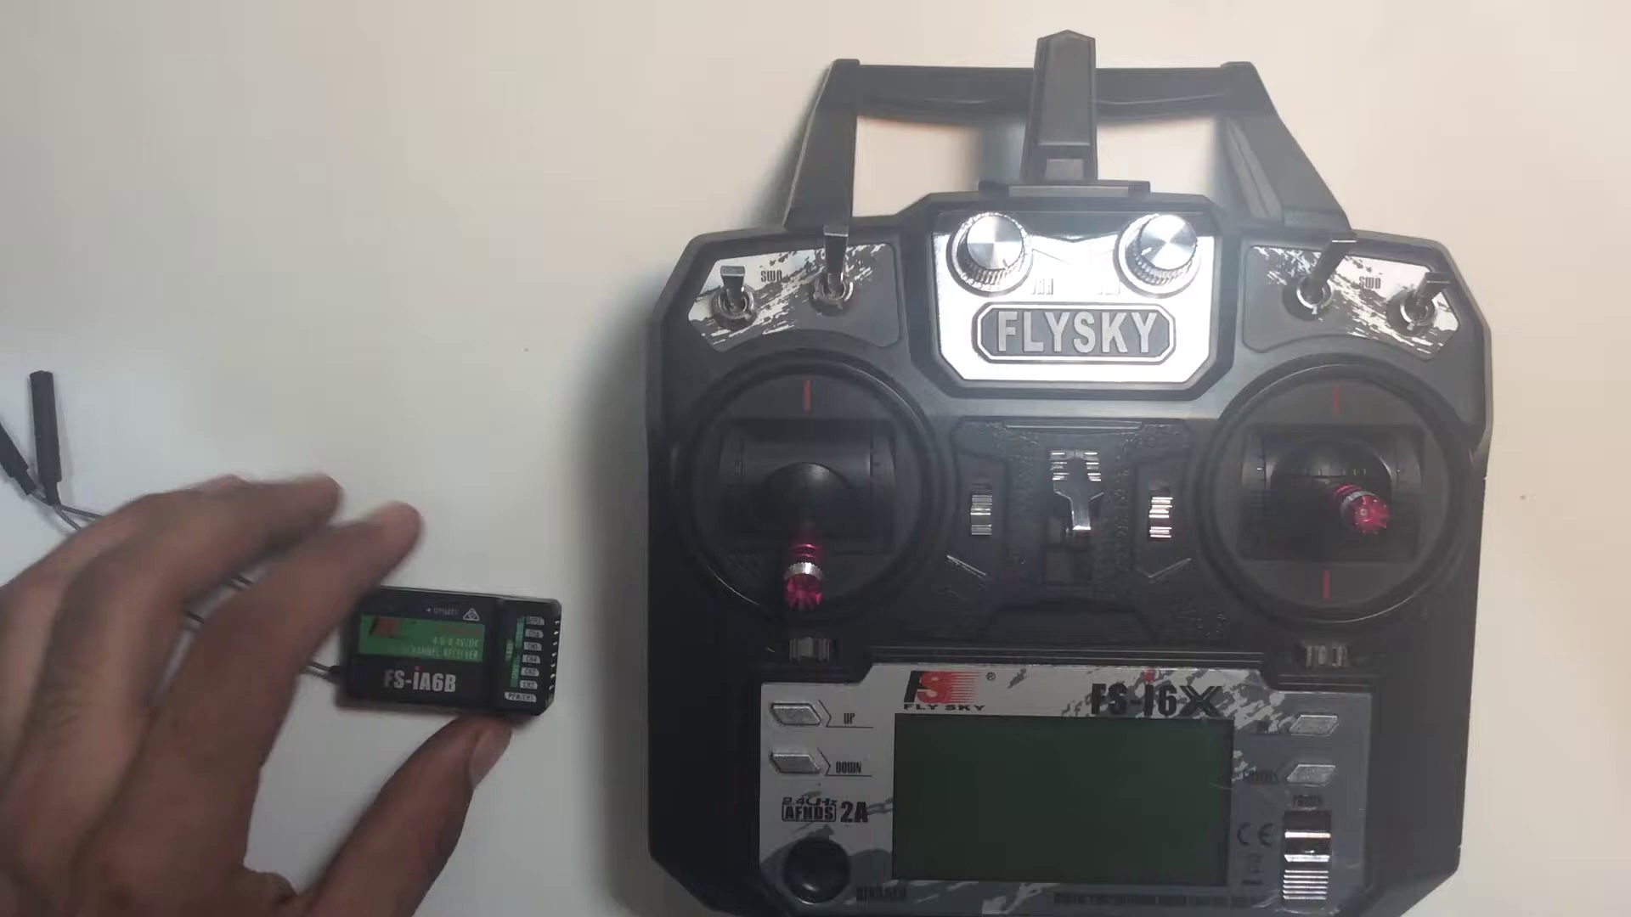 | 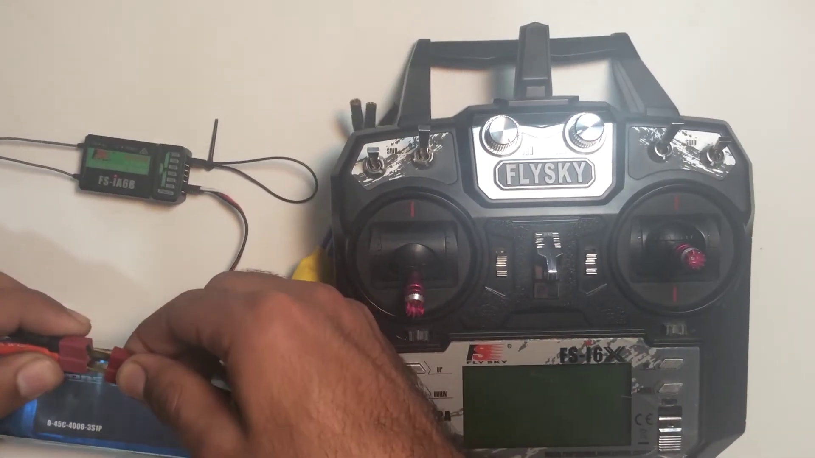 | 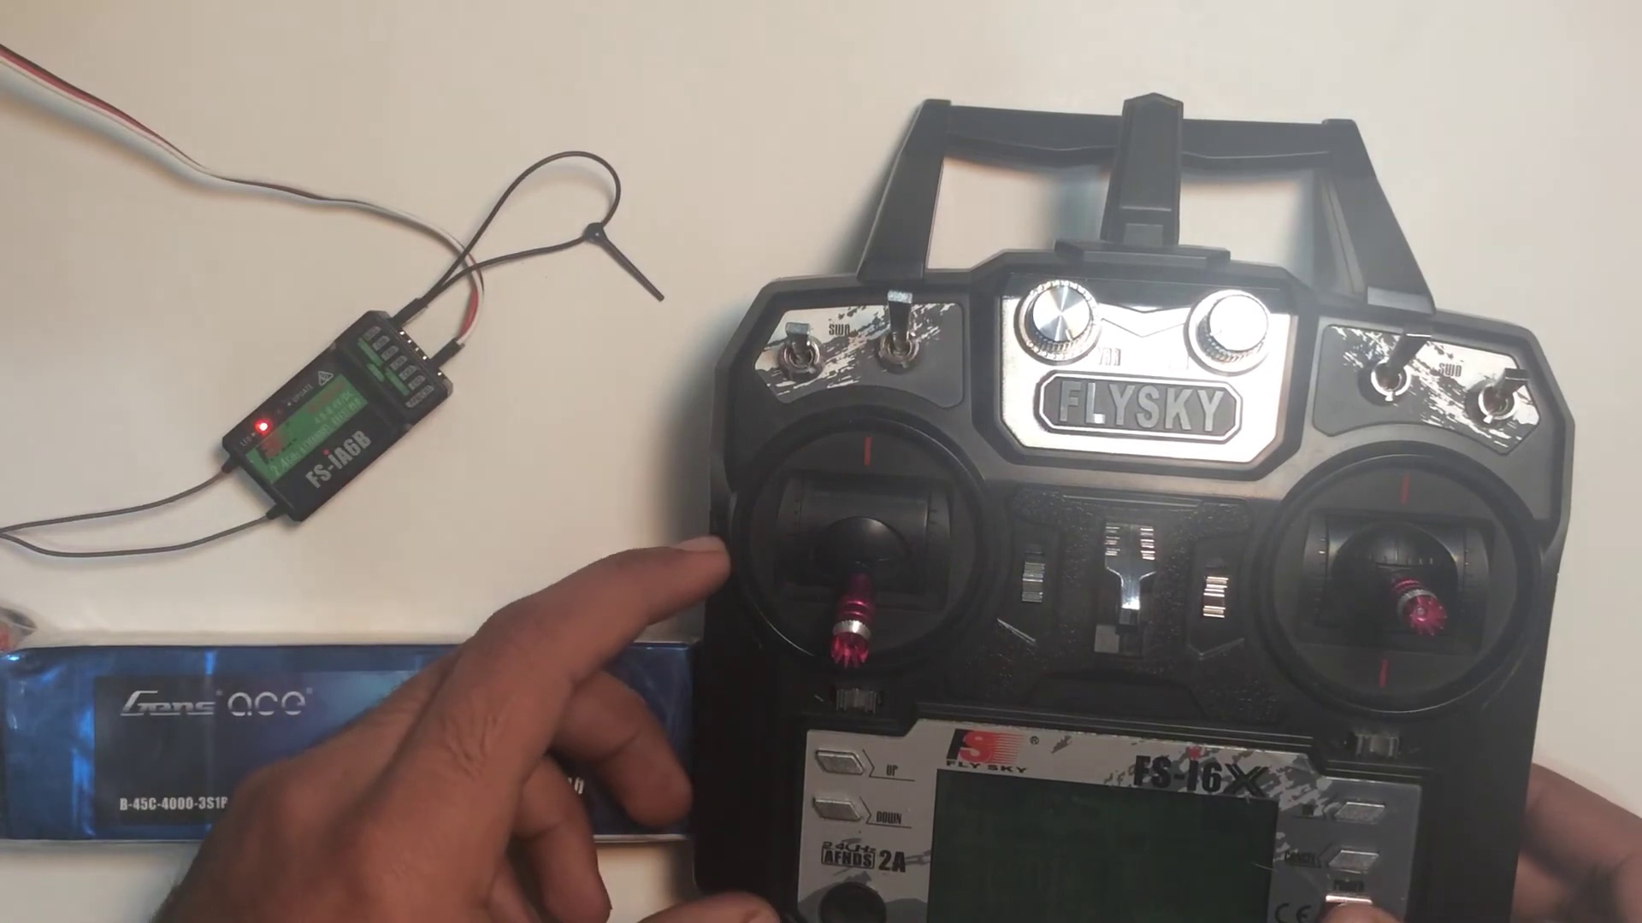
Description: The speaker lists the necessary components required to bind the receiver, including an ESC, battery, and bind key.
Correlated (true): 4 (16.7%)
Score >= 60: 4 (16.7%)
Average Score (of valid matches): 81.25

Top 4 Correlated Comments:
Score: 85
Comment: some times ESC. cannot match. Why. ESC. Amp diff. Need high or low. Match
Reason: The comment discusses the importance of matching ESC settings, which is directly related to the topic's description about the necessary components required for binding, including an ESC. The mention of 'Amp diff' and 'high or low' also shows a clear connection to the topic.
Source: https://www.youtube.com/watch?v=3cFSNRG2xfA

Score: 80
Comment: My receiver is binding with the transmitter. It is showing "Rx binding" and it stays the same no matter what i do.how to solve?
Reason: The comment directly mentions the receiver and transmitter binding process, which aligns with the topic's focus on components needed for binding. Although it doesn't explicitly mention specific components like ESC or bind key, the context is strongly related to the topic.
Source: https://www.youtube.com/watch?v=3cFSNRG2xfA

Score: 80
Comment: Thank you for your video! Quick question mate, I bind receiver Flysky FS-iA10B (R1) which came with Flysky transmitter and works fine. I would like to bind another Flysky FS-iA10B receiver (R2) to same Flysky transmitter. Only one receiver will be operating at any given time. I would like to perform testing debugging without having to disconnect/remove receiver (R1) mounted on Arduino ROBOT. Cheers mate!
Reason: The comment directly discusses the same components (Flysky FS-iA10B receiver and transmitter) mentioned in the topic, specifically binding multiple receivers to the same transmitter, which is relevant to the 'Components Needed for Binding' topic.
Source: https://www.youtube.com/watch?v=3cFSNRG2xfA

Score: 80
Comment: Perfect video. Watched a few. This is right to the direct info
Reason: The comment mentions 'direct info', which strongly suggests that the viewer is referencing the specific components listed in the topic description (ESC, battery, and bind key), indicating a high degree of correlation with the topic.
Source: https://www.youtube.com/watch?v=3cFSNRG2xfA

Topic T3: Plugging in Components
 |  | 
Description: The speaker explains how to plug in the components, including the bind key into the receiver and the BEC wire from the ESC.
Correlated (true): 5 (20.8%)
Score >= 60: 5 (20.8%)
Average Score (of valid matches): 80.00

Top 5 Correlated Comments:
Score: 90
Comment: Perfect video. Watched a few. This is right to the direct info
Reason: The comment directly references the video's content ('right to the direct info'), indicating a strong correlation with the topic 'Plugging in Components', specifically mentioning plugging in components and binding key into receiver.
Source: https://www.youtube.com/watch?v=3cFSNRG2xfA

Score: 80
Comment: My receiver is binding with the transmitter. It is showing "Rx binding" and it stays the same no matter what i do.how to solve?
Reason: The comment directly discusses the same component (receiver) and binding process mentioned in the topic title and description.
Source: https://www.youtube.com/watch?v=3cFSNRG2xfA

Score: 80
Comment: Thank you for your video! Quick question mate, I bind receiver Flysky FS-iA10B (R1) which came with Flysky transmitter and works fine. I would like to bind another Flysky FS-iA10B receiver (R2) to same Flysky transmitter. Only one receiver will be operating at any given time. I would like to perform testing debugging without having to disconnect/remove receiver (R1) mounted on Arduino ROBOT. Cheers mate!
Reason: The comment directly discusses binding a receiver (Flysky FS-iA10B) to a transmitter, which is the same process described in the topic 'Plugging in Components', specifically plugging in the bind key into the receiver and the BEC wire from the ESC.
Source: https://www.youtube.com/watch?v=3cFSNRG2xfA

Score: 80
Comment: some times ESC. cannot match. Why. ESC. Amp diff. Need high or low. Match
Reason: The comment mentions ESC and Amp diff, which are directly related to the topic description's discussion of the ESC and BEC wire. The mention of 'matching' also aligns with the topic's focus on plugging in components.
Source: https://www.youtube.com/watch?v=3cFSNRG2xfA

Score: 70
Comment: the receiver, or the radio??
Reason: The comment mentions the receiver, which is a key component plugged in according to the topic. The ambiguity about whether it's the radio or receiver adds some uncertainty to the correlation.
Source: https://www.youtube.com/watch?v=3cFSNRG2xfA

Topic T1: Binding FSIA6B Receiver to Transmitter
 |  | 
Description: The speaker explains how to bind the FSIA6B receiver to a transmitter, including the necessary components and steps.
Correlated (true): 3 (12.5%)
Score >= 60: 3 (12.5%)
Average Score (of valid matches): 80.00

Top 3 Correlated Comments:
Score: 80
Comment: Thank you for your video! Quick question mate, I bind receiver Flysky FS-iA10B (R1) which came with Flysky transmitter and works fine. I would like to bind another Flysky FS-iA10B receiver (R2) to same Flysky transmitter. Only one receiver will be operating at any given time. I would like to perform testing debugging without having to disconnect/remove receiver (R1) mounted on Arduino ROBOT. Cheers mate!
Reason: The comment discusses binding a Flysky receiver to a transmitter, which is directly related to the topic of binding an FSIA6B receiver to a transmitter. The specific model numbers and scenario (binding multiple receivers to one transmitter) also show strong correlation.
Source: https://www.youtube.com/watch?v=3cFSNRG2xfA

Score: 80
Comment: Perfect video. Watched a few. This is right to the direct info
Reason: The comment directly mentions 'direct info', which is a clear reference to the specific steps and information provided in the topic about binding an FSIA6B receiver to a transmitter.
Source: https://www.youtube.com/watch?v=3cFSNRG2xfA

Score: 80
Comment: some times ESC. cannot match. Why. ESC. Amp diff. Need high or low. Match
Reason: The comment mentions ESC and Amp diff., which are directly related to the topic of binding a receiver (FSIA6B) to a transmitter. The commenter is discussing potential issues with matching, which is a crucial step in the process described by the topic.
Source: https://www.youtube.com/watch?v=3cFSNRG2xfA

