Comment–Topic Correlation Report
Model: llama3

Summary
Topics processed: 3
Comments available for this video: 863
Comments with correlated=True: 106 (12.3%)
Comments with score >= 60: 106 (12.3%)
Total candidate pairs checked: 600
----------------------------------------

Topic T3: Class D-Amp Power and Music Playback
 | 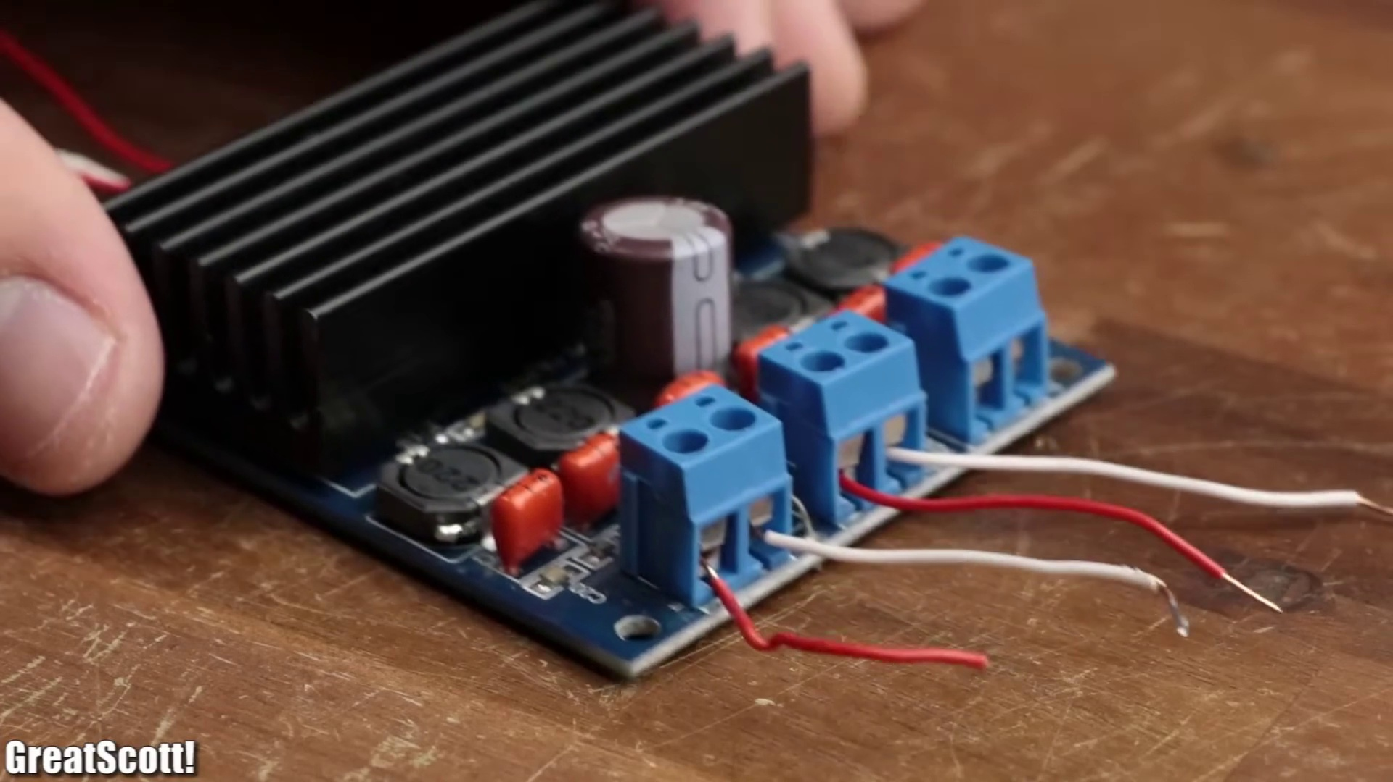 | 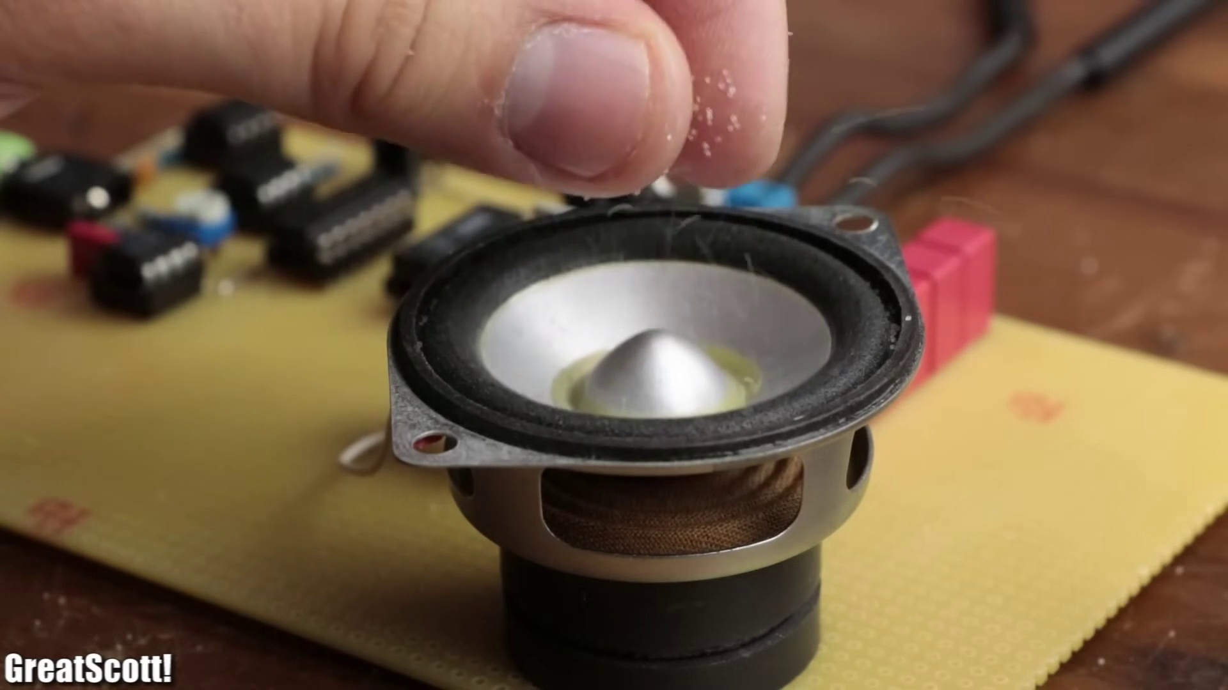
Description: The class D amplifier's power capabilities and music playback features.
Correlated (true): 85 (9.8%)
Score >= 60: 85 (9.8%)
Average Score (of valid matches): 80.76

Top 5 Correlated Comments:
Score: 90
Comment: Could you explain how class D amp circuit works?
Reason: The comment directly asks about the internal workings of a class D amp, which is closely related to its power capabilities and music playback features mentioned in the topic description.
Source: https://www.youtube.com/watch?v=3dQjIeYoIdM

Score: 90
Comment: I've been looking to make a class D amp but don't know where to start. I need 300w at 2 ohms for two channels for mids/bass, and I need a separate one for 50w at 4 ohms for two channels for my tweeters. I've tried finding schematics, but the ones I've found are messy and confusing to follow. Any suggestions?
Reason: The comment directly discusses the same power and playback features mentioned in the topic, specifically mentioning the need for a class D amp with certain specifications (300w at 2 ohms, separate channel for tweeters) and expressing frustration with existing schematics, which aligns with the topic's focus on the class D amplifier's capabilities.
Source: https://www.youtube.com/watch?v=3dQjIeYoIdM

Score: 90
Comment: I made my own filterless class D amplifier just with Arduino. No filter, just plug in the speaker directly to the I/O pin then it works. It still requires biasing circuit and preamp. The key is the direct modification of PWM registry and some brute computation.
Reason: The comment directly discusses the same topic of Class D amplifiers and music playback features, mentioning specific details such as 'filterless' and 'PWM registry modification', which are highly relevant to the topic.
Source: https://www.youtube.com/watch?v=3dQjIeYoIdM

Score: 90
Comment: Can a class D amp be used as a driver for a sine wave inverter?
Reason: The comment directly discusses the class D amp, which is a key aspect of the topic. The mention of 'driver' and 'sine wave inverter' shows an understanding of the topic's description regarding power capabilities.
Source: https://www.youtube.com/watch?v=3dQjIeYoIdM

Score: 90
Comment: Maximum output power of this amp?
Reason: The comment directly asks about the maximum output power, which is a specific parameter discussed in the topic description (power capabilities). The comment shows strong correlation with the topic.
Source: https://www.youtube.com/watch?v=3dQjIeYoIdM

Topic T1: Audio Input Modulation
 |  | 
Description: The process of modulating an audio signal to drive a class D amplifier.
Correlated (true): 32 (3.7%)
Score >= 60: 32 (3.7%)
Average Score (of valid matches): 80.31

Top 5 Correlated Comments:
Score: 90
Comment: For me to make a class D amplifier that has 12 Mhz on the 2 digital pins (which is the frequency of USB 2.0 type C) to play MP3 songs I need how many mH in the inductor and how many uF in the capacitor?
Reason: The comment discusses modulating an audio signal to drive a class D amplifier (as described in the topic), and specifically asks for values of inductor and capacitor, which are parameters relevant to the process of modulation mentioned in the topic.
Source: https://www.youtube.com/watch?v=3dQjIeYoIdM

Score: 80
Comment: Practical class d amps do not use open loop pwm. They use self oscillating closed loop modulation that create a variable frequency pwm. Latest gen class d operate at around 750kHz av frequency.
Reason: The comment directly discusses the modulation process of a class D amplifier, mentioning specific types (self oscillating closed loop) and frequencies (750kHz), which are all related to the topic's description of modulating an audio signal.
Source: https://www.youtube.com/watch?v=3dQjIeYoIdM

Score: 80
Comment: I made my own filterless class D amplifier just with Arduino. No filter, just plug in the speaker directly to the I/O pin then it works. It still requires biasing circuit and preamp. The key is the direct modification of PWM registry and some brute computation.
Reason: The comment mentions a class D amplifier, which is a key concept in the topic's description. Additionally, the mention of PWM registry and direct modification hints at the modulation aspect discussed in the topic.
Source: https://www.youtube.com/watch?v=3dQjIeYoIdM

Score: 80
Comment: Scott please a FM Transmiter from a source of audio
Reason: The comment mentions 'audio' and requests a FM transmitter, which is directly related to the topic of modulating an audio signal for driving a class D amplifier.
Source: https://www.youtube.com/watch?v=3dQjIeYoIdM

Score: 80
Comment: Is it ok to say, that the LM386 is directly driving the speaker ? Lm386 has 1w capability.
And the comparator inputs are limited to a few nanoamps.
So even with a higher voltage or amperage, it will still send approximately the same RMS signal.
Is the speaker running on LM386 feedback ? (and its a class ab amp, not a discrete op-amp)
Reason: The comment discusses the LM386, its capabilities (1W), and limitations (comparator inputs), which are directly related to the topic of audio input modulation. The mention of speaker running on LM386 feedback also shows understanding of the modulated signal being used as an input.
Source: https://www.youtube.com/watch?v=3dQjIeYoIdM

Topic T2: Class D Amplifier Circuit
 |  | 
Description: The class D amplifier circuit design and testing process.
Correlated (true): 57 (6.6%)
Score >= 60: 57 (6.6%)
Average Score (of valid matches): 80.26

Top 5 Correlated Comments:
Score: 90
Comment: How to make a 20w class d audio amp
Reason: The comment directly discusses the same topic of 'Class D Amplifier Circuit', specifically mentioning a 20w class d audio amp, which is an implementation detail matching the description.
Source: https://www.youtube.com/watch?v=3dQjIeYoIdM

Score: 90
Comment: Why would class D require any negative feedback? It's literally supposed to be non linear. It's a switch. There isn't anything to feed back
Reason: The comment directly discusses the design and testing process of a Class D amplifier circuit, specifically questioning the need for negative feedback in its non-linear operation.
Source: https://www.youtube.com/watch?v=3dQjIeYoIdM

Score: 90
Comment: I have followed this video to build a class D amp. There's some thing you should know if you also want to follow this video.
:thanksdoc: the 1nf capacitor at 555 timer is used to convert square wave into triangle wave. In my case 1nf is to small to fully convert the square wave, you should hook up a oscilloscope and swap a few different capacitor until you see triangle wave.
:thanksdoc: R3 (2k ohm) is used to control the frequency at which 555 timer oscillate. I'm not using TLC555, instead I use NE555, in which case the frequency is only 2k Hz if I use 2k ohm resistor for R3. To solve this, you simply replace R3 with a 10k potentiometer, and see what resistance is required to get 200k Hz.
:thanksdoc: I added a 1000uF capacitor in series with the speaker as a coupling capacitor to block the dc at output stage.
Any way, thank you @GreatScott! for making all the awesome videos about electrical stuff. It helped me a lot.:face-red-heart-shape: Keep on
Reason: The comment directly discusses the class D amplifier circuit design and testing process, referencing specific components (1nf capacitor, R3, NE555) and settings (frequency control, coupling capacitor), indicating a strong correlation with the topic.
Source: https://www.youtube.com/watch?v=3dQjIeYoIdM

Score: 90
Comment: So... you don't have a 1uF capacitor laying around somewhere???? Gawd, I've got hundreds! Typical 1st layer IC decoupling cap... And why did you not wind your own inductor if you did not have the value? Got copper wire? Got a #2 pencil?? 40KHz is WAY too high of a value for a speaker that will barely put out 10Khz. I am just wanting to warn the peeps that might scale your schematic UP to a higher wattage... :-O Yes, you cannot "hear" 40Khz, but it can certainly cause your speaker coils to heat up (causing failure). Locally, we had a church that kept blowing high wattage compression diaphragms. Yes, you are not expecting ROCK CONCERT levels at most churches... It was found that a signal at a much higher frequency was on the line (heterodyning radio signals). An inductor installed at the horn cured it! At a nightclub it was determined that high freqs from a distorted "hi-hat" (cymbal) was blowing the horns out! Yes, what you CAN'T hear CAN hurt you! Remember, with a simple LC filter, you are calculating the -3dB cutoff point. The response will be -3dB down at that point - and only a curve of -12dB per octave above that. So, at 80Khz (4 octaves above human hearing) you will only be down 15dB! If your Fc was 20Khz (with a 2nd order filter) you would be down to -27dB! With a 10Khz cutoff (which would be "barely" noticeable to 90% of the population) you would be down to -39dB!!! Your tweeter would be totally protected at that point! :-) AND, a totally useless waste of money to use silver clad copper wire in the actual circuit. Silver is the best conductor on the planet BUT only 6% better than copper. SO, with all other things being equal (i.e not getting into the boring equations) say that the resistance of a same gauge copper wire vs a silver wire - at 100 feet. Well, copper (being the baseline) would be at maybe 6 ohms (remember ARBITRARY number - don't flame me over this...). The silver wire would be still around 0 ohms (or tenths - or hundredth's of an ohm) BUT in your circuit, we are talking about fractions of an inch - not a hundred feet! PLUS, this is the high impedance part of your circuit! Silver vs. copper vs. steel vs. aluminium wire would not matter at all (except for maybe their solderability). (BTW aluminum can not be soldered - easily). Remembner, what are the leads of your OTHER components made out of??? On the output side (low impedance - 4 ohm speaker) , if you were running a wire more than 50 feet, silver "might" make a slight difference... but this all gets back to that "audiophiles hear with their eyes" kind of a thing...
Reason: The comment discusses the same parameters and settings described in the topic, specifically the class D amplifier circuit design and testing process. The commenter references decoupling caps, inductors, and speaker coils, which are all mentioned in the topic description.
Source: https://www.youtube.com/watch?v=3dQjIeYoIdM

Score: 85
Comment: So, IF you ended up adding in the simple LM386 amplifying circuit from the data sheet, how does it compare, this circuit with the MosFETs AND the LM386 circuit, to just the LM386 circuit?? I’ll build one to find out, as I have about five or so of those LM396 amps already soldered on pcb laying around my gear. I’ll need to look out for the specific op amp that you’ve used. Also, how come only a single, positive DC power supply? Is it because of the way you’ve wired the FETs, or perhaps incorporated some output from the amp to create a feedback loop to the opamp’s inverting stage? I’ll check out your circuit, and Thank You for sharing this. I’m fond of your videos, and also your penmanship!!
Oh yeah, and where do you live, where you’d write the numeral ‘1’ to look a little more like an upside down ‘v’, and yet you write from left to right!!?? I know of no such place on this planet where this is the custom.
Reason: The comment directly discusses the design and testing process of the class D amplifier circuit (steps), mentions specific components (MosFETs, LM386, op amp), and asks questions about the circuit's operation (single positive DC power supply, feedback loop)
Source: https://www.youtube.com/watch?v=3dQjIeYoIdM

