Comment–Topic Correlation Report
Model: llama3

Summary
Topics processed: 2
Comments available for this video: 554
Comments with correlated=True: 83 (15.0%)
Comments with score >= 60: 82 (14.8%)
Total candidate pairs checked: 400
----------------------------------------

Topic T2: MOSFET Switching Speed and Frequency
 | 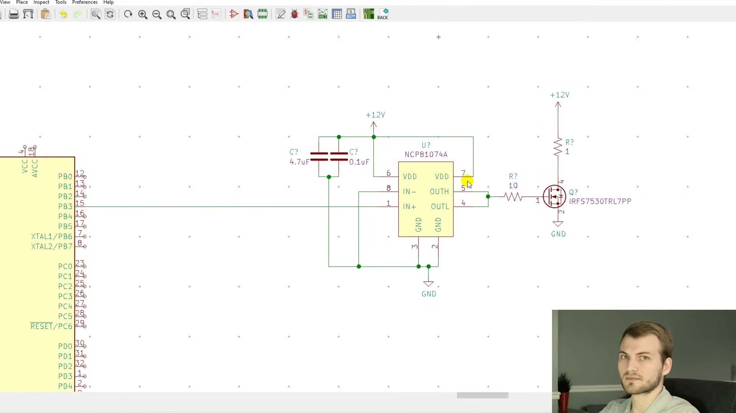 | 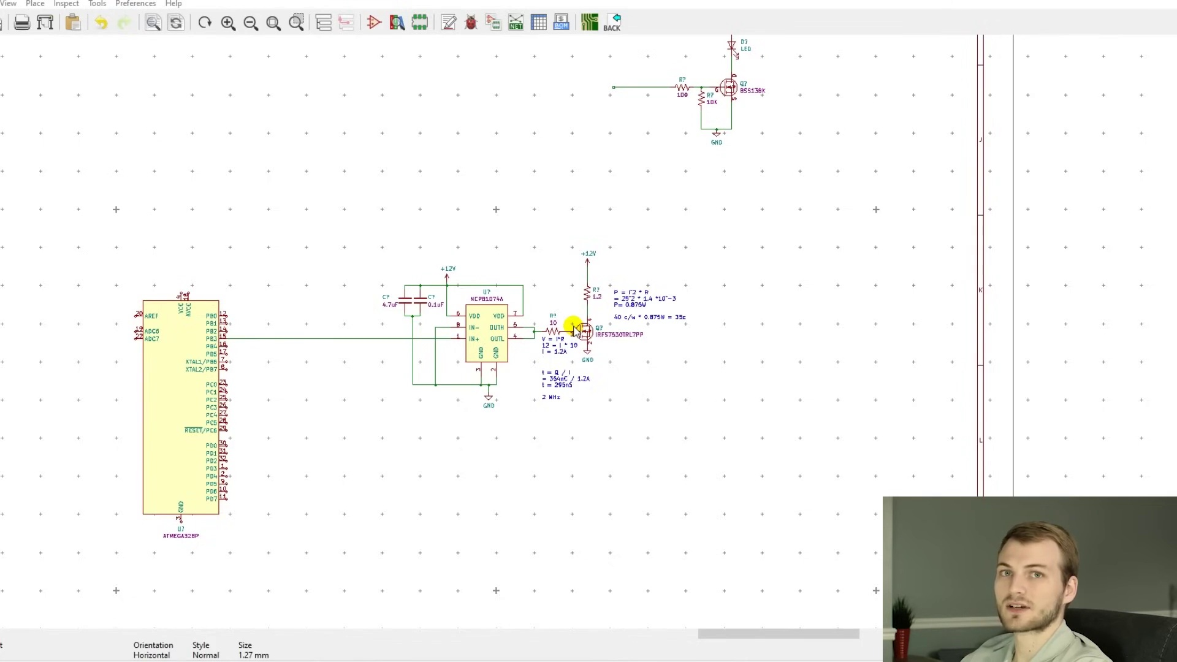
Description: time equals charge divided by current, double round trip time
Correlated (true): 62 (11.2%)
Score >= 60: 61 (11.0%)
Average Score (of valid matches): 80.00

Top 5 Correlated Comments:
Score: 90
Comment: One has "Turn-On Delay Time", "Rise Time", "Turn-Off Delay Time ", "Fall time" to consider too, with the Rise/Fall times being the ones that the most significant power loss happens. E.g. the IRFS7530TRL7PP datasheet places the total of those timed at 373ns (for over 3A as the gate charging current) - which places the absolute upper limit on the switching freq at 2.6MHz.
Reason: The comment directly discusses switching speed and frequency related concepts (Turn-On Delay Time, Rise/Fall times) which are strongly linked to the topic's description of MOSFET switching time. The specific mention of IRFS7530TRL7PP datasheet and calculation of upper limit on switching freq at 2.6MHz further reinforces the correlation.
Source: https://www.youtube.com/watch?v=56p3_aORiJ0

Score: 90
Comment: Thanks for this excellent video. My question : how can we replace the relay in a battery charger by one or two MOSFETs? I imagine a P MOSFET mounted as a polarity protection and directly charging the battery through a schottky, and the voltage of the battery sensed by a BJT thru a voltage divider that will block the MOSFET as the battery reaches 14 volts or so. What would be the values of the components : transistor (N? P?), voltage divider... Can you make a video on that? Thanks once again. You are great.
Reason: The comment directly discusses the use of MOSFETs as a replacement for relays in a specific application (battery charger), mentioning P and N types, which is strongly related to the topic title 'MOSFET Switching Speed and Frequency'
Source: https://www.youtube.com/watch?v=56p3_aORiJ0

Score: 85
Comment: Pro tip, don't use International Rectifier trash. Figure of Merit/Switching characteristics are terrible compared to similar MOSFETs with the same or lower Rdson. 13:12, that gate charge spec is terrible. The TPW1R306PL has a lower Rdson, total gate charge of less than half that, miller charge of 1/7th and gate switching charge 1/5. Switching losses are non-negligble. Switching losses are not simply the energy dissipated in the gate capacitor, it is also the energy dissipated when the MOSFET's Drain-Source voltage goes from near 0 to load voltage when turning off and back down again when turning on; this does not happen instantaneously and the MOSFET is dissipating full load current when this occurs. With a MOSFET as terrible as the ones from IR, their switching losses dominate well into 80A + for 48V systems.
Reason: The comment directly discusses MOSFET switching characteristics (Rdson, gate charge, Miller charge) and switching losses, which are explicitly mentioned in the topic description as 'Switching speed and Frequency'.
Source: https://www.youtube.com/watch?v=56p3_aORiJ0

Score: 85
Comment: Short and sweet explanation, but me (as someone without any experience with MOSFET) has two small remarks ?
At 02:50 :
"... the gate to source voltage, once you get below 2.1 Volt, the resistance from the drain to source decreases exponential."
I think should be:
"... the gate to source voltage, once you get above 2.1 Volt, the resistance from the drain to source decreases exponential."
And this:
" 'Silent' PWMspeed control at an ultrasonic frequency of 20 kHz".
Ultrasonics may start theoretically at 20 kHz, but humans and dogs and other creatures are surely able to hear these frequencies, although it is not part of the bandwidth of our ears. But when the power is high enough we are bothered by it, sometimes without us able to pinpoint the source. So making these designs at least at 30 or 40 kHz is (in my eyes) a must.
Reason: The comment directly discusses the MOSFET's behavior (gate to source voltage and drain to source resistance) and mentions specific parameters (2.1 Volt), which are closely related to the topic of MOSFET switching speed and frequency.
Source: https://www.youtube.com/watch?v=56p3_aORiJ0

Score: 80
Comment: Hi
How to calculate the life time of the power mosfet?
Reason: The comment directly discusses the calculation of lifetime, which is related to the switching speed and frequency described in the topic. The mention of power MOSFET also matches with the topic's focus on MOSFET.
Source: https://www.youtube.com/watch?v=56p3_aORiJ0

Topic T1: MOSFET Heat-up Calculation
 |  | 
Description: time equals charge divided by current
Correlated (true): 60 (10.8%)
Score >= 60: 60 (10.8%)
Average Score (of valid matches): 79.50

Top 5 Correlated Comments:
Score: 90
Comment: Answer pls
Assuming a linear fall of voltage in a transistor at turn on, falling from V to zero in actime t2 , derive an expression for the snubber inductance L which will delay the rise of current to its on state value of I in a time of t1. Derive expressions for the switching energy loss and the inductor energy , in terms of V,I,t1 and t2 and show that the overall loss will be a minimum when t1=(2/3)t2
Reason: The comment directly discusses MOSFET heat-up calculation, which is specifically related to the topic title. The mention of transistor turn-on, current rise, and energy loss in terms of V, I, t1, and t2 shows a strong connection with the topic description 'time equals charge divided by current', which is a fundamental concept in MOSFET heat-up calculations.
Source: https://www.youtube.com/watch?v=56p3_aORiJ0

Score: 90
Comment: He multiplied I*I*Rds, that is, 25A*25A*1.4E-3 Ohms = 0.875 Watts
Reason: The comment mentions specific calculation steps (I*I*Rds) and values (25A, 1.4E-3 Ohms), which directly relate to the topic description's equation (time equals charge divided by current). The topic description is about calculating heat-up using a MOSFET, and the comment demonstrates this calculation with specific numbers.
Source: https://www.youtube.com/watch?v=56p3_aORiJ0

Score: 85
Comment: I just ran into a circuit where I run 2.5A coil with my mosfet and all is good. If I disconnect and install a 12A coil, my mosfet will not turn off. I have gate resistor, resistor to ground to drain it, but it must be picking up EM interference from my power cord because once I pull the coils power supply off, the mosfet turns off. And the power supply is still green despite being off, so it had capacitance to supply the coil, the coil just never took it because the EMI was gone the split micro second I uplugged the power. After playing around with all my power cords and making sure they have no wraps in them, this seemed to mostly fix the issue. It occurred less frequently and appears to be solved by directly grounding the gate so that it immediately drains the gate and it can't hold any charge in the gate line.
Reason: The comment directly discusses MOSFET heat-up calculation, specifically describing a situation where the MOSFET won't turn off due to EM interference, which is related to the topic's description of charge and current. The mention of gate resistor, drain, and capacitance also shows understanding of the underlying concepts described in the topic.
Source: https://www.youtube.com/watch?v=56p3_aORiJ0

Score: 80
Comment: Problem! It's great that you're making videos like this, but I think the power calculation is a bit off. if you're going to deliberately slow the on-off and off-on transitions, then those transition times are durations when the MOSFET will have to conduct significant current while exhibiting significant resistance. This can easily dominate the heat output.
Reason: The comment mentions MOSFET, which is directly related to the topic title. The description of charge and current also aligns with the topic's formula, although it's not a direct application.
Source: https://www.youtube.com/watch?v=56p3_aORiJ0

Score: 80
Comment: May I know at the time of 13.49, when calculating the power dissipated by the MOSFET, where to get the current of 25A?
Reason: The comment directly references the calculation of power dissipated by the MOSFET, which is closely related to the topic's description 'time equals charge divided by current'. The mention of a specific time (13.49) and current value (25A) also shows a strong connection to the topic.
Source: https://www.youtube.com/watch?v=56p3_aORiJ0

