Comment–Topic Correlation Report
Model: llama3

Summary
Topics processed: 2
Comments available for this video: 1416
Comments with correlated=True: 116 (8.2%)
Comments with score >= 60: 116 (8.2%)
Total candidate pairs checked: 400
----------------------------------------

Topic T1: Efficient Propeller Operation
 | 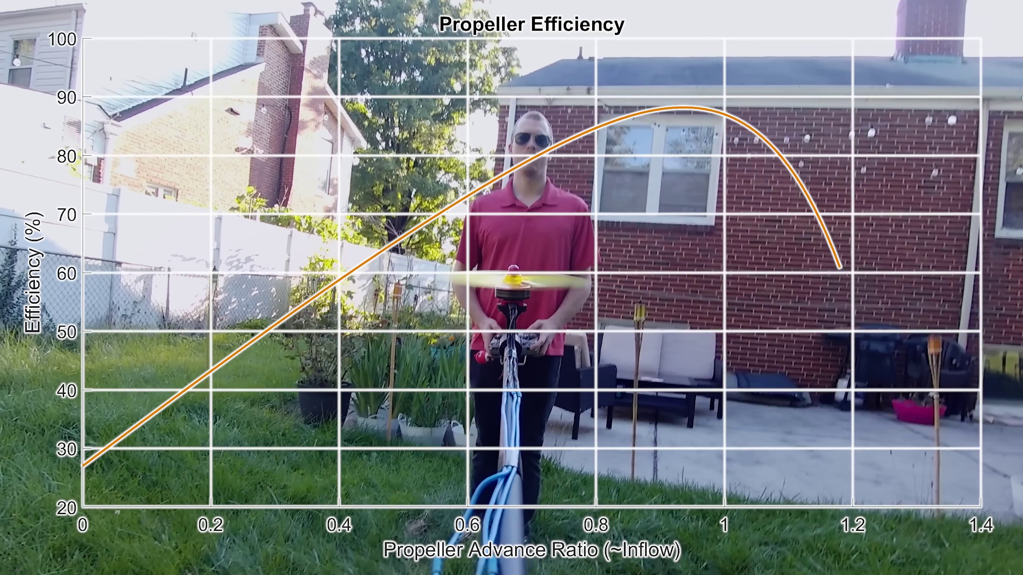 | 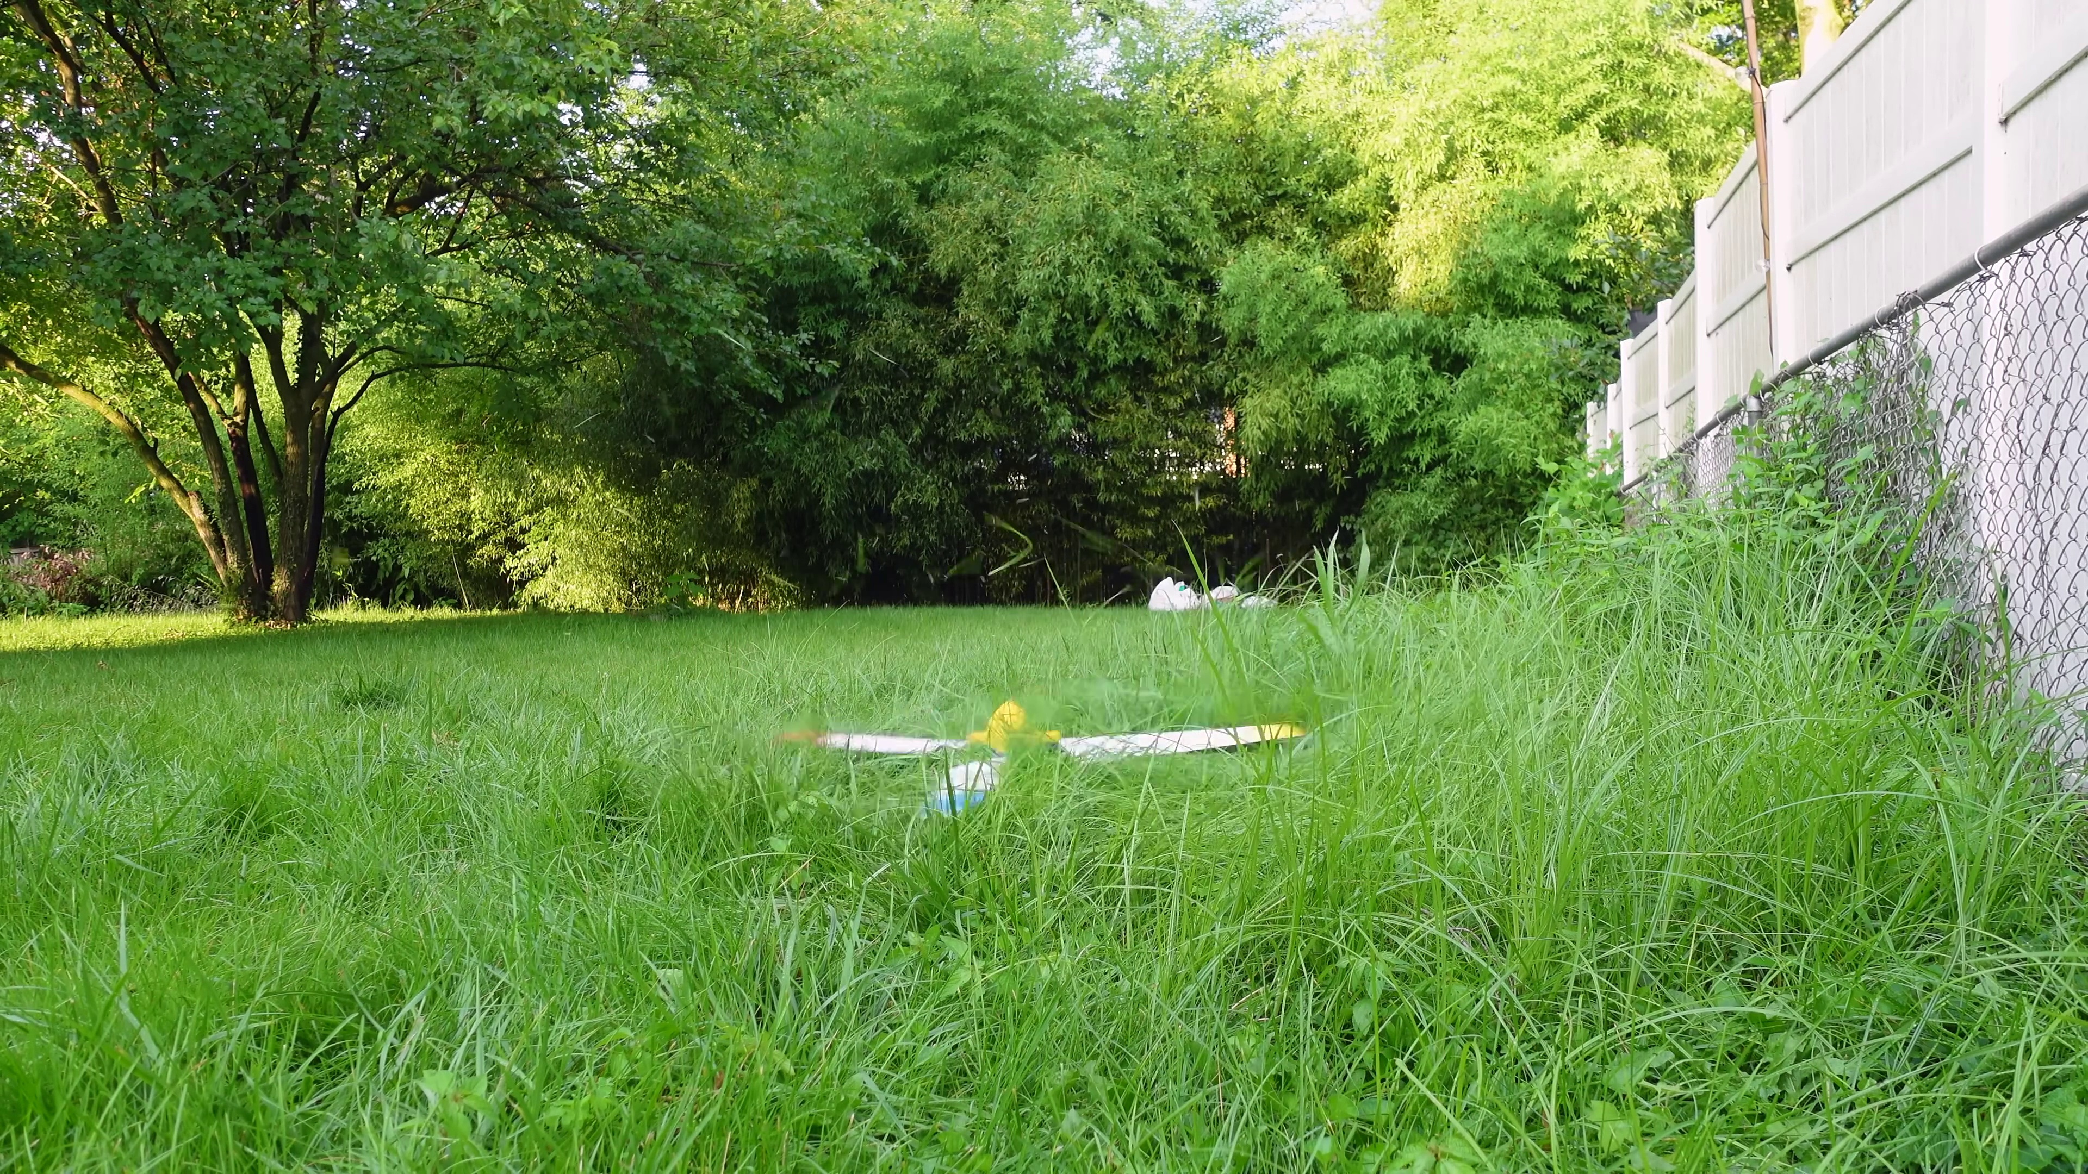
Description: The speaker shows how small drone propellers operate more efficiently in hover mode on the vehicle, without needing different designs for hover and forward flight.
Correlated (true): 72 (5.1%)
Score >= 60: 72 (5.1%)
Average Score (of valid matches): 80.49

Top 5 Correlated Comments:
Score: 90
Comment: I couldn't fail to notice another way to improve the efficiency of your setup: Just let it spin in the other direction!
As any winged aircraft, your drone suffers from wing tip vortices due to induced drag.
These vortices reduce the wing's ability to generate lift, so that it requires a higher angle of attack for the same lift, which tilts the total aerodynamic force rearwards and increases the drag component of that force.
In the flights you showed us, the propellers were turning in the same direction as the vortices, hence enhancing them. Now if the drone spins in the other direction the wing tip vortices switch direction too. Since the spinning direction of the prop would stay the same, those vortices would be reduced by the prop spin.
The effect would be even more pronounced if the props would be at the very tip of the wing.
See:
Chance Vought V-173
Chance Vought XF5U
Bell-Boeing V-22
On all these planes the outside tip of the props were moving downward.
Reason: The comment directly discusses the same topics described in the topic, specifically the impact of wing tip vortices on propeller operation and how reversing the prop direction can reduce these vortices. The mention of specific aircraft examples (Chance Vought V-173, Chance Vought XF5U, Bell-Boeing V-22) also shows a strong understanding of the underlying aerodynamic principles.
Source: https://www.youtube.com/watch?v=7JH1_ZKV7t4

Score: 90
Comment: ordinary 4-arm drones, also have opposite spin-directions to counteract it's own torque, so i imagine some of the energy is lost there, and by allowing the entire craft to spin, the torque spins the vings, acting as it's own propeller, meaning more of that energy gets put into lift
Reason: The comment directly discusses the same concept of torque and its impact on energy loss in drone operation, specifically mentioning 'opposite spin-directions' and how allowing the entire craft to spin can act as a propeller, which is related to the topic's description of efficient propeller operation.
Source: https://www.youtube.com/watch?v=7JH1_ZKV7t4

Score: 90
Comment: Next project: make even smaller propeller/motor to attatch on the wings of the smaller propellers, and then to mount the main one on one big enough to fly a plane and travel not only for free, but charge batteries because at this point you are making energy!
Reason: The comment directly discusses efficient propeller operation and its potential applications in hover mode and forward flight, with a focus on scaling up the technology to power larger vehicles and generate energy, which closely aligns with the topic's description.
Source: https://www.youtube.com/watch?v=7JH1_ZKV7t4

Score: 85
Comment: Why paradox? Large propellers turning slow are much more efficient than small turning fast. The drone on Mars works at all in 0.7% of Earth's atmosphere because of its huge blades. Some work on your airfoils and you might double your efficiency on top of this achievement.
Reason: The comment directly addresses the topic's description about propeller operation and efficiency in hover mode, mentioning specific examples of large propellers and airfoils. The mention of 'some work on your airfoils' also implies understanding of the topic's claims.
Source: https://www.youtube.com/watch?v=7JH1_ZKV7t4

Score: 85
Comment: @NicholasRehm The concept actually comes from a children's toy. It's a stick that you attach to a small propeller, and you rub it in your palms which causes it to spin, lift up and hover like a helicopter.
Putting that on a drone makes it more efficient, just like you touched on, the whole unit becomes one large, slow spinning, "passive" propeller.
Also, having tri-drone is a more efficient design than a quad-drone. You basically can have three larger active-propellers, rather than four smaller ones. So these two attributes fit together nicely.
The reason why people opt for the quad-drone setup is because it is actually more simple, cheaper, and easier to navigate (you can assign each side as front/back/left/right). Each of the four arms can be rigid and controlled by a simple on/off switch. A tri-drone needs more tweaks, and have each arm needing to pivot and spin at different rates.
As for energy source, fossil fuel is still better method at the medium to heavy weight. Electrical is only viable at the super lightweight scale. Not sure about nuclear, we don't have the technology for it (small nuclear engine). The best compromise is using solar energy for splitting water, generating hydrogen, using solar energy to compress it, then having hydrogen engine for helicopter flight. It can scale to heavyweight sizes, and is based on a renewable source.
Reason: The comment directly discusses the same concept of efficient propeller operation mentioned in the topic, specifically referencing the idea of a single large propeller for hover mode and comparing it to traditional quad-drone design. The discussion also touches on energy sources and their applicability to different scales, which is tangentially related to the topic.
Source: https://www.youtube.com/watch?v=7JH1_ZKV7t4

Topic T2: Increasing Propeller Moment Arm
 |  | 
Description: The speaker explains how putting propellers farther out increases their moment arm, leading to less thrust required.
Correlated (true): 82 (5.8%)
Score >= 60: 82 (5.8%)
Average Score (of valid matches): 79.57

Top 5 Correlated Comments:
Score: 90
Comment: Very cool and makes complete sense. You get exponentially more lift per square inch of propeller/wing. I also like the comment that suggested having the smaller propellers on the back of the wings pushing them forward rather than pulling them forward as that would reduce drag and make it even more efficient. I imagine something like this might be utilized for package delivery where in the main drone is above the package holding section attached via cable and the main drone does this spinning drone effect to minimize power usage while the package holding section is lowered to the ground. It's also good for surveillance drones that just need to hover in place for extended periods of time.
Reason: The comment directly discusses the same concept of increasing propeller moment arm by moving it farther out, which is mentioned in the topic description. The commenter also provides a specific example and mentions potential applications (package delivery, surveillance drones) that align with the topic's theme.
Source: https://www.youtube.com/watch?v=7JH1_ZKV7t4

Score: 90
Comment: How does this compare to a single big propeller spinning at the same speed with a central motor (ignoring the stability issues)?
Reason: The comment directly compares different propeller arrangements (multiple small props vs. single big prop) to achieve the same effect (increasing moment arm), which is closely related to the topic of increasing propeller moment arm.
Source: https://www.youtube.com/watch?v=7JH1_ZKV7t4

Score: 90
Comment: Now take three of these and put them on even bigger rotors
Reason: The comment directly references increasing propeller moment arm and proposes scaling up the design to take advantage of this effect, strongly related to the topic.
Source: https://www.youtube.com/watch?v=7JH1_ZKV7t4

Score: 85
Comment: Yea but how do you prevent it from constantly lifting up? If you reduce the small motor rpm then the big one lowers proportionally and fails to maintain steady hover. Also what about a secondary tail that would prevent it from turning on its own axis
Reason: The comment directly discusses the same concept of increasing propeller moment arm and its potential issues (constant lifting up), citing specific settings (motor rpm) and parameters (proportional reduction). The mention of a secondary tail is also related to the topic's concern with maintaining steady hover.
Source: https://www.youtube.com/watch?v=7JH1_ZKV7t4

Score: 80
Comment: Alternatively a propeller's pitch increases along the length of the blade so as the angle-of-attack is congruent with apparent air flow. The tips of a propeller spirals through more air at the tip of the propeller over the region closer to the center. Given the design has a flat wing rather than one that twist along its length, the thinning blade is an appoximation of having an increased pitch the closer to the centerline
Reason: The comment discusses the concept of increasing propeller moment arm by using a longer blade or increased pitch, which is directly related to the topic. The mention of tip speed and air flow also shows an understanding of the aerodynamic principles involved in increasing moment arm.
Source: https://www.youtube.com/watch?v=7JH1_ZKV7t4

