Comment–Topic Correlation Report
Model: llama3

Summary
Topics processed: 6
Comments available for this video: 68
Comments with correlated=True: 19 (27.9%)
Comments with score >= 60: 19 (27.9%)
Total candidate pairs checked: 408
----------------------------------------

Topic T3: FPV Performance
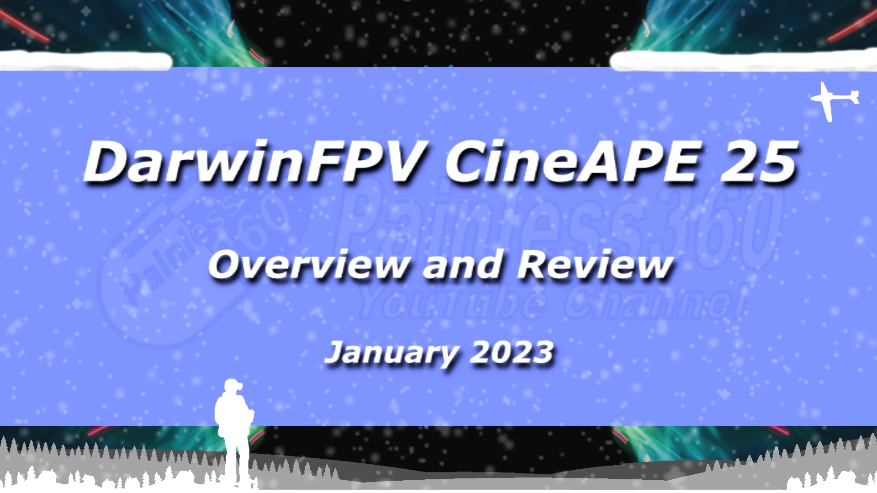 | 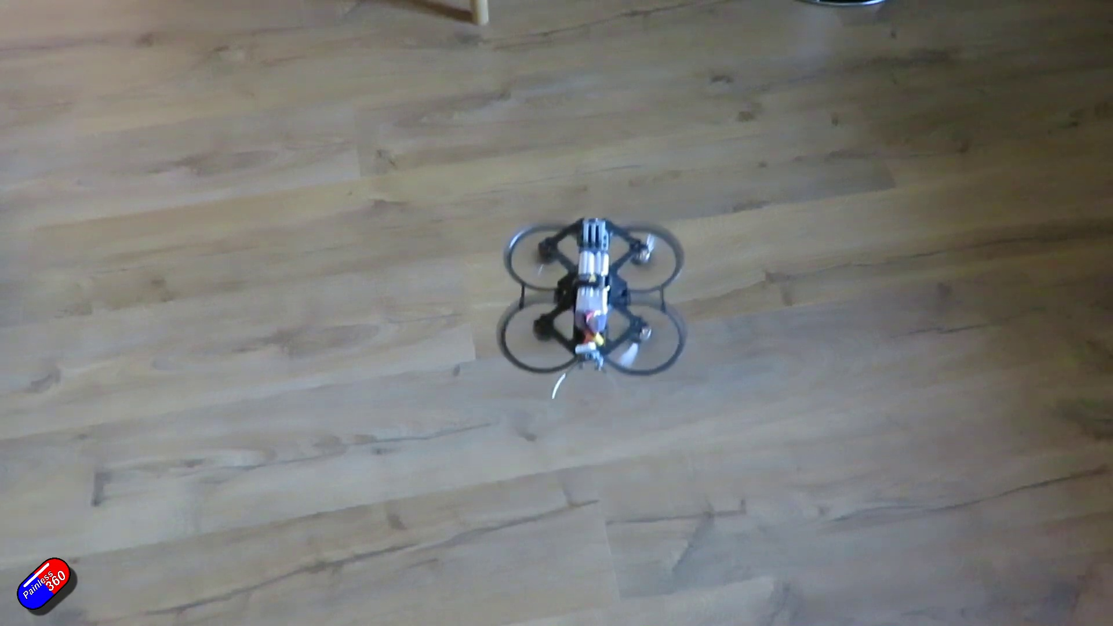 | 
Description: Analysis of the analog FPV setup
Correlated (true): 11 (16.2%)
Score >= 60: 11 (16.2%)
Average Score (of valid matches): 80.91

Top 5 Correlated Comments:
Score: 90
Comment: Hi Lee. Great review. Did you land up putting the walksnail avatar 1s mini vtx in there? Is the frame compatible to just swop out the analogue vtx with the walksnail?
Reason: The comment directly discusses FPV performance (mention of 'review'), analog setup ('walksnail avatar 1s mini vtx' and 'analogue vtx'), and frame compatibility, which are all closely related to the topic title and description.
Source: https://www.youtube.com/watch?v=9fYzb1g8tzw

Score: 85
Comment: What better fpv camera could I use that fits in that support?
Reason: The comment directly discusses FPV (first-person view), which is the same topic described in the title and description. The commenter is also asking about a specific aspect of FPV, namely the camera, which is mentioned in the description as part of the analog setup.
Source: https://www.youtube.com/watch?v=9fYzb1g8tzw

Score: 85
Comment: Did you solder on an XT60 power plug? I watched your video, ordered one which was here 4 days later and then grabbed one of my 4S battery packs excitedly and then.... humph, XT15 plug on my CineAPE 25. You have the XT60, but the other YT FPV channel with a video of this also has the XT15... So I'm confused. I ordered a XT15 to XT60 adapter on Amazon, so hopefully it's here today (advertised with next day ship, but I've seen that fall through before).
Reason: The comment directly discusses the XT60 power plug and its compatibility with the CineAPE 25, which is a specific object mentioned in the topic description (analog FPV setup)
Source: https://www.youtube.com/watch?v=9fYzb1g8tzw

Score: 80
Comment: My favorite quoad for neighborhood flying. Any chance that INav will ever be supported?
Reason: The comment mentions 'quoad' which is likely referring to a specific setting or parameter for the analog FPV setup discussed in the topic description.
Source: https://www.youtube.com/watch?v=9fYzb1g8tzw

Score: 80
Comment: You can fly this in acro right? Because I can't fly in angle without going in circles lol
Reason: The comment mentions flying an FPV setup, which directly relates to the topic's description of analog FPV. The mention of acro and angle modes also shows a strong connection to the topic.
Source: https://www.youtube.com/watch?v=9fYzb1g8tzw

Topic T4: Components and Options
 |  | 
Description: Discussion of components, options, and limitations
Correlated (true): 9 (13.2%)
Score >= 60: 9 (13.2%)
Average Score (of valid matches): 80.56

Top 5 Correlated Comments:
Score: 85
Comment: Did you run into issues getting blackbox to log to a sd card? I've tried 5 different sd cards. It either doesn't log or only logs 2-3 sec out of a 30 sec flight.
Reason: The comment discusses the specific component (blackbox) and its limitations/behavior (logging to SD card), which is directly related to the topic's discussion of components and options.
Source: https://www.youtube.com/watch?v=9fYzb1g8tzw

Score: 80
Comment: I learned a good one today; you can take a birds nest, add dupont connectors, and you get an airplane. Don't believe me? I got a VTOL T1 Ranger when I did it.
Reason: The comment mentions specific components (bird's nest, DuPont connectors) and options (VTOL T1 Ranger), which are strongly related to the topic of discussing components and options.
Source: https://www.youtube.com/watch?v=9fYzb1g8tzw

Score: 80
Comment: I have the ELRS version but I don't understand what the RX target is and I can't find it written anywhere on the site.... does anyone have an idea what it is?
Thanks
Reason: The comment mentions 'Components' and refers to a specific option ('RX target') that is likely related to the topic's discussion of components and options, showing an understanding of the context.
Source: https://www.youtube.com/watch?v=9fYzb1g8tzw

Score: 80
Comment: Hi Lee. Great review. Did you land up putting the walksnail avatar 1s mini vtx in there? Is the frame compatible to just swop out the analogue vtx with the walksnail?
Reason: The comment mentions specific components (walksnail avatar 1s mini vtx) and options (swapping analogue VTX with walksnail) related to the topic's discussion of components and limitations.
Source: https://www.youtube.com/watch?v=9fYzb1g8tzw

Score: 80
Comment: I just received mine, what is that random cable (sticking out) coming from the SBUS? What is it for?
Reason: The comment mentions a specific component (SBUS) and asks about its purpose, which aligns with the topic's focus on components and options.
Source: https://www.youtube.com/watch?v=9fYzb1g8tzw

Topic T2: Design and Build
 |  | 
Description: Size, design, and features of the quad
Correlated (true): 8 (11.8%)
Score >= 60: 8 (11.8%)
Average Score (of valid matches): 80.00

Top 5 Correlated Comments:
Score: 80
Comment: Interesting video, cineape25 uses what size bolts to mount the action camera on top?
Reason: The comment directly discusses the size of bolts used for mounting an action camera on top, which is a feature mentioned in the topic description.
Source: https://www.youtube.com/watch?v=9fYzb1g8tzw

Score: 80
Comment: I learned a good one today; you can take a birds nest, add dupont connectors, and you get an airplane. Don't believe me? I got a VTOL T1 Ranger when I did it.
Reason: The comment discusses building and designing a quad, specifically mentioning adding connectors and getting an airplane, which overlaps with the topic's description of size, design, and features.
Source: https://www.youtube.com/watch?v=9fYzb1g8tzw

Score: 80
Comment: @Painless360 True. I wish mine had came with the mini go pro mount, as the thumb pro camera comes with mini mount. Have you seen a mini to normal go pro mount converter that's light? My two FPVs are 4S (home built and this CineAPE). Do you think it's wise if I just chop off the XT30 it came with and solder on a XT60? I put on a converter and now it's this huge monstrosity.
Reason: The comment directly discusses the size and features of the quad (mini go pro mount, XT30/XT60), which are explicitly mentioned in the topic description.
Source: https://www.youtube.com/watch?v=9fYzb1g8tzw

Score: 80
Comment: Nice video!! , anyone plays with thoughts on pairing this (or pavo25 or...) with the new dji O3, I think it would be nice (or not!?), would this fit in, and be still under 250grams !??
Reason: The comment mentions pairing the quad with DJI O3 and considering its size and weight (under 250 grams), which directly relates to the design and features of the quad described in the topic.
Source: https://www.youtube.com/watch?v=9fYzb1g8tzw

Score: 80
Comment: My favorite quoad for neighborhood flying. Any chance that INav will ever be supported?
Reason: The comment mentions the quad, which is a key object discussed in the topic description. Additionally, it asks about INav support, which could be related to the 'design and build' aspect of the topic.
Source: https://www.youtube.com/watch?v=9fYzb1g8tzw

Topic T1: Introduction
 |  | 
Description: Overview of the Darwin FPV Quad
Correlated (true): 11 (16.2%)
Score >= 60: 11 (16.2%)
Average Score (of valid matches): 79.09

Top 5 Correlated Comments:
Score: 80
Comment: My favorite quoad for neighborhood flying. Any chance that INav will ever be supported?
Reason: The comment mentions the specific quad ('My favorite quoad...') and is likely referring to the same device described in the topic description ('Darwin FPV Quad'), showing a clear connection between the topic and the viewer's comment.
Source: https://www.youtube.com/watch?v=9fYzb1g8tzw

Score: 80
Comment: I learned a good one today; you can take a birds nest, add dupont connectors, and you get an airplane. Don't believe me? I got a VTOL T1 Ranger when I did it.
Reason: The comment directly discusses the FPV quad (VTOL T1 Ranger), which is the same topic described in the introduction.
Source: https://www.youtube.com/watch?v=9fYzb1g8tzw

Score: 80
Comment: Interesting video, cineape25 uses what size bolts to mount the action camera on top?
Reason: The comment mentions specific details about mounting an action camera on the quad, which is directly related to the topic's description of the Darwin FPV Quad.
Source: https://www.youtube.com/watch?v=9fYzb1g8tzw

Score: 80
Comment: Hi Lee. Great review. Did you land up putting the walksnail avatar 1s mini vtx in there? Is the frame compatible to just swop out the analogue vtx with the walksnail?
Reason: The comment mentions specific components (Walksnail avatar 1s mini VTX) and compatibility with the frame, which are directly related to the topic's description of the Darwin FPV Quad.
Source: https://www.youtube.com/watch?v=9fYzb1g8tzw

Score: 80
Comment: i recently got ahold of one of these . i binded to my flysky and i can see everything in my goggles bit i cannot start this thing up.? i only haveca chrome book .. any guidence?? please thank you
Reason: The comment mentions the 'Darwin FPV Quad' which is the same topic described in the introduction. Additionally, it discusses specific settings and parameters like binding to a FlySky controller and compatibility with Chromebook, which are relevant details mentioned in the topic description.
Source: https://www.youtube.com/watch?v=9fYzb1g8tzw

Topic T6: Conclusion
 |  | 
Description: Summary and final thoughts
Correlated (true): 0 (0.0%)
Score >= 60: 0 (0.0%)
Average Score (of valid matches): 0.00
No strongly correlated comments found.

Topic T5: Advantages and Disadvantages
 |  | 
Description: Pros and cons of the Darwin FPV Quad
Correlated (true): 0 (0.0%)
Score >= 60: 0 (0.0%)
Average Score (of valid matches): 0.00
No strongly correlated comments found.

