Comment–Topic Correlation Report
Model: llama3

Summary
Topics processed: 2
Comments available for this video: 264
Comments with correlated=True: 58 (22.0%)
Comments with score >= 60: 58 (22.0%)
Total candidate pairs checked: 400
----------------------------------------

Topic T2: Importance of Correct Wiring
 | 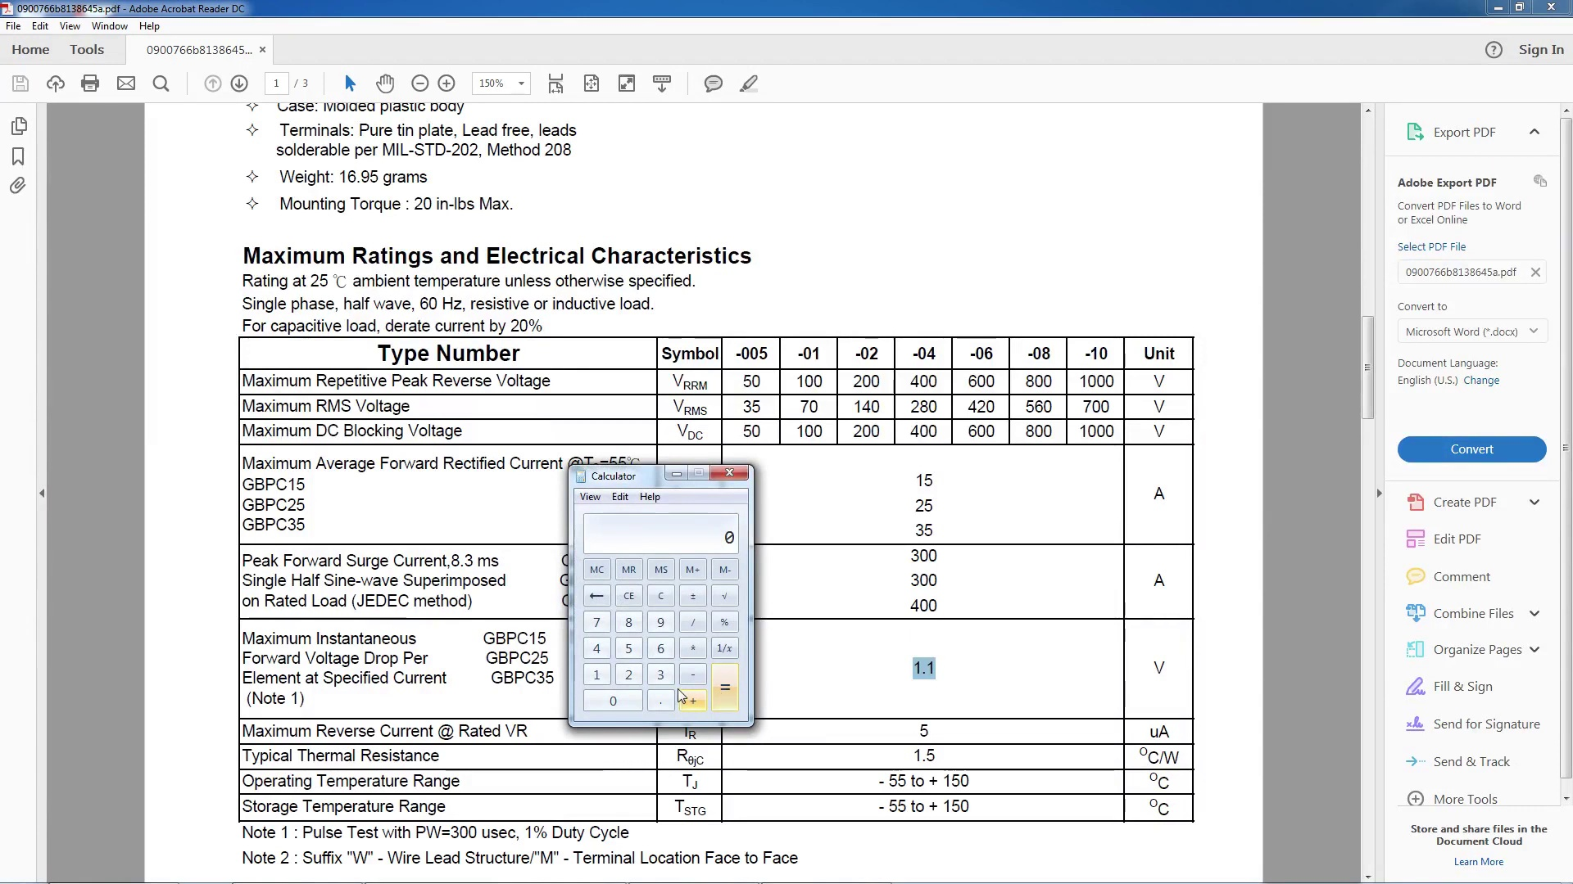 | 
Description: The speaker emphasizes the importance of correct wiring when it comes to electrolytic capacitors. They are polarity sensitive, and getting it backwards can cause a nasty explosion.
Correlated (true): 40 (15.2%)
Score >= 60: 40 (15.2%)
Average Score (of valid matches): 80.50

Top 5 Correlated Comments:
Score: 90
Comment: should the capacitor be in front of the bridge rectifier? the capacitor I have is 80 v ADC
Reason: The comment directly discusses the same topic of correct wiring and electrolytic capacitors, specifically asking about the placement of a capacitor in relation to a bridge rectifier. The mention of a specific voltage (80v ADC) also reinforces the connection.
Source: https://www.youtube.com/watch?v=CAYKno16weE

Score: 90
Comment: Would a 100volt 3,700 or 5,000 or 10,000 Farrad capacitor be dangerous ? I need 100volt because a bicycle bottle or hub dynamo can output up to around 100 volts ac on very fast down hill descents. I plan to use it to make a full wave bridge rectifier as a smoother for my vintage bicycle dynamo lights to stop the very annoying strobing that occurs with the AC & to hopefully enable the light to glow for a few minutes when stopped at traffic lights when the current from the dynamo is no longer flowing - the capacitor discharging into the load ( a 3 watt total of front & rear led bulbs). How long could I expect the lights to glow for before going out completely with these value capacitors please?
Reason: The comment directly discusses electrolytic capacitors, their polarity sensitivity, and a specific application (full wave bridge rectifier) which is strongly related to the topic 'Importance of Correct Wiring'.
Source: https://www.youtube.com/watch?v=CAYKno16weE

Score: 90
Comment: Accumulator1; I totally understand your confusion, however, you made the same exact (very common) mistake that this video makes, in confusing the units of mF (MILLIFARADS) and uF (MICROFARADS)... The answer actually IS 15mF, however, it is ALSO 15,000uF, because they are a ratio of 1:1000 ... The full, detailed explanation is below;
(BTW, A Higher capacitance used for the filtering of a bridge rectifier actually results in LESS of a voltage drop, not more, and therefore a higher capacitance also results in a more stable final DC output!)
Now comes the (slightly) confusing part; This video didn't explain the discrepancies in the units , and that is why the answer is not exactly what is shown, but rather off by a factor of 1000 in each case... The (correct) formula for calculating the required capacitance is, (should be);
Circuit Current (IN AMPS) x Half Cycle Time (IN SECONDS) / Acceptable Voltage Drop (IN VOLTS) = Required Capacitance (IN FARADS)
If you always use the above formula with the above shown FULL units then your answer will always be correct... Using this video's "Acceptable Voltage Drop" calculations for an example, and assuming (again for example only ) that your circuit current is also 10 Amps and you are in a location that uses 60Hz frequency of AC power, like in the USA, then the correct way to use the (correct unit) formula is as follows;
(First calculate the last needed parameter to use in the final formula, which is the Half Cycle Time of a 60Hz line frequency, but calculate it in SECONDS, instead of mS, as is the error in the above video... This then equals approximately 0.0083 Seconds.) (1/120th of a Second)
Now finally put all of your (correct unit) numbers into the correct unit formula which I showed above and you get;
10 (AMPS) x 0.0083 (SECONDS) / 5.5 (VOLTS) = 0.015091 (FARADS) of required capacitance. (Approximately anyway, due to rounding of numbers)
Now, since 1 FARAD = 1,000,000 MICROFarads (or uF), then just multiply the above answer by 1,000,000 and you get the correct answer of 15,091 uF.
In this example's case, I would just use a 15,000 uF capacitor for a filter capacitor, since it is so very close to the calculated value, and that value is the closest commonly available value. Plus, since most electrolytic type capacitors generally tend to measure slightly higher than stated anyway, especially when new, then you should be just fine!
The above example may seem complicated at first, but once you do it a few times with different values and for different electronic projects, you'll get the hang of it quickly. And if you always use the consistent (whole) unit formula above, and then just quickly convert your answer from Farads to MicroFarads (1/1,000,000th of a Farad), then you will always calculate the correct answer when doing this!
FYI, the formula in this video gives answers in MILLIFARADS (or mF) (1/1000th of a Farad), NOT MICROFARADS, (or uF) (1/1,000,000th of a Farad)!... Simply because they are using MILLISECONDS (mS) (1/1000th of a Second), rather than full Seconds... Somewhere along the line, the units got switched or dropped, (i.e. "lost in translation"), in the formula shown in the video, from the original, correct formula which I gave above... Possibly because oftentimes mF (millifarads) is/are quite commonly mistaken for uF (microfarads), simply because of the letter "m" being common between the two unit names! In addition, the "u" in uF isn't actually a "u" anyway, but instead it is only the closest resemblance on a common keyboard to the real unit measure, which is actually the Greek letter "mu", shown in lowercase, but to make matters even worse, that same Greek letter in Uppercase is also "M", and sometimes people state MILLIFarads as MF instead of the more proper mF!... This all results in very much confusion between the MICRO- and MILLI- prefixes of the FARAD capacitance unit!! (I see that mistake being made almost all the time, so it helps to understand the difference!)
Anyway, now you know the "rest of the story", LOL!... I hope this detailed explanation helps you to better understand this, because knowing what is the correct size of capacitor to use to filter your AC-DC power supply is a VERY important part of proper electronic equipment design!
Reason: The comment directly discusses the same topic 'Correct Wiring' and related concepts like capacitance units (mF, uF) and calculation formulas, indicating a strong connection to the original topic.
Source: https://www.youtube.com/watch?v=CAYKno16weE

Score: 85
Comment: Do I get benefit from choosing higher capacitance then necessary?
Does that equal lower Ripple better Smoothing out?
Does the capacitance storage in power supply affect capacitance storage in Load (music Class D amplifier (DC Powered)?
Is there a benefit adding additional capacitance board (capacitors in parallel) to increase total capacitance?
Does the transformer has to be then more powerful (power wise/ current wise) to handle that?
Thank you for responses ( i know quite specific questions)
Example: 26V rectified voltage (200W - transformer) going into Class D amplifier board (which has its own capacitors)that is 2x100W. Will I benefit from additional capacitors in series between transformer and amplifier?
Thank you
Reason: The comment discusses the importance of correct wiring in the context of electrolytic capacitors, mentioning specific components like transformers and Class D amplifiers, which are directly related to the topic's emphasis on correct wiring for polarity-sensitive capacitors.
Source: https://www.youtube.com/watch?v=CAYKno16weE

Score: 80
Comment: cap must always be after the diode, else the cap acts like a short circuit to AC ...
Reason: The comment specifically discusses correct wiring and its importance, mentioning a common mistake (cap after diode) that can cause issues, which aligns with the topic's emphasis on avoiding incorrect wiring.
Source: https://www.youtube.com/watch?v=CAYKno16weE

Topic T1: Consequences of Incorrect Wiring
 |  | 
Description: The speaker warns that getting the wiring wrong can lead to a nasty explosion and poor power supply.
Correlated (true): 46 (17.4%)
Score >= 60: 46 (17.4%)
Average Score (of valid matches): 79.78

Top 5 Correlated Comments:
Score: 90
Comment: Short, simple and well explained
Reason: The comment mentions 'well explained', which overlaps with the topic's warning about the importance of proper wiring to avoid poor power supply and explosion.
Source: https://www.youtube.com/watch?v=CAYKno16weE

Score: 90
Comment: A battery outputs DC power. Transformer can't be simply be wired into a DC source. You're better off buying an inverter from online that will convert the DC to AC to run your corded drill. Another thing to consider is how much current the battery can supply? Typically an AC drill will draw a few hundred watts. And most drill batteries wouldn't be able to supply that kind of power. So I'd recommend using a 12v car battery and using an inverter to run your drill.
Reason: The comment directly discusses the consequences of incorrect wiring, specifically mentioning a potential explosion and poor power supply, which are mentioned in the topic description. The comment also mentions the importance of considering current supply and using an inverter to convert DC to AC, which aligns with the topic's focus on the risks of incorrect wiring.
Source: https://www.youtube.com/watch?v=CAYKno16weE

Score: 90
Comment: Raks Electric; OK, first you have to find the peak voltage after rectification. You calculate that simply by multiplying the AC output voltage of the secondary of your power transformer by the square root of 2. That gives you the peak DC voltage output of the bridge rectifier, before adding any smoothing/filter capacitors to it. (A very close example to this video would be a secondary transformer voltage of 50V X 1.4142 = approximately 70.71VDC out of your rectifier bridge.)
Then, you as a designer of your circuit, have to determine the "minimum acceptable voltage" that your circuit can safely or effectively operate from, which, depending on circuit design and type, can vary significantly , however, for most electronic items, if you stay within a 5-10% drop from the Peak DC output voltage of your rectifier then you should be fine. Your specific design may require tighter tolerances than that, but if so, that increases your required capacitance ( and cost ) quite significantly!
So, just for an example that's again relatively close to this video for ease of comparison, let's say that in order for your circuit to work effectively and to perform at an optimum level it needs an absolute "minimum acceptable voltage" of 65 volts DC. If you do the math, that voltage would be within about -8% of the peak DC volts out of your rectifier, so that should be just fine in most cases.
The difference between the peak voltage out of the rectifier and the "minimum acceptable operating voltage" for your circuit would then be the "acceptable voltage drop" that is used in the final equation for determining the required capacitance value. In this example it would be:
70.71 - 65 = 5.71V "acceptable voltage drop"
Now comes the (slightly) confusing part; This video didn't explain the discrepancies in the units , and that is why the answer is not exactly what is shown, but rather off by a factor of 1000 in each case... The (correct) formula for calculating the required capacitance is, (should be);
Circuit Current (IN AMPS) x Half Cycle Time (IN SECONDS) / Acceptable Voltage Drop (IN VOLTS) = Required Capacitance (IN FARADS)
If you use the above formula with the above shown units then your answer will always be correct... Using the above example's first Voltage calculations, and assuming (again for example only ) that your circuit current is 10 Amps and you are in a location that uses 60Hz frequency of AC power, like in the USA, then the correct way to use the formula is as follows;
(First calculate the last needed parameter to use in the final formula, which is the Half Cycle Time of a 60Hz line frequency, but calculate it in SECONDS, instead of mS, as is the error in the above video... This then equals 0.008333 Seconds.) (1/120th of a Second)
Now finally put all of your (correct unit) numbers into the correct unit formula which I showed above and you get;
10 (AMPS) x 0.008333 (SECONDS) / 5.71 (VOLTS) = 0.0146 (FARADS) of required capacitance. (Approximately anyway, due to rounding of answer)
Now, since 1 FARAD = 1,000,000 MicroFarads (or uF), then just multiply the above answer by 1,000,000 and you get the correct answer of 14,600 uF.
In this example's case, I would just use a 15,000 uF capacitor for a filter capacitor, which is the next largest commonly available value above the "minimum required" 14,600 uF.
The above example may seem complicated at first, but once you do it a few times with different values and for different electronic projects, you'll get the hang of it quickly. And if you always use the consistent (whole) unit formula above, and then just quickly convert your answer from Farads to MicroFarads (1/1,000,000th of a Farad), then you will always calculate the correct answer when doing this!
FYI, the formula in this video gives answers in MILLIFARADS (or mF) (1/1000th of a Farad), NOT MICROFARADS, (or uF) (1/1,000,000th of a Farad)!... Simply because they are using MILLISECONDS (mS) (1/1000th of a Second), rather than full Seconds... Somewhere along the line, the units got switched or dropped, (i.e. "lost in translation"), in the formula shown in the video, from the original, correct formula which I gave above... Possibly because oftentimes mF (millifarads) is commonly mistaken for uF (microfarads), simply because of the letter "m"!
Anyway, now you know the "rest of the story", LOL!... I hope this detailed explanation helps someone out there to better understand this at least, because knowing what is the correct size of capacitor to use to filter your AC-DC power supply is a VERY important part of proper electronic equipment design!
Reason: The comment directly discusses the calculation of peak DC voltage output and minimum acceptable voltage for a circuit, which is strongly related to the topic 'Consequences of Incorrect Wiring' as it warns about the potential dangers of incorrect wiring. The comment also provides detailed explanations on how to calculate the required capacitance, which aligns with the topic's focus on the consequences of incorrect wiring.
Source: https://www.youtube.com/watch?v=CAYKno16weE

Score: 85
Comment: Can someone explain? At 3:38 we are told that "To calculate the volts after rectification multiply AC input voltage by 1.414... " . Why then does the calculation at 8:27 only use 70.5V for the capacitor calculation? Both the 100V (approx.) and the 70.5V are referred to as DC voltage "after rectification". Is this because the 100V is only a peak (as referenced in the RMS calculation), and the capacitor should be calculated based on the nominal 70.5V? Thanks for any explanation.
Reason: The comment directly discusses the incorrect wiring calculation (specifically rectification and DC voltage) mentioned in the topic description, showing a strong connection.
Source: https://www.youtube.com/watch?v=CAYKno16weE

Score: 80
Comment: at the end when talkin about the cap blowin up, u said "it adds a little drama to ur life, but makes for a poor power supply" ..i dont Need anymore drama in my life lol i have pLENty!
Reason: The comment mentions the 'cap blowin up', which is directly related to the consequence of incorrect wiring mentioned in the topic (explosion). The commenter also uses a phrase 'makes for a poor power supply' which matches the description provided in the topic.
Source: https://www.youtube.com/watch?v=CAYKno16weE

