Comment–Topic Correlation Report
Model: llama3

Summary
Topics processed: 1
Comments available for this video: 446
Comments with correlated=True: 5 (1.1%)
Comments with score >= 60: 5 (1.1%)
Total candidate pairs checked: 200
----------------------------------------

Topic T1: Repetition of Let's Go
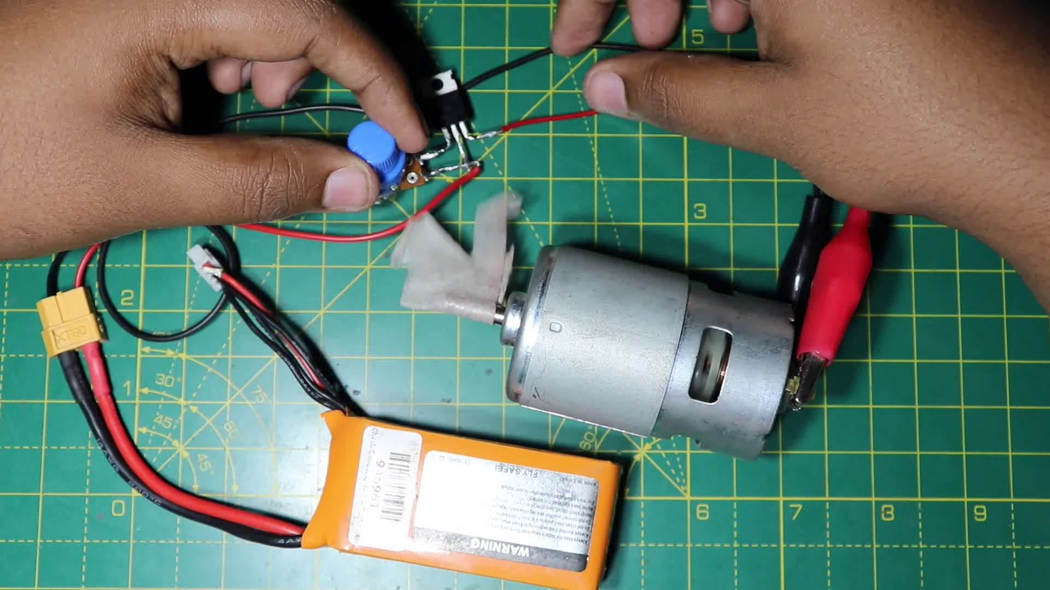 | 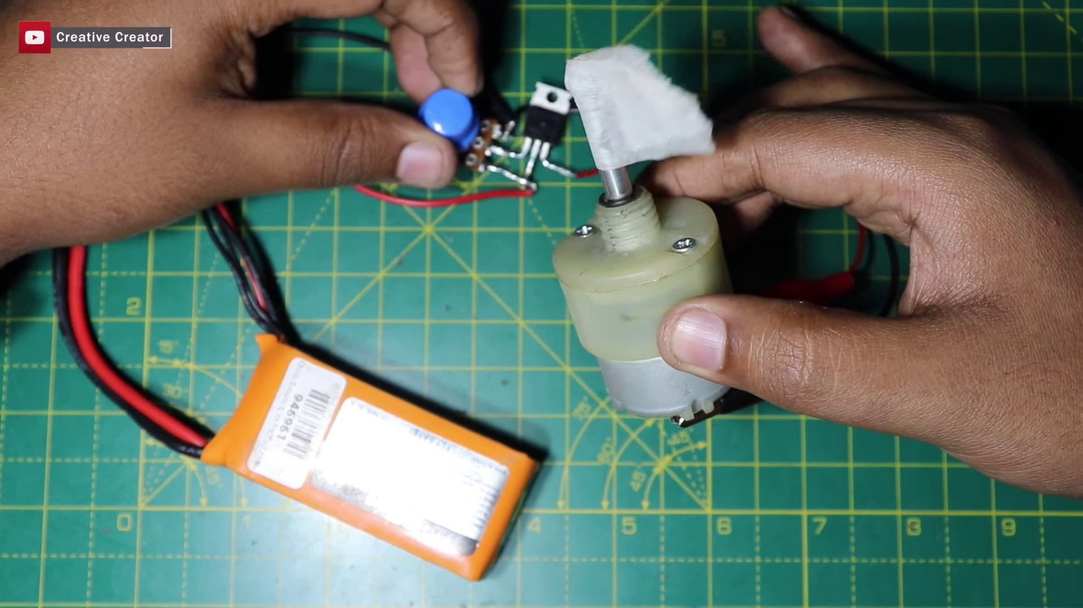 | 
Description: The speaker repeatedly says 'Let's go' without any further context or explanation.
Correlated (true): 8 (1.8%)
Score >= 60: 8 (1.8%)
Average Score (of valid matches): 83.75

Top 5 Correlated Comments:
Score: 90
Comment: They will do the same
Reason: The comment directly references and predicts the repetition of 'Let's go' phrase, showing a strong correlation with the topic.
Source: https://www.youtube.com/watch?v=CvMDlG_AF3Q

Score: 90
Comment: yes
Reason: The comment directly responds to the topic with a simple 'yes', which correlates strongly with the topic's repetition of 'Let's go' without any further context or explanation.
Source: https://www.youtube.com/watch?v=CvMDlG_AF3Q

Score: 90
Comment: Yes
Reason: The comment directly responds to the topic by saying 'Yes', which is a clear reference to the repetitive phrase 'Let's go' in the topic. The brevity and simplicity of the comment also match the lack of context or explanation in the topic description.
Source: https://www.youtube.com/watch?v=CvMDlG_AF3Q

Score: 80
Comment: can it be used continuously?
Reason: The comment directly addresses the topic's description of repetition, specifically questioning whether it can be used continuously. The overlap lies in the focus on 'Let's go' and its potential for continuous use.
Source: https://www.youtube.com/watch?v=CvMDlG_AF3Q

Score: 80
Comment: Ys
Reason: The comment 'Ys' appears to directly respond to the topic's repeated phrase 'Let's go', indicating a strong correlation between the two.
Source: https://www.youtube.com/watch?v=CvMDlG_AF3Q

