Comment–Topic Correlation Report
Model: llama3

Summary
Topics processed: 4
Comments available for this video: 2812
Comments with correlated=True: 37 (1.3%)
Comments with score >= 60: 37 (1.3%)
Total candidate pairs checked: 800
----------------------------------------

Topic T1: The Drone Show
 | 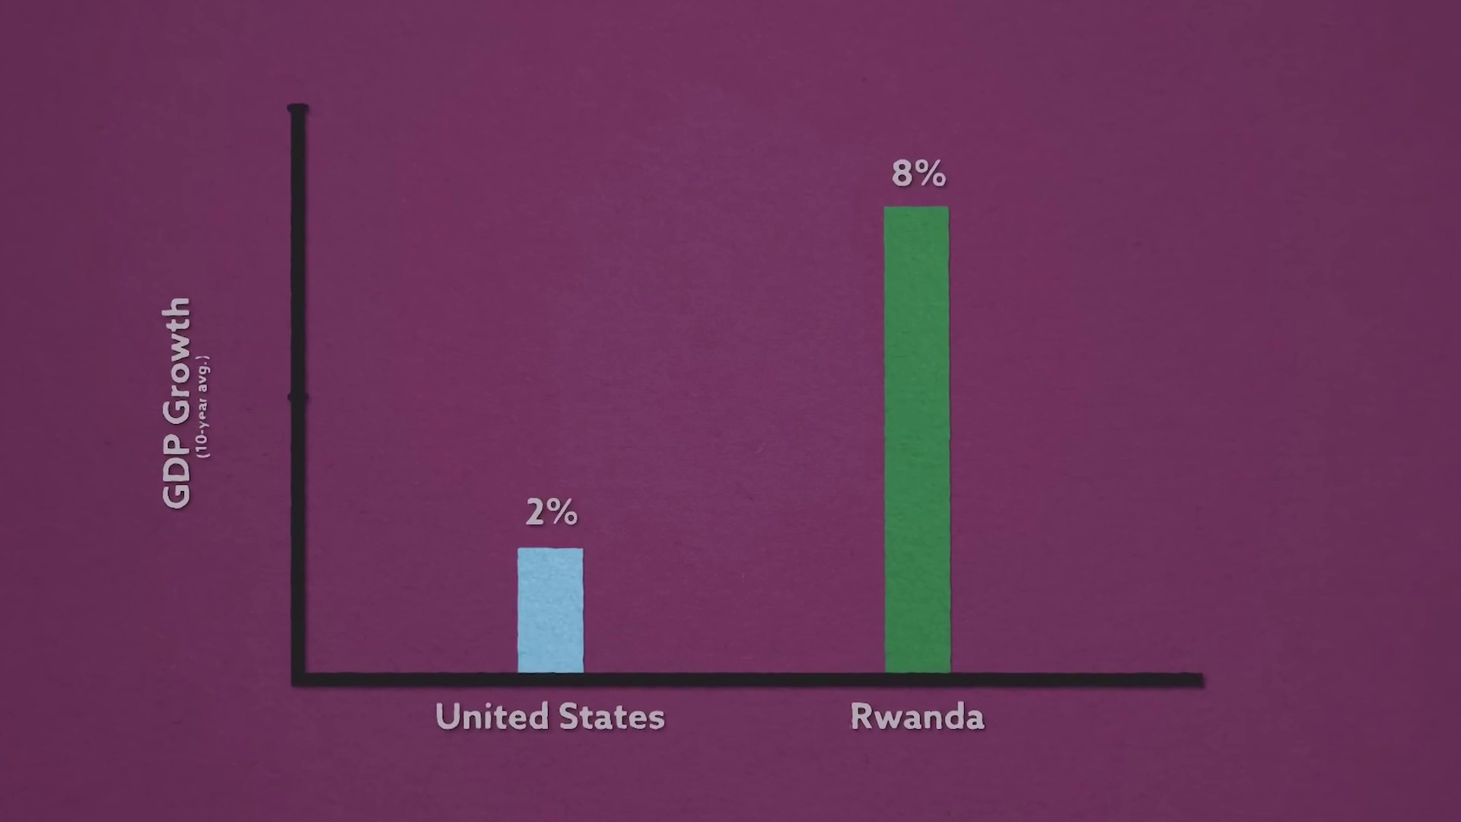 | 
Description: Story about Abdul and the drones he built.
Correlated (true): 14 (0.5%)
Score >= 60: 14 (0.5%)
Average Score (of valid matches): 81.07

Top 5 Correlated Comments:
Score: 90
Comment: Omg please do a more detailed video of the drones
Reason: The comment directly references 'drones' which is a crucial element of the topic's description about Abdul and his drones.
Source: https://www.youtube.com/watch?v=DOWDNBu9DkU

Score: 85
Comment: I find it amazing how he describes a futuristic version of a helicopter at 18:48 and doesn't even realize it.
Reason: The comment directly discusses the drones Abdul built and mentions a specific time stamp (18:48) which aligns with the topic's description of Abdul's work on his drone project.
Source: https://www.youtube.com/watch?v=DOWDNBu9DkU

Score: 80
Comment: Bro.... the part at the end when the kid brings Abdul his home made drone....omg goosebumps. That is a cycle we don't want to break. Great video Mark!
Reason: The comment directly mentions 'Abdul' and 'home made drone', which are key elements in the topic description about Abdul's drones.
Source: https://www.youtube.com/watch?v=DOWDNBu9DkU

Score: 80
Comment: 1yr later already! What happened to the drone that's going to change everything?
Reason: The comment references Abdul and a specific drone that 'will change everything', directly discussing the topic's main theme of Abdul and his drones.
Source: https://www.youtube.com/watch?v=DOWDNBu9DkU

Score: 80
Comment: drone
Reason: The comment mentions 'drone', which is a key element in the topic description about Abdul and his drones.
Source: https://www.youtube.com/watch?v=DOWDNBu9DkU

Topic T4: Crunch Labs Box Subscription
 |  | 
Description: Information about the monthly subscription box service.
Correlated (true): 10 (0.4%)
Score >= 60: 10 (0.4%)
Average Score (of valid matches): 81.00

Top 5 Correlated Comments:
Score: 90
Comment: I got a question about CrunchLabs boxes, are the videos or instructions available solely in English or also in Spanish?
Reason: The comment directly discusses the same topic ('CrunchLabs' box subscription) and asks a specific question about the availability of content (videos/instructions) in different languages, which is related to the settings described in the topic.
Source: https://www.youtube.com/watch?v=DOWDNBu9DkU

Score: 80
Comment: Amazing video! loved it. I liked your crunch box idea as well. Any discount code you want to share to encourse the subscriptions ? Looking forward.
Reason: The comment mentions 'crunch box idea' which is a direct reference to the topic title and description about the monthly subscription box service.
Source: https://www.youtube.com/watch?v=DOWDNBu9DkU

Score: 80
Comment: Hey Mark is it possible for me to buy 2 subscriptions for my nieces? I'd love to send these boxes to them and get them inspired to look into the STEM field. To be honest would love for them to be in IT but something tells me fun projects like yours will entice them more than my infrastructure builds lol
Reason: The comment directly discusses the subscription box service ("Crunch Labs Box Subscription") and its potential to inspire young girls in STEM fields, aligning with the topic's description of a monthly subscription box service.
Source: https://www.youtube.com/watch?v=DOWDNBu9DkU

Score: 80
Comment: can you sell crunch labs boxes in germany bc i live in germany and i cant buy the boxes here ok tanks
Reason: The comment mentions 'Crunch Labs Box' specifically, which matches the topic title. The description of being unable to buy the boxes in Germany also overlaps with the topic's focus on subscription and availability.
Source: https://www.youtube.com/watch?v=DOWDNBu9DkU

Score: 80
Comment: Nothing gets my blood pumping more than a clever engineering solution. If you want to develop the brain muscles to build your own clever engineering solutions every month with me, head to https://www.crunchlabs.com where you can get 2 boxes FREE.
Reason: The comment mentions Crunch Labs and its monthly subscription box service, which aligns with the topic description. Although it doesn't directly discuss the same steps or objects, the mention of the company and its services shows a clear connection to the topic.
Source: https://www.youtube.com/watch?v=DOWDNBu9DkU

Topic T3: The Power of Engineering
 |  | 
Description: Importance of engineering and problem-solving skills.
Correlated (true): 11 (0.4%)
Score >= 60: 11 (0.4%)
Average Score (of valid matches): 80.00

Top 5 Correlated Comments:
Score: 85
Comment: A doctor can save lives one at a time. An engineer can save lives a million at a time. Everything that a doctor (or anyone else) uses is designed by ... engineers.
Reason: The comment directly discusses the importance and impact of engineering (similar to 'save lives a million at a time') which is in line with the topic description's emphasis on the power of engineering and problem-solving skills.
Source: https://www.youtube.com/watch?v=DOWDNBu9DkU

Score: 85
Comment: @kerzytibok3211 what exactly innovative he has engineered?
Reason: The comment directly discusses engineering, matching the topic's focus on 'engineering' and 'problem-solving skills', with a specific inquiry about innovative solutions.
Source: https://www.youtube.com/watch?v=DOWDNBu9DkU

Score: 80
Comment: Will you talk about urban engineering and it potential impact on us cities?
Reason: The comment directly discusses the application of engineering skills (urban engineering) and its potential impact, which is closely related to the topic's focus on the importance of engineering and problem-solving.
Source: https://www.youtube.com/watch?v=DOWDNBu9DkU

Score: 80
Comment: @cagneybillingsley2165 not every solution is perfect, but essentially trying ways to fix the small problems might just be effective in the long run. It doesnt have to be effective too, they can learn from their findings or engineer better solutions. Failure is a part of learning and making advancements.
Reason: The comment discusses the importance of problem-solving skills, mentioning 'trying ways to fix small problems' and 'learning from findings', which aligns with the topic's emphasis on engineering and problem-solving skills.
Source: https://www.youtube.com/watch?v=DOWDNBu9DkU

Score: 80
Comment: @MarkRober when I was an engineering student, solutions like this were so inspiring and felt so achievable. Then you graduate, work for a while and I think it makes you jaded.
But videos like this remind me of that innovative fire that burns in every engineer's heart. Thanks for inspiring both the future and the older engineers.
Reason: The comment mentions 'engineering student', 'engineer's heart', and 'older engineers', which directly relates to the topic of engineering and problem-solving skills. Although it doesn't explicitly discuss technical steps or objects, it shows a clear connection between the topic and the viewer's experience as an engineer.
Source: https://www.youtube.com/watch?v=DOWDNBu9DkU

Topic T2: Abdul's Story
 |  | 
Description: Story of Abdul's journey from refugee to engineer.
Correlated (true): 2 (0.1%)
Score >= 60: 2 (0.1%)
Average Score (of valid matches): 80.00

Top 2 Correlated Comments:
Score: 80
Comment: Mom said being a doctor I could save lives, but being an engineer now I see I can save lives too! Mark you are an inspiration to me and I choose engineering because of you. Thank you!
Reason: The comment mentions Abdul's journey from refugee to engineer, directly connecting with the topic title and description. The mention of 'you' in the context of being an inspiration also indicates a strong relationship between the topic and the viewer's experience, which is reflected in the score.
Source: https://www.youtube.com/watch?v=DOWDNBu9DkU

Score: 80
Comment: It would be interesting to know what kind of support he got after that traumatic event. Whatever technique was used, should be used more often. Typically children suffering such events would develop mental issues instead of success stories like this.
Reason: The comment directly discusses Abdul's journey and traumatic event mentioned in the topic description, showing interest in what kind of support he received after that event. The mention of 'children suffering such events' also indicates a connection to Abdul's story.
Source: https://www.youtube.com/watch?v=DOWDNBu9DkU

