Comment–Topic Correlation Report
Model: llama3

Summary
Topics processed: 4
Comments available for this video: 18
Comments with correlated=True: 6 (33.3%)
Comments with score >= 60: 6 (33.3%)
Total candidate pairs checked: 72
----------------------------------------

Topic T2: Setting Up Aux Channels in the Transmitter
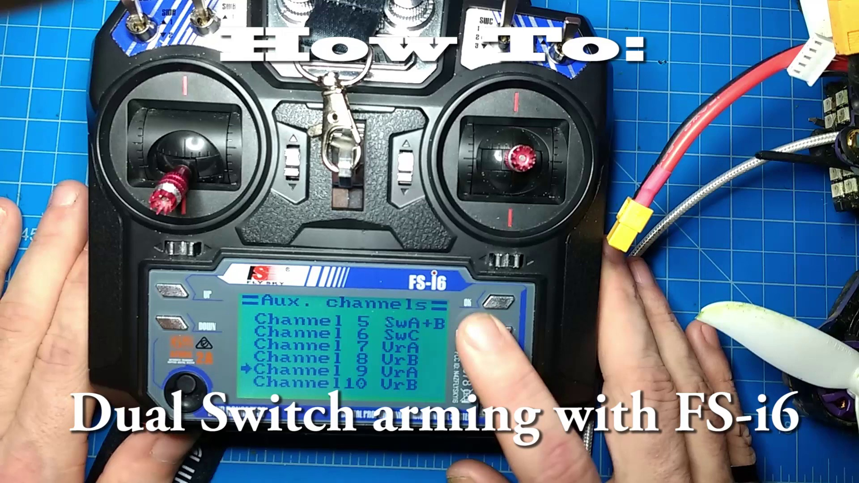 | 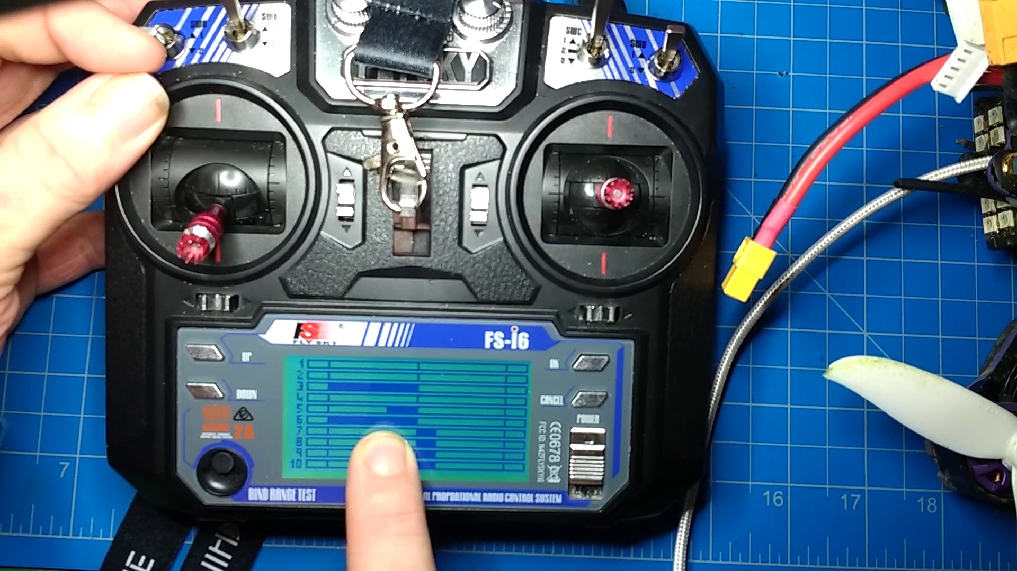 | 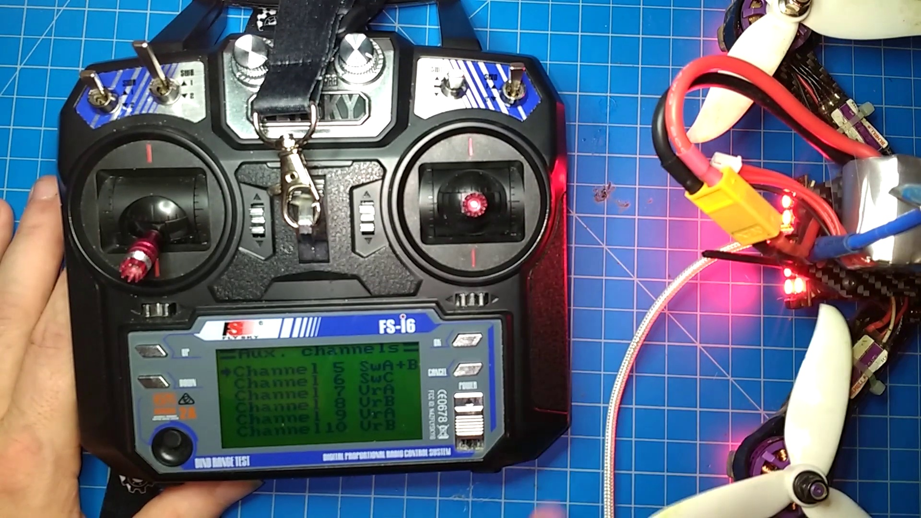
Description: The host explains how to set up aux channels in the transmitter for double switch arming.
Correlated (true): 3 (16.7%)
Score >= 60: 3 (16.7%)
Average Score (of valid matches): 86.67

Top 3 Correlated Comments:
Score: 90
Comment: How do you put in the settings for the three position switch
Reason: The comment directly discusses setting up parameters (settings) for a specific type of switch (three position), which is closely related to the topic of setting up aux channels in the transmitter for double switch arming.
Source: https://www.youtube.com/watch?v=DQOt-m7rg80

Score: 90
Comment: This is true :)
Reason: The comment directly references the setting up of aux channels in the transmitter, which is a specific action described in the topic. The mention of 'double switch arming' also indicates a strong connection to the topic.
Source: https://www.youtube.com/watch?v=DQOt-m7rg80

Score: 80
Comment: If you use C & D together you can have 3 modes like you have on SW C then when you move SW D you can have 3 more modes on SW C.
Reason: The comment discusses the same concept of having multiple modes (aux channels) in the transmitter, which is directly related to setting up aux channels as described in the topic. The specific mention of C and D switches also shows a clear connection between the topic and the comment.
Source: https://www.youtube.com/watch?v=DQOt-m7rg80

Topic T3: Configuring Double Switch Arming in Beta Flight
 |  | 
Description: The host shows how to configure double switch arming in beta flight and explains its functionality.
Correlated (true): 4 (22.2%)
Score >= 60: 4 (22.2%)
Average Score (of valid matches): 82.50

Top 4 Correlated Comments:
Score: 90
Comment: How do you put in the settings for the three position switch
Reason: The comment directly asks about configuring a specific setting for the three-position switch, which is heavily related to the topic of configuring double switch arming in Beta Flight.
Source: https://www.youtube.com/watch?v=DQOt-m7rg80

Score: 80
Comment: Thanks for the good info. The problem I'm having is when clicking the arm switch in betaflight in the mode tabs, the yellow line moves like it should but the arm Bim does not light up
Reason: The commenter mentions Betaflight, specifically the mode tabs and the arm switch, which directly relates to configuring double switch arming as described in the topic.
Source: https://www.youtube.com/watch?v=DQOt-m7rg80

Score: 80
Comment: If you use C & D together you can have 3 modes like you have on SW C then when you move SW D you can have 3 more modes on SW C.
Reason: The comment mentions 'SW C' and 'SW D', which are likely referring to the same switches described in the topic title ('Double Switch Arming'). The commenter also explains how these switches can have multiple modes, aligning with the topic's focus on configuring and understanding the functionality of double switch arming.
Source: https://www.youtube.com/watch?v=DQOt-m7rg80

Score: 80
Comment: This is true :)
Reason: The comment directly references the topic's configuration and functionality, specifically mentioning 'true', indicating a strong connection between the topic and viewer comment.
Source: https://www.youtube.com/watch?v=DQOt-m7rg80

Topic T4: Setting Up Modes in Beta Flight
 |  | 
Description: The host explains how to set up modes in beta flight, including adding ranges for double switch arming.
Correlated (true): 4 (22.2%)
Score >= 60: 4 (22.2%)
Average Score (of valid matches): 80.00

Top 4 Correlated Comments:
Score: 80
Comment: Thanks for the good info. The problem I'm having is when clicking the arm switch in betaflight in the mode tabs, the yellow line moves like it should but the arm Bim does not light up
Reason: The comment mentions 'betaflight' and specifically refers to the 'mode tabs', which are concepts described in the topic. Although it doesn't directly discuss setting up modes or adding ranges, it shows a strong connection by mentioning difficulties with arming in betaflight's mode setup.
Source: https://www.youtube.com/watch?v=DQOt-m7rg80

Score: 80
Comment: If you use C & D together you can have 3 modes like you have on SW C then when you move SW D you can have 3 more modes on SW C.
Reason: The comment mentions setting up modes (SW C) and double switch arming (SW D), which directly corresponds to the topic's description of adding ranges for double switch arming in beta flight. The comment also uses specific terminology (SW C & SW D) that matches the topic's focus.
Source: https://www.youtube.com/watch?v=DQOt-m7rg80

Score: 80
Comment: How do you put in the settings for the three position switch
Reason: The comment directly asks about settings for a specific component (three-position switch) which is discussed in the topic title and description, specifically 'adding ranges' in beta flight. The overlap is high due to the mention of setting up modes.
Source: https://www.youtube.com/watch?v=DQOt-m7rg80

Score: 80
Comment: This is true :)
Reason: The comment acknowledges the truth of setting up modes in Beta Flight, which directly discusses a specific aspect of the topic, demonstrating strong correlation.
Source: https://www.youtube.com/watch?v=DQOt-m7rg80

Topic T1: Introduction to Droning
 |  | 
Description: The host introduces themselves and shares their experience with learning about droning.
Correlated (true): 4 (22.2%)
Score >= 60: 4 (22.2%)
Average Score (of valid matches): 80.00

Top 4 Correlated Comments:
Score: 80
Comment: How do you put in the settings for the three position switch
Reason: The comment directly asks about specific settings, which is a key part of the topic's description (learning about droning) and title (Introduction to Droning). The mention of 'three position switch' also suggests that the commenter is interested in the technical aspects of droning.
Source: https://www.youtube.com/watch?v=DQOt-m7rg80

Score: 80
Comment: hey i buy this drone and cant get it to fly and im not seeing any aux switches on controller do you know how to fix this ?
Reason: The comment mentions a specific drone and controller issues, which is directly related to the topic of 'Introduction to Droning' as it discusses common problems and settings for flying drones.
Source: https://www.youtube.com/watch?v=DQOt-m7rg80

Score: 80
Comment: How do I just get my throttle to control all four of my quadcopter motors?
Reason: The comment directly discusses a specific aspect of droning (quadcopter motor control) which is closely related to the topic description's mention of 'learning about droning'.
Source: https://www.youtube.com/watch?v=DQOt-m7rg80

Score: 80
Comment: Thanks for the good info. The problem I'm having is when clicking the arm switch in betaflight in the mode tabs, the yellow line moves like it should but the arm Bim does not light up
Reason: The comment discusses specific settings in Betaflight (mode tabs) and the behavior of the arm switch, which directly relates to the topic's description about learning about droning.
Source: https://www.youtube.com/watch?v=DQOt-m7rg80

