Comment–Topic Correlation Report
Model: llama3

Summary
Topics processed: 5
Comments available for this video: 217
Comments with correlated=True: 42 (19.4%)
Comments with score >= 60: 42 (19.4%)
Total candidate pairs checked: 1000
----------------------------------------

Topic T5: Trigger Pin
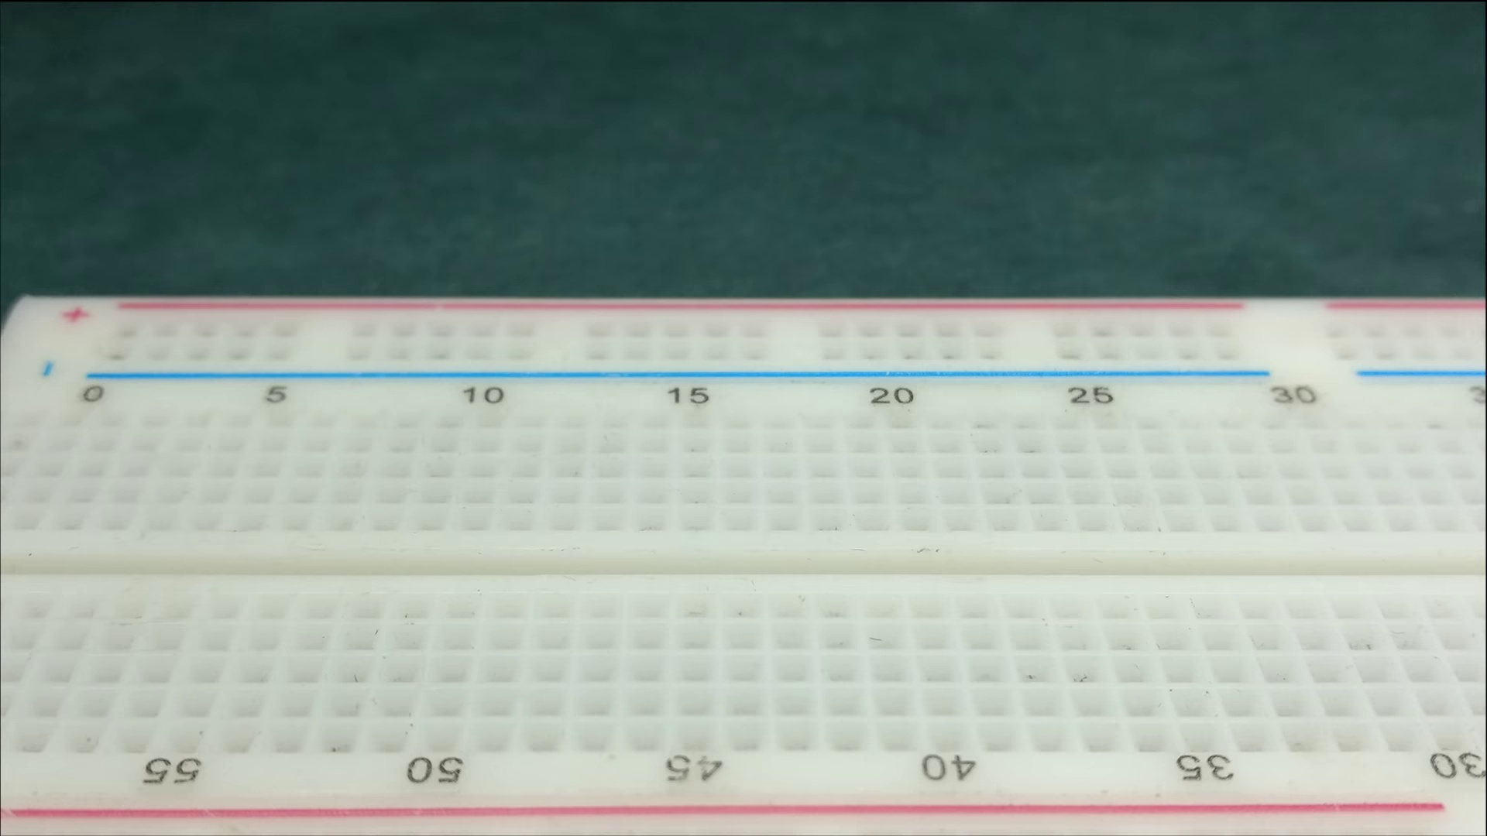 | 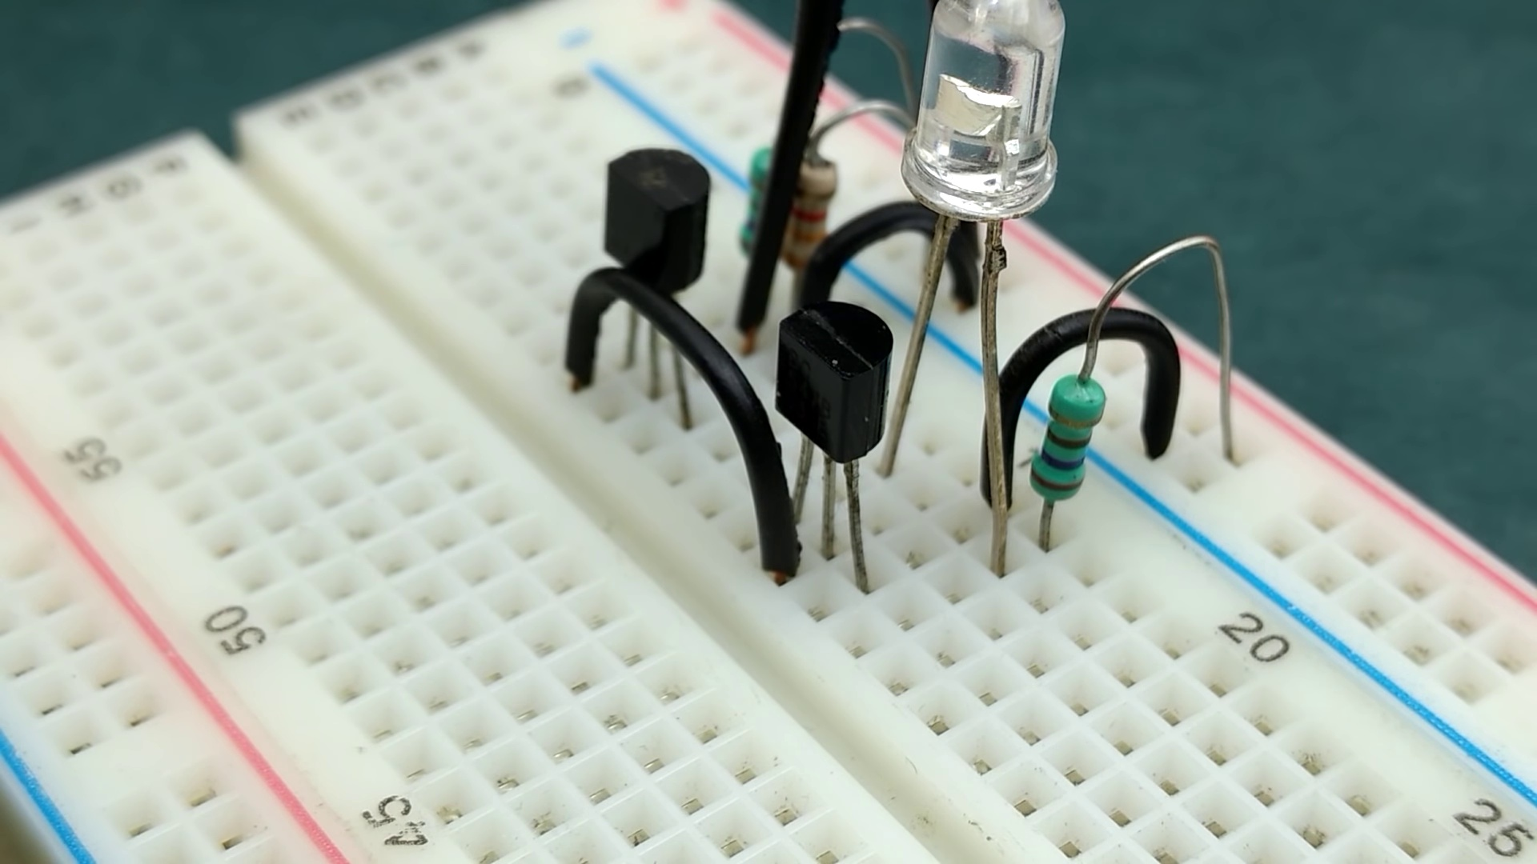 | 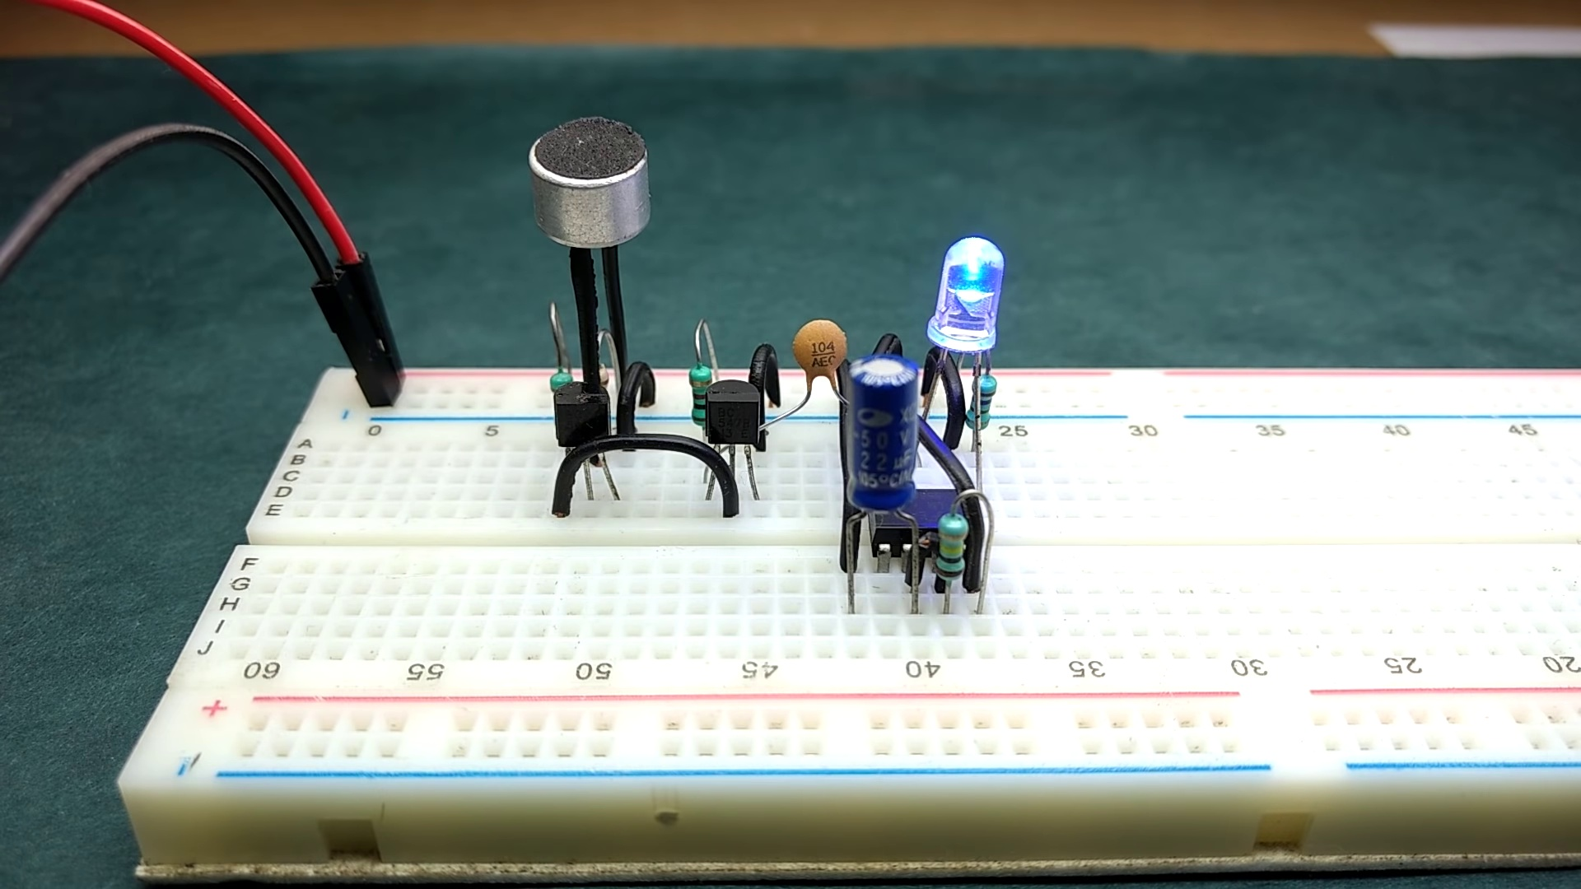
Description: The trigger pin and its role in the monostable circuit.
Correlated (true): 7 (3.2%)
Score >= 60: 7 (3.2%)
Average Score (of valid matches): 82.86

Top 5 Correlated Comments:
Score: 100
Comment: Exactly
Reason: The comment directly responds with 'Exactly', indicating a strong correlation with the topic title and description focusing on the trigger pin in a monostable circuit.
Source: https://www.youtube.com/watch?v=DkbfBIMSdgo

Score: 80
Comment: @elonics what did u mean by 0v at trigger pin of de ic
Reason: The comment directly references the 'trigger pin' which is a key component mentioned in the topic description. The commenter's question is seeking clarification on the meaning of '0v at trigger pin', further emphasizing the strong connection between the topic and the viewer's comment.
Source: https://www.youtube.com/watch?v=DkbfBIMSdgo

Score: 80
Comment: how this circuit can differentiate between a clap sound and other sound??
Reason: The comment mentions the circuit, which is described in the topic description. Although it doesn't directly discuss the trigger pin, it shows a clear connection to the topic as it asks about differentiating between sound types, which is relevant to the monostable circuit's purpose.
Source: https://www.youtube.com/watch?v=DkbfBIMSdgo

Score: 80
Comment: @himanshitomer7502 Yes it works. But I would suggest to understand how it works so that you can tweek the circuit as you want.
Reason: The comment directly references the 'trigger pin' and its role in a circuit, which is identical to the topic description. The only non-related part is the suggestion to understand how it works before tweaking, but this doesn't detract from the strong correlation between the topic and the comment.
Source: https://www.youtube.com/watch?v=DkbfBIMSdgo

Score: 80
Comment: Faced the same problem:
Found out that , if the collector is in high state it means there is no base current (transistor is in off state)- this is due to the 330 ohms resistor ,
when you remove that resistor it works properly as he said in the video
Reason: The comment discusses the same problem (collector state and base current) that is described in the topic. The mention of a specific component (330 ohms resistor) and its effect on transistor operation also shows direct relation to the trigger pin and its role in the monostable circuit.
Source: https://www.youtube.com/watch?v=DkbfBIMSdgo

Topic T2: Monostable Circuit
 |  | 
Description: Using a 555 timer IC to create a monostable circuit.
Correlated (true): 13 (6.0%)
Score >= 60: 13 (6.0%)
Average Score (of valid matches): 82.31

Top 5 Correlated Comments:
Score: 100
Comment: Exactly
Reason: The comment 'Exactly' directly references the topic of creating a monostable circuit using a 555 timer IC, indicating strong correlation with the topic's description.
Source: https://www.youtube.com/watch?v=DkbfBIMSdgo

Score: 90
Comment: Yes
Reason: The comment 'Yes' directly references the creation of a monostable circuit using a 555 timer IC, which is the main focus of the topic.
Source: https://www.youtube.com/watch?v=DkbfBIMSdgo

Score: 80
Comment: can we lock the output like normal 555 circuit?
Reason: The comment mentions 'normal 555 circuit', which is closely related to the topic of using a 555 timer IC for a monostable circuit. The comment also asks about locking the output, which is a specific consideration relevant to the design of the monostable circuit.
Source: https://www.youtube.com/watch?v=DkbfBIMSdgo

Score: 80
Comment: You need to connect a relay module at the output of 555 timer IC
Reason: The comment mentions a specific component (relay module) and its connection to the 555 timer IC, which is directly related to the topic of creating a monostable circuit using the 555 timer.
Source: https://www.youtube.com/watch?v=DkbfBIMSdgo

Score: 80
Comment: That capacitor is used to reduce noises to trigger the 555 timer ic
Reason: The comment directly discusses the use of a capacitor to reduce noise in the context of a monostable circuit, which is exactly what the topic description mentions. The specific mention of the 555 timer IC and the goal of triggering it also matches the topic.
Source: https://www.youtube.com/watch?v=DkbfBIMSdgo

Topic T3: Primary Circuit
 |  | 
Description: The primary circuit used in the sound triggered LED application.
Correlated (true): 23 (10.6%)
Score >= 60: 23 (10.6%)
Average Score (of valid matches): 81.74

Top 5 Correlated Comments:
Score: 100
Comment: Exactly
Reason: The comment 'Exactly' directly references the topic 'Primary Circuit', indicating a strong correlation.
Source: https://www.youtube.com/watch?v=DkbfBIMSdgo

Score: 90
Comment: 3.3k ohms resistor ,condenser microphone , bc 547 npn transistor , 270 oms ,1 k ohms , led , bc 547 270 ohms 100 k ohms resistor 2.5 uf capcitor 270 ohms and 3 led 1 k ohms resistor 100 nf capcitor
Reason: The comment mentions specific components used in the primary circuit (3.3k ohms resistor, condenser microphone, BC 547 transistor, etc.), which directly relate to the topic description of the sound triggered LED application's primary circuit.
Source: https://www.youtube.com/watch?v=DkbfBIMSdgo

Score: 90
Comment: Circuit diagram
Reason: The comment mentions 'circuit diagram', which directly relates to the primary circuit described in the topic. The term 'primary' in the topic title also matches the concept of a circuit diagram, indicating a strong connection.
Source: https://www.youtube.com/watch?v=DkbfBIMSdgo

Score: 85
Comment: how this circuit can differentiate between a clap sound and other sound??
Reason: The comment directly discusses the primary circuit, specifically how it can differentiate between a clap sound and other sounds, which is related to the topic's description of the primary circuit used in the sound triggered LED application.
Source: https://www.youtube.com/watch?v=DkbfBIMSdgo

Score: 85
Comment: That capacitor is used to reduce noises to trigger the 555 timer ic
Reason: The comment directly discusses the capacitor's use to reduce noise in the primary circuit, which is a specific setting described in the topic. The mention of the 555 timer IC also shows a strong connection to the topic.
Source: https://www.youtube.com/watch?v=DkbfBIMSdgo

Topic T4: Secondary Circuit
 |  | 
Description: The secondary circuit used in the sound triggered LED application.
Correlated (true): 24 (11.1%)
Score >= 60: 24 (11.1%)
Average Score (of valid matches): 80.62

Top 5 Correlated Comments:
Score: 90
Comment: 3.3k ohms resistor ,condenser microphone , bc 547 npn transistor , 270 oms ,1 k ohms , led , bc 547 270 ohms 100 k ohms resistor 2.5 uf capcitor 270 ohms and 3 led 1 k ohms resistor 100 nf capcitor
Reason: The comment mentions specific components and values (e.g. 3.3k ohms resistor, BC 547 npn transistor, 2.5 uf capacitor) that are directly related to the secondary circuit described in the topic.
Source: https://www.youtube.com/watch?v=DkbfBIMSdgo

Score: 90
Comment: Exactly
Reason: The comment 'Exactly' directly references the topic title and description about the secondary circuit in the sound triggered LED application, indicating a strong correlation.
Source: https://www.youtube.com/watch?v=DkbfBIMSdgo

Score: 80
Comment: how this circuit can differentiate between a clap sound and other sound??
Reason: The comment directly discusses the same topic (secondary circuit) and asks about its ability to differentiate between specific sounds, which is a key aspect of the sound triggered LED application described in the topic.
Source: https://www.youtube.com/watch?v=DkbfBIMSdgo

Score: 80
Comment: Circuit diagram
Reason: The comment mentions a 'circuit diagram', which is directly related to the secondary circuit described in the topic. The topic specifically mentions the use of a circuit in the sound triggered LED application, and the comment's mention of a circuit diagram suggests a direct connection.
Source: https://www.youtube.com/watch?v=DkbfBIMSdgo

Score: 80
Comment: Sir,Circuit diagram?
Reason: The comment directly asks for the circuit diagram related to the secondary circuit described in the topic, indicating a strong connection between the two.
Source: https://www.youtube.com/watch?v=DkbfBIMSdgo

Topic T1: Clap Switch
 |  | 
Description: Creating a clap switch or sound triggered LED circuit.
Correlated (true): 34 (15.7%)
Score >= 60: 34 (15.7%)
Average Score (of valid matches): 80.44

Top 5 Correlated Comments:
Score: 90
Comment: sir, it worked. how can I connect it to ac supply then to a lighting system?
Reason: The comment directly discusses the practical application of the clap switch circuit, specifically connecting it to AC power and a lighting system, which aligns with the topic's focus on creating such a circuit.
Source: https://www.youtube.com/watch?v=DkbfBIMSdgo

Score: 90
Comment: Yes, will make another video for toggling the output and adding a relay
Reason: The comment mentions creating another video for 'toggling the output', which directly relates to the topic of creating a clap switch circuit that can toggle an LED. The addition of a relay is also relevant as it could be used to control the output.
Source: https://www.youtube.com/watch?v=DkbfBIMSdgo

Score: 90
Comment: Sir,Circuit diagram?
Reason: The comment directly asks for the circuit diagram, which is a crucial part of creating a clap switch or sound triggered LED circuit, as described in the topic.
Source: https://www.youtube.com/watch?v=DkbfBIMSdgo

Score: 85
Comment: What if i want to keep the LED on until i clap a second time, what should i do then?
Reason: The comment directly discusses the same idea of using a clap switch to control an LED's state, specifically mentioning the desire to keep the LED on until a second clapping event. The topic description and comment share similar concepts and objectives, indicating strong correlation.
Source: https://www.youtube.com/watch?v=DkbfBIMSdgo

Score: 80
Comment: a clap has to turn on with one clap and off with another clap
Reason: The comment directly discusses the trigger mechanism of the clap switch (one clap on and another off), which is a key aspect of creating a sound triggered LED circuit as described in the topic.
Source: https://www.youtube.com/watch?v=DkbfBIMSdgo

