Comment–Topic Correlation Report
Model: llama3

Summary
Topics processed: 3
Comments available for this video: 84
Comments with correlated=True: 2 (2.4%)
Comments with score >= 60: 2 (2.4%)
Total candidate pairs checked: 252
----------------------------------------

Topic T2: Collaboration and Feedback
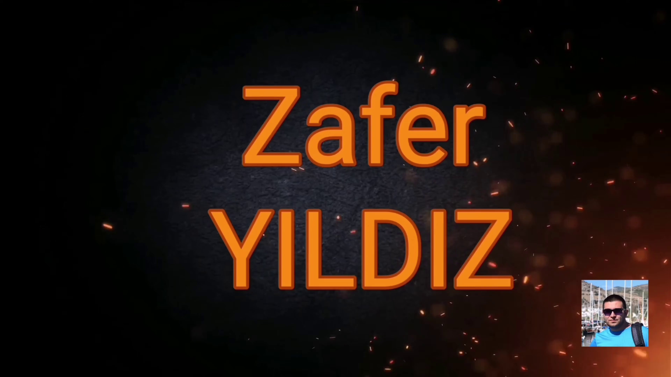 | 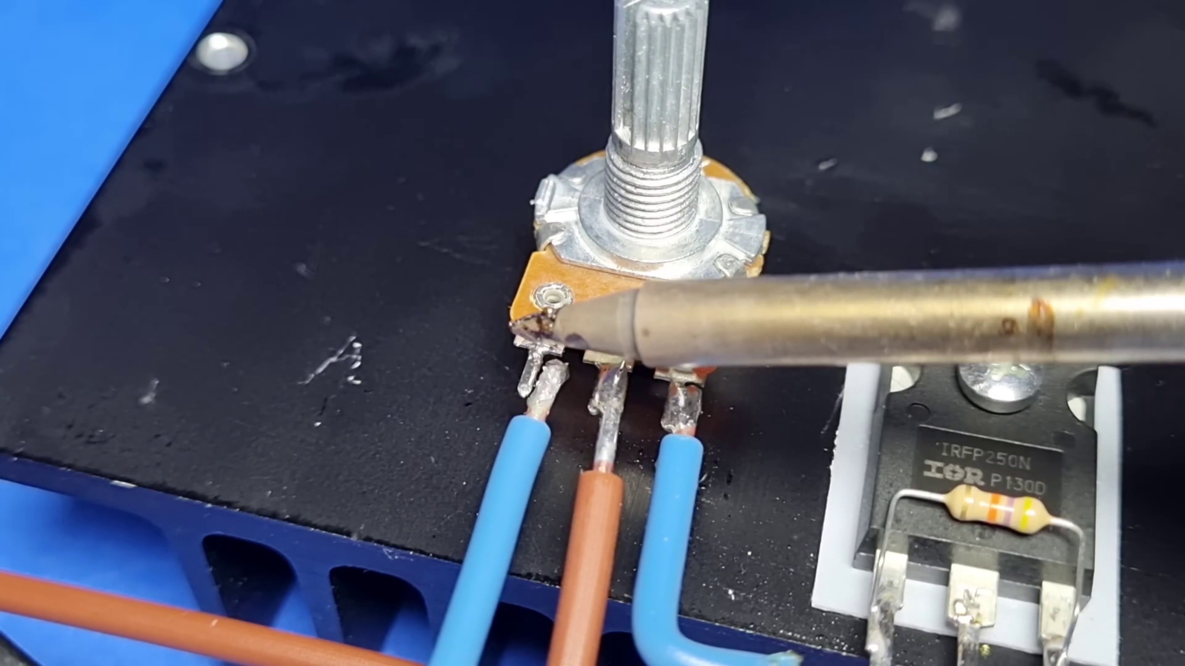 | 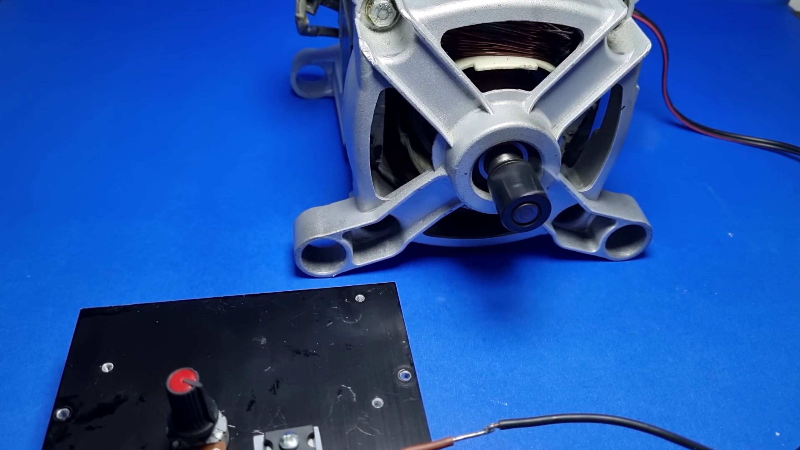
Description: The speaker highlights the platform's collaboration features, allowing users to share their work with others and receive feedback and evaluations.
Correlated (true): 1 (1.2%)
Score >= 60: 1 (1.2%)
Average Score (of valid matches): 80.00

Top 1 Correlated Comments:
Score: 80
Comment: Good video sir. How can I get a similar circuit like your but suitable for a bigger motor (4kw/48v/100amp for rotor 10amp for field). Thank you so much sir
Reason: The comment mentions collaboration (sharing circuit) and feedback (evaluation) which are directly discussed in the topic. Although it's not a generic praise, it shows an interest in the platform's features and how to apply them in a specific context.
Source: https://www.youtube.com/watch?v=ERLMO-nay30

Topic T1: Altyum Designer Introduction
 |  | 
Description: The speaker introduces Altyum 365 as an electronic product design platform that combines PCB design, MCAT data management, and team collaboration.
Correlated (true): 1 (1.2%)
Score >= 60: 1 (1.2%)
Average Score (of valid matches): 80.00

Top 1 Correlated Comments:
Score: 80
Comment: Good video sir. How can I get a similar circuit like your but suitable for a bigger motor (4kw/48v/100amp for rotor 10amp for field). Thank you so much sir
Reason: The comment directly asks how to modify the circuit design for a bigger motor, which is closely related to the topic of introducing Altyum as an electronic product design platform for PCB design and team collaboration.
Source: https://www.youtube.com/watch?v=ERLMO-nay30

Topic T3: Free Trial and Access
 |  | 
Description: The speaker explains that there is no extra cost or license required to use the platform, and users can access it directly from Altyum Designer.
Correlated (true): 2 (2.4%)
Score >= 60: 2 (2.4%)
Average Score (of valid matches): 70.00

Top 2 Correlated Comments:
Score: 80
Comment: Good video sir. How can I get a similar circuit like your but suitable for a bigger motor (4kw/48v/100amp for rotor 10amp for field). Thank you so much sir
Reason: The commenter mentions accessing the platform directly from Altyum Designer, which is related to the topic of 'Free Trial and Access'. Additionally, they ask about getting a similar circuit suitable for a bigger motor, showing an understanding of the platform's capabilities.
Source: https://www.youtube.com/watch?v=ERLMO-nay30

Score: 60
Comment: por supuesto, puedes probar los circuitos de atenuación en el canal
Reason: The comment mentions trying out circuits, which aligns with the topic's discussion of accessing the platform to try it out.
Source: https://www.youtube.com/watch?v=ERLMO-nay30

