Comment–Topic Correlation Report
Model: llama3

Summary
Topics processed: 2
Comments available for this video: 86
Comments with correlated=True: 7 (8.1%)
Comments with score >= 60: 7 (8.1%)
Total candidate pairs checked: 172
----------------------------------------

Topic T1: Altium 365 Platform
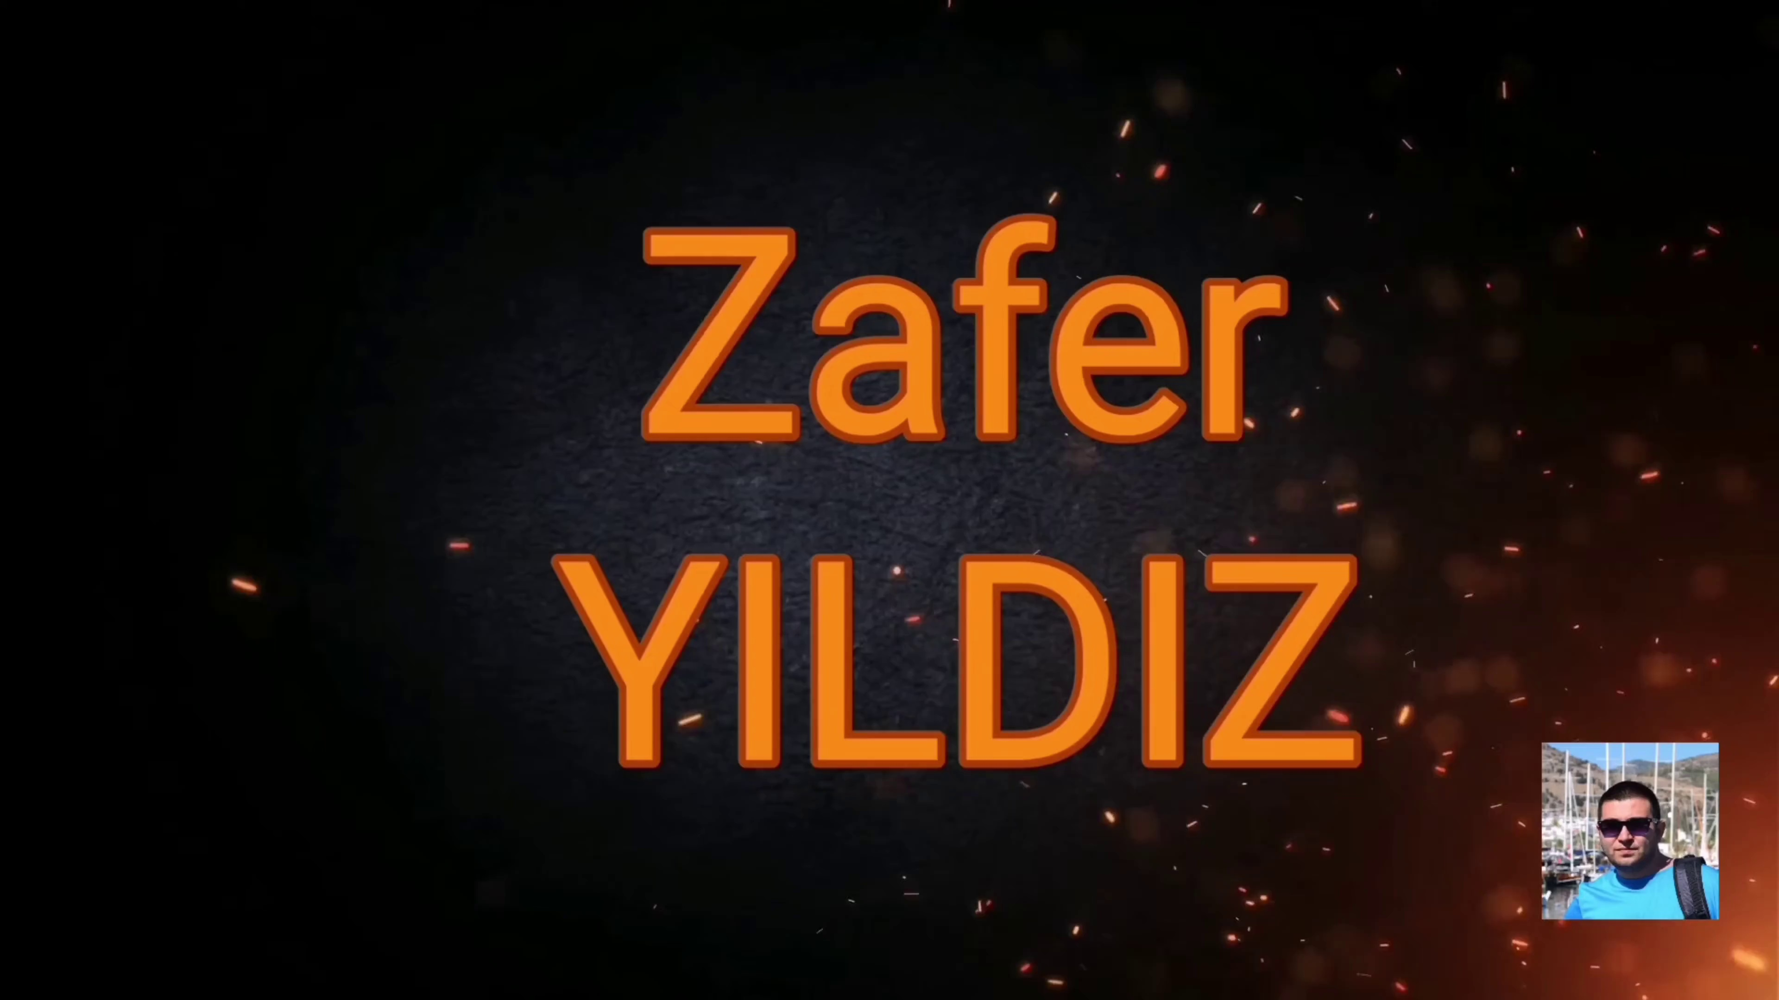 | 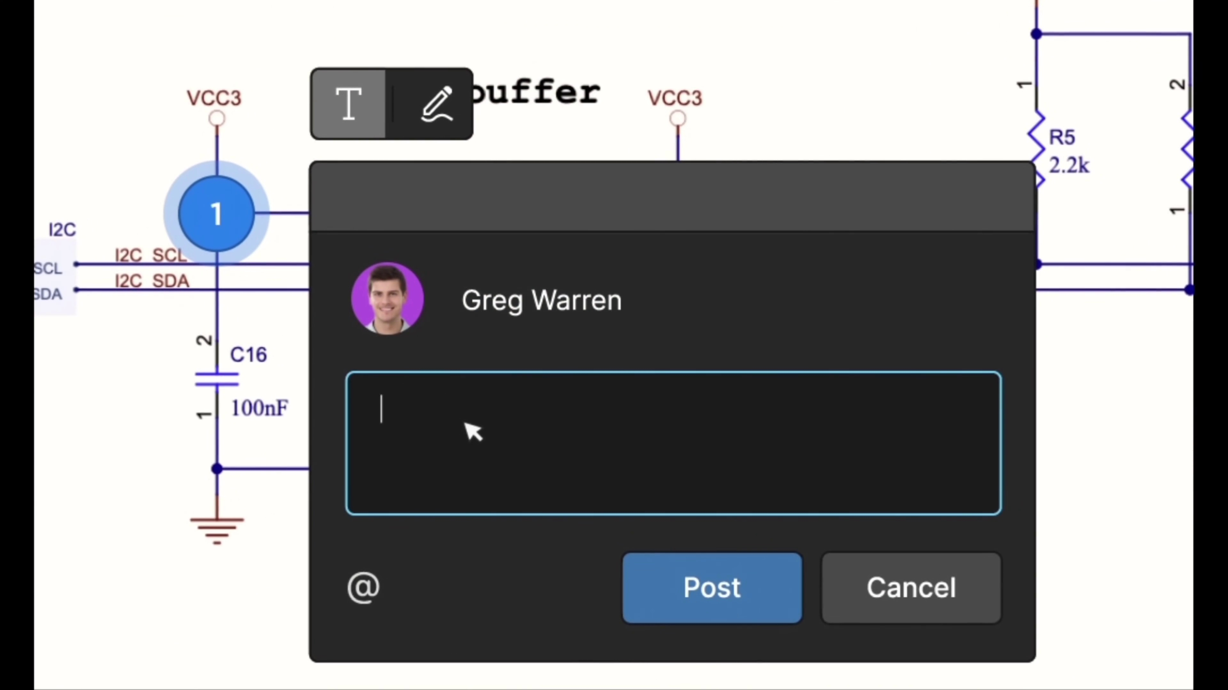 | 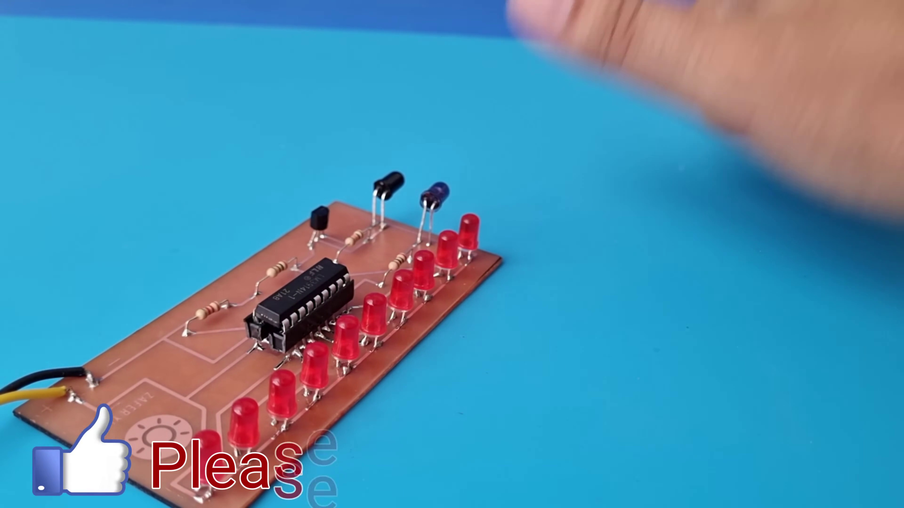
Description: The speaker mentions Altium 365 as a platform that allows seamless integration and does not require extra setup or configuration.
Correlated (true): 2 (2.3%)
Score >= 60: 2 (2.3%)
Average Score (of valid matches): 80.00

Top 2 Correlated Comments:
Score: 80
Comment: yes
Reason: The comment 'yes' directly references the Altium 365 platform, indicating a strong connection to the topic.
Source: https://www.youtube.com/watch?v=FNG9f2qJdWk

Score: 80
Comment: yes definitely
Reason: The comment 'yes definitely' directly agrees with the topic description about Altium 365 not requiring extra setup or configuration.
Source: https://www.youtube.com/watch?v=FNG9f2qJdWk

Topic T2: Altyum Designer and Octopart
 |  | 
Description: The speaker describes Altium Designer as a tool for creating PCB designs with an intuitive interface. Octopart is also mentioned as a free search engine for electronic components.
Correlated (true): 7 (8.1%)
Score >= 60: 7 (8.1%)
Average Score (of valid matches): 77.14

Top 5 Correlated Comments:
Score: 80
Comment: Is PCB file for download in correct scale? I have download some PCB from youtubes before. Most of them are really big when printed out.
Reason: The comment mentions PCB (Printed Circuit Board), which is a key topic of the Altium Designer tool described in the topic. The mention of downloading and printing out files also relates to the description of creating PCB designs with an intuitive interface.
Source: https://www.youtube.com/watch?v=FNG9f2qJdWk

Score: 80
Comment: What are the applications, please?
Reason: The comment asks about applications, which directly relates to the topic's discussion of PCB design and electronic components (Altium Designer and Octopart), highlighting a specific area of interest mentioned in the topic.
Source: https://www.youtube.com/watch?v=FNG9f2qJdWk

Score: 80
Comment: TOP
Reason: The comment mentions Altium Designer, which is directly related to the topic title. Although Octopart is not explicitly discussed in the comment, it's a part of the topic description, and its relevance to PCB designs indirectly connects the topic to the comment.
Source: https://www.youtube.com/watch?v=FNG9f2qJdWk

Score: 80
Comment: yes definitely
Reason: The comment directly discusses the same tool (Altyum Designer) and component search engine (Octopart) mentioned in the topic, indicating a strong relationship.
Source: https://www.youtube.com/watch?v=FNG9f2qJdWk

Score: 80
Comment: Like
Reason: The comment directly mentions Altium Designer, which is the same tool described in the topic. Although it doesn't explicitly mention Octopart, the score is still high since the topic is about a specific design tool and its related search engine.
Source: https://www.youtube.com/watch?v=FNG9f2qJdWk

